Comparative performance between human and automated face recognition systems, using CCTV imagery, different compression

levels and scene parameters

A. Tsifouti^{a,b}, S. Triantaphillidou^{b}, M.-C. Larabi^{c}, E. Bilissi^{b}, A. Psarrou^{b}
ª Home Office Centre for Applied Science and Technology, UK; ^{b}, Imaging Technology Research Group, University of Westminster, London, UK; ^{c} XLIM-SIC Labs, University of Poitiers, France

Abstract

In this investigation we identify relationships between human and automated face recognition systems with respect to compression. Further, we identify the most influential scene parameters on the performance of each recognition system. The work includes testing of the systems with compressed Closed-Circuit Television (CCTV) footage, consisting of quantified scene (footage) parameters. Parameters describe the content of scenes concerning camera to subject distance, facial angle, scene brightness, and spatio-temporal busyness. These parameters have been previously shown to affect the human visibility of useful facial information, but not much work has been carried out to assess the influence they have on automated recognition systems. In this investigation, the methodology previously employed in the human investigation is adopted, to assess performance of three different automated systems: Principal Component Analysis, Linear Discriminant Analysis, and Kernel Fisher Analysis. Results show that the automated systems are more tolerant to compression than humans. In automated systems, mixed brightness scenes were the most affected and low brightness scenes were the least affected by compression. In contrast for humans, low brightness scenes were the most affected and medium brightness scenes the least affected. Findings have the potential to broaden the methods used for testing imaging systems for security applications.

Keywords: Human face recognition, Principal Component Analysis, Linear Discriminant Analysis, Kernel Fisher Analysis, H.264/MPEG-4 AVC, Closed-Circuit Television footage, Scene characterization, Image acceptance

INTRODUCTION
The police use both human (i.e. visual examinations) and automated (i.e. face recognition systems) systems for the completion of face identification tasks. Uncontrollable environmental conditions, such as variable lighting encountered by CCTV camera systems, create challenges on the usefulness (in terms of visibility of facial information) [1] of the reproduced imagery. The usefulness of the imagery is further compromised by compression, implemented to satisfy limited storage capacity of CCTV recording systems, or transmission bandwidths. In order to make use of the already available vast amount of video CCTV data, [2, 3] automated face recognition systems should be aiming to work efficiently with imagery obtained under uncontrollable environmental conditions and compression. CCTV imagery is used in UK courts as documentary evidence [4] and it has been found to have an effective impact on conviction of crimes [5].

Image usefulness is associated with image quality and relates to the suitability of the imagery to satisfy a specific task [6]. In this context, the specific task requires the suitable facial information to remain in the compressed image in order to allow human and automated recognition systems to identify a person. This suitable facial information might differ between human and automated recognition systems. Adler and Dembinsky [7] have shown that low brightness facial images (low key scenes) have scored the lowest by humans in terms of image usefulness, but not by automated algorithms. Furthermore, Aggarwal et al. [8] have identified that face recognition systems performed differently on different datasets due to the dissimilar parameters of the facial imagery under each dataset. Most face recognition systems are evaluated based on their performance of correct identification from large datasets and the individual parameters of each facial image is not considered [9, 10].

The aim of this investigation is to identify relationships between human and automated face recognition systems with respect to compression. Further, to identify the most influential scene parameters on the performance of each recognition system. The work includes testing of the systems with compressed footage (i.e. 25 scenes compressed with H.264/MPEG-4 AVC video coding standard) consisting of quantified scene (footage) parameters. These include measures of camera to subject distance, angle of the face to camera plane, scene brightness, and spatio-temporal busyness. These parameters have been previously shown to affect the human visibility of useful facial information [1], but no much work has been carried out to assess the influence they have on automated recognition systems.

Results and test material previously obtained from a human investigation [1] are also used here. Thus, in the present investigation four systems have been assessed, one human face recognition (HFR) system, and three basic automated face recognition (AFR) systems [11]: a) Principal Component Analysis (PCA), b) Linear Discriminant Analysis (LDA), and c) Kernel Fisher Analysis (KFA). PCA and LDA use linear subspace projection techniques (i.e. from the input space to the feature space). LDA is an execution of the Fisherface technique [12] and a PCA step is implemented before LDA. PCA utilizes the Eigenface technique as explained in [13]. KFA is a nonlinear variation of LDA and was initially introduced in [14].

Section 2 presents the experimental methodology. Data analysis of the results is described in Section 3. Section 4 discusses the results. Lastly, in Section 5, conclusions are drawn along with suggestions for future work.

Methodology

The aim of the human study was to derive acceptable bitrates from five CCTV recording systems installed on London buses (i.e. these systems used proprietary formats based on the H.264/MPEG-4 AVC video coding standard) [1]. Before testing the CCTV systems, a consumer quality implementation encoder (MPEG Streamclip with H.264/MPEG-4 AVC video coding standard) was employed, to act as a filter in identifying the most affected scenes by compression from out of a total of twenty-five initially tested scenes. The filtering step was implemented in order to reduce the number of scenes to test the five CCTV recording systems and as a result the experiment viewing time for the observers. The identified most affected scenes were six and were these perceived (by the observers) to require relatively less compression than the remaining test scenes in the dataset, in order to maintain useful facial information. Only these six scenes were finally used to test the five CCTV recording systems.

The test material in this current investigation consists of different formats (reference and degraded) and implementations of H.264/MPEG-4 AVC. The following material were utilized:

- Twenty five reference “uncompressed” scenes. The reference “uncompressed” format was compressed using MPEG-2 at approximately 25Mbits/s, 25 frames per second (25fps), and 4:2:0 chroma subsampling. This compression was applied to the original recorded footage (i.e. DV format) in order to provide the test scenes on a DVD to the CCTV suppliers for the testing of the CCTV systems. Empirical studies showed no visible difference between the original recorded (DV format) and the assigned reference (MPEG-2 format) footage [1].
- Twenty five scenes, compressed with MPEG Streamclip implementation. The compression bitrates used were at 25fps, with video coding standard H.264/MPEG-4 AVC, and approximately the following in kilobits per second (kbps): 300, 400, 800, 1000, 1200, 1400, 1600, 1800, 2000;
- The six most affected scenes, compressed with five CCTV recording systems. The compression bitrates used were at 4fps, with video coding standard H.264/MPEG-4 AVC, and approximately the following in kbps: 10, 160, 352, 544, 736, 928, 1120, 1312, 1504.

Overall four face recognition systems have been assessed with these test material, one human face recognition (HFR) system, and the three basic automated face recognition (AFR) systems mentioned in section 1 (Introduction).

Figure 1 and Table I provide information relating to the content of the 25 scenes (named s1 to s25) included in the test material. Figure 1 provides a visual illustration, whereas Table I lists the groups that each scene belongs to after applying the scene characterization techniques reported in [1]. Each scene was of a 20 second duration, to enable the compressor to adjust to the specific scene characteristics (i.e. video compression algorithms apply temporal information reduction). In this duration, a face that appeared in 8 images at an approximately consistent subject to camera distance, angle of the face to the camera plane, and constant illumination, was selected. The characterization techniques were applied on local (i.e. on the 8 images of the face) and global (i.e. on the entire scene) scene contents. In summary, the characterization included the following four groups:

- Camera to subject distance. This local property was derived objectively, by measuring manually the inter-pupillary distance, in pixels. Scenes were classified empirically into two groups: a) close (approx. 40 pixels distance), and b) far (approx. 20 pixels distance)
- Brightness. This local property was derived objectively from measuring skin lightness using the CIELAB L* metric. The scenes fell into 5 groups of L* measurements using two types of illumination (daylight and bus illumination): a) Medium lightness (bus illumination): L*≈ 50 b) Medium lightness (daylight): L* ≈ 50, c) Low lightness (daylight): L* ≈ 10, d) High lightness (daylight): L*≈ 90, and e) Mixed lightness (daylight): approximately half of the face had L*≈ 90 and the other half L*≈ 50.
- Angle of face to camera plane. This local property was deduced subjectively, by visual inspection. Two groups were derived: tilted angle and frontal angle.
- Busyness. This global property was deduced objectively, by implementing an ITU specification measure [15] to derive the spatial and temporal properties of the scenes. The following four groups were created: a) High Spatial – High Temporal: spatial value > 14.58 and temporal value > 27.16, b) High Spatial – Low Temporal: Spatial value > 14.58 and temporal value < 27.16, b) Low Spatial – High Temporal: Spatial value < 14.58 and the temporal value > 27.16, and c) Low Spatial – Low Temporal: Spatial value < 14.58 and the temporal value > 27.16.

In the investigation with humans [1], experienced civilian analysts and police staff (i.e. in total 27 observers) were polled to give their opinion on what they considered to be acceptable reduction of information from an uncompressed reference source by answering with a yes or no to the question “Is the compressed version (s) as useful as the reference source in terms of facial information? The obtained results have scores of 1 to the yes responses and 0 to the no responses.

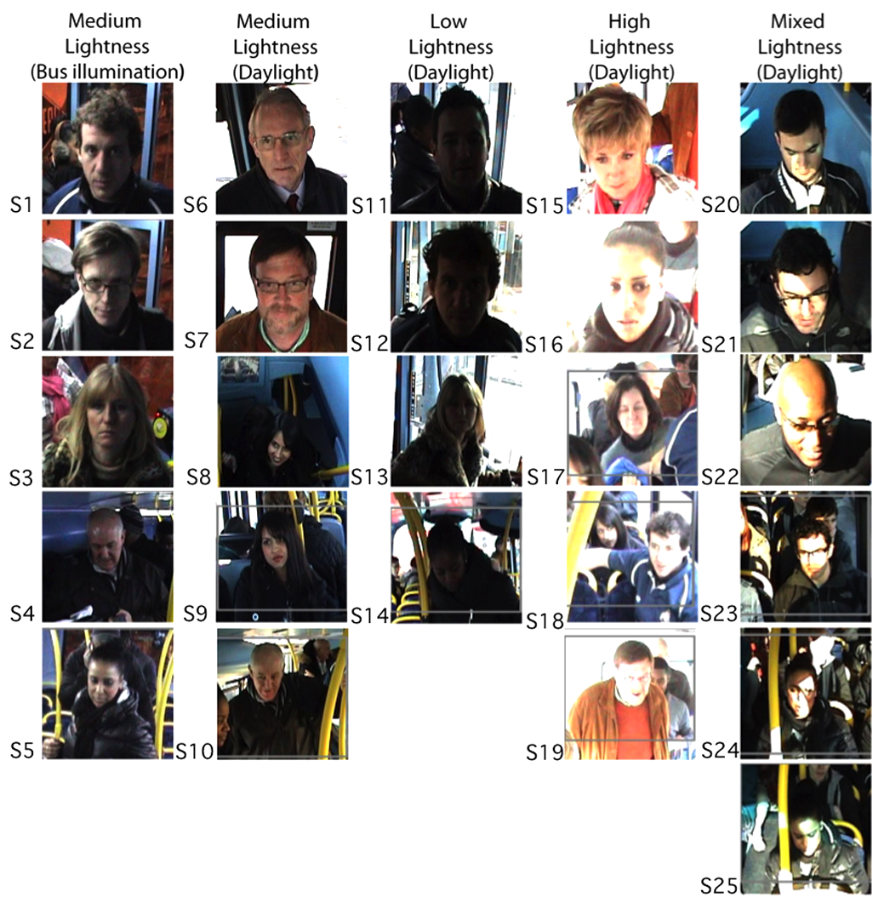
Figure 1. The 25 scenes grouped based on skin lightness

Similarly to the human investigation, the automated systems were assessed based on similarity score distance (between a degraded image from its reference version) and not on correct identification/recognition rate. Similarity scores provide a distance measure of facial information between two images of faces, or biometric signatures [16, 17] The three AFR systems under investigation were executed using a publicly available MATLAB face recognition toolbox [11, 18, 19].

Table I. Summary of scene grouping. Each scene from Figure 1 belongs to different groups.
The totals indicate the total number of scenes in the specific group.
Group name | Scene Name | Totals
Camera to Subject Distance
Close | S1, S2, S3, S6, S7, S11, S12, S15, S16, S20, S21, S22 | 12
Far | S4, S5, S8, S9, S10, S13, S14, S17, S18, S19, S23, S24, S25 | 13
Scene Brightness
Medium Lightness Bus illumination (Bus) | S1, S2, S3, S4, S5 | 5
Medium Lightness Daylight illumination (Medium) | S6, S7, S8, S9, S10 | 5
Low Lightness Daylight illumination (Low) | S11, S12, S13, S14 | 4
High Lightness Daylight illumination (High) | S15, S16, S17, S18, S19 | 5
Mixed Lightness Daylight illumination (Mixed) | S20, S21, S22, S23, S24, S25 | 6
Angle of Face to the Camera plane
Frontal | S1, S2, S3, S6, S7, S9, S11, S12, S13, S16, S17, S23, S24 | 13
Tilted | S4, S5, S8, S10, S14, S15, S18, S19, S20, S21, S22, S25 | 12
Scene Busyness
Low Spa. Low Temp. | S1, S2, S3, S4, S7 | 5
Low Spa. High Temp. | S5, S6, S20, S21 | 4
High Spa. Low Temp. | S8, S9, S15, S18, S23, S24, S25 | 7
High Spa. High Temp. | S10, S11, S12, S13, S14, S16, S17, S19, S22 | 9

The testing of the AFR systems included the following actions:

1. Normalization of facial images. The footage of all 25 scenes (reference and degraded) was converted, with the MPEG Streamclip software, into a sequence of color still images in TIFF uncompressed format. As mentioned above, each scene included a consistent face that appeared in 8 images. These 8 images were used to extract only the facial regions, based on eye coordinates (i.e. these were the same among reference and degraded images with MPEG Streamclip encoder). Later, the extracted facial regions were normalized in terms of geometry (i.e. orientation), size (i.e. rescaled to 125x125 pixels) and were saved as color images, in TIFF format (see Figure 2). This has resulted in the normalization of 8 images for each scene (single individual) and each type of footage (reference and degraded with MPEG Streamclip encoder). Initial tests have indicated that size and representation (i.e. color/grayscale - grayscale images produced lower matching scores than color images) of facial regions influence the derived matching scores, thus these were kept constant.

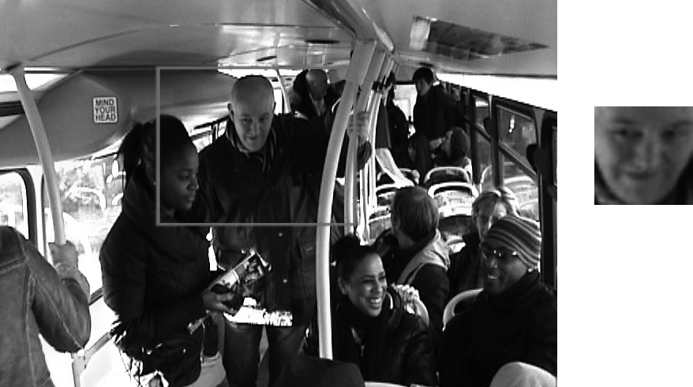
Figure 2. Extraction (left image) and normalization (right image) of facial region.

2. Creation of the gallery dataset for the testing of the AFR systems. A single dataset was created for the testing. The dataset was represented with a single folder, consisting with 25 subfolders, corresponding to each of the 25 scenes in Figure 1. Furthermore, each subfolder consisted of 149 facial region images (as right image in Figure 2). More specifically, the 149 facial images in each subfolder were in the following order: a) 8 images from the reference (MPEG-2 format), b) again 8 images from the reference (MPEG-2 format), c) 8 images from the original recorded “uncompressed” (DV format), d) 8 images from each of the 10 compressed types using the MPEG Streamclip implementation (at kbps: 300, 400, 600, 800, 100, 1200, 1400, 1600, 1800, 2000), and e) the remaining images were derived from the five CCTV recorders for the six identified most affected scenes; the remaining scenes included repetitions of the reference (in order to create balancing number of images in the subfolders). Results obtained from the CCTV recorders will not be presented here but in a future work.

Inclusion of the images from the CCTV recorders did not affect the similarity scores (these were perceived, in the human investigation, to have a different quality from that of the MPEG Streamclip encoder). For example, the similarity scores were the same between the gallery dataset under investigation and a dataset that included instead of the images from the CCTV recorder (for the six most affected scenes) repetitions of the reference. Number and size of subfolders influence the derived matching scores, but not the order of subfolders, or the order of the images in the subfolders. It was considered important to include all the degraded footage (from MPEG Streamclip and CCTV recorders) in order to follow the methodology / steps implemented in the human investigation.

3. Testing of the AFR systems. There is a variety of testing procedures to evaluate automated systems [9, 20]. In this investigation, the entire aforementioned gallery dataset was processed by the AFR systems. The first 8 images, for each scene/subfolder, corresponded to the facial images in the reference format and were used to train the AFR systems (these are called enrolls or known faces). The remaining images (from all subfolders) in the gallery dataset acted as the probes, or unknown faces. Every single image that belonged to the known faces was compared against every single image of unknown faces and the produced similarity scores were presented in a matrix form. The distance/similarity between two biometric signatures was calculated using the Euclidian distance. The latter, in comparison to other distance measures (i.e. cosine mahalanobis, cosine, City block distance), provided more cohesive values among the three AFR systems.

4. Preparation of results for statistical analysis. The derived similarity values were scaled, in order to range between 0 (no similarity between known and unknown face images) and +1 (perfect similarity between known and unknown face images), using a simple normalization formula (Eq. 1):

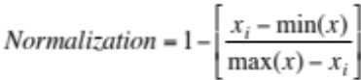 (Eq. 1)

Where x_{i}, is a single similarity value in a sample x, and min(x) and max(x) correspond to the minimum and maximum values of that sample respectively. The sample consists of all the similarity values obtained from the entire testing of the gallery dataset for each AFR system. Figure 3, illustrates an example relating to the generated similarity matrices from the automated systems. As mentioned previously, each scene contained 8 consistent facial images of the same individual. In Figure 3, similarity scores are obtained between the eight known facial images (in reference format) with the eight unknown facial images (in reference format) and with the eight unknown facial images (in H.264/MPEG-4 AVC at 300kbps format) from scene 1. The average value of the derived similarity scores between each two set of 8 images (8 known × 8 unknown) was used for further analysis.

 |  | S1 | S1 | S1 | S1 | S1 | S1 | S1 | S1
 |  | Known 1 | Known 2 | Known 3 | Known 4 | Known 5 | Known 6 | Known 7 | Known 8
S1 | Unknown_Ref 1 | 1 | 0.9999 | 0.9998 | 0.9999 | 0.9999 | 0.9999 | 0.9998 | 0.9998 | Average
S1 | Unknown_Ref 2 | 0.9999 | 1 | 0.9999 | 0.9999 | 0.9999 | 0.9999 | 0.9998 | 0.9998 | 0.9999
S1 | Unknown_Ref 3 | 0.9998 | 0.9999 | 1 | 0.9999 | 0.9999 | 0.9999 | 0.9999 | 0.9999
S1 | Unknown_Ref 4 | 0.9999 | 0.9999 | 0.9999 | 1 | 0.9999 | 0.9999 | 0.9998 | 0.9998
S1 | Unknown_Ref 5 | 0.9999 | 0.9999 | 0.9999 | 0.9999 | 1 | 0.9999 | 0.9999 | 0.9999
S1 | Unknown_Ref 6 | 0.9999 | 0.9999 | 0.9999 | 0.9999 | 0.9999 | 1 | 0.9998 | 0.9999
S1 | Unknown_Ref 7 | 0.9998 | 0.9998 | 0.9999 | 0.9998 | 0.9999 | 0.9998 | 1 | 0.9999
S1 | Unknown_Ref 8 | 0.9998 | 0.9998 | 0.9999 | 0.9998 | 0.9999 | 0.9999 | 0.9999 | 1
S1 | Unknown_300 1 | 0.9040 | 0.9040 | 0.904 | 0.904 | 0.904 | 0.904 | 0.904 | 0.904 | Average
S1 | Unknown_300 2 | 0.9038 | 0.9038 | 0.9038 | 0.9038 | 0.9038 | 0.9038 | 0.9038 | 0.9038 | 0.9073
S1 | Unknown_300 3 | 0.9203 | 0.9203 | 0.9203 | 0.9203 | 0.9203 | 0.9203 | 0.9203 | 0.9203
S1 | Unknown_300 4 | 0.9160 | 0.916 | 0.916 | 0.916 | 0.916 | 0.916 | 0.916 | 0.916
S1 | Unknown_300 5 | 0.9052 | 0.9053 | 0.9052 | 0.9052 | 0.9052 | 0.9052 | 0.9052 | 0.9052
S1 | Unknown_300 6 | 0.9006 | 0.9006 | 0.9005 | 0.9006 | 0.9006 | 0.9006 | 0.9006 | 0.9006
S1 | Unknown_300 7 | 0.9094 | 0.9094 | 0.9094 | 0.9094 | 0.9094 | 0.9094 | 0.9094 | 0.9093
S1 | Unknown_300 8 | 0.9116 | 0.9116 | 0.9115 | 0.9116 | 0.9115 | 0.9116 | 0.9115 | 0.9115
Figure 3. Example of the generated similarity matrices. The values are the derived similarity scores obtained between the eight known facial images from scene 1 (in reference format) with the eight unknown facial images from scene 1 in the reference format (Unknown_Ref) and in H.264/MPEG-4 AVC at 300kbps format (Unknown_300). The average value is obtained from averaging the similarity scores between each two set of 8 images (8 known × 8 unknown).

Results
The analysis of the results has been divided into three parts. The first part includes an analysis on the global performance of each recognition system with respect to compression (section 4.1); the second part involves a detailed analysis on the performance (based on the grouped parameters in Table I) of each recognition system with respect to compression (section 4.2); and the third part identifies the most influential scene parameters (using an analysis of variance) on the performance of each recognition system and each combination of reference/degraded footage (e.g. H.264/MPEG-4 AVC at 300kbps) (section 4.3).

4.1 Global performance of recognition systems

The global performance of the systems was modeled using nonlinear regression for the data from the AFR systems (i.e. as data belong to Gaussian distribution and a nonlinear relationship was identified between compression rate and matching scores) and logistic regression for the data from the HFR system (i.e. as data belong to binomial distribution and required the use of a weighting function) [21]. In Figure 4, from left to right, the four graphs represent results obtained from face recognition systems AFR- LDA, AFR- KFA, AFR – PCA, and HFR respectively. In all graphs, the raw data (matching scores for AFR and proportion of yes responses for HFR) of all the 25 scenes are plotted vs. the different levels of compression (in ln kbps) and the reference (displayed separately and next to the main graphs). The lines in the graphs are regression models obtained from modeling the raw data. All the statistical analysis of results, in this section, section 4.2 and section 4.3 were curried out in R software for statistics [22].

The human results are in binary form; the yes responses (presented with a scores of 1) and no responses (presented with a score of 0). In order to take into consideration the number of yes responses in an n number of trials (i.e. in this case responses of 27 observers) for each scene, the recorded results were modeled using logistic regression with the generalized linear model (gml) function in R. In this way a weighted regression is carried out, using the number of trials as weights and the logit link function to ensure linearity [23, 24]. The logistic regression formula for p (proportions) as a function of x (in this case in ln kbps) is given by the following formula (Eq.2):

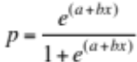 (Eq. 2)

Where a and b are the intercept and slope correspondingly, of the logistic regression model. Eq. 2 was transformed to a linear function before modeling the human data. The linearization involved the substitution of the proportions (p) with odds (p/q, where p are the yes responses and where q the no responses) and the use of natural logs [23, 24].

Eq. 2 was also used in the nonlinear regression modeling without linearization (using the nls function in R) of the raw data for the AFR systems, in order to keep the statistical analysis constant among all the face recognition systems. Also, Eq. 2 seemed to fit the raw data from the AFR systems well.

Table II, includes details of the fitted regression models from Figure 4. The first column provides the system name. The second and fifth columns provide information on the derived coefficients of each model (A - intercept and B - slope). Their next columns provide the calculated standard error on the coefficients (STD). Where Pr(>|T|) is the statistical p value identifying any significant trends (Signif. codes: 0 ‘***’ 0.001 ‘**’ 0.01 ‘*’ 0.05 ‘.’ 0.1 ‘ ’ 1). For example, the results in Table II indicate a significant correlation between matching scores and compression rate for AFR systems LDA and KFA, but not for PCA (this is also visible from the graphs in Figure 4). Furthermore, a significant correlation between the proportion of yes responses and the compression rate for the HFR system is derived. Comparing the derived coefficients, along with their associated calculated standard error, of all the face recognition systems, indicates that the systems have performed differently. For example, the derived models from the recognition systems do not overlap when comparing coefficients and their associated errors. Also, raw data points for systems AFR-PCA and HFR are more scattered than AFR systems LDA and KFA.

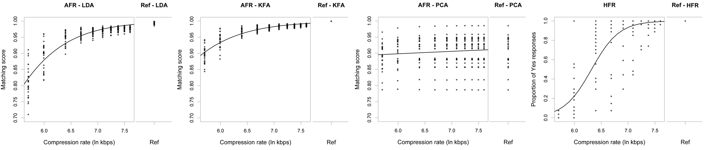
Figure 4. Analysis of global performance. The raw data (matching scores for AFR and proportion of yes responses for HFR) of all the 25 scenes are plotted with respect to the different levels of compression (in ln kbps) and the reference (displayed separately and next to the main graphs). The lines in the graphs are regression models obtained from modeling the raw data.

Table II. Coefficient information of the fitted regression models in Figure 4. The first column provides the system name, where A and B are the coefficients for intercept and slope respectively. STD columns provide the calculated standard error on the coefficients. Where Pr(>|T|) is the statistical p value identifying any significant trends. Signif. codes: 0 ‘***’ 0.001 ‘**’ 0.01 ‘*’ 0.05 ‘.’ 0.1 ‘ ’ 1
System | a | Std | Pr(>|t|) | b | Std | Pr(>|t|)
AFR - LDA | -7.238 | 0.363 | 0.000*** | 1.538 | 0.061 | 0.000***
AFR - KFA | -5.766 | 0.317 | 0.000*** | 1.403 | 0.053 | 0.000***
AFR - PCA | 1.663 | 0.361 | 0.000*** | 0.086 | 0.053 | 0.106
HFR | -24.529 | 1.735 | 0.000*** | 3.881 | 0.268 | 0.000***

4.2 Detailed analysis on the performance of recognition systems

This section includes a detailed analysis on the performance of each recognition system for each group of scene parameters in Table I (e.g. close and far parameters of the camera to subject distance group). Figures 5 to 8 include raw points and their fitted regression models (nonlinear regression models for AFR systems and logistic regression for the HFR system), as in section 4.1 and Figure 4, but this time is based on scene parameters. For example, in Figure 5 the behavior of the recognition systems under the angle of the face to camera plane group with respect to compression rate is investigated. The grey points represent raw data and grey lines represent fitted regression models for the frontal parameter and the black points represent raw data and black lines represent fitted regression models for the tilted parameter. Further, the raw data (y- axis: matching scores for AFR and proportion of yes responses for HFR) of each scene parameter under the angle group is plotted with respect to compression rate (x- axis: in ln kbps)

Tables III to VI provide details of the fitted regression models in Figures 5 to 8 respectively. The coefficients of the fitted models, A and B, together with their associated calculated standard errors, STD, are used for model comparison. For example, both coefficients A and B in Table III of the LDA system between the tilted fitted model (A= -6.759 +/- 0.462 and B= 1.449+/- 0.076) and the frontal fitted model (A= -7.821 +/- 0.566 and B= 1.644+/- 0.095) do not overlap, so the models appear to be different. Thus, the scenes that include the tilted parameter have produced lower matching scores from the scenes with the frontal parameter with respect to compression rates. For systems KFA and PCA the coefficients of the models representing the tilted and frontal parameters overlap indicating no difference between tilted and frontal scenes. The models do not overlap for the HFR system but this time the frontal scenes have produced lower scores (less yes responses) than the tilted scenes with respect to compression rate.

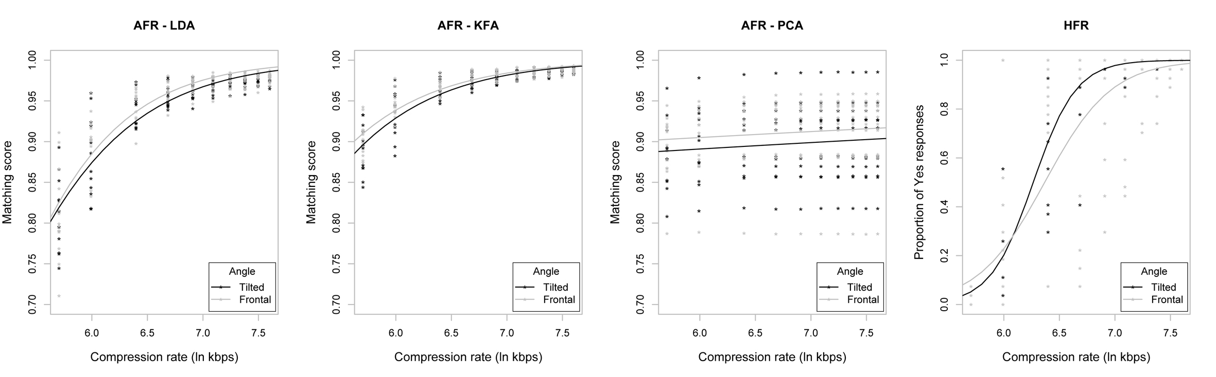
Figure 5. The angle of face to camera plane group. For all graphs, the raw data points (x- axis: matching scores for AFR and proportion of yes responses for HFR) are plotted with respect to compression rate (y- axis: in ln kbps). The black points (*) and lines represent raw data and regression models respectively of scenes with the tilted angle parameter. The gray points (*) and lines represent raw data and regression models respectively of scenes with the frontal angle parameter.

Table III. Coefficient information of the fitted regression models in Figure 5. The first column provides the system name. Where A and B are the coefficients for intercept and slope respectively. STD columns provide the calculated standard error on the coefficients.
System | a | Std | b | Std | System | a | Std | b | Std
LDA_Tilted | -6.759 | 0.462 | 1.449 | 0.076 | PCA_Tilted | 1.598 | 0.490 | 0.084 | 0.072
LDA_Frontal | -7.821 | 0.566 | 1.644 | 0.095 | PCA_Frontal | 1.726 | 0.524 | 0.088 | 0.077
KFA_Tilted | -5.866 | 0.483 | 1.406 | 0.080 | HFR_Tilted | -32.459 | 2.297 | 5.181 | 0.362
KFA_Frontal | -5.672 | 0.381 | 1.400 | 0.063 | HFR_Frontal | -21.104 | 2.149 | 3.314 | 0.327

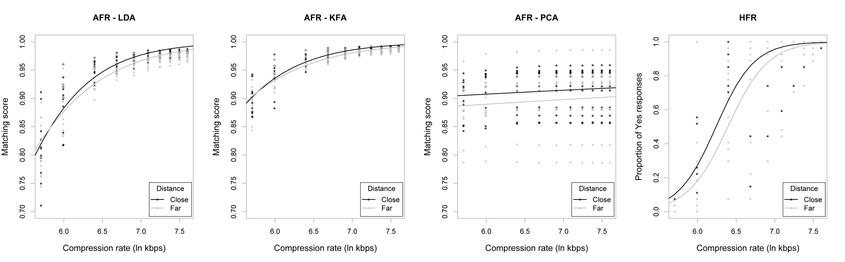
Figure 6. Camera to subject distance group. For all graphs, the raw data points (x- axis: matching scores for AFR and proportion of yes responses for HFR) are plotted with respect to compression rate (y- axis: in ln kbps). The black points (*) and lines represent raw data and regression models respectively of scenes with the close distance parameter. The gray points (*) and lines represent raw data and regression models respectively of scenes with the far distance parameter.

Table IV. Coefficient information of the fitted regression models in Figure 6 (same as Table III).
System | a | Std | b | Std | System | a | Std | b | Std
LDA_Close | -8.269 | 0.608 | 1.715 | 0.102 | PCA_Close | 1.771 | 0.464 | 0.085 | 0.068
LDA_Far | -6.425 | 0.438 | 1.398 | 0.072 | PCA_Far | 1.570 | 0.522 | 0.086 | 0.076
KFA_Close | -6.583 | 0.513 | 1.544 | 0.086 | HFR_Close | -25.319 | 2.637 | 4.059 | 0.413
KFA_Far | -5.106 | 0.393 | 1.288 | 0.065 | HFR_Far | -24.636 | 2.370 | 3.854 | 0.362

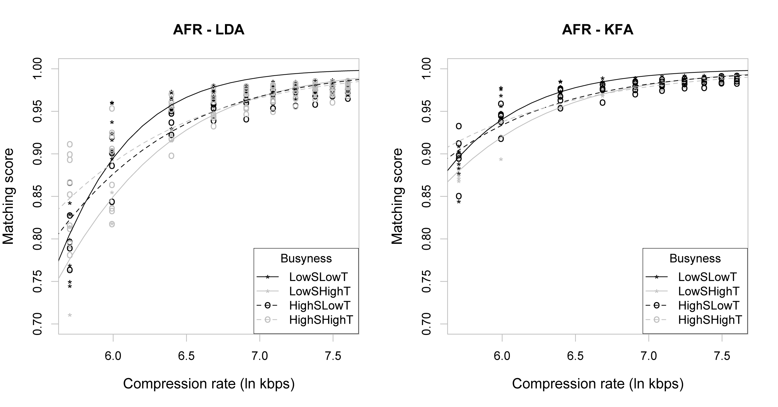

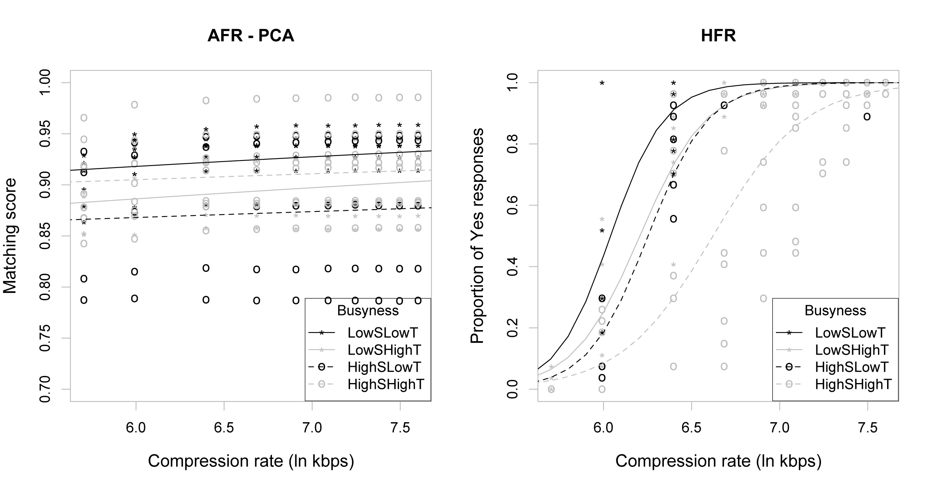
Figure 7. Busyness. For all graphs, the raw data points (x- axis: matching scores for AFR and proportion of yes responses for HFR) are plotted with respect to compression rate (y- axis: in ln kbps). The black points (*) and solid lines represent raw data and regression models respectively of scenes with the Low spatial - Low temporal busyness parameter. The gray points (*) and solid lines represent raw data and regression models respectively of scenes with the Low spatial - High temporal busyness parameter. The black points (o) and dashed lines represent raw data and regression models respectively of scenes with the High spatial - Low temporal busyness parameter. The gray points (o) and dashed lines represent raw data and regression models respectively of scenes with the High spatial - High temporal busyness parameter.

Table V. Coefficient information of the fitted regression models in Figure 7 (same as Table III).
System | a | Std | b | Std | System | a | Std | b | Std
LDA_LowSLowT | -12.455 | 1.179 | 2.433 | 0.202 | PCA_LowSLowT | 1.620 | 0.453 | 0.132 | 0.067
LDA_LowSHighT | -8.159 | 0.578 | 1.649 | 0.096 | PCA_LowSHighT | 1.375 | 0.661 | 0.113 | 0.097
LDA_HighSLowT | -6.626 | 0.578 | 1.431 | 0.096 | PCA_HighSLowT | 1.575 | 0.900 | 0.051 | 0.133
LDA_HighSHighT | -5.414 | 0.529 | 1.250 | 0.087 | PCA_HighSHighT | 1.838 | 0.536 | 0.069 | 0.078
KFA_LowSLowT | -9.534 | 0.934 | 2.049 | 0.159 | HFR_LowSLowT | -39.370 | 4.004 | 6.518 | 0.662
KFA_LowSHighT | -6.684 | 0.451 | 1.521 | 0.075 | HFR_LowSHighT | -32.849 | 3.523 | 5.293 | 0.561
KFA_HighSLowT | -5.483 | 0.629 | 1.355 | 0.104 | HFR_HighSLowT | -36.591 | 7.592 | 5.852 | 1.202
KFA_HighSHighT | -4.087 | 0.447 | 1.133 | 0.073 | HFR_HighSHighT | -25.417 | 2.553 | 3.838 | 0.377

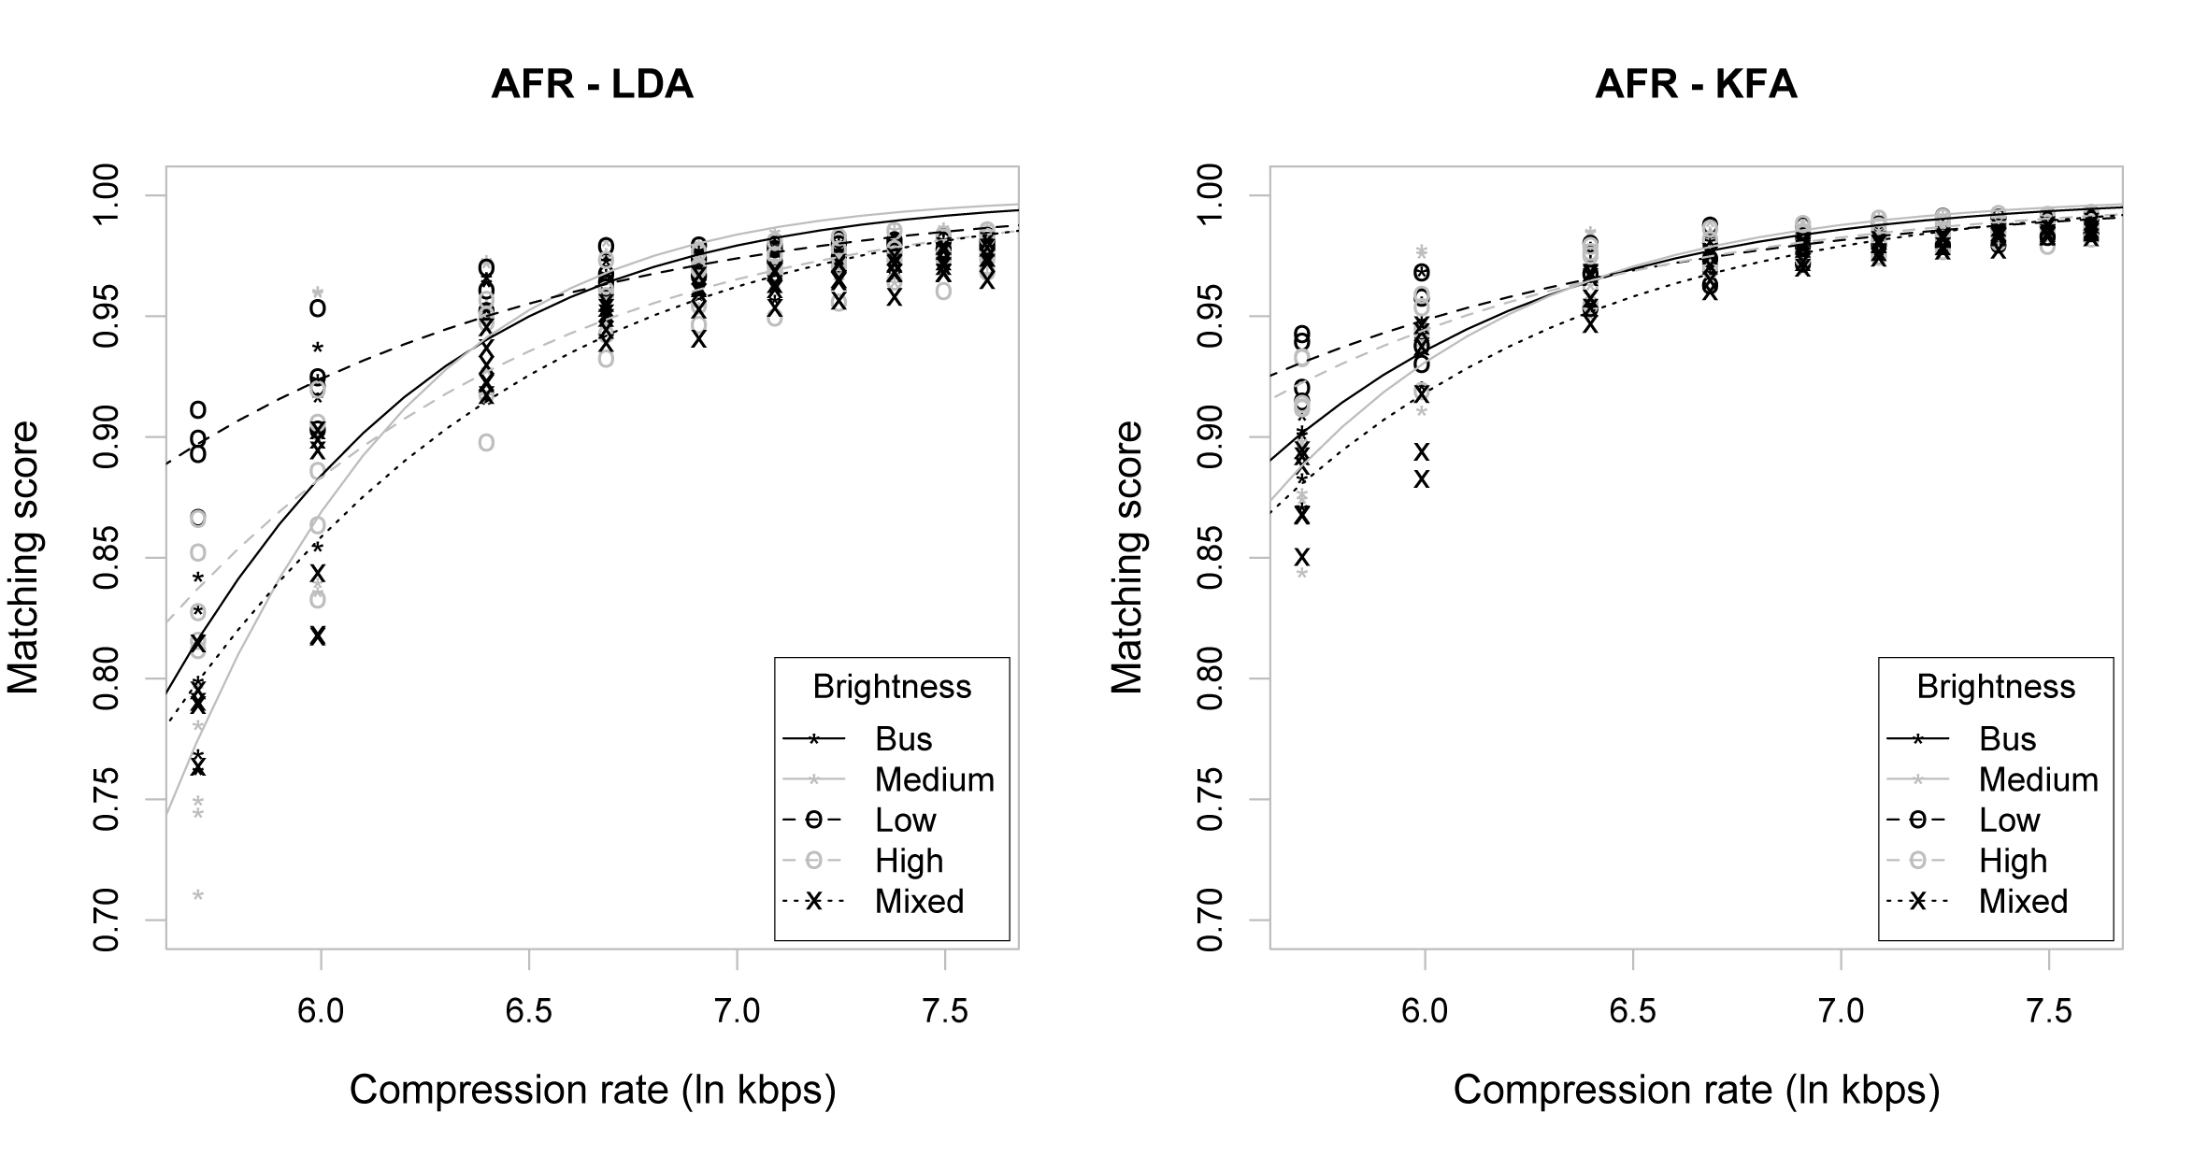

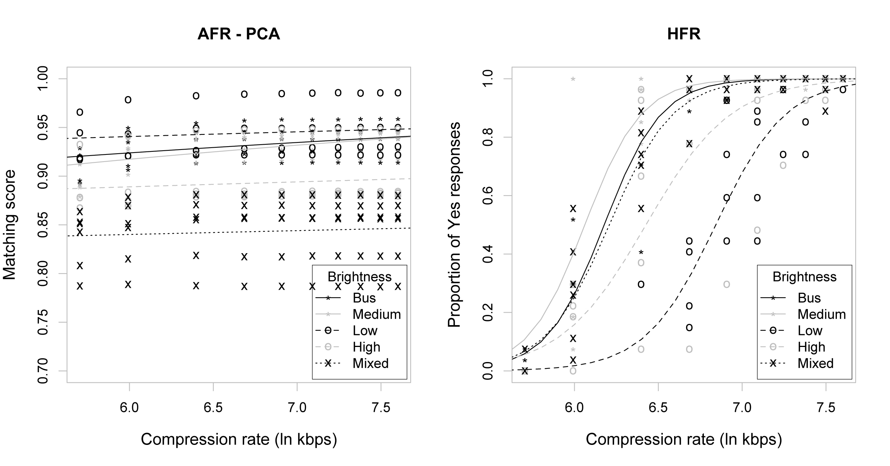
Figure 8. Scene brightness group. For all graphs, the raw data points (x- axis: matching scores for AFR and proportion of yes responses for HFR) are plotted with respect to compression rate (y- axis: in ln kbps). The black points (*) and solid lines represent raw data and regression models respectively of scenes with the Bus medium lightness – brightness parameter (Bus). The gray points (*) and solid lines represent raw data and regression models respectively of scenes with the Daylight medium lightness – brightness parameter (Medium). The black points (o) and dashed lines represent raw data and regression models respectively of scenes with Daylight low lightness – brightness parameter (Low). The gray points (o) and dashed lines represent raw data and regression models respectively of scenes with the Daylight high lightness – brightness parameter (High). The black points (x) and dotted lines represent raw data and regression models respectively of scenes with Daylight mixed lightness – brightness parameter (Mixed).

Table VI. Coefficient information of the fitted regression models in Figure 8 (same as Table III).
System | a | Std | b | Std | System | a | Std | b | Std
LDA_Bus | -8.911 | 0.836 | 1.824 | 0.141 | PCA_Bus | 1.520 | 0.395 | 0.163 | 0.058
LDA_Medium | -11.395 | 1.243 | 2.214 | 0.212 | PCA_Medium | 1.159 | 0.306 | 0.208 | 0.045
LDA_Low | -4.236 | 0.445 | 1.122 | 0.073 | PCA_Low | 2.222 | 0.808 | 0.090 | 0.118
LDA_High | -5.785 | 0.495 | 1.301 | 0.081 | PCA_High | 1.766 | 0.439 | 0.052 | 0.064
LDA_Mixed | -6.802 | 0.393 | 1.434 | 0.065 | PCA_Mixed | 1.481 | 0.352 | 0.029 | 0.051
KFA_Bus | -6.708 | 0.634 | 1.564 | 0.106 | HFR_Bus | -36.103 | 2.966 | 5.844 | 0.477
KFA_Medium | -8.134 | 0.973 | 1.789 | 0.165 | HFR_Medium | -35.739 | 5.652 | 5.896 | 0.928
KFA_Low | -3.433 | 0.528 | 1.057 | 0.086 | HFR_Low | -32.595 | 3.277 | 4.763 | 0.472
KFA_High | -4.379 | 0.450 | 1.202 | 0.074 | HFR_High | -25.160 | 3.992 | 3.915 | 0.606
KFA_Mixed | -6.105 | 0.449 | 1.421 | 0.075 | HFR_Mixed | -32.489 | 4.624 | 5.234 | 0.736

4.3 The most influential scene parameters

Tables VII to X provide results obtained from factorial regression analysis for face recognition systems AFR-LDA, AFR-KFA, AFR-PCA and HFR respectively. Each table provides calculated coefficients for all the scene parameters (left column) at 10 compression rates in kbps (produced from the MPEG Streamclip encoder) and the reference. The factorial regression (an analysis of variance) executed for the AFR systems was based on Gaussian distribution and for HFR on binomial distribution.

The calculated coefficients for each parameter at the different combinations of footage (e.g. at 300kbps, 400kbps see Tables VII to X) are scores associating the importance of the parameter to the overall obtained results, from all the scenes, with respect to the rest of the parameters. For example, if the score is negative then it is a penalty score (parameter contributed to lower value of matching score or yes response) and if the score is positive then it is a bonus score (parameter contributed to high value of matching score or yes response). If a parameter does not have a score (does not appear in the table), it is assumed to be zero [25]. The prediction on the performance of a scene with specific parameters is given by adding up the scores of these parameters plus the intercept. Extreme score values are caused when a parameter does not consist with a variety of data. For example, when the reference format of all scenes is compared against itself then the matching scores and proportion of yes responses values are close to 1 for all parameters. In these situations the optimizer in regression overfits the model and becomes more generous with the scores.

Table VII. Factorial logistic regression for system AFR - LDA. The table provides the values of the obtained coefficients for each parameter (left column) at different bitrates (i.e. 300kbps, 400kbps and so on). For example, parameter Daylight mixed lightness (Mixed) has scored -0.00 and Daylight low lightness (Low) has score 0.10 at 400kbps.
kbps | 300 | 400 | 600 | 800 | 1000 | 1200 | 1400 | 1600 | 1800 | 2000 | Ref
Group: Parameter (LDA)
Intercept | 0.80 | 0.82 | 0.92 | 0.95 | 0.95 | 0.96 | 0.97 | 0.97 | 0.97 | 0.97 | 0.99
Brightness:High | 0.02 | 0.04 | 0.01 | 0.00 | 0.01 | 0.01 | 0.00 | 0.00 | 0.00 | 0.01 | 0.00
Brightness:Low | 0.09 | 0.10 | 0.04 | 0.02 | 0.02 | 0.01 | 0.01 | 0.01 | 0.01 | 0.01 | -0.00
Brightness:Medium | -0.04 | 0.02 | 0.01 | 0.01 | 0.00 | 0.01 | 0.00 | 0.00 | 0.00 | 0.00 | 0.00
Brightness:Mixed | -0.01 | -0.00 | -0.01 | -0.00 | -0.00 | -0.00 | -0.01 | -0.00 | -0.00 | -0.00 | 0.01
Distance:Far | -0.01 | -0.00 | -0.01 | -0.01 | -0.01 | -0.01 | -0.01 | -0.01 | -0.01 | -0.01 | -0.00
Angle:Tilted | 0.01 | 0.00 | 0.01 | 0.00 | 0.00 | 0.00 | 0.00 | 0.00 | 0.00 | 0.00 | -0.00
Busyness:HighSLowT | 0.01 | 0.05 | 0.03 | 0.01 | 0.01 | 0.00 | 0.00 | 0.00 | 0.00 | 0.00 | -0.00
Busyness:LowSHighT | -0.03 | 0.02 | 0.01 | 0.00 | 0.01 | 0.00 | 0.00 | 0.00 | 0.00 | 0.00 | -0.00
Busyness:LowSLowT | -0.00 | 0.10 | 0.04 | 0.02 | 0.02 | 0.02 | 0.01 | 0.01 | 0.01 | 0.01 | -0.00

Table VIII. Factorial logistic regression for system AFR - KFA. The table provides the values of the obtained coefficients for each parameter (left column) at different bitrates (i.e. 300kbps, 400kbps and so on). For example, parameter Daylight mixed lightness (Mixed) has scored -0.00 and Daylight low lightness (Low) has score 0.05 at 400kbps.
kbps | 300 | 400 | 600 | 800 | 1000 | 1200 | 1400 | 1600 | 1800 | 2000 | Ref
Group: Parameter (KFA)
Intercept | 0.90 | 0.90 | 0.95 | 0.96 | 0.97 | 0.98 | 0.98 | 0.98 | 0.98 | 0.98 | 0.99
Brightness:High | 0.02 | 0.03 | 0.02 | 0.01 | 0.01 | 0.01 | 0.00 | 0.00 | 0.00 | 0.00 | 0.00
Brightness:Low | 0.03 | 0.05 | 0.02 | 0.01 | 0.01 | 0.01 | 0.01 | 0.01 | 0.01 | 0.00 | -0.00
Brightness:Medium | -0.02 | 0.02 | 0.01 | 0.01 | 0.00 | 0.00 | 0.00 | 0.00 | 0.00 | 0.00 | 0.00
Brightness:Mixed | -0.02 | -0.00 | 0.00 | -0.00 | 0.01 | 0.00 | -0.00 | -0.00 | -0.00 | 0.00 | 0.00
Distance:Far | -0.00 | 0.00 | -0.01 | -0.00 | -0.00 | -0.00 | -0.00 | -0.00 | -0.00 | -0.00 | -0.00
Angle:Tilted | -0.01 | -0.00 | 0.00 | 0.00 | 0.00 | 0.00 | 0.00 | 0.00 | 0.00 | 0.00 | -0.00
Busyness:HighSLowT | 0.00 | 0.03 | 0.01 | 0.01 | 0.00 | 0.00 | 0.00 | 0.00 | 0.00 | 0.00 | -0.00
Busyness:LowSHighT | -0.01 | 0.03 | 0.01 | 0.01 | 0.01 | 0.00 | 0.00 | 0.00 | 0.00 | 0.00 | -0.00
Busyness:LowSLowT | -0.01 | 0.06 | 0.03 | 0.02 | 0.01 | 0.01 | 0.01 | 0.01 | 0.01 | 0.01 | -0.00

Table IX. Factorial logistic regression for system AFR - PCA. The table provides the values of the obtained coefficients for each parameter (left column) at different bitrates (i.e. 300kbps, 400kbps and so on). For example, parameter Daylight mixed lightness (Mixed) has scored -0.07 and Daylight low lightness (Low) has score 0.06 at 400kbps.
kbps | 300 | 400 | 600 | 800 | 1000 | 1200 | 1400 | 1600 | 1800 | 2000 | Ref
Group: Parameter (PCA)
Intercept | 0.89 | 0.89 | 0.89 | 0.90 | 0.90 | 0.90 | 0.90 | 0.90 | 0.90 | 0.91 | 0.91
Brightness:High | -0.01 | -0.00 | -0.01 | -0.01 | -0.01 | -0.01 | -0.01 | -0.01 | -0.01 | -0.01 | -0.01
Brightness:Low | 0.05 | 0.06 | 0.05 | 0.05 | 0.05 | 0.05 | 0.05 | 0.04 | 0.04 | 0.04 | 0.04
Brightness:Medium | -0.00 | 0.02 | 0.01 | 0.01 | 0.01 | 0.01 | 0.01 | 0.01 | 0.01 | 0.01 | 0.01
Brightness:Mixed | -0.06 | -0.07 | -0.07 | -0.08 | -0.08 | -0.08 | -0.08 | -0.08 | -0.08 | -0.08 | -0.08
Distance:Far | -0.02 | -0.02 | -0.02 | -0.02 | -0.02 | -0.02 | -0.02 | -0.02 | -0.02 | -0.02 | -0.02
Angle:Tilted | 0.01 | 0.02 | 0.02 | 0.02 | 0.02 | 0.02 | 0.02 | 0.02 | 0.02 | 0.02 | 0.02
Busyness:HighSLowT | 0.01 | 0.01 | 0.01 | 0.01 | 0.01 | 0.01 | 0.01 | 0.01 | 0.01 | 0.01 | 0.01
Busyness:LowSHighT | 0.01 | 0.02 | 0.02 | 0.02 | 0.02 | 0.02 | 0.02 | 0.02 | 0.02 | 0.02 | 0.02
Busyness:LowSLowT | 0.02 | 0.04 | 0.04 | 0.04 | 0.03 | 0.03 | 0.03 | 0.03 | 0.03 | 0.03 | 0.03

Table X. Factorial logistic regression for system HFR. The table provides the values of the obtained coefficients for each parameter (left column) at different bitrates (i.e. 300kbps, 400kbps and so on). For example, parameter Daylight mixed lightness (Mixed) has scored 1.10 and Daylight low lightness (Low) has score -17.01 at 400kbps.
kbps | 300 | 400 | 600 | 800 | 1000 | 1200 | 1400 | 1600 | 1800 | 2000 | Ref
Group: Parameter (HFR)
Intercept | -5.48 | -3.65 | -0.24 | 1.57 | 1.48 | 3.17 | 2.97 | -16.71 | 22.50 | 23.40 | 29.04
Brightness:High | -17.98 | 1.66 | 0.72 | -0.44 | 0.04 | -1.16 | -0.30 | 21.08 | -19.47 | 4.43 | -0.00
Brightness:Low | -18.71 | -17.01 | -1.28 | -2.02 | -0.57 | -1.91 | -0.94 | 19.34 | -19.11 | -19.43 | -0.00
Brightness:Medium | -38.63 | 2.81 | 1.99 | 1.39 | 1.54 | -0.06 | 19.99 | -0.22 | 21.52 | -0.20 | -0.00
Brightness:Mixed | -11.85 | 1.70 | 0.89 | 0.08 | -0.38 | -0.15 | -0.13 | 18.49 | -20.33 | -0.06 | -0.00
Distance:Far | -11.85 | -1.14 | -1.19 | -1.60 | -1.30 | -1.70 | -1.46 | -1.64 | -0.36 | 20.30 | -0.00
Angle:Tilted | -7.11 | 0.65 | 0.48 | 1.35 | 2.37 | 2.05 | 22.09 | 21.83 | 22.16 | 1.89 | -0.00
Busyness:HighSLowT | 5.74 | 0.62 | 1.15 | 1.43 | 2.29 | 19.75 | 1.88 | 42.34 | 0.27 | -4.49 | -0.00
Busyness:LowSHighT | 21.19 | 0.61 | 0.37 | 0.72 | 0.20 | 0.13 | 1.12 | 41.10 | -20.36 | 2.57 | -0.00
Busyness:LowSLowT | 2.23 | 3.32 | 1.94 | 3.25 | 3.99 | 2.59 | 21.71 | 41.99 | 21.59 | 2.98 | -0.00

Discusion

The produced similarity scores, for all AFR systems, between reference MPEG-2 format and original recorded DV format were very similar, indicating no difference between the original recorded and the assigned reference footage. Results between human and automated identification systems were compared and relevant correlations were drawn between the performance of each system and the selected scene parameters.

In the global performance analysis, results show that the automated recognition systems are more tolerant to compression than humans (Figure 4). Each recognition system has performed differently, since none of the global performance models between the systems overlap (Table II). Furthermore, the results in Table II indicate a significant correlation between increase values of matching scores with increased bitrate for LDA and KFA, but not for PCA, clearly indicated in Figure 4. Significant correlation between increase of proportion of yes responses with increased bitrate for the HFR system is also indicated. All the systems have performed well, apart from PCA, when the reference was compared with itself. This could be because the average value among the 8 images depicted the same individual (8 known × 8 known) was used instead of the exact matching of the images.

More detailed results relating to how the systems have performed with scenes of various parameters are provided in sections 4.2 and 4.3. Under the angle to the camera plane group (Figure 5 and Table III), the LDA and HFR systems have produced different curve models. This indicates that for LDA frontal scenes have produced higher scores than tilted scenes, and for HFR that tilted scenes have produced higher scores than frontal scenes. Whereas the curve models for KFA and PCA overlap indicating no difference between scenes with title and frontal parameters (intercept and slope overlap). For humans, the frontal scenes include more facial information than the tilted scenes and as a result have been affected more by compression.

For the camera to subject distance group (Figure 6 and Table IV), the LDA and KFA systems have produced different curve models (indicating close scenes have produced higher scores than far scenes), whereas the curve models for HFR and PCA overlap (indicating no difference between these two parameters - intercept overlap but not slope). All systems (Figure 5) illustrate a tendency for the close distance parameter scenes to have scored higher than the far distance parameter scenes.

For the busyness group (Figure 7 and Table V), the LDA system has produced different curve models (Low spatial Low temporal scenes have produced the lowest scores) from the rest models. For the HFR system, the High temporal High spatial model is different from the rest models and the rest models are all overlapping with each other. KFA and PCA have produced models that overlap (either intercept or slope or both).

As the number of parameters under each group increases, it becomes more difficult to derive conclusions on the derived regression models. For example, the brightness group consists of 5 parameters distributed across 25 scenes and most of the derived models overlap (Figure 8 and Table VI). In a future investigation more scenes should be included. Nonetheless, the graphs in Figure 8 can still be observed to understand tendencies. For the automated systems, mixed brightness scenes were the most affected (i.e. produced the lowest matching scores) and low brightness scenes were the least affected (i.e. produced the higher matching scores) by compression. In contrast for humans, low brightness scenes were the most affected and, medium and mixed brightness scenes the least affected by compression.

Observing the results from the factorial analysis (Table VII to X), across the different bitrates (between 400kbps and 1600kbps), we can observe that the AFR systems have scored lowest with coefficients representing the mixed brightness and far distance scenes. The coefficients of the low brightness scenes have scored the highest from the rest brightness parameters. In contrast, for the HFR system, low and high brightness, and far distance coefficient parameters have scored the lowest. The finding from the brightness group agrees with findings from Adler and Dembinsky [7].

Conclusion

In this investigation one HFR and three AFR systems are tested using controlled footage in terms of conveyed information in order to allow a better understanding on how the systems perform. Overall, automated recognition systems are more tolerant to compression than humans. In addition, the performance of the AFR systems is dependent on different face/scene parameters. This is perhaps against all the research investment in image processing for optimizing facial images for AFR as normally these apply optimization techniques according to what human perception considers a good quality image (e.g. a well-illuminated scenes) [26]. Findings in this investigation have shown AFR systems performing better with under-exposed (low brightness) than well-illuminated (medium brightness) scenes. This is the opposite of what human’s perceive as a good quality facial image.

Also, often the term image quality for security applications is used similarly for both humans and automated systems[27] whilst this investigation proves that different scene parameters influence identification systems differently. The term “image quality” has been defined by imaging scientists to be strictly subjective [28, 29]. Perhaps, a new definition such as image acceptance could be employed for automated systems that will relate to the parameter acceptance by the system/algorithm to complete the recognition task.

Future work will involve the testing of more automated systems (both from academia and industry) with more scenes.

Reference

[

This was performed using the following command line in R: LogisticModel <- glm(System Score ~ Brightness+Distance+Angle+Busyness, family = binomial – for HFR, or Gaussian – for AFR)

