E.02.35-ComplexityCosts-D3.1-Scenario definition
Document information
Project Title | ComplexityCosts
Project Number | E.02.35
Project Manager | University of Westminster
Deliverable Name | Scenario definition
Deliverable ID | D3.1
Edition | 01.01.00
Template Version | 03.00.00
Task contributors
University of Westminster
Fundación Instituto de Investigación Innaxis (Innaxis)
Deutsches Zentrum für Luft-und Raumfahrt e.V. (DLR)
Abstract
The characteristics of the mechanisms that will be implemented in ComplexityCosts, including stakeholders’ uptake, costs and technical models are provided. For the different disturbances considered, the underlying principles of their modelling are described. The combination of mechanisms, stakeholders’ uptake and disturbances are used to identify the scenarios that will be analysed. The data requirements for these models are also summarised.
Authoring & Approval
Prepared By - Authors of the document.
Name & Company | Position & Title | Date
Luis Delgado / University of Westminster | Consortium Member | 21DEC15
Andrew Cook / University of Westminster | Project Leader | 21DEC15
Graham Tanner / University of Westminster | Consortium Member | 21DEC15
Samuel Cristóbal / Innaxis | Consortium Member | 21DEC15
Michael Schultz / DLR | Consortium Member | 21DEC15

Reviewed By - Reviewers internal to the project.
Name & Company | Position & Title | Date
Graham Tanner / University of Westminster | Consortium Member | 23DEC15

Reviewed By - Other SESAR projects, Airspace Users, staff association, military, Industrial Support, other organisations.
Name & Company | Position & Title | Date
N/A

Approved for submission to the SJU By - Representatives of the company involved in the project.
Name & Company | Position & Title | Date
Andrew Cook / University of Westminster | Project Leader | 24DEC15

Rejected By - Representatives of the company involved in the project.
Name & Company | Position & Title | Date
N/A

Rational for rejection
None.
Document History
Edition | Date | Status | Author | Justification
01.00.00 | 24DEC15 | Release | Andrew Cook | New document for review by EUROCONTROL
01.01.00 | 04MAR16 | Release | Andrew Cook | Clarificatory changes made, as requested by EUROCONTROL
Intellectual Property Rights (foreground)
This deliverable consists of Foreground owned by one or several Members or their Affiliates.
Table of Contents
Executive summary 5
1 Introduction 6
1.1 Purpose of the document 6
1.2 Intended readership 6
1.3 Inputs from other projects 6
1.4 Glossary of terms 6
1.5 Acronyms and Terminology 6
1.6 Acknowledgement 7
2 Mechanisms modelling 8
3 Disturbance modelling 17
3.1 Staff capacity shortage 20
3.2 Industrial action (ATC) 24
3.3 Meteorological events with local effects at airports 25
3.4 Background delay 32
4 Scenarios 34
5 Data requirements 35
6 Next steps and look ahead 36
7 References 37

List of tables
Table 1. Simplified overview of mechanism modelling 8
Table 2. Full mechanism modelling plan 9
Table 3. Summary of disturbance modelling 19
Table 4. Summary of background delay modelling 20
Table 5. Selected days for ATCO staff shortage regulations 21
Table 6. Parameters Burr distribution ATFM delay ATCO staff shortage regulations 23
Table 7. Selected days for industrial action regulations 25
Table 8. Parameters Burr distribution ATFM delay industrial action regulations 25
Table 9. Number of airports modelled per ICAO region 28
Table 10. Example of airport delay and cancellation model due to weather 28
Table 11. Days with weather related ATFM regulations 29
Table 12. Parameters Burr distribution ATFM delay weather regulations 32
Table 13. Scenarios to be modelled 34
Table 14. Main data requirements and sources for the different submodels 35

List of figures
Figure 1. Diagram of the disturbances that will be modelled 17
Figure 2. Experimental cumulative probability of ATFM delay 18
Figure 3. Number of ANSPs and regulations reported due to ATCO staff shortage 20
Figure 4. Average delay per flight going through the regulations due to ATCO staff shortages 21
Figure 5. ACCs with most delay that could benefit from increasing ATCO hours 22
Figure 6. Delay and cost of the delay generated due to ATCO staff shortages 22
Figure 7. Staff shortage ATFM regulations delay as a function time entering regulation 23
Figure 8. ATFM delay probability distribution fitting for ATCO staff shortage regulations 23
Figure 9. Average delay per flight through the regulations due to industrial action 24
Figure 10. ATFM delay probability distribution fitting for industrial action regulations 25
Figure 11. Airport movements and significant weather scores (Frankfurt Airport, 2013) 26
Figure 12. Days with relevant weather score and delays 26
Figure 13. Correlation of cancelations and delay regarding the weather score 27
Figure 14. Quantification of delay for aircraft with delay of 15 mins or more 27
Figure 15. Days when regulations due to weather issues were implemented at airports 29
Figure 16. Average delay per delayed flight for all regulations due to weather at airports per day 29
Figure 17. Weather ATFM regulations delay as a function time entering regulated traffic volume 31
Figure 18. ATFM delay probability distribution fitting for weather regulations 32
Figure 19. Delay generation concept 33

Executive summary
The characteristics of the mechanisms that will be implemented in ComplexityCosts, including stakeholders’ uptake, costs and technical models are provided. For the different disturbances considered, the underlying principles of their modelling are described. The combination of mechanisms, stakeholders’ uptake and disturbances are used to identify the scenarios that will be analysed. The data requirements for these models are also summarised.
Four different mechanisms have been selected for their implementation in ComplexityCosts: increasing ATCO hours in selected sectors, A-CDM, dynamic cost indexing and passenger reaccommodation tools. For each mechanism the modelling of the uptake will be considered at three different levels: baseline, early adopters and followers. The baseline is required to model the effect of the technology when the enhancement obtained by the mechanism is not present. This allow us to define a baseline for the mechanism and to perform a cross comparison between mechanisms, as the system will already perform at a given level even if the enhancement of the mechanism is not implemented. Increasing ATCO hours in selected sectors will be modelled for the ANSPs that might get a better benefit from this strategy. In A-CDM an evolution of the performance and the uptake of the mechanism will be modelled. In the baseline model, airports already providing A-CDM will be assumed to provide a 3% improvement in delay. The dynamic cost indexing mechanism will be modelled as an improvement on the baseline 'rules of thumb' delay recovery strategies followed by airlines. Finally, passenger reaccommodation tools uptake will replicate the modelled dynamic cost indexing mechanism. In this case the baseline solution will provide a local, airport-by-airport, solution to reaccommodate passengers with disrupted itineraries.
Three disturbances will be explicitly modelled: staff capacity restrictions, industrial action and airport weather disturbances. The delay model for flights will be completed with background ATFM delay and a baseline weather delay, modelled to be implemented when the weather at airport disturbances are not explicitly modelled.
When modelling the disturbances, their scope (location and duration) and their intensity will be considered. The three disturbances will have an impact in terms of ATFM delay generated. This ATFM delay will be modelled following different Burr distributions that represents the historical ATFM delay generated by the different types of disturbances between AIRACs 1313 and 1413. The effect of the disturbances will be totally, or partially, averted by the mechanisms under study. Different mechanisms might deliver different performances as a function of the spatial distribution of the disturbances. In some cases a mechanism might be better suited for localised disturbances in the network, but provide a lower return when disturbances affect the network in a wider manner. For this reason, each disturbance will be modelled with two different spatial scopes: with a localised or a wider impact on the network. The scope of the ATFM disturbances will be based on a given specific day during the period AIRAC 1313 to AIRAC 1413 that meets this dispersion criteria.
For weather at airport disturbances a model based on historical METAR will be also implemented. This model will allow us to estimate tactical delay due to weather at airports through Europe even if they did not issue ATFM regulations.
The background ATFM delay will be generated by assigning the delay provided on the day from which the traffic is based on (12th September 2014). This will ensure that there is adequate amount of ATFM delay in the system and that it follows a realistic distribution through the network.
For each mechanism there are two uptakes (early adopters and followers) that will be modelled and for each disturbance two scopes (local and global), this gives us a total of 48 combinations. However, note that the mechanism of adding ATCO hours to selected sectors only generates a benefit if ATFM regulations issued due to ATCO staff shortages can be averted. Therefore, there will not be an improvement on the performance of the system under the other disturbances types. For this reason, a total of 40 scenarios are considered. All these scenarios will allow us to analyse the performance of the mechanism, and cross compare them, for the same disturbance type. It will also be possible to analyse the cost resilience of each mechanism under different disturbances and spatial scopes.
To analyse synergies or crossed effects between mechanism scenarios where more than one mechanism are conjointly implemented should be modelled. However, this is out of scope of the project, if time allows it some scenarios might be considered in this respect once the first results are obtained.

Introduction

Purpose of the document
The primary objective of ComplexityCosts is to better understand ATM network performance trade-offs for different stakeholder investment in the context of uncertainty. A variety of investment mechanisms and disruptions will be considered.
The following are the key objectives of this deliverable:
- update progress on the ComplexityCosts models for disruptions and investment mechanisms;
- define the different parameters that will be considered for the simulations and hence defining the different scenarios;
- provide an update on the data requirements.

Intended readership
This report is primarily intended for internal usage. A background in computational sciences and software development would be useful for the technical texts.

Inputs from other projects
Not applicable.

Glossary of terms
Not applicable.

Acronyms and Terminology
Term | Definition
ACC | Area Control Centre
A-CDM | Airport Collaborative Decision Making
ACE | ATM Cost-Effectiveness
AIRAC | Aeronautical Information Regulation And Control
ANSP | Air Navigation Service Provider
AO | Airline Operator
ATC | Air Traffic Control
ATCO/ATCo | Air Traffic Controller
ATFM | Air Traffic Flow Management
ATM | Air Traffic Management
ATMAP | ATM Airport Performance Framework
CC | ComplexityCosts
CODA | Central Office for Delays Analysis
CRM | Customer relationship management
DCI | Dynamic cost indexing
DDR/DDR2 | Demand Data Repository
E-AMAN | Extended Arrival Manager
EFB | Electronic Flight Bag
GDS | Global Distribution System (a system that distributes inventory on behalf of airlines)
IATA | International Air Transport Association
INX | Innaxis Foundation and Research Institute
MCT | Minimum connecting time
METAR | Meteorological Aerodrome Report
MUAC | Maastricht Upper Area Control Centre
NDA | Non-Disclosure Agreement
O/D | Origin and Destination
SESAR | Single European Sky ATM Research
SJU | SESAR Joint Undertaking
UoW | University of Westminster

Acknowledgement
We are very grateful in particular to PACE Aerospace Engineering and Information Technology GmbH (Berlin, Germany) and Sabre Airline Solutions (Sabre Corporation, Delaware, US), and other industry contacts, for assistance in the production of Section 2.

Mechanisms modelling
The four mechanisms that are considered for implementation in ComplexityCosts are:
- increasing ATCO hours in selected sectors;
- airport Collaborative Decision Making (A-CDM);
- dynamic cost indexing;
- passenger reaccommodation tools.
Each mechanism will be modelled as:
- baseline mechanism: reflecting the current capabilities and functionalities of the mechanism;
- enhanced mechanism: incorporating improved functionalities with respect to current practice – the focus of our cost-benefit analysis.
Three levels of stakeholder uptake will be modelled:
- baseline: reflecting current uptake (often pretty limited);
- early adopter: stakeholders that already have basic capabilities adopt the enhanced mechanism; other stakeholders might adopt the basic (current state-of-the-art) mechanism;
- follower: stakeholders likely to benefit from the mechanism implemented, even if they do not currently have any such mechanism in place.

Table 1. Simplified overview of mechanism modelling
Mechanism |  | Early adopter | Follower
Increasing ATCO hours in selected sectors | Tactical cost
 | Strategic cost
A-CDM | Tactical cost
 | Strategic cost
Dynamic cost indexing | Tactical cost
 | Strategic cost
Passenger reaccommodation tools | Tactical cost
 | Strategic cost

Table 1 summarises the modelling implementation in a simplified form for an overview; Table 2 presents the modelling in more detail. With regard to these rules, it will be noted that there are no strategic implementation costs associated with the baseline scenarios or some early adopter scenarios. These realistic assumptions will afford some contrasting comparisons for the cost-benefit analysis with regard to the early adopters, and homogenised comparisons across the follower groups (all of which have associated strategic costs). The baseline situations have no associated tactical, enhanced mechanism costs, by definition.

Table 2. Full mechanism modelling plan
Mech-anism | Uptake |  | Costs modelling |  |  | Implementation
 |  |  | Stakeholder bearing the cost | Tactical cost  (of enhanced mechanism) | Strategic cost  (of enhanced mechanism) | Description | Hypotheses and assumptions with respect to implementation
Increasing ATCO hours in selected sectors | Baseline | - ANSPs that have already implemented advanced rostering and ATCO staff management systems | ANSPs  (although could be modelled as charges recovered from airspace users) | Not applicable | Not applicable | - ANSPs do not consider the (enhanced) mechanism of adding extra ATCO hours to avert regulations due to staff shortages. If a regulation is implemented due to staff shortages it will generate delays as already observed (EUROCONTROL, 2015c). | Not applicable
 | Early adopter | - ANSPs that have already implemented advanced rostering and ATCO staff management systems implement the enhanced mechanism to mitigate regulations by adding extra staff:  - MUAC  - Germany (ED) |  | - Tactical cost of ATCO hours considered from (EUROCONTROL, 2014a).  - This tactical cost of hour of ATCO was reported between 10 EUR/hour in Armenia and 202 EUR/hour in Maastricht. The average value being 92 EUR/hour.  - In ComplexityCosts the rate of the controllers of the ANSP where the mechanism is implemented will be considered.  - See (Delgado et al., 2015) for a trade-off analysis of the cost of this mechanism. | Not applicable | - In the ACCs where the mechanism is implemented, if an ATFM regulation is required due to staff shortages, it would be averted by adding ATCOs.  - The ATCOs will be added following the 'operationally realistic' (as opposed to 'best case') methodology from (Delgado et al., 2015). This means that full, 7-hour shifts will be deployed.  - Maximum number of controllers seen in the ACC will be considered and base number of controllers extracted from controllers available during the regulation implementation, using DDR2 database. | - There is no optimisation of the rostering, the assumption being that adding ATCOs in 7-hour shifts adds flexibility to the sectorisations that can be implemented.  - Some degree of flexibility when dealing with the regulations is assumed, this means that a 7-hour shift is assumed to be able to avert an 8-hour regulation.  - There is no explicit modelling of the sectorisation and the opening schemes.  - By adding the maximum number of controllers in the ACC a bound on the benefit is obtained as the regulation might be averted with fewer than the maximum.  - The strategic cost of implementing the IT solution required to gain rostering flexibility is considered. Other costs, such as training controllers (if more staff are required), are out of scope.  - One of the barriers for this mechanism is the regulatory framework required to add flexibility to the controllers' availability. In this research it is considered that the level of flexibility needed is available at the ANPs implementing the mechanism.
 | Follower | - ANSPs that might obtain a higher return based on the analysis of costs due to disruptions that might be solved with extra staff (as presented in D2.2):  - Poland (EP)  - Greece (LG)  - Portugal (LP)  - Cyprus (LC) |  |  | - EUR 1-3M based on the maximum number of controllers available at the ANSP during 2014. Considering the maximum number of controllers that were available per ANSP allows us to make an adjustment to the cost that is related to the size of the ANSP.

Table 2. Full mechanism modelling plan (continued)
Mech-anism | Uptake |  | Costs modelling |  |  | Implementation
 |  |  | Stakeholder bearing the cost | Tactical cost (of enhanced mechanism) | Strategic cost  (of enhanced mechanism) | Description | Hypotheses and assumptions with respect to implementation
A-CDM | Baseline | - Airports that already have A-CDM fully implemented¹. | Airspace users | - According to (EUROCONTROL, 2008) the operating cost of A-CDM for the airline is divided into: full-time function dedicated to ATC, flight dispatch staffing and travel costs.  Full-time function dedicated to ATC will be considered to be independent of the number of airports where A-CDM is implemented and ranging between EUR 60-105k, with a base value of EUR 90k.  - Flight dispatch staffing and travel costs will be related to the number of airports where A-CDM is implemented and the number of flights operated by the airline at the airport ranging between EUR 203-320k per airport, with a base cost of EUR 255k.  - Costs will be assigned over baseline, early adopter and follower phases (with only the subsequent phases costed in the analyses for consistency with the other mechanisms) | Not applicable | - In the airports where A-CDM is implemented it will be assumed that delays can be handled in a more efficient manner. This has particularly the effect that turnaround times can be reduced to absorb delay and (thus) reduce the propagation of delay. The benefits of A-CDM will be quantified in terms of delay that can be recovered/saved. According to (EUROCONTROL, 2008), for airspace users there is a ‘3% improvement in terms of delay at the Airport’. This is consistent with report from airports such as Munich where an improvement on the outbound flights with a delay longer than the inbound delay has been reduced by more than 3% between 2008 and 2012 (Deutsche Flugsicherung: 2010, 2013).  - In the baseline scenario, the airports implementing A-CDM will have a reduction in the delay propagated following a distribution centred on the 3% reduction. | - Note that the costs (of implementation and benefits) are only considered for the airspace user stakeholders. Therefore, the costs of other stakeholders (airport, ground handlers, ANSPs) are out of scope of this analysis. The benefit is estimated only for the airspace users, which allows us to make a fairer comparison between mechanisms. The investment of those other stakeholders should, however, be estimated and reported as it has an impact on the requirements to implement the mechanism.  - Only the benefit of A-CDM in terms of delay reduction by obtaining shorter turnaround times in case of disruption are considered.  - The fact that airlines might strategically be willing to reduce their buffers by modifying their schedules is not considered.
 | Early adopter | - Airports that already have A-CDM fully implemented improve their performance^{1,3}.  - Main airports identified as in the process of implementing A-CDM have it operational at the baseline performance level^{2,3}. |  |  | - Reporting from EUROCONTROL (2008) shows that the system investment requirement per airline is estimated to vary between EUR 50-250k, the base scenario EUR 150k. An implementation cost in this range per airline is considered as a function of the number of operations the airline has at the airports that implement A-CDM.  - Costs will be assigned over early adopter and follower phases | - The cost-benefit analysis conducted in (EUROCONTROL, 2008) suggests benefits in terms of delay reduction between 2% and 4%. For airports that form part of the baseline scenario, an improvement in their performance will be modelled. Therefore, the delay distribution will be centred on a 4% reduction.  - For airports newly implementing A-CDM, a 3% centred reduction will be modelled.
 | Follower | - All airports implementing A-CDM (from the early adopters) improve their performance. |  |  |  | - All the airports implementing A-CDM will achieve a delay reduction centred on 4%.
¹ According to (EUROCONTROL, 2015a): Berlin Schönefeld, Brussels, Düsseldorf, Frankfurt, Helsinki, London Gatwick, London Heathrow, Madrid, Milan Malpensa, Munich, Paris CDG, Oslo, Rome Fiumicino, Stuttgart, Venice, Zurich.
² According to (EUROCONTROL, 2015b): Amsterdam Schiphol, Istanbul Atatürk, Barcelona, Palma, Vienna, Arlanda, Manchester, Dublin, Lisbon, Geneva, Hamburg, Athens, Nice, Prague, Warsaw, Lyon, Budapest, Kiev Boryspil, Heraklion.
³ The list of airports at the different degrees of A-CDM implementation will be validated before the final modelling of the mechanism.

Table 2. Full mechanism modelling plan (continued)
Mech-anism | Uptake |  | Costs modelling |  |  | Implementation
 |  |  | Stakeholder bearing the cost | Tactical cost (of enhanced mechanism) | Strategic cost  (of enhanced mechanism) | Description | Hypotheses and assumptions with respect to implementation
Dynamic cost indexing | Baseline | - Airlines implement basic 'rules of thumb' | Airspace users | Not applicable | Not applicable | - Airlines implement basic 'rules of thumb' e.g. recover as much delay as possible on given flights e.g. when delay exceeds 15 minutes / flight into hub / first rotation. | - This basic strategy is driven by absolute delay and not by a quantification of the cost of time (delay)
 | Early adopter | - Three major, full-service carriers on operations to-from their hubs:  - BA at LHR  - LH at FRA  - AF at CDG |  | - A cost model that is currently, increasingly implemented in the marketplace is proportional to the benefit obtained by the airlines (as with the 'passenger reaccommodation tools' mechanism)  - A realistic cost here is [C1]%* of the total saving accrued to the airline through use of the mechanism, which currently equates to 1% of fuel burn (averaged over a fleet)  - This means that implementing an enhanced dynamic cost indexing management system has a negative tactical cost for the airline as it is computed as a percentage of the savings obtained.  - As the enhanced DCI system is not focused on (only) optimising the fuel required for the flight, but rather on the net saving with full regard to the cost of recovering the delay, the tactical cost will be computed as [C1]%* of the total net saving accrued to the airline. | - Cost of crew training regarding the new procedures with DCI. This cost will be estimated per airline as the number of pilots per aircraft, multiplied by the number of aircraft in the fleet, multiplied by the hours of training required (2 hours) per pilot, multiplied by the cost of crew per hour (all sourced from UoW internal databases) | - For each aircraft implementing the enhanced DCI mechanism:  - When a flight is delayed, the cost of recovering the delay, totally or partially, by speeding up during cruise, is assessed at the top of climb.  - The delay will be considered to be recovered in blocks of minutes (2 or 5 minutes blocks, the granularity of this recovery will be adjusted once analysis of the maximum delay that can be recovered are carried out dynamically in the model).  - Fuel and cost of time (delay) costs will be considered; costs of delay will be considered from historical look-up tables (i.e. will not be tactically updated)  - Different costs of delay will be considered for inbound and outbound flight from the airlines' hubs. | - Early adopters already operate Class 2 EFBs in their fleet.  - There is no update of the cruise speed during the flight for flights shorter than 3 hours. If the flight is longer than 3 hours, an update of the speed can be assessed at a midpoint during the cruise.  - Only cruise speeds are considered. The vertical profile of the flight is maintained as initially intended.  - There is no consideration of speed variation strategies made by ATC to manage inbound traffic at airports (e.g. E-AMAN implementation).  - For inbound flights to the hub, 'high' scenario costs of delay are considered (Cook and Tanner, 2015); for outbound flights, 'base' scenario costs are considered (ibid.).
 | Follower | - Same carriers as early adopters, across whole network  - All other hub operators, on operations to-from their hubs.  - Selection of regional and low-cost carriers. |  |  | - For airlines that do not operate Class 2 EFBs (i.e. connected to the aircraft's navigation system; assumed to be the regional and low-cost carriers), the strategic costs include the training cost, as described for the early adopters, plus an installation cost per aircraft, i.e. [C2]*.
* These costs have been disclosed (in strict confidence) to the EUROCONTROL Project Officer to demonstrate their sourcing and veracity, but may not be reported here due to NDA / confidentiality restrictions.

Table 2. Full mechanism modelling plan (continued)
Mech-anism | Uptake |  | Costs modelling |  |  | Implementation
 |  |  | Stakeholder bearing the cost | Tactical cost (of enhanced mechanism) | Strategic cost  (of enhanced mechanism) | Description | Hypotheses and assumptions with respect to implementation
Passenger reaccommodation tools | Baseline | - Airlines in the early adopter and follower groups already have a system for reaccommodating passengers during disruption. | Airspace users | Not applicable | Not applicable | - Local, airport-by-airport solutions only  - Passengers with disrupted itineraries (missed connections) will be reaccommodated on subsequent flights  - The final destination of the passenger is considered during the accommodation process, a different itinerary might be used  - The process minimises the cost of reaccommodating the passenger, looking for solutions within the airline and airline alliance, before reaccommodating on competing carriers for high-yield passengers only  - The passenger compensation cost (Regulation 261) is considered during this reaccommodation process. | - Consideration such as individual customer relationship management (CRM) values per passenger are not considered, although high-yield passengers are prioritised for reaccommodation (based on ticket type).
 | Early adopter | - Three major, full-service carriers on operations to-from their hubs:  - BA at LHR  - LH at FRA  - AF at CDG |  | - A cost model that is currently, increasingly implemented in the marketplace is proportional to the benefit obtained by the airlines (as with the 'dynamic cost indexing' mechanism)  - The cost of implementing the enhanced passenger reaccommodation tool with wait / no-wait rules (see RHS of table) is based on a fixed cost charged to the airlines per passenger boarded, i.e. [C3]*. | Not applicable  (basic system already assumed to be in place) | - Network-wide solutions  - For each outbound flight, an assessment is made to analyse how many passengers would miss their connection if the departure is made on-time.  - Total network costs (including reactionary delays in the network) are calculated for 15-minute increments of wait times (taking into account prevailing ATFM slot conditions)  - An optimised wait/no-wait rule is implemented, based on the net cost best wait time (which could be zero wait)
 | Follower | - Same carriers as early adopters, across whole network  - All other hub operators, on operations to-from their hubs.  - Selection of regional and low-cost carriers. |  |  | - Implementation cost for airlines that were not considered in the early adopter group: as the basic passenger recovery system needs to be implemented. The cost of this implementation is well-modelled by a value proportional to the volume of passengers boarded, i.e. [C4]*.
* These costs have been disclosed (in strict confidence) to the EUROCONTROL Project Officer to demonstrate their sourcing and veracity, but may not be reported here due to NDA / confidentiality restrictions.

Disturbance modelling
As defined in D2.2 Model implementation and as shown in Figure 1, different types of disturbances will be modelled in ComplexityCosts:
- staff capacity restrictions,
- industrial action, and
- airport weather disruptions.
To these disturbances, background ATFM delays will be added, generating in this manner the delay experienced by the flights.

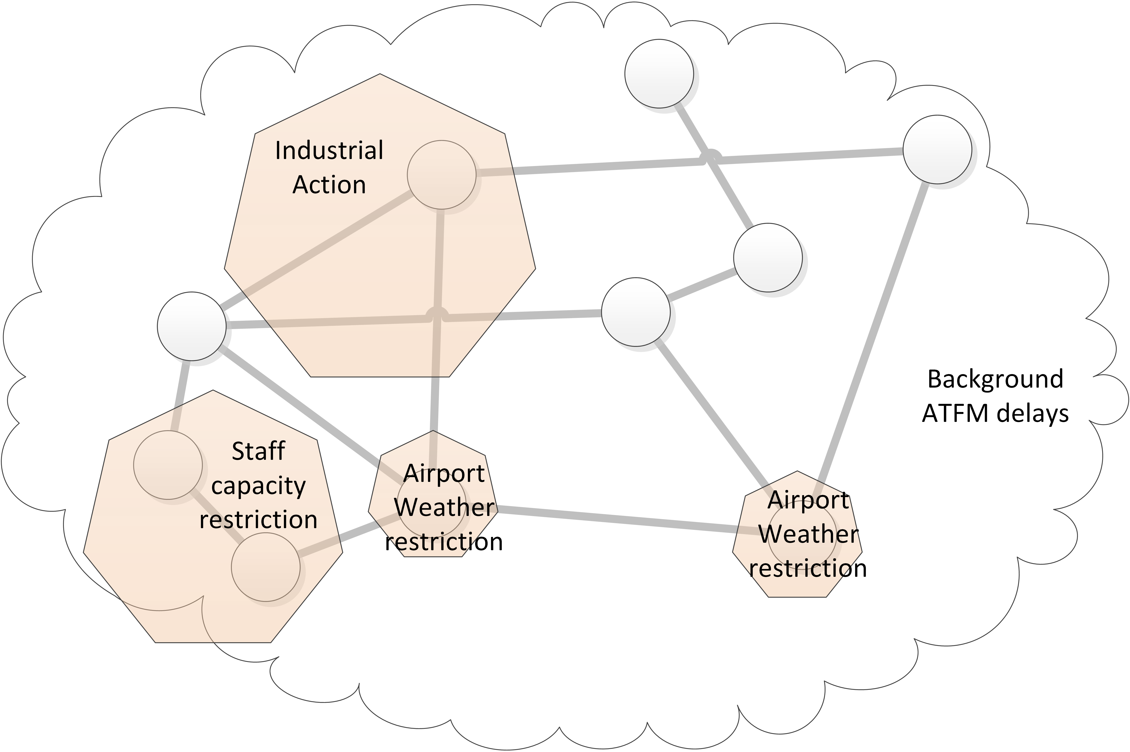
Figure 1. Diagram of the disturbances that will be modelled
For every disturbance type two days will be modelled: one day, when the effect of the disturbance is affecting a limited geographical area, and another day, when the impact of that type of disturbance is spread through a wider region. This will allow us to analyse the effect of the mechanisms under different operational situations. It might be possible that a given mechanism delivers a higher performance when the problem is localised in a region, as delay can be recovered in the rest of the network, while another mechanism might be better suited for situations where the disturbance is widely spread.
The scope of the disturbances modelled will be based on days when those disturbances were present in Europe. Their impact, i.e. delay generated, cancellations, etc., will be modelled based on the historical distribution of delay for that type of disruption. For staff capacity shortage and industrial action, this historical analysis will be based on ATFM regulations from the period between AIRAC 1313 to AIRAC 1413; for weather disturbances there will also be a tactical delay component based on the historical METARs of the day from which the disturbance is modelled.
The ATFM delay distribution for the disturbances can be fitted by a Burr probability distribution. As shown in Figure 2, the probability of being assigned a given amount of delay if crossing an ATFM regulation is different for different causes. Therefore three different models, one per reason, are preferred rather than a model for all the ATFM delay. This is particularly important for industrial action which presents higher values of delay for the same probabilities. For weather regulations, the Generalised Extreme Value probability functions presents a better fitting being a Burr distribution which is the second best fit; however, in order to keep the homogeneity between the distributions types Burr distribution is preferred for its modelling.
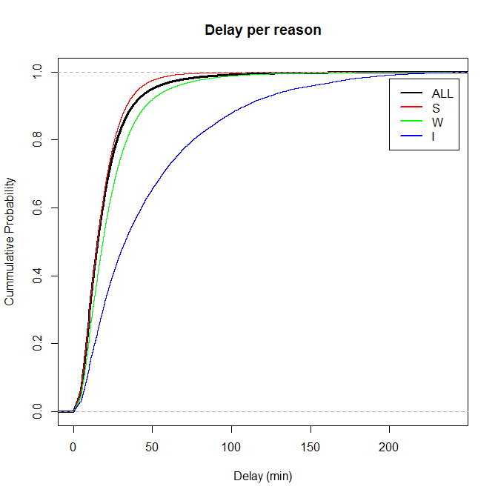
Figure 2. Experimental cumulative probability of ATFM delay

Finally, to model the total delay experience by flights in the network, background ATFM delay will be based on the ATFM delay experienced during the 12th September 2014, the traffic baseline day; and the impact of weather, on tactical delay, modelled based on the meteorological situation (METARs) of the 12th September 2014, when airport weather restrictions disturbances are not explicitly modelled.
Table 3 summarises the different disturbances and their modelling including the selected days as base for the scope of the disturbances and the parameters of the Burr distributions that model the ATFM delay. Table 4 summarises the ideas to model the background ATFM and weather delay. The remainder of the section presents more detail regarding to the modelling of the disturbances and the selection of the days for their scope.

Table 3. Summary of disturbance modelling
 | Disturbance effect | Scope |  | Delay modelling cumulative probability distribution for ATFM delay
 |  |  |  | Burr distribution
 |  | Local/Regional | Global | α | c | k
Staff capacity shortage | - ATFM delay based on probability distribution estimated from all ATFM delay generated in the period AIRAC 1313 to AIRAC 1413 by all regulations issued due to ATCO staff shortage. | - Regulations of the 27/05/2014  - ANSPs affected: EP, ED | - Regulations of the 11/08/2014  - ANSPs affected: LG, LD, ED, LZ, EP, LE | 30.712 | 1.870 | 2.916
Industrial action (ATC) | - ATFM delay based on probability distribution estimated from all ATFM delay generated in the period AIRAC 1313 to AIRAC 1413 by all regulations issued due to industrial action.  - Cancellations will be estimated based on CODA reports.  - For flights which trajectory is affected by a regulated area but with origin-destination outside the regulated regions, re-routing options will be considered. | - Regulation of the 24/06/2014  - ANSPs affected: LF | - Regulation of the 30/01/2014  - ANSPs affected: LF, LZ, LO, LP, LH | 141.474 | 1.282 | 4.531
Meteorological events with local effects at airports | - ATFM delay based on probability distribution estimated from all ATFM delay generated in the period AIRAC 1313 to AIRAC 1413 by all regulations issued due to weather at airport.  - Tactical delay and cancellations modelled at all airports based on METAR data from the days used for the modelling of the disturbances. | - Regulation of the 18/10/2014  - Airports affected: EDDF, EDDM, EDDT, EDDH, LSZH | - Regulation of the 08/09/2014  - Airports affected: EBBR, EGKK, EPWA, ESSA, ESSB, LEBL, LEJR, LFMD, LFOB, LOWW, LPFR, LPPT, LSGG, LSZH, LTBA, LFTJ | 27.913 | 1.874 | 1.805

Table 4. Summary of background delay modelling
Background delay
- Background ATFM
  - Based on shifting of ATFM delay occurred on the 12th September 2014.
  - Flights going through traffic volumes that were regulated on the 12th September 2014 get delay assigned from a pool of delay.
- Tactical weather effect
  - When 'Meteorological events with local effects at airports' is not explicitly modelled, the effect of weather on tactical delay and cancellations is modelled based on the METAR data from the 12th September 2014.

Staff capacity shortage
All the ATFM regulations that were reported due to ATCO staff shortage during the period AIRAC 1313 to AIRAC 1413 are grouped by day and shown in Figure 3. The number of ANSPs gives us an indication of the spatial distribution of the regulations (i.e. generally, more ANSPs declaring regulations implies a wider dispersion of the disturbance through Europe on that day); the number of regulations allow us to identify days when there was a significant number of disturbances due to staff capacity shortages.
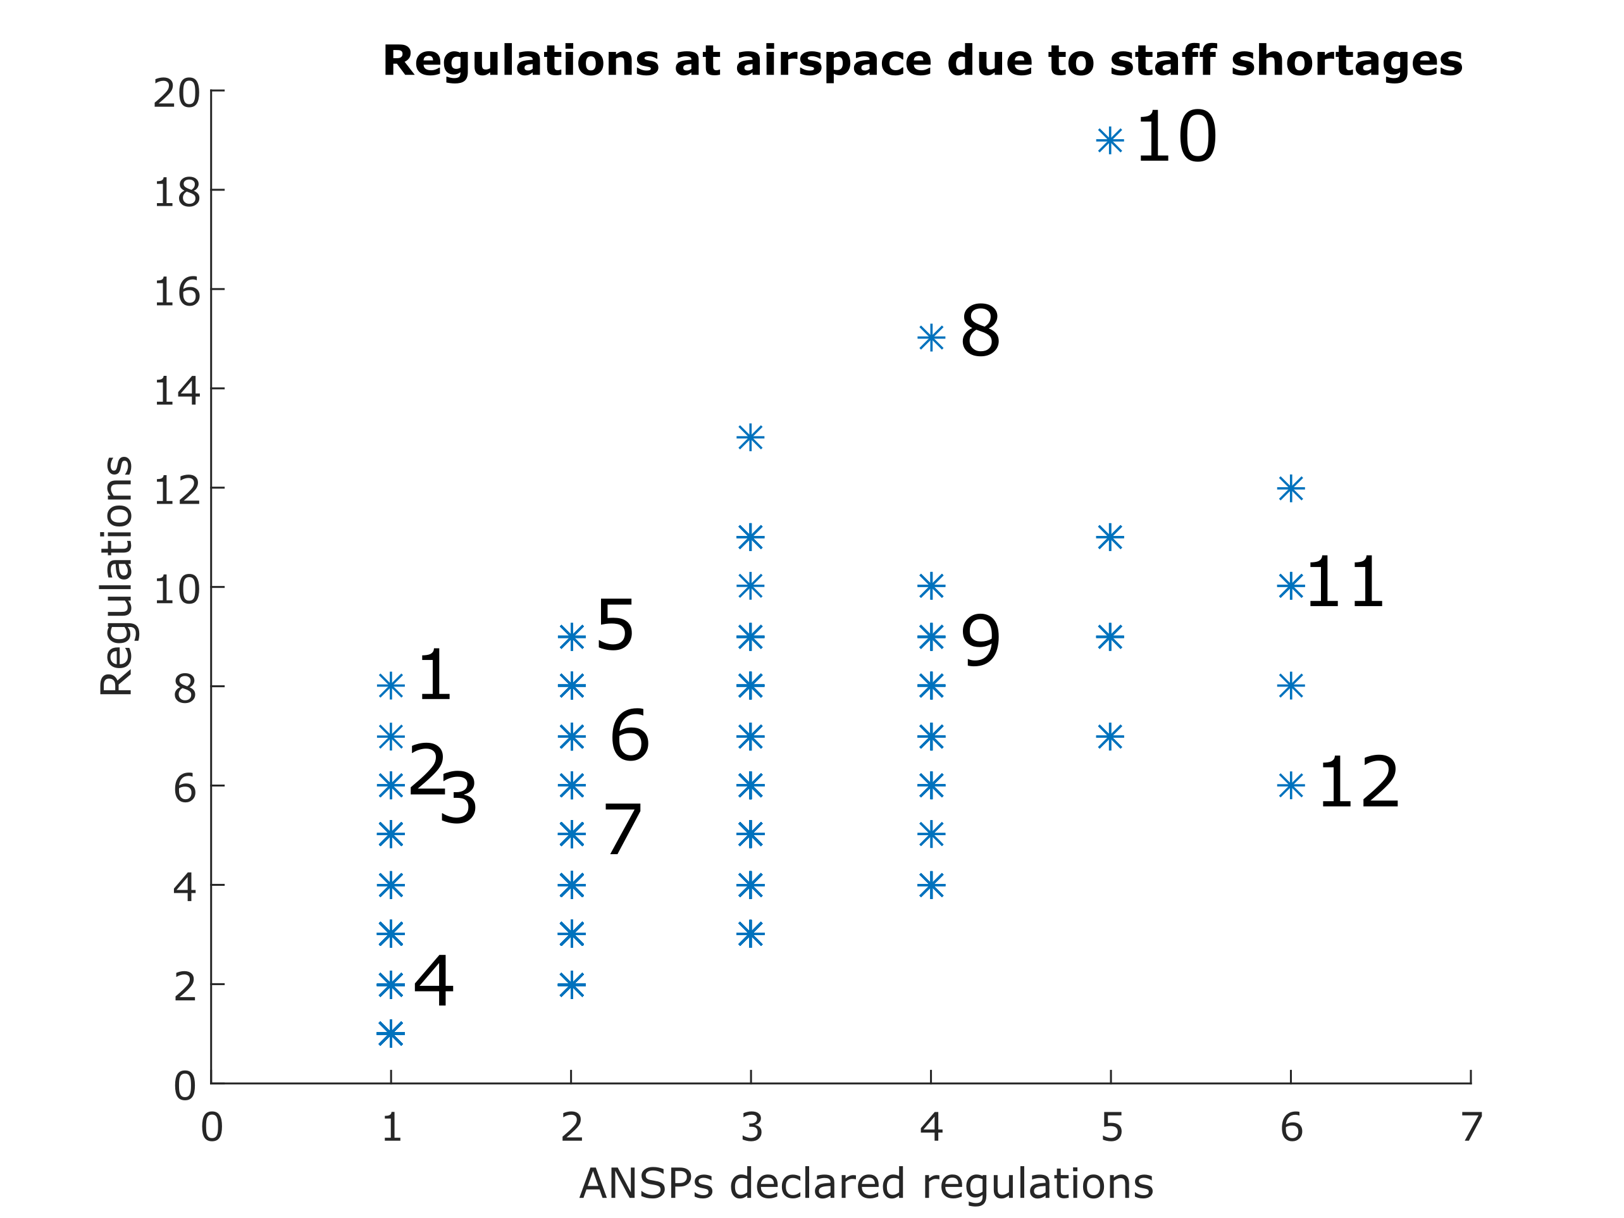
Figure 3. Number of ANSPs and regulations reported due to ATCO staff shortage

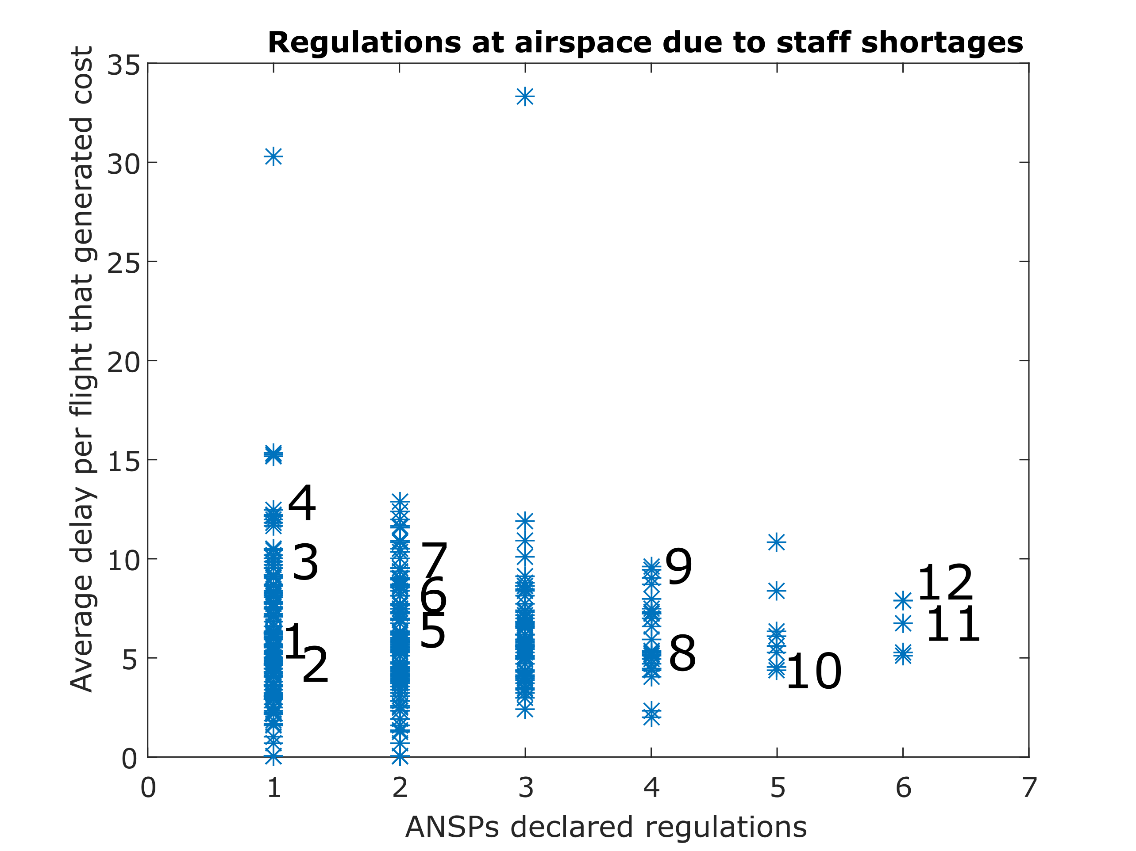
Figure 4. Average delay per flight going through the regulations due to ATCO staff shortages

Table 5. Selected days for ATCO staff shortage regulations
 | Number in Figure 3 and Figure 4 | Day | AIRAC | Number of regulations | Number of ANSPs | Average delay per delayed flight | ANSPs affected
Local scope | 1 | 11/10/2014 | 1410 | 8 | 1 | 5 | LP
 | 2 | 03/09/2014 | 1409 | 6 | 1 | 5 | ED
 | 3 | 15/11/2014 | 1412 | 6 | 1 | 10 | LP
 | 4 | 22/11/2014 | 1412 | 2 | 1 | 12 | LP
 | 5 | 27/05/2014 | 1405 | 9 | 2 | 6 | EP ED
 | 6 | 26/08/2014 | 1409 | 7 | 2 | 7 | ED LG
 | 7 | 05/11/2014 | 1411 | 5 | 2 | 10 | LP ED
Global scope | 8 | 09/08/2014 | 1408 | 15 | 4 | 5 | LF ED LZ LG
 | 9 | 27/08/2014 | 1409 | 9 | 4 | 10 | LP LE ED EG
 | 10 | 08/08/2014 | 1408 | 19 | 5 | 4 | LE LF ED LZ LG
 | 11 | 11/08/2014 | 1408 | 10 | 6 | 8 | LG LD ED LZ EP LE
 | 12 | 07/07/2014 | 1407 | 6 | 6 | 8 | EN EP ED LS LG LC

Figure 4 presents the average delay per flight that went through the regulations for each day. These values give us an indication of the intensity of the regulations. Finally, Table 5 summarises the information of the 12 candidate days that could be used as a base to model the disturbances due to ATCO staff capacity shortage. From the 12 listed days, 7 have a local/regional geographical scope with regulations in one or two ANSPs. The 5 remaining days’ regulations due to ATCO staff shortages were reported by between 4 to 6 ANSPs in Europe.
It is worth noting that this type of disturbance will be averted by 'increasing ATCO hours in selected sectors' mechanism. Therefore, preference should be given to disruptions at ANSPs that will implement this mechanism according to the mechanism uptake (see Section 2). Figure 5, from D2.2, presents the ACCs that would potentially benefit the most from the increasing the ATCO hours’ mechanism; and Figure 6 shows the ANSPs and ACCs that generated a higher delay and cost due to ATFM regulations. Considering the information from both figures the ANSPs of Portugal, Germany, Poland, Greece and Cyprus are selected as potential ANSPs to implement this mechanism and hence 27/05/2014 (EP and ED) and 11/08/2014 (EP, ED, LG, LE, LZ, LD) are adequate days to base the disturbances on.
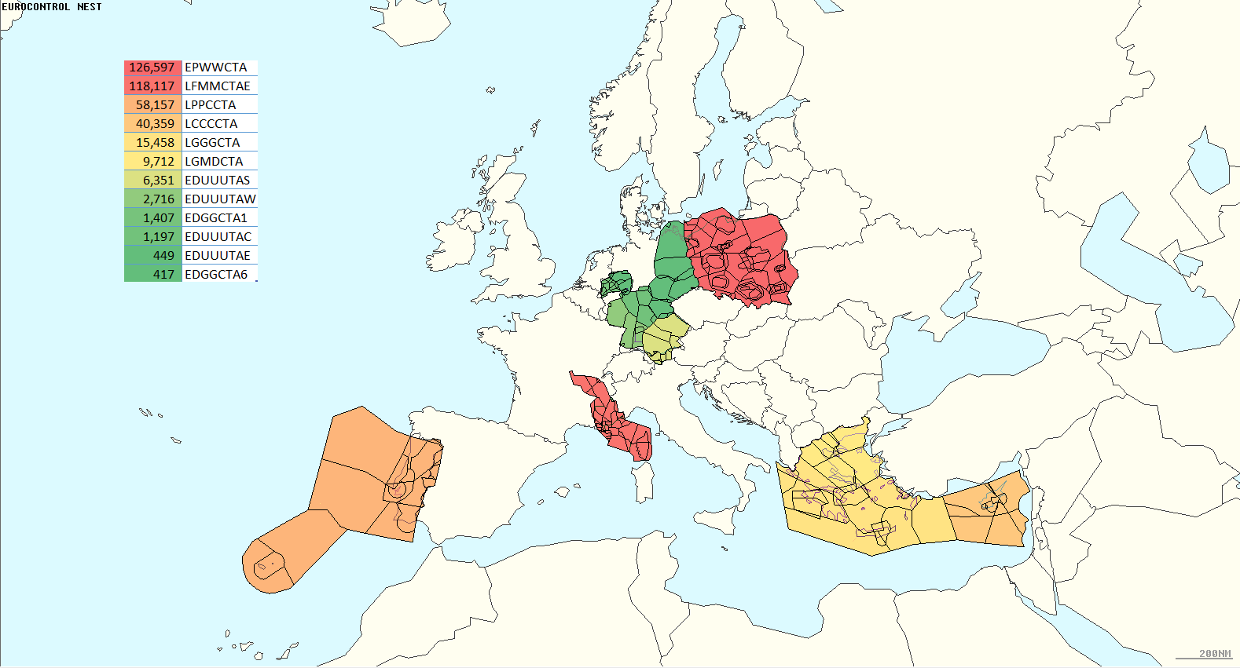
Figure 5. ACCs with most delay that could benefit from increasing ATCO hours

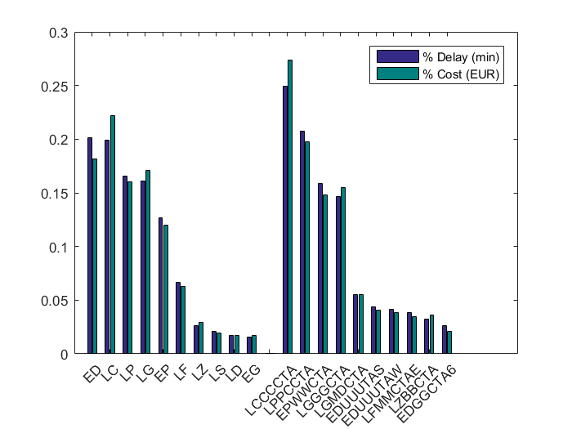
Figure 6. Delay and cost of the delay generated due to ATCO staff shortages

Figure 7(a) shows the experimental cumulative probability function of the delay assigned per flight with delay due to staff shortages regulations as a function of the time when the flight enters the traffic volume from when the regulation is declared. In D2.2, it was thought that the time when the flight enters the regulation might affect the amount of delay assigned. As shown in Figure 7(b), there is an increment on the values of delay assigned but this increment is small. For this reason, it has been preferred to model the ATFM delay due to staff shortages as a single probability distribution. Figure 8 presents the cumulative probability of the delay and the fitting obtained with the model of the distribution as a Burr distribution with parameters as presented in Table 6.

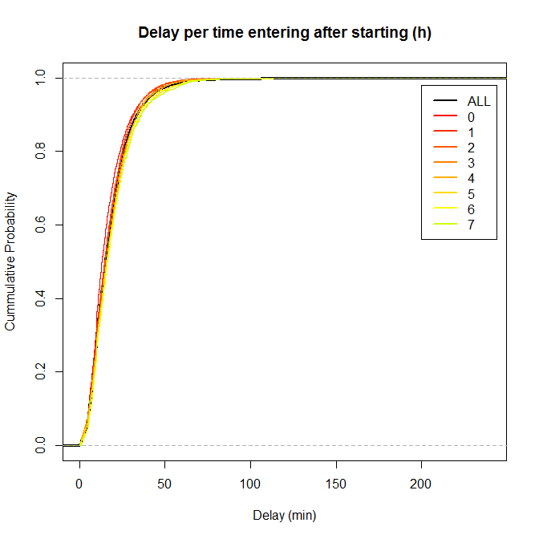  (a) Cumulative probability | 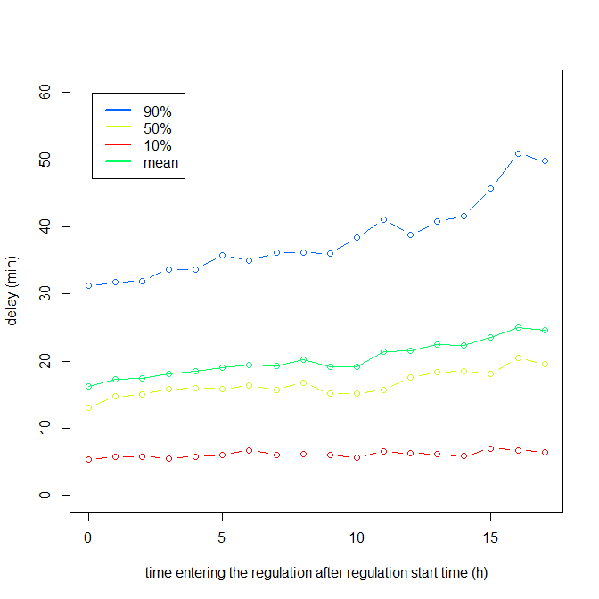  (b) Distribution of delay
Figure 7. Staff shortage ATFM regulations delay as a function time entering regulation

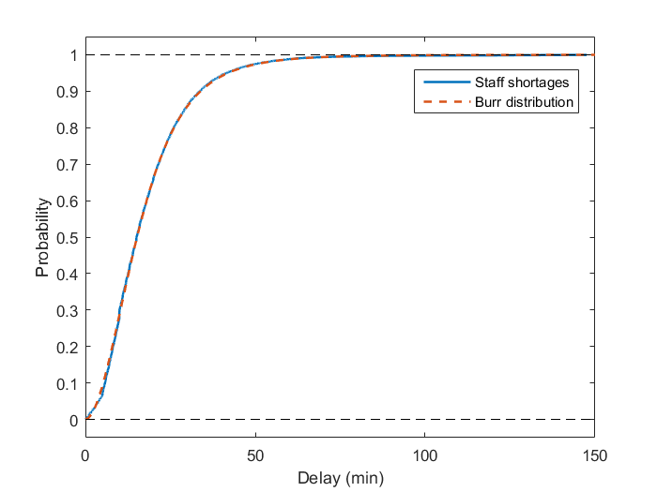  (a) Cumulative probability function | 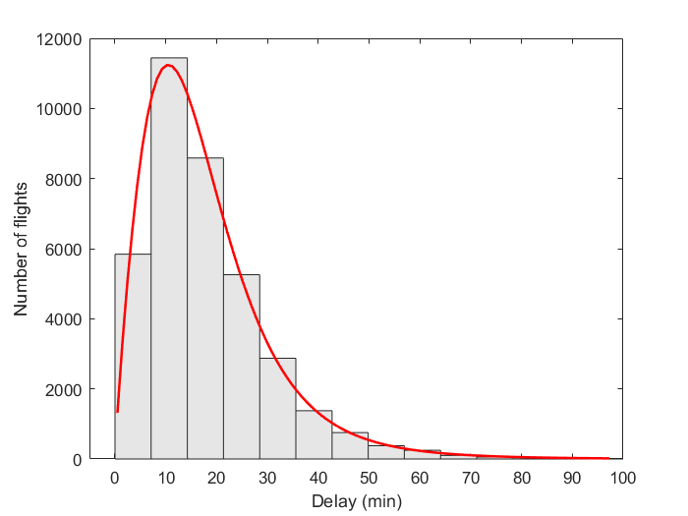  (b) Histogram
Figure 8. ATFM delay probability distribution fitting for ATCO staff shortage regulations

Table 6. Parameters Burr distribution ATFM delay ATCO staff shortage regulations
α = 30.712
c = 1.870
k= 2.916

Industrial action (ATC)
Industrial action is less frequent than meteorological or staff related disturbances, however, they are very disruptive (EUROCONTROL, 2014b). Figure 9 presents the average delay per flight going through the regulations issued due to industrial action during the period AIRAC 1313 to AIRAC 1413. As observed, generally, the regulations are issued by a single ANSP; this is consistent with local national disputes. In some cases, more than one ANSP report during the same day regulations due to coordinated industrial action.
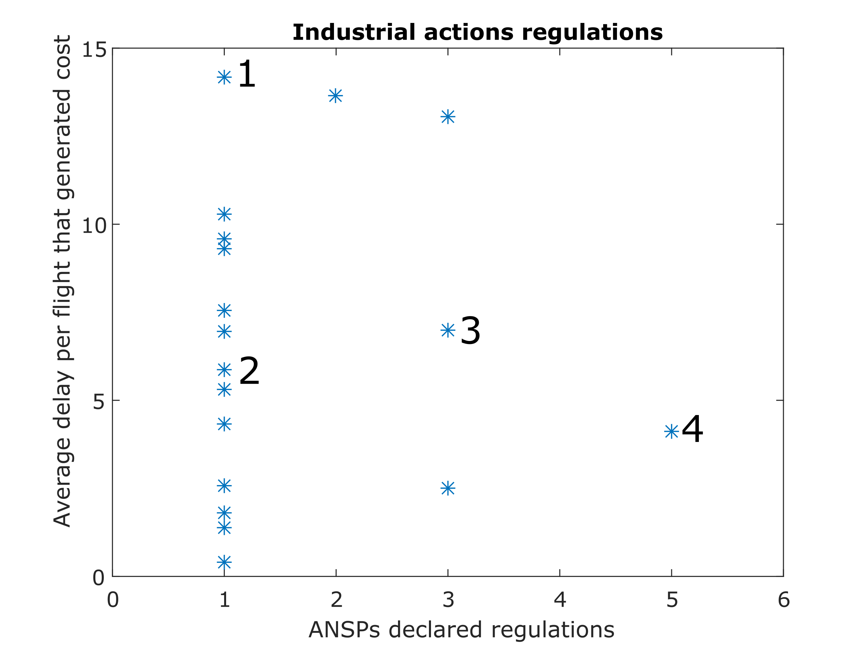
Figure 9. Average delay per flight through the regulations due to industrial action

As reported in D2.2, France was the largest single ANSP contributor to delay due to ATCO industrial action and as presented in Table 7, there was an industrial action period in France between the 24th and 25th of July 2014 (EUROCONTROL, 2014d; BBC, 2014a; BBC, 2014b; The Guardian, 2014a). Therefore, the 24th July 2014 is selected as a candidate day to base the modelling of industrial action as it had a high average delay per delayed flight, i.e. higher intensity. According to (EUROCONTROL, 2014d), the industrial action in France on 24th, 25th and 26th June affected approximately 3,000 flights and generated a notable peak in the quarter of cancellations with a cancellation rate up to 5%.
Industrial action in France, due to its geographical location, generates high disruption through the network (EUROCONTROL, 2014b); for this reason, it might be interesting to analyse the effect of another local industrial action but in a different region of Europe. On the 27th of November 2014 Greece carried out a national strike (EUROCONTROL, 2014e; Reuters, 2014); one would expect to find a reduced impact in comparison with the industrial action in France as the airspace affected is peripheral. At this stage, the France industrial action is selected as LF was the first contributor of disruptions due to industrial action.
Finally, when considering an industrial action with a global scope, two options have been selected in Table 7. They correspond to a coordinated industrial action that took place in several ANSPs during the days 29th and 30th January 2014 (EUROCONTROL, 2014c; The Guardian, 2014b; The Telegraph, 2014). The regulations of the 30th January 2014 are preferred to the ones of the 29th, as it affects the centre of Europe, and even if the French ANSP reported some regulations due to industrial action, they only cover partially its airspace. This means that the industrial action regulations on the 30th January 2014 have a disperse effect through Europe but without completely blocking a significant part of the European airspace. According to (EUROCONTROL, 2014c), industrial action on the 29th and 31th January caused en-route delays in the French ACCs as well as Lisbon, Milan and Rome areas.

Table 7. Selected days for industrial action regulations
 | Number in Figure 9 | Day | AIRAC | Average delay per delayed flight | ANSPs affected
Local scope | 1 | 24/06/2014 | 1406 | 14 | LF
 | 2 | 27/11/2014 | 1412 | 6 | LG
Global scope | 3 | 29/01/2014 | 1401 | 7 | LP LI LF
 | 4 | 30/01/2014 | 1401 | 4 | LF LZ LO LP LH

An important factor with industrial action is the effect on flights in terms of cancellations and re-routings. By their nature, industrial action covers a wider area which mean that the delay experience is higher and leads to higher cancellations (EUROCONTROL, 2014b). This should be explicitly included in our modelling (EUROCONTROL, 2014c; EUROCONTROL, 2014d; EUROCONTROL, 2014e).
In order to model the ATFM delay generated by industrial action, the industrial action that occurred during AIRAC 1313 to AIRAC 1413 have been analysed. Figure 10 shows the experimental cumulative probability function of the delay assigned per flight with delay due to industrial action and its fitting with a Burr distribution with parameters as shown in Table 8.

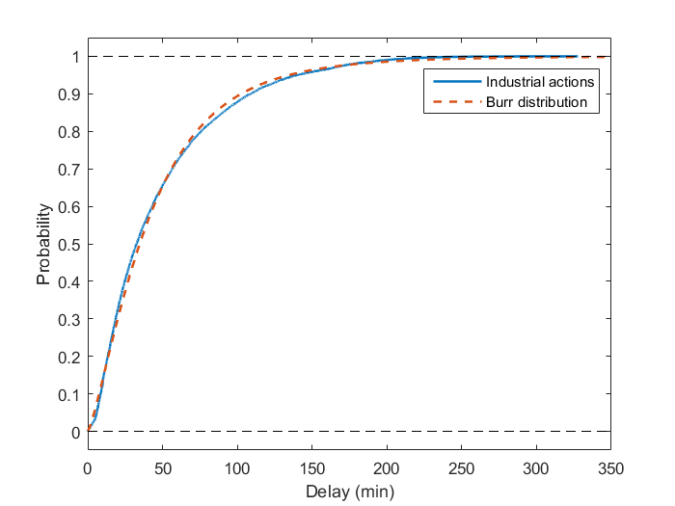  (a) Cumulative probability function | 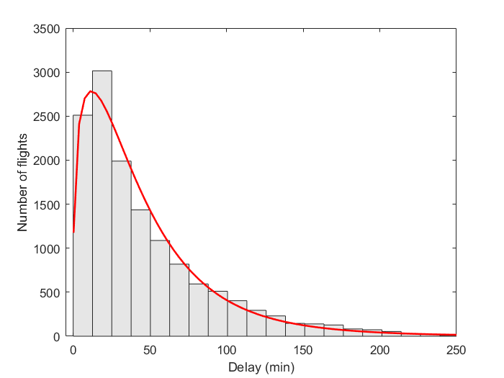  (b) Histogram
Figure 10. ATFM delay probability distribution fitting for industrial action regulations

Table 8. Parameters Burr distribution ATFM delay industrial action regulations
α = 141.474
c = 1.282
k= 4.531

Meteorological events with local effects at airports
The delay of an airport is mainly driven by the meteorological events. In the case of severe weather events (e.g. fog, snow, strong winds, freezing conditions), the hourly capacity of the airport decreases. In the case of significant demand for arrivals and departures, the resulting flow leads to delayed aircraft operations. This type of disturbance has therefore a significant effect both at ATFM and at tactical level.
To quantify weather effects at airports the ATMAP weather algorithm (EUROCONTROL, 2011) provides a weather score by classifying the METAR information into five relevant areas (visibility, wind, precipitation, freezing conditions and dangerous phenomena). According to the derived weather score, weather conditions are defined as significant if the score is higher than 1.5 (default European score for bad weather).
If the weather score is compared to the airport performance, measured by on-time performance (delay < 15 minutes), a clear correlation could be derived (see Figure 11, for an example of Frankfurt airport during 2013). The dataset is not complete (e.g. missing timestamps, broken records, contradictory data), but covers more than 90% of the aircraft movements.

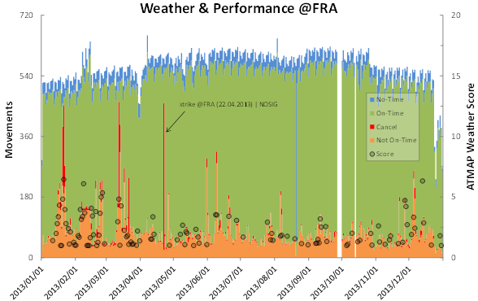
Figure 11. Airport movements and significant weather scores (Frankfurt Airport, 2013)

A picture of the delay effect at the airport is given in Figure 12 where days with relevant weather score and delays are shown (in (a) dangerous phenomenon and in (b) freezing conditions). Figure 12(a) (06/08/2013) emphasises a single weather event followed by the induced delay (full response after approx. 2 hours). Figure 12(b) shows a scenario with freezing conditions in the morning peak, with a significant impact on the airport operations (14/12/2013).

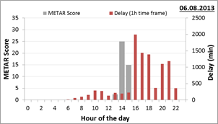  (a) Dangerous phenomenon | 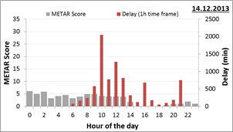  (b) Freezing conditions
Figure 12. Days with relevant weather score and delays

To model the delay and the cancellation according to the actual weather score, a statistical analysis clearly indicate a linear correlations for the arrival and departure operations (see Figure 13 with cancellations (a) and delay correlations (b) regarding to the weather score). Assuming a linear correlation of weather score and airport performance (median of amount of delayed flights) the analysis points out a significant coefficient of determination (r²) which ranges from 0.7 to 0.87.

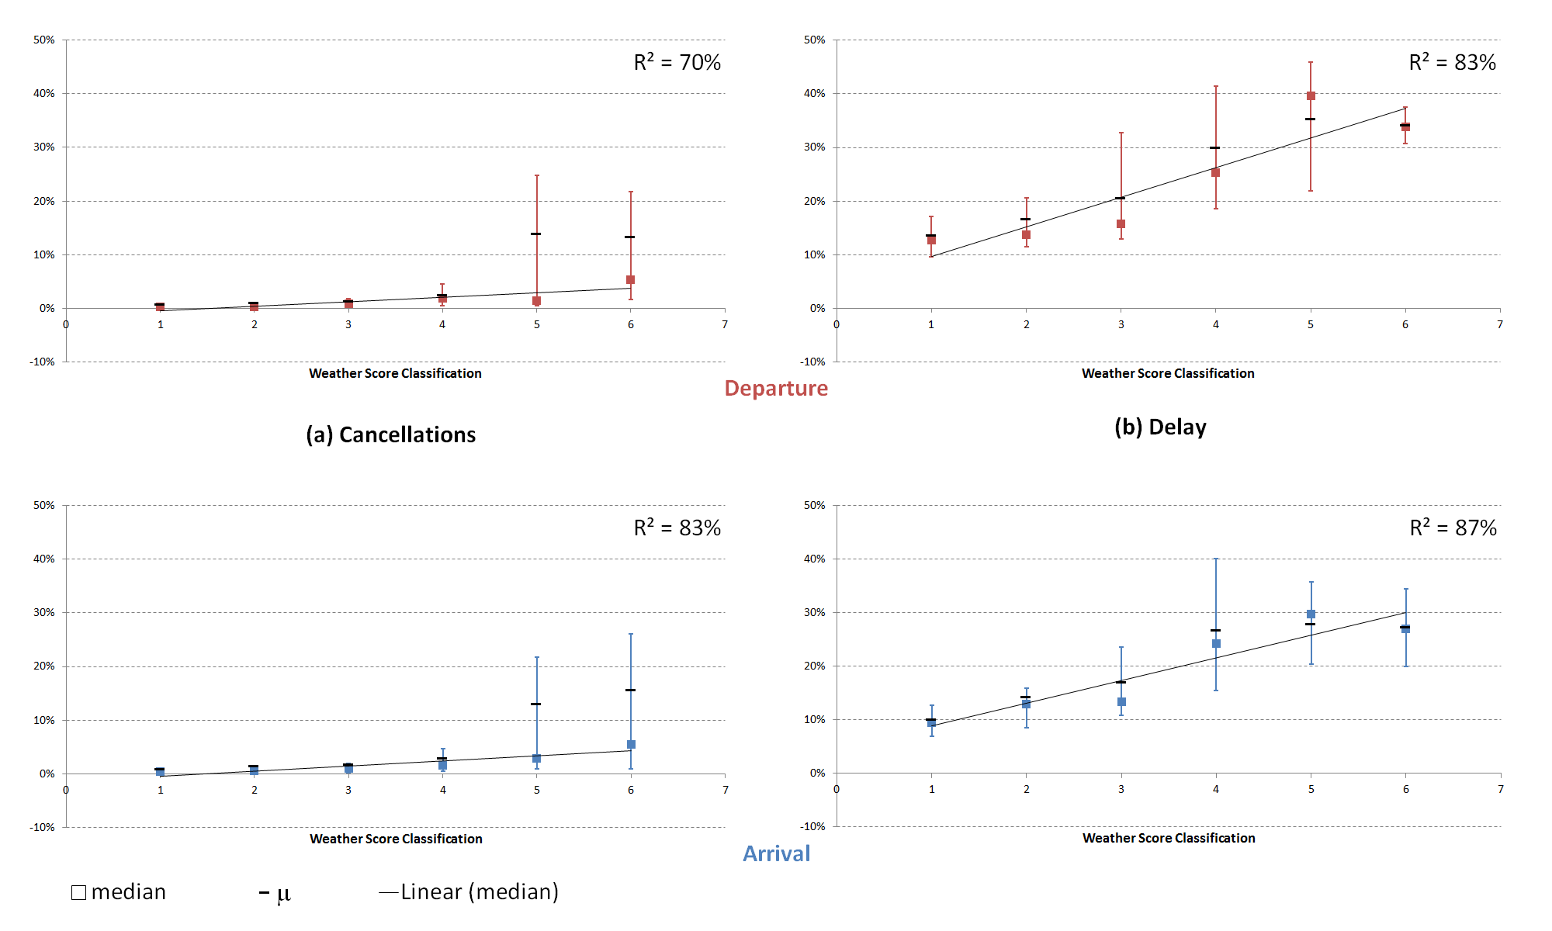
Figure 13. Correlation of cancelations and delay regarding the weather score
If the amount of cancelled and delayed aircraft increases, the character of the delay increases as well (see Figure 14). Assuming a linear correlation of weather score and quantified delay (median of delay minutes of delayed flights) the analysis points out a significant coefficient of determination (r²) of 0.87 for arrivals and 0.77 for departures.
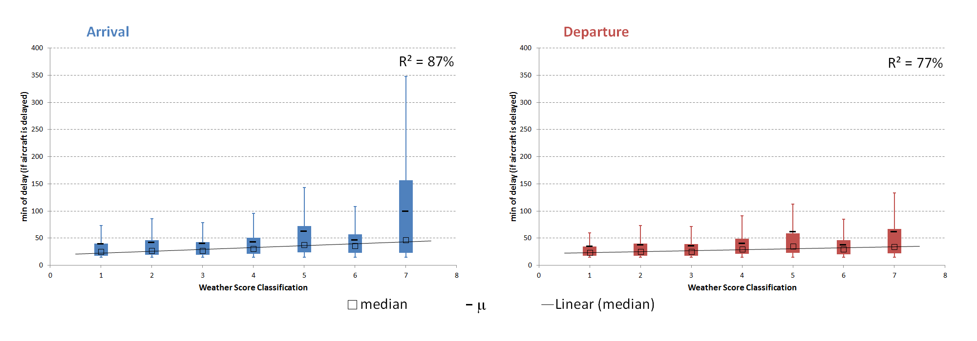
Figure 14. Quantification of delay for aircraft with delay of 15 mins or more

This detailed airport performance analysis provides a solid basis to model airport delay and cancellation using the available METAR information as the primary input factor. Note that the METAR information will evolve during time allowing us to model the temporal variation on delay generation associated with a weather event. To cover different airport capacities and local characteristics, this analysis covers a set of European airports. The airport performance model for the European air traffic is calibrated with a dataset from 2013. To derive a realistic performance according to the 2014 scenarios, each airport specific dataset is used for the available airports. If the simulated airport was not part of the analysis, an airport of the same size is used as an appropriate surrogate. This model will be developed for 84 airports in Europe within 25 ANSPs (see Table 9). Table 10 shows examples of the correlation parameters for some airports in the model with respect to the percentage of flights experiencing delays and cancellations. The amount of delay will be modelled based on the analysis of the quantified delay as shown in Figure 14.

Table 9. Number of airports modelled per ICAO region
ICAO region code | Number of airports modelled |  | ICAO region code | Number of airports modelled |  | ICAO region code | Number of airports modelled
BI | 1 |  | EP | 3 |  | LM | 1
EB | 1 |  | ES | 2 |  | LO | 1
ED | 13 |  | GC | 5 |  | LP | 4
EF | 1 |  | LB | 1 |  | LR | 1
EG | 5 |  | LE | 11 |  | LS | 2
EH | 1 |  | LF | 5 |  | LT | 2
EI | 1 |  | LG | 6 |  | UL | 1
EK | 1 |  | LH | 1 |  | UU | 2
EN | 1 |  | LI | 11

Table 10. Example of airport delay and cancellation model due to weather
Airport | Arrivals |  | Departure
 | % Delays | % Cancellations | % Delays | % Cancellations
EDDM | 0.04803x + 0.00686 | 0.00378x - 0.00056 | 0.06343x + 0.00228 | 0.00497x - 0.00444
EHAM | 0.02100x + 0.05380 | 0.00120x + 0.00154 | 0.02571x + 0.11402 | 0.00114x + 0.00092
LFPG | 0.07477x + 0.00010 | 0.00229x - 0.00020 | 0.06013x + 0.17123 | 0.00161x + 0.00040
Percentages of flights experiencing delay and cancellation as a function of METAR weather score.
In order to select the days on which to base the disturbance of weather at airports, the ATFM regulations of the period AIRAC 1313 to AIRAC 1413 have been analysed. Figure 15 shows the number of ANSPs that declared regulations on each day with respect to the number of regulations declared on that day due to weather at airports. As with staff capacity shortage, the number of ANSPs gives us an indication of the spatial distribution of the disturbances (i.e. generally, more ANSPs declaring regulations implies a wider dispersion of the disturbance through Europe on that day). We are using the distribution of ATFM regulations to get an approximation of the distribution of weather related disturbances at airports (including tactical (holding) delay). Figure 16 presents the average delay per delayed flight for each of the days studied. These values give a sense of the intensity of the regulations.
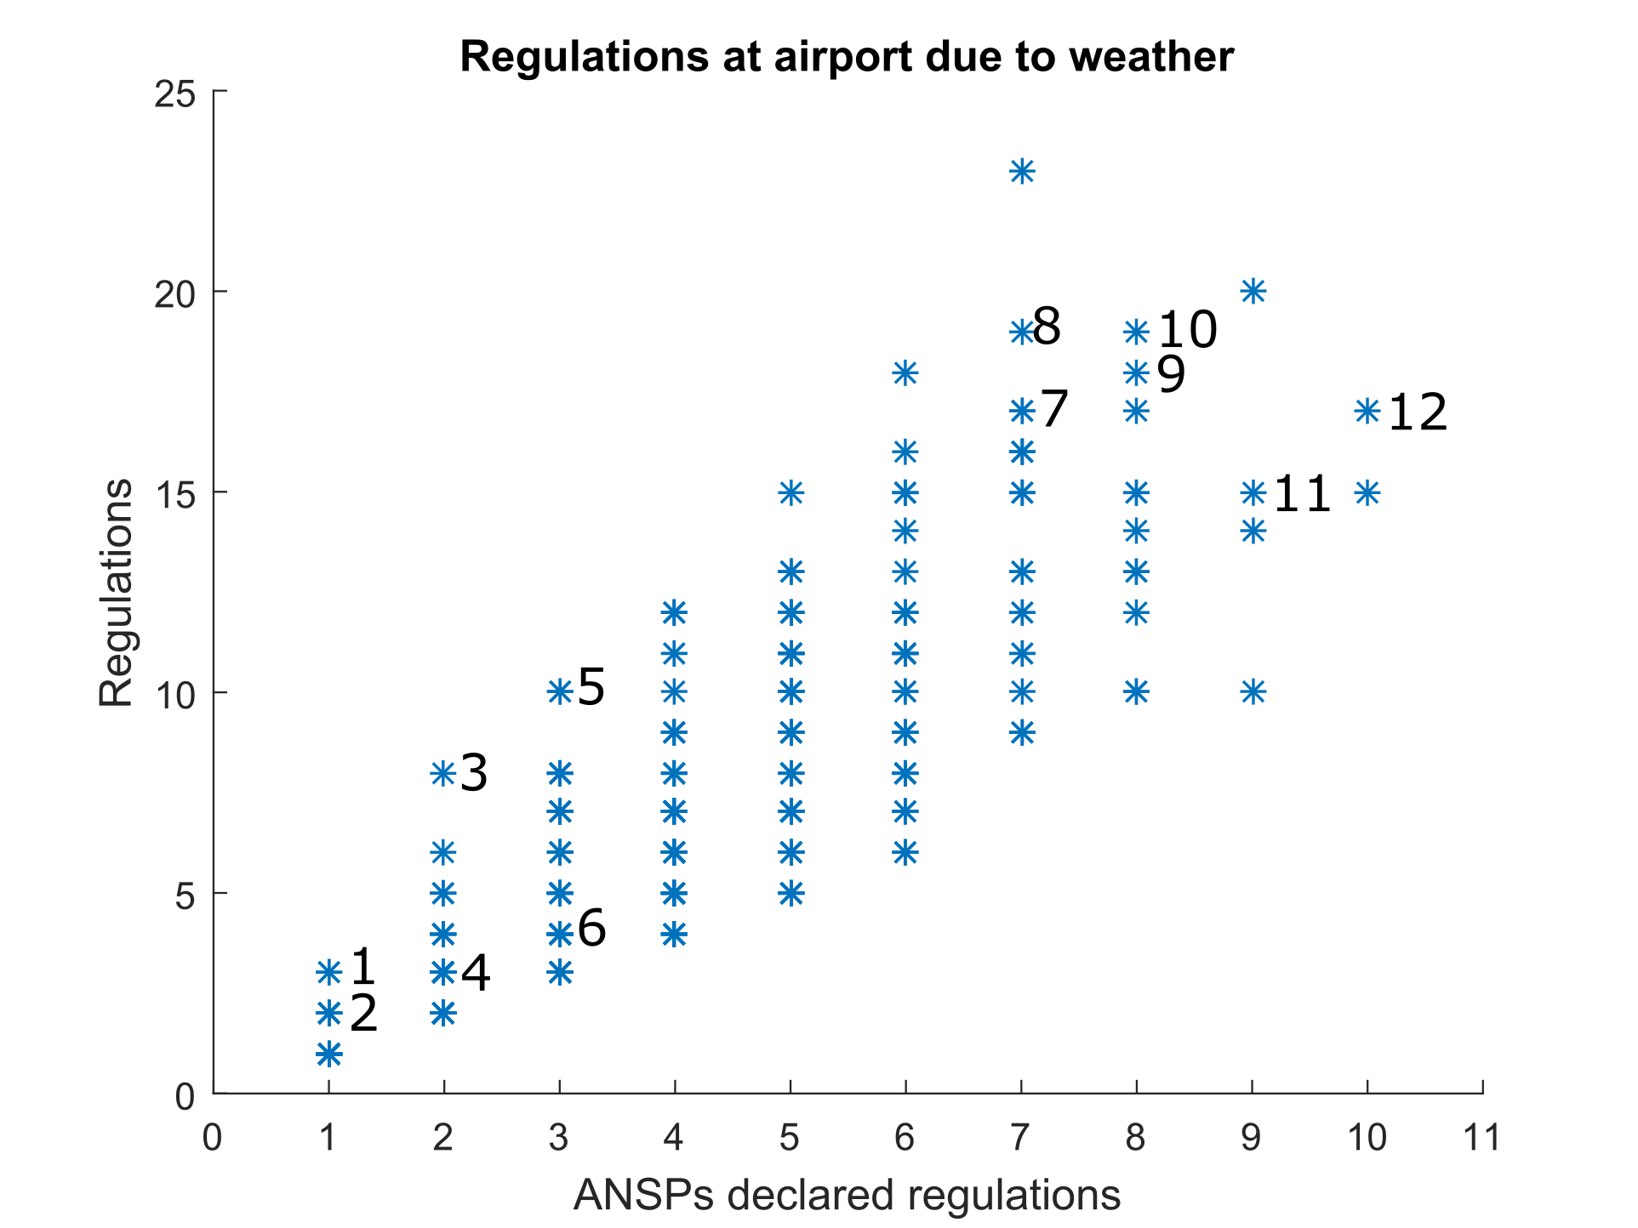
Figure 15. Days when regulations due to weather issues were implemented at airports

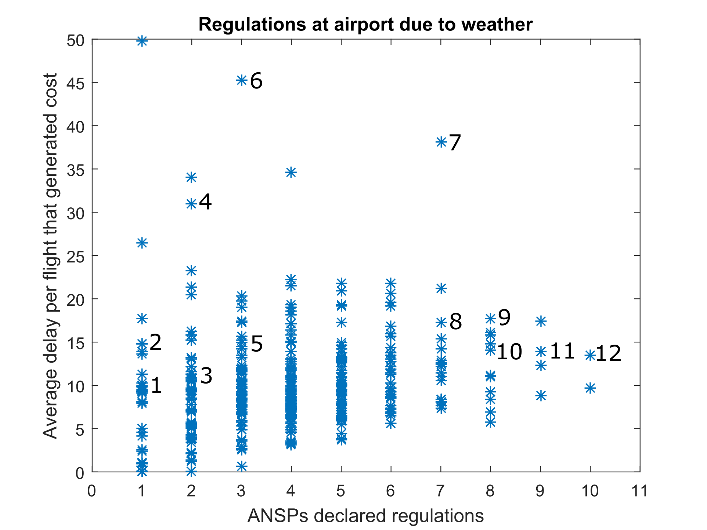
Figure 16. Average delay per delayed flight for all regulations due to weather at airports per day

Table 11 selects 12 specific days from parallel analyses and presents the characteristics of those days with respect to ATFM regulations at airports due to weather. During days 1 to 6, between 1 and 3 ANSPs declared ATFM regulations due to weather issues; days 7 to 12 cover days with between 7 and 10 ANSPs declaring regulations.

Table 11. Days with weather related ATFM regulations
 | Number in Figure 15 and Figure 16 | Day | AIRAC | Number of regulations | Number of ANSPs | Average delay per delayed flight | ANSPs affected | Airports affected
Local scope | 1 | 22/01/2014 | 1411 | 3 | 1 | 10 min | LS | LSZH
 | 2 | 17/08/2014 | 1408 | 2 | 1 | 15 min | LT | LTBA LTFJ
 | 3 | 18/10/2014 | 1411 | 8 | 2 | 11 min | ED LS | EDDF EDDM EDDT  EDDH LSZH
 | 4 | 21/11/2014 | 1412 | 3 | 2 | 31 min | EB ED | EBBR EDDH EDDT
 | 5 | 07/05/2014 | 1405 | 10 | 3 | 14 min | ED LI LS | EDDF EDDM LIRA  LIRF LSGG LSZH
 | 6 | 24/10/2014 | 1411 | 4 | 3 | 45 min | ED EG EL | EDDF EDDM EGKK  ELLX
Global scope | 7 | 07/08/2014 | 1408 | 17 | 7 | 38 min | EB ED LE LF LP LS LT | EBBR EDDM LEMG  LFPG LFPO LFSB  LPPR LSZH LTBA  LTFJ
 | 8 | 26/11/2014 | 1412 | 19 | 7 | 17 min | EB EG EN ES LE LF LI | EBBR EGGW EGLC  ENGM ESSA ESSB  LEJR LFBO LFPO  LFRS LFTZ LIRN
 | 9 | 28/09/2014 | 1410 | 18 | 8 | 18 min | ED EG LE LG LO LP LS LT | EDDM EGKK LEBL  LEPA LGRP LOWW  LPPT LSZH LTBA  LTFJ
 | 10 | 18/09/2014 | 1410 | 19 | 8 | 14 min | EB ED EG EI ES LF LP LT | EBBR EDDF EDDM  EGLC EGNM EGPD  EGSS EIDW ESSA  LFPO LPPT LTBA  LTFJ
 | 11 | 19/09/2014 | 1410 | 15 | 9 | 14 min | EB ED EI EG EK EN ES LE LP | EBBR EDDF EDDL  EDDM EGKK EGLC  EIDW EKCH ENGM  ESSA ESSB LEBL  LPPT
 | 12 | 08/09/2014 | 1409 | 17 | 10 | 14 min | EB EG EP ES LE LF LO LP LS LT | EBBR EGKK EPWA  ESSA ESSB LEBL  LEJR LFMD LFOB  LOWW LPFR LPPT  LSGG LSZH LTBA  LFTJ

During the 18th October 2014 (day 3 in the table) there were regulations due to weather at airports in the region of Germany and Switzerland. This day seems like a good candidate for a regional/local meteorological disruption that affected the centre of Europe. The other days are either too local (e.g. 22/01/2014 when only Switzerland reported a regulation due to weather at an airport) or too widespread (e.g. 07/05/2014 when Germany, Switzerland and Italy reported problems). The 21/11/2014 might be another candidate day for regional effects as only Germany and Belgium issued regulations.
For the global scope, even if the average delay per delayed flight was very high on the 07/08/2014 (day 7 in the table), the region affected is not as wide as on the 08/09/2014 (day 12 in the table). For this reason, 08/09/2014 is preferred. On that day, the average delay per delayed flight is similar to the days when the effect was more localised. This will facilitate the comparison as the intensity are similar even if the scope are different.
As mentioned, the ATFM regulations will be based on the ones reported on the different selected days and the tactical delay and cancellations based METARs reported on those days for airports in Europe. Note however, that the delay generated with the METAR based model is the total delay experience by flights. Hence, this delay generated will be, in some cases, divided between ATFM and tactical airborne delay and other sources of delay to avoid over counting the effect of weather.
An analysis of the ATFM delay assigned due to weather regulations during the period AIRAC 1313 to AIRAC 1413 was conducted in order to model the distribution of this type of delay. As shown in Figure 17 there seems to be a variability on the probability of getting delay assigned as a function of the time when the aircraft enters the regulated traffic volume with respect to the time when the regulation is issued. For this reason, in Figure 18 two possible models are suggested:
- for simplicity and symmetry with the other disturbances, it could be preferred to use a single probability model for all the ATFM delay due to weather regulations (Figure 18(a),(b));
- different models could be used based on the time when the flight enters the regulated volume (Figure 18(c)).
Table 12 presents the parameters of the different distributions that could be used.
As the number of ATFM regulations due to weather that will be explicitly modelled are small, a simplified version that captures the behaviour of the system, including the model from the METAR analysis, might be preferred. For this reason the option of using a single distribution for the ATFM delay is prioritised.

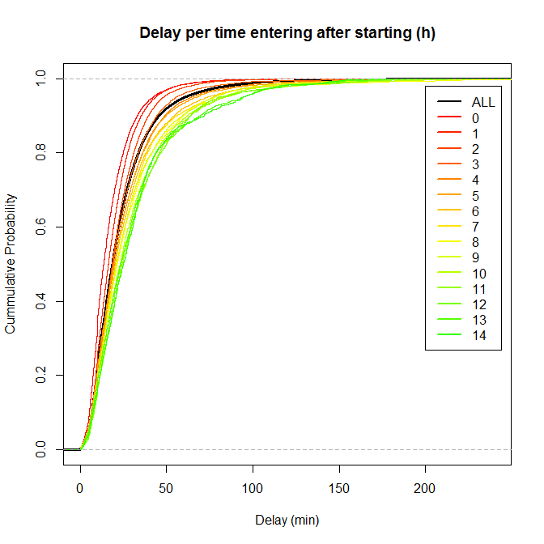
Figure 17. Weather ATFM regulations delay as a function time entering regulated traffic volume

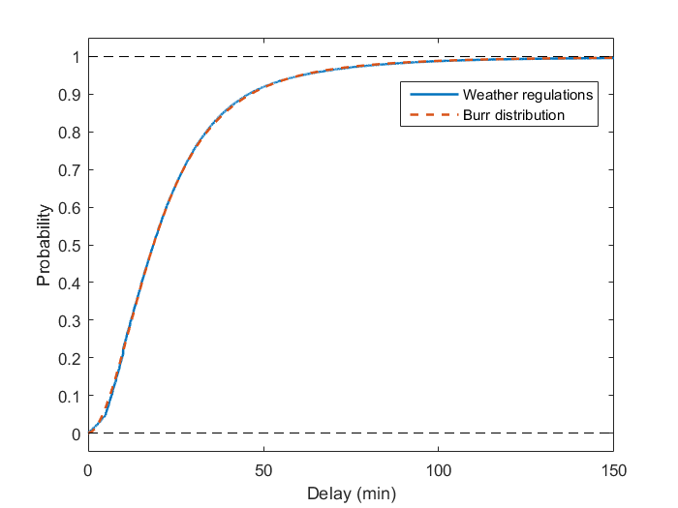  (a) Cumulative probability function | 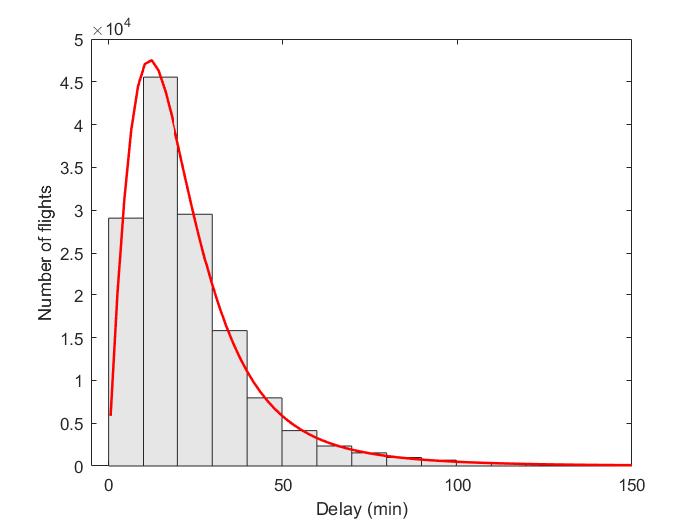  (b) Histogram
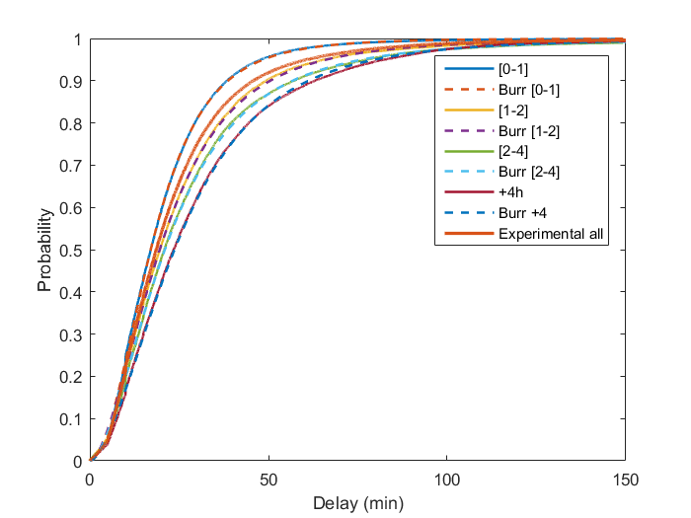
(c) Cumulative probability function as a function of time entering regulated traffic volume
Figure 18. ATFM delay probability distribution fitting for weather regulations

Table 12. Parameters Burr distribution ATFM delay weather regulations
All* | [0-1] | [1-2] | [2-4]* | +4
α = 27.913  c = 1.874  k= 1.805 | α = 28.910  c = 1.947  k= 2.269 | α = 32.806  c = 1.735  k= 2.028 | α = 31.706  c = 1.737  k= 1.742 | α = 44.184  c = 1.674  k= 2.297
* Burr distribution second best fitting
(For all regulations and by hour when entering the regulated traffic volume.)

Background delay
ATFM delay from the day under study will be used as the baseline for the background delay. Figure 19 presents the mechanism to assign ATFM delay to the flights. A pool of potential delays is generated with all the individual ATFM delays reported on the 12th September 2014. This delay is assigned to flights that operate through the regulated traffic volumes on that day. In this manner, the distribution of delay is similar to that of the baseline.

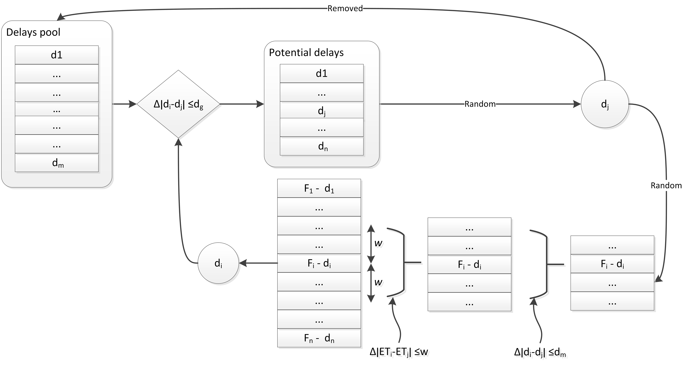
Figure 19. Delay generation concept

1. Delay generation
A delay is selected for each flight which had ATFM delay assigned in the original data. The delays that are within a given delay window (d_{g}) from the flight original delay (d_{i}) will be selected from the pool of delays. A delay will be randomly selected (d_{j}) among them and withdrawn from the pool of delays. The delay which triggers the selection and the delay selected will be randomly chosen. The range used to select the flights (d_{g}) will control the uncertainty level in terms of where the delay is generated.
2. Delay assignment
The next step is to assign the selected delay to an individual flight. The set of flights that enter the traffic volume around the same time as the flight which generated the delay are selected (i.e. flights with an entry time in the traffic volume within a given number of minutes (w)). Only flights which originally had a delay with a difference smaller than a given threshold (d_{m}) with respect to the flight which generated the delay will be kept as potential flights to get the delay assigned. These thresholds will be also used to control the desired degree of variability with respect to the initial data.
For the assignment of ATFM background delay the parameters that need to be tuned in the system are:
- d_{g}: delay window around delay to be assigned;
- w: time window for entry time in regulated traffic volume around the flight which generated delay;
- d_{m}: maximum delay difference between original delay in selected flight and generated delay.
As one of the disruptions that will be considered is the effect of weather in airports, it is considered that modelling the delay due to weather on the scenarios where the meteorological disruption is not explicitly considered will help to obtain results that are more adequate for cross comparison. For this reason, the weather model previously presented will be used considering the METAR data available from the 12th September 2014.

Scenarios

Table 13. Scenarios to be modelled
Mechanism | Staff shortage |  | Industrial action |  | Weather
 | Local | Disperse | Local | Disperse | Local | Disperse
Increasing ATCO hours in selected sectors |  |  | ? | ? | ? | ?
Dynamic cost indexing
A-CDM
Improved airline passenger reaccommodation policies

Table 13 presents the relationship between investment mechanisms and disruptions. As presented, all the investment mechanisms a priori can deliver some degree of benefit when the system is affected by the different types of disruptions. The only exception is ‘increasing ATCO hours in selected sectors’ as this mechanism only avert disruptions that are produced due to ATFM regulations issued in periods of ATCO staff shortages. For this reason, modelling the performance of ‘increasing ATCO hours’ with disruptions rather than ‘staff shortage’ is out of scope of the project.
Table 13 shows the number of scenarios considered, but note that for each mechanism two stakeholder uptakes are modelled. Therefore there will be a total of 40 scenarios to be analysed. In order to facilitate the comparison of the benefit obtained by the introduction of the mechanism, the baseline uptake (see Section 2) of the different mechanism will be modelled when the mechanism is not the one under assessment. (If resources permit, some form of targeted, bilevel fuel price sensitivity will be incorporated into the analyses, but avoiding creating 80 full scenarios to be analysed.)
A cross comparison of the benefits obtained by the different mechanism will be possible by analysing the same disruption under different mechanism and having a comparable baseline situation.
Finally, the possibility of assessing the implementation of more than one mechanism at the same time would give us insight to the fact that some mechanism might have synergies between them. However, due to the large amount of scenarios already considered this possibility is out of scope of the current project. If time allows it, after obtaining the first results some simultaneous mechanism implementations might be considered for specific disruptions types.

Data requirements
The data requirements build on D2.1 and D2.2, although the fundamental data requirements are unchanged. Table 14 presents a summary of the data requirements for the different submodels of ComplexityCosts.

Table 14. Main data requirements and sources for the different submodels
Submodel |  | Data requirements
Mechanisms | Increasing ATCO hours in selected sectors | Strategic costs | - Industry data
 |  | Tactical costs | - Controller hourly cost from ATM Cost-Effectiveness (ACE) 2013 benchmarking report with 2014-2018 outlook (EUROCONTROL, 2014a)
 |  | Implementation | - Avert ATFM regulations as in (Delgado et al., 2015)  - ACC ATCOs on duty data from DDR2
 | A-CDM | Strategic costs | - Airport CDM cost benefit analysis (EUROCONTROL, 2008)  - Airport reports (Deutsche Flugsicherung, 2010; Deutsche Flugsicherung, 2013)  - Airports implementing A-CDM (EUROCONTROL, 2015a; EUROCONTROL, 2015b)
 |  | Tactical costs
 |  | Implementation
 | Dynamic cost indexing | Strategic costs | - Industry data
 |  | Tactical costs
 |  | Implementation | - Industry data  - SESAR projects (SESAR, 2013; SESAR, 2014)  - AO delay cost data*
 | Passenger reaccommodation tools | Strategic costs | - Industry data
 |  | Tactical costs
 |  | Implementation | - Industry data  - AO delay cost data*
Disturbances |  | - ATFM delay from AIRAC 1313 to 1414 from DDR2  - ATFM delay from the 12 September 2014 from DDR2  - METAR data from which days when airport weather disruptions are based  - METAR data for the 12 September 2014  - Estimation of cancellations from selected industrial action days from CODA (EUROCONTROL, 2014c; EUROCONTROL, 2014d; EUROCONTROL, 2014e)
Passenger and traffic itineraries | Flights | - Schedule data  - DDR2 data
 | Passengers | - Updated 2014 passenger itineraries from an existing 2010 dataset, developed in-house using passenger data sourced from IATA’s PaxIS dataset assigned to individual flights supplied by EUROCONTROL’s PRISME data service.  - Anonymised September 2014 sample supplied by a large GDS  - Eurostat O/D data  - MCT data
* Cook and Tanner (2015); also used to assess the AO impacts of each mechanism.

Next steps and look ahead
The next steps of the development of ComplexityCosts project will be focused on finalising the details of the technical models for the mechanism, the disturbances and the passenger itineraries. These models will be implemented and tested before obtaining the first trade-off results that will be reported in D3.2, due in May 2016. In particular the next steps are:

Regarding the model implementation:
- expand the simulation environment and actor methods to reflect the investment mechanisms;
- parameterise actors to incorporate mechanisms uptake and classification;
- determine new events to be added to the sequence and check for integrity and compatibility with existing ones;
- run a series of tests; verification.

Regarding the mechanisms:
- finalise the definition of specific stakeholders for their uptake of the mechanisms;
- test the validity of the models implemented.

Regarding the disturbances:
- finalise the specification for the implementation for the different disruptions;
- produce the distribution of delay based on METAR data for the effect of weather at airports;
- finalise the modelling of weather delay and its integration with the rest of the delay types;
- test the validity of the models implemented.

Regarding the passenger and traffic modelling:
- finalise the generation of specific passengers itineraries in the network, updated to the 12th September 2014.

The next major deliverable is D3.2 (Investment trade-offs), scheduled for submission on 09MAY16.

References
BBC, 2014a. French air traffic strike comes to an end, 26th June 2014. http://www.bbc.co.uk/news/uk-28012987 (accessed December 2015).
BBC, 2014b. Air traffic control strike disrupts European flights, 24th June 2014. http://www.bbc.co.uk/news/uk-27991400 (accessed December 2015).
Cook, A., Tanner, G., 2015. European airline delay cost reference values - updated and extended values (Version 4.1). (In press for December 2015).
Delgado, L., Cook, A., Cristóbal, S., and Plets, H., 2015. Controller time and delay costs - a trade-off analysis, Proceedings of the Fifth SESAR Innovation Days (2015) EUROCONTROL, Bologna, December 2015.
Deutsche Flugsicherung, 2010. Airport CDM Munich. Results 2009.
Deutsche Flugsicherung, 2013. Airport CDM Munich. Results 2012.
EUROCONTROL, 2008. Airport CDM Cost Benefit Analysis. Ed. 1.4.
EUROCONTROL, 2011. Technical Note: Algorithm to describe weather conditions at European airports. ATMAP weather algorithm, (Version 2.3).
EUROCONTROL, 2014a. ATM Cost-Effectiveness (ACE) 2013 benchmarking report with 2014-2018 outlook.
EUROCONTROL, 2014b. The Network Manager reports on the French and Belgian strikes, 26th June 2014. http://www.eurocontrol.int/news/network-manager-reports-french-and-belgian-strikes (accessed December 2015).
EUROCONTROL, 2014c. CODA Digest, All-Causes Delay and Cancellations to Air Transport in Europe – Quarter 1 2014.
EUROCONTROL, 2014d. CODA Digest, All-Causes Delay and Cancellations to Air Transport in Europe – Quarter 2 2014.
EUROCONTROL, 2014e. CODA Digest, All-Causes Delay and Cancellations to Air Transport in Europe – Quarter 4 2014.
EUROCONTROL, 2015a. Airport Collaborative Decision Making (A-CDM). http://www.eurocontrol.int/services/acdm (accessed December 2015).
EUROCONTROL, 2015b. European Airport CDM. http://www.euro-cdm.org/ (accessed December 2015).
EUROCONTROL, 2015c. Performance Review Report - An Assessment of Air Traffic Management in Europe during the Calendar Year 2014 - PRR 2014.
Reuters, 2014, Greece paralyzed by major strike, flights canceled, 27th November 2014. http://www.reuters.com/article/us-greece-strike-idUSKCN0JB0NE20141127 (accessed Dec. 2015).
SESAR, 2013. E.02.14 - CASSIOPEIA - Study Report: Case Study 3, Deliverable D4.3.
SESAR, 2014. E.02.14 - DCI-4HD2D Dataset Management and case study design, Deliverable D1.1.
The Guardian, 2014a. UK flights could be hit by French air traffic controllers' strike, 23th June 2014. http://www.theguardian.com/world/2014/jun/23/uk-flights-hit-french-air-traffic-controllers-strike (accessed December 2015).
The Guardian, 2014b. European traffic controllers' strike prompts delay fears, 28th January 2014. http://www.theguardian.com/world/2014/jan/28/european-air-traffic-control-strike-delay-fears (accessed December 2015).
The Telegraph, 2014. Flight cancellations due to European strike, 29th January 2014. http://www.telegraph.co.uk/travel/travelnews/10603142/Flight-cancellations-due-to-European-strike.html (accessed December 2015).
ICAO (2011). Manual of Aeronautical Meteorological Practice (Doc 8896 AN/893).
-END OF DOCUMENT-

