E.02.35-D02-ComplexityCosts-Theoretical Stochastic Layered Network Model
Document information
Project Title | ComplexityCosts
Project Number | E.02.35
Project Manager | University of Westminster
Deliverable Name | Theoretical Stochastic Layered Network Model
Deliverable ID | D02 (D2.1 in contract)
Edition | 01.01.00
Template Version | 03.00.00
Task contributors
University of Westminster
Fundación Instituto de Investigación Innaxis (Innaxis)
Deutsches Zentrum für Luft-und Raumfahrt e.V. (DLR)
Abstract
The primary objective of ComplexityCosts is to better understand ATM network performance trade-offs for different stakeholder investment mechanisms. Modelling progress and planned methods are reported, with a key focus on short-listing related mechanism and disturbance types. Model impact metrics are presented. New (provisional) airline delay costs are calculated. An airline consultation will be conducted regarding the passenger costing methodology.
Authoring & Approval
Prepared By - Authors of the document.
Name & Company | Position & Title | Date
Alberto Blanch / Innaxis | Consortium Member | 04MAY15
Andrew Cook / University of Westminster | Project Leader | 04MAY15
Samuel Cristóbal / Innaxis | Consortium Member | 04MAY15
Luis Delgado / University of Westminster | Consortium Member | 04MAY15
Norbert Fürstenau / DLR | Consortium Member | 29APR15
Graham Tanner / University of Westminster | Consortium Member | 04MAY15

Reviewed By - Reviewers internal to the project.
Name & Company | Position & Title | Date
Luis Delgado / University of Westminster | Consortium Member | 05MAY15
Graham Tanner / University of Westminster | Consortium Member | 05MAY15

Reviewed By - Other SESAR projects, Airspace Users, staff association, military, Industrial Support, other organisations.
Name & Company | Position & Title | Date
N/A

Approved for submission to the SJU By - Representatives of the company involved in the project.
Name & Company | Position & Title | Date
Andrew Cook / University of Westminster | Project Leader | 05MAY15

Rejected By - Representatives of the company involved in the project.
Name & Company | Position & Title | Date
N/A

Rational for rejection
N/A
Document History
Edition | Date | Status | Author | Justification
01.00.00 | 05MAY15 | Release | Andrew Cook | New document for review by EUROCONTROL
01.01.00 | 30JUL15 | Release | Andrew Cook | Editorial and clarificatory changes made, as requested by EUROCONTROL
Intellectual Property Rights (foreground)
Foreground owned by one or several Members or their Affiliates.
Table of Contents
Executive summary 6
1 Introduction 7
1.1 Purpose of the document 7
1.2 Intended readership 7
1.3 Inputs from other projects 7
1.4 Glossary of terms 7
1.5 Acronyms and Terminology 7
2 Principle of the model 10
2.1 Overview of the model 10
2.1.1 Network, layers and complexity science approach 10
2.1.2 Mesoscopic models 11
2.1.3 Stochastic simulations and soft-computing 11
2.1.4 Event-driven simulation 12
2.2 Definition of layers 14
2.3 Definition of parameters and indicators 14
3 Final mechanism selection 19
3.1 Alignment with mechanism costs and disturbance types 20
3.1.1 Cost alignment 21
3.1.2 Disturbances types alignment 30
3.1.3 Mechanism characteristics summary 31
3.2 Modelling stakeholder update 39
3.3 Selected mechanisms 50
4 Model Integration 52
4.1 Conceptual model description 52
4.1.1 Simulation framework 52
4.1.2 Environment definition 54
4.1.3 Events description 64
4.2 Passenger and traffic models 72
4.2.1 Temporal and spatial scope of the passenger and traffic model 72
4.2.2 Update on passenger allocation method 74
4.2.3 Sourcing of schedule data 75
4.3 Disturbance models 76
4.3.1 Types of disturbances 76
4.3.2 Disturbance modelling and data sources 92
4.3.3 Conclusions on disturbance types and corresponding data sources 98
4.4 Delay cost models 99
4.4.1 Introduction to the delay cost modelling 99
4.4.2 New aircraft to be included in the model 99
4.4.3 Fuel (and carbon), maintenance, crew and fleet costs 101
4.4.4 Passenger cost allocations 109
4.4.5 Reactionary cost model 109
5 Next steps and look ahead 111
6 References 112
Appendix A The cost of passenger delay to airlines 119
Appendix B Provisional, strategic delay cost values for 2014 149
Appendix C CO₂ emission cost in 2014 for aircraft type analysed 152

List of tables
Table 1. Flight-centred metrics 14
Table 2. Passenger-centred metrics 16
Table 3. Cost metrics 17
Table 4. Statistics considered 18
Table 5.Mechanism main characteristics and cost availability 28
Table 6.Disturbances alignment 31
Table 7.Summary of the characteristics of the mechanism 32
Table 8. Stakeholders uptake 40
Table 9. Summary of selected mechanisms 51
Table 10. Methods to be implemented by the stack-manager 52
Table 11. List of environment actor classes for ComplexityCosts model 54
Table 12. List of meta actions 55
Table 13. List of Network Manager actor actions 56
Table 14. List of ANSPs actors actions 57
Table 15. List of Airport actor actions 57
Table 16. List of Airline actor actions 59
Table 17. List of Flight actor actions 60
Table 18. List of passenger actor actions 63
Table 19. Top 10 busiest traffic days in 2014 73
Table 20. Schedule data requirements – overview 75
Table 21. Schedule data requirements – standard data fields 75
Table 22.Mechanism main characteristics and cost availability 76
Table 23.Threshold values for aviation 81
Table 24.ILS-Categories 84
Table 25.Ratio of time airspace was used vs. allocated (pre-tactically) 92
Table 26.Disturbance types and their modelled effects on flights 93
Table 27.Mapping between disturbances and DDR2 regulations reasons 94
Table 28.Disturbance types and their modelled effects on flights 97
Table 29. The ten candidate aircraft types 100
Table 30. The three shortlisted aircraft types 100
Table 31. Updated core aircraft types in airline cost of delay models 101
Table 32. Cost of fuel 103
Table 33.Cost of a CO₂ allowance (1 tonne of CO₂) 2014 105
Table 34.Airlines having surrendered the largest amounts of CERs in 2012 106
Table 35.CO2 emitted by minute of flight at typical cruise and cost in carbon allowances for 2014 107
Table 36.Cost of carbon 108

List of figures
Figure 1. Illustration of a complex network 10
Figure 2. Example of a multi-layered Network 11
Figure 3. Single simulation, multiple runs 12
Figure 4. Event stack, Data Store and Environment interaction scheme 13
Figure 5. Environment and actors structure 14
Figure 6. State diagram. 19
Figure 7. Resilience-enhancing investments. 19
Figure 8. Cost per composite flight-hour 25
Figure 9. Cost per composite flight-hour per ANSP 26
Figure 10. Cost per hour of ATCO on duty 26
Figure 11. Composite flight-hours per ATCO-hour 27
Figure 12. Characteristics of mechanism from which cost can be modelled. 30
Figure 13. Innovation adoption lifecycle 39
Figure 14. Main simulator loop 54
Figure 15. Languages enrichment and hierarchy 55
Figure 16. Consequence and precursor events scheme 64
Figure 17. Flow diagram for the Ask For Departure Slot event 65
Figure 18. Flow diagram for the Ask For Arrival Slot event 65
Figure 19. Flow diagram for the Flight Leg End event 66
Figure 20. Flow diagram for the Flight Leg Start event 67
Figure 21. Flow diagram for the Landing event 68
Figure 22. Flow diagram for the Take-off event 68
Figure 23. Flow diagram for the Runway Hit event 69
Figure 24. Flow diagram for the Hit PTI event 70
Figure 25. Flow diagram for the Ready for Push Back event 71
Figure 26. Flow diagram for the Pax Gate Arrival event 71
Figure 27. Flow diagram for the Runway Management event 72
Figure 28. Total passengers per year 75
Figure 29.Casual diagram aviation 78
Figure 30.European climate regions based on selected climatic extremes. 79
Figure 31.Classification of climate regions for the 2050s. 80
Figure 32.Potential climate change aviation impact 80
Figure 33.Annual number of hours that CATII ,CATIIIa and CATIIIb/c conditions occurred. 85
Figure 34.Visibility during winter month at European Airports. 85
Figure 35.Annual numbers of hours with particular visibility conditions averaged over 24 airports. 86
Figure 36.Annual numbers of hours with visibility <200 m. 86
Figure 37.Traffic in Europe before and during the April crisis. 87
Figure 38.ATFCM network situation 23/05/2015. 88
Figure 39.Typical passenger arrival distribution at check-in counters 90
Figure 40.Typical passenger arrival patterns. 91
Figure 41.Military sectors in Europe as 12th September 2014 92
Figure 42.Example of regulation with traffic affected from DDR2. 95
Figure 43.Causes of ATFCM delay in 2009 and 2010 95
Figure 44.Causes for ATFM delays at airports 95
Figure 45.Initial test example for fog (vertical visibility < 100m) analysis for EDDF in 2014. 97
Figure 46. Average Jet A-1 fuel spot prices paid by airlines ($/US gallon) 102
Figure 47. Average into-plane Jet A-1 fuel price by three 2014 fuel cost scenarios (EUR/kg) 102
Figure 48.EU Emission Allowance price 2014 105
Figure 49.EUA & CER futures historical 105

Executive summary
The primary objective of ComplexityCosts is to better understand ATM network performance trade-offs for different stakeholder investment mechanisms in the context of uncertainty, under different types of disturbance. A variety of investment mechanisms for affording network resilience and robustness will be considered. ComplexityCosts seeks to quantify, and improve the understanding of, complex interdependencies that are often overlooked in trade-off models.
This document sets out to scope previously identified mechanisms into a final selection list. Mechanisms for which appropriate cost data look unlikely to be obtainable have been screened out. Adequate alignment with the disruptions to be modelled is also required. Preferably, a range of different mechanism types is desirable, such as advanced (e.g. based on new technologies) and basic types, to compare their performance during given disturbances. Some mechanisms can be seen as mitigation investment mechanisms aimed at improving performance when specific disturbances affect the system. Other mechanisms are directly aimed at improving system capacities and not aligned with a specific disturbance.
The stakeholder adoption process of each mechanism is explored, identifying if the stakeholder uptake can be segregated into early adopters, early majority and late majority. A preliminary modelling strategy is selected, to further the selection process. The level of maturity of the selected mechanisms is classified to further understand the status of each.
The negative effects of the disturbances should be improved by the selected mechanisms and produce a significant impact on the network. Otherwise, only small variations in the performance indicators will be observed. The main sources of information to model the disturbances are meteorological data, CODA reports and DDR2 regulations databases. The latter can be analysed to identify the severity of the traffic impact and its spatial and temporal location and evolution. The disturbances will be modelled individually (e.g. the impact of adverse weather at a given airport) and also at the scenario level, with realistic worst-case scenarios (e.g. airports affected by a widespread meteorological episode). The disturbances selected to be modelled are: meteorological events with impacts on airport infrastructures; industrial actions with significant disturbance (not at the airport level), and; ATFM restrictions due to staff shortages.
The ComplexityCosts model will assess the European air transport network’s response to these disturbances through impact metrics quantifying system robustness and resilience. Disturbance will be reflected through the different (model input) scenarios. The air transportation system is first interpreted in the language of complex network theory by building a stochastic multi-layered network with interacting elements and feedback loops.
The soft-computing tools enable the model to work with uncertainty and partial information. Due to the highly demanding computational power required to deal with such tools, a cloud-based solution is developed to simultaneously run the model using random input samples and reconstructing the stochastic outputs until the desired confidence levels are reached. Instead of traditional sequential programming, the model follows an event-driven paradigm. The environment is defined as the set of actors. Each actor is an entity defined in the layered model.
In order to be able to assess the mechanisms under the disturbances, it is necessary to model the corresponding cost impacts. These are modelled as costs of delay to the airline, across a range of delay durations, according to ‘low’, ‘base’ and ‘high’ cost scenarios, for the year 2014. The cost models comprise 15 aircraft, thus adding three new aircraft to the previously modelled set. The rationale for the selection of the three new aircraft is presented. The main costs of delay to the airline are comprised of passenger, fuel, maintenance, crew and (strategically) fleet costs.
Another major component of this work is the production of a new model for the passenger costs. This has been developed as an independent airline consultation document and is presented in Appendix A. It includes a detailed review of Regulation 261. Subsequent case law and planned future regulatory changes are assessed.
In addition, and partly funded through the project work effort, the delay costs will be used in parallel statistical models to produce a separate, stand-alone reference publication with a user ‘how-to’ guide.

Introduction

Purpose of the document
The primary objective of ComplexityCosts is to better understand ATM network performance trade-offs for different stakeholder investment mechanisms in the context of uncertainty. A variety of investment mechanisms for affording network resilience and robustness will be considered. Embracing the non-linearities of complexity, thus significantly advancing the state of the art, the project’s stochastic, layered network model will include interacting elements and feedback loops.
The key objectives of this Deliverable are to:
- Define a theoretical framework suitable for the forthcoming trade-off analysis;
- Specify the model requirements and functionalities;
- Scope the mechanism and disturbance types;
- Scope the airline delay costs.

Intended readership
This report is primarily intended for internal usage, except the consultation document comprising Appendix A.

Inputs from other projects
Not applicable.

Glossary of terms
Not applicable.

Acronyms and Terminology
Term | Definition
AEA | Association of European Airlines
AIBT | Actual in-block time
AIRAC | Aeronautical information regulation and control
AOBT | Actual off-block time
APTI | Actual passing time to IAF
APU | Auxiliary power unit
ARWR | Actual runway reach time
ASPA | airborne spacing
ATA | Actual time of arrival
ATFM | Air traffic flow management
ATOT | Actual take-off time
CDR | Conditional route
CFMU | Central Flow Management Unit (now Network Manager Operations Centre)
CIBT | Calculated in-block time
CJEU | Court of Justice of the European Union
COBT | Calculated off-block time
CODA | Central Office for Delay Analysis
CPTI | Calculated passing time to IAF
CRWR | Calculated runway reach time
CTA | Calculated time of arrival
CTOT | Calculated take-off time
DCB | Demand and capacity balancing
DCI | Dynamic cost index
DDR2 | Demand Data Repository (second phase)
DMAN | Departure manager
DRL | Depreciation, rental and lease (costs)
E-AMAN | Extended arrival manager
ECAC | European Civil Aviation Conference
EEA | European Economic Area
EIBT | Estimated in-block time
EOBT | Estimated off-block time
ETOT | Estimated take-off time
EU-27 | European Union with 27 Member States (01JAN07-30JUN13)
EU-28 | European Union with 28 Member States (from 01JUL13)
FFP | Frequent flyer program
GDS | Global Distribution System (a system that distributes inventory on behalf of airlines)
IAF | Initial Approach Fix
IAG | International Airlines Group
IATA | International Air Transport Association
ICAO | International Civil Aviation Organization
IFR | Instrument flight rules
LCC | Low-cost carrier
MCT | Minimum connecting time
MTOW | Maximum take-off weight
NM | Network Manager
OEM | Original equipment manufacturer
PRU | Performance Review Unit
PTI | Passing Time to IAF
ROT | Runway occupancy time
SIBT | Scheduled in-block time
SOBT | Scheduled off-block time
STA | Scheduled time of arrival
STOT | Scheduled take-off time
UTC | Coordinated universal time

Principle of the model

Overview of the model
In this section we introduce the basic principles of the ComplexityCosts model which will be further expanded in Section 4. A clear comprehension of those concepts is fundamental for understanding the actual application of those to the Air Traffic system and in particular the ComplexityCosts model. This section has a more general focus that Section 4, in which the concepts here defined are further developed to cope with the modelling requisites.

Network, layers and complexity science approach
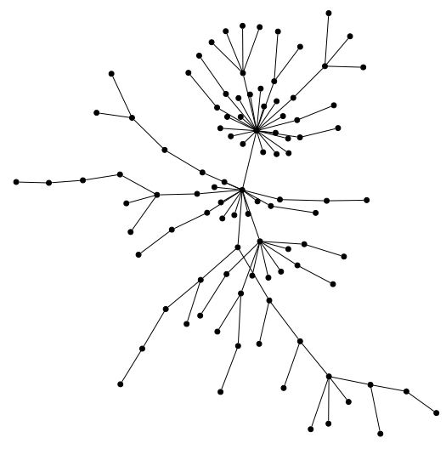
Figure 1. Illustration of a complex network

A network is a set of items, usually called vertices or nodes, connected through the so called edges. Systems taking the form of networks abound in the world. Examples include the Internet, the World Wide Web, social networks of acquaintance, organizational networks, neural networks, food distribution, transportation systems and a long etc. It is not a surprise that the Air Traffic system is suitable for a network representation as well. In its simpler form, the ComplexityCosts model is a network model for the Air Transportation system.

A set of vertices joined by edges is only the simplest type of network; there are many ways in which networks may be more complex than this. For instance, there may be more than one different type of vertex in a network, or more than one different type of edge. And vertices or edges may have a variety of properties, numerical or otherwise, associated with them. There are many potential network representations for the same physical system, all of them valid simultaneously. It is enough to consider nodes as representatives of different elements of the real system and edges to symbolize different relation between them. One way of coping with different representation of the same real system is by means of a multi-layered network. In a multi-layered network, nodes are categorized by their representation type and connected by what we call inner edges. Nodes from different layers are also connected by so called outer edges.
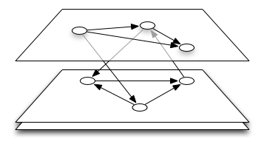
Figure 2. Example of a multi-layered Network

The ComplexityCosts model is a multi-layer network representation of the Air Transport system in which transportation dynamics takes place. Elements are represented by nodes and their relations by edges, categorized by layers. Further description of the layers, dynamics and nodes/edges definitions are to follow in this deliverable.

Mesoscopic models
When performing an analysis of transport systems, depending on the level of detail with which the dynamics of the vehicles is considered, three types of traffic flow studies can be distinguished: Microscopic models are those that consider the detailed dynamics of every individual vehicle, and are typically designed to deal with tactical issues; Macroscopic models do not consider the dynamic interaction of the vehicles in the traffic system, but global variables that describe the state of the system. These models are used primarily for strategic purposes (policy analysis, strategy development, cost-benefit evaluation...); Mesoscopic models constitute a third, intermediate, possibility. While more detailed than macroscopic ones, they are still rather strategic in nature. They can be defined as macroscopic models in which the global variables allow to obtain information on the dynamics of each vehicle in the system, e.g. models that define a function f(t, x, V) that expresses the probability of having a vehicle at time t in position x which runs with velocity V, which is then solved following methods of statistical mechanics.
In a mesoscopic model the elements of the analysed system do not need to be modelled with the same level of detail. Depending on the available information, the importance of the process or the computational power required to correctly simulate the process it may be more suitable to use a statistical approximation instead. Some other key elements, however, may require a deeper more detailed modelling, especially when there is enough information available or when the process is under study. This combination of fine and course simulation can only be possible in an appropriate computational framework, like using soft computing techniques.

Stochastic simulations and soft-computing
In many socio-technological systems it is usually the case that some information is missing, incomplete or strongly biased. In many cases data collection methods are not statistically sound or the data simply doesn’t exist or cannot be trusted. In other situations the system can be so complex and involving so many different actors that modelling each individual piece of the system does not warranty a sensible model for the whole system, in terms of performance and precision, in this case a mesoscopic modelling approach could be more convenient.
Also when information is partially unknown (hard) computational programs are no longer valid. A hard computational program is a piece of code that produces the same unambitious answer when given the same input. An alternative to hard-computing is the so call soft-computing techniques. Using this technique it is possible to give partial solutions to complex problems, even when they are deterministic. The ComplexityCosts model implements a soft-computing model based on multiple deterministic sub-models and random inputs running on a cloud-based infrastructure to make the simulation computational-wise feasible.
To cope with the previous challenges one has to introduce uncertainty on the models and so does the ComplexityCosts Network Model. Prior to the model construction an extensive analysis of data availability and validity is performed, revealing the strengths and weaknesses of the available data sets. When there is no data set available the only solution is to explicitly model the processes. These sub-models are deterministic in nature and produce the same output whenever initial conditions are the same. On the other hand if there is sufficient data a statistical model can be produced and the explicit simulation is replaced by a stochastic representation. Sampling from the random model produces a different output even when the initial conditions remain the same.
Repeatedly sampling from the stochastic models and plugging the outputs into the deterministic models produces an output sample of random nature, but distribution unknown. Then it is task of the integration to merge all the sample outputs and produce an approximation for the statistic of the output variable. Note that an exact solution for the distribution cannot always be achieved, and it is task of the output integrator to estimate the confidence of the output statistics.
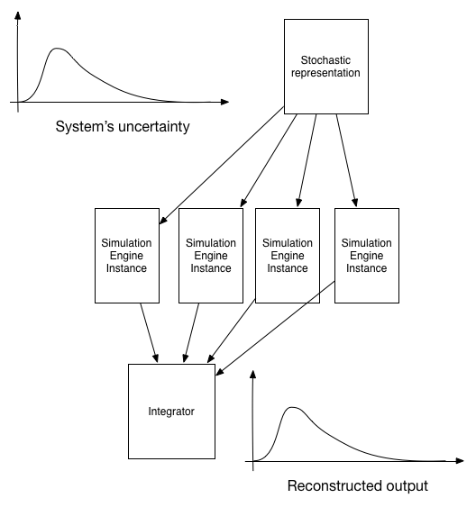
Figure 3. Single simulation, multiple runs

This approach stresses the model, because several runs of the deterministic model are needed to produce an stochastic output, as many as the integrator needs to ensure a minimum confidence level on the results. So a single simulation consists of hundreds or thousands of runs. However, the advantage here is that to properly reconstruct the output, the integrator needs each of those deterministic simulations to be statistically independent. The solution in ComplexityCosts is to launch a cloud-based infrastructure to run each deterministic sub-model, meanwhile the integrator processes the outputs as they are available until the desired confidence on the results is achieved.
This key-concept of using cloud-based infrastructure drastically reduces computation times required in soft-computing and it is a key element of the ComplexityCosts model.

Event-driven simulation
In contrast to continuous simulation, discrete-event simulation (DES) models the system by a discrete sequence of Events. Each Event on the sequence changes the estate of the system and no change is assumed between two consecutive Events. Each Event represents a process triggered in a particular time and potentially introducing new events during its execution. This generates a cascade effect on the number of Events controlling the flow of the model which differentiates it from the more traditional sequentially programmed models.
Consequence Events are any events introduced during a precursor Event. Hence, precursor Events are unique, while consequence Events can be multiple, this gives the program flow a tree structure. This tree structure is also ranked by the execution time of each Event and it is of great value for effect-cause analyses.
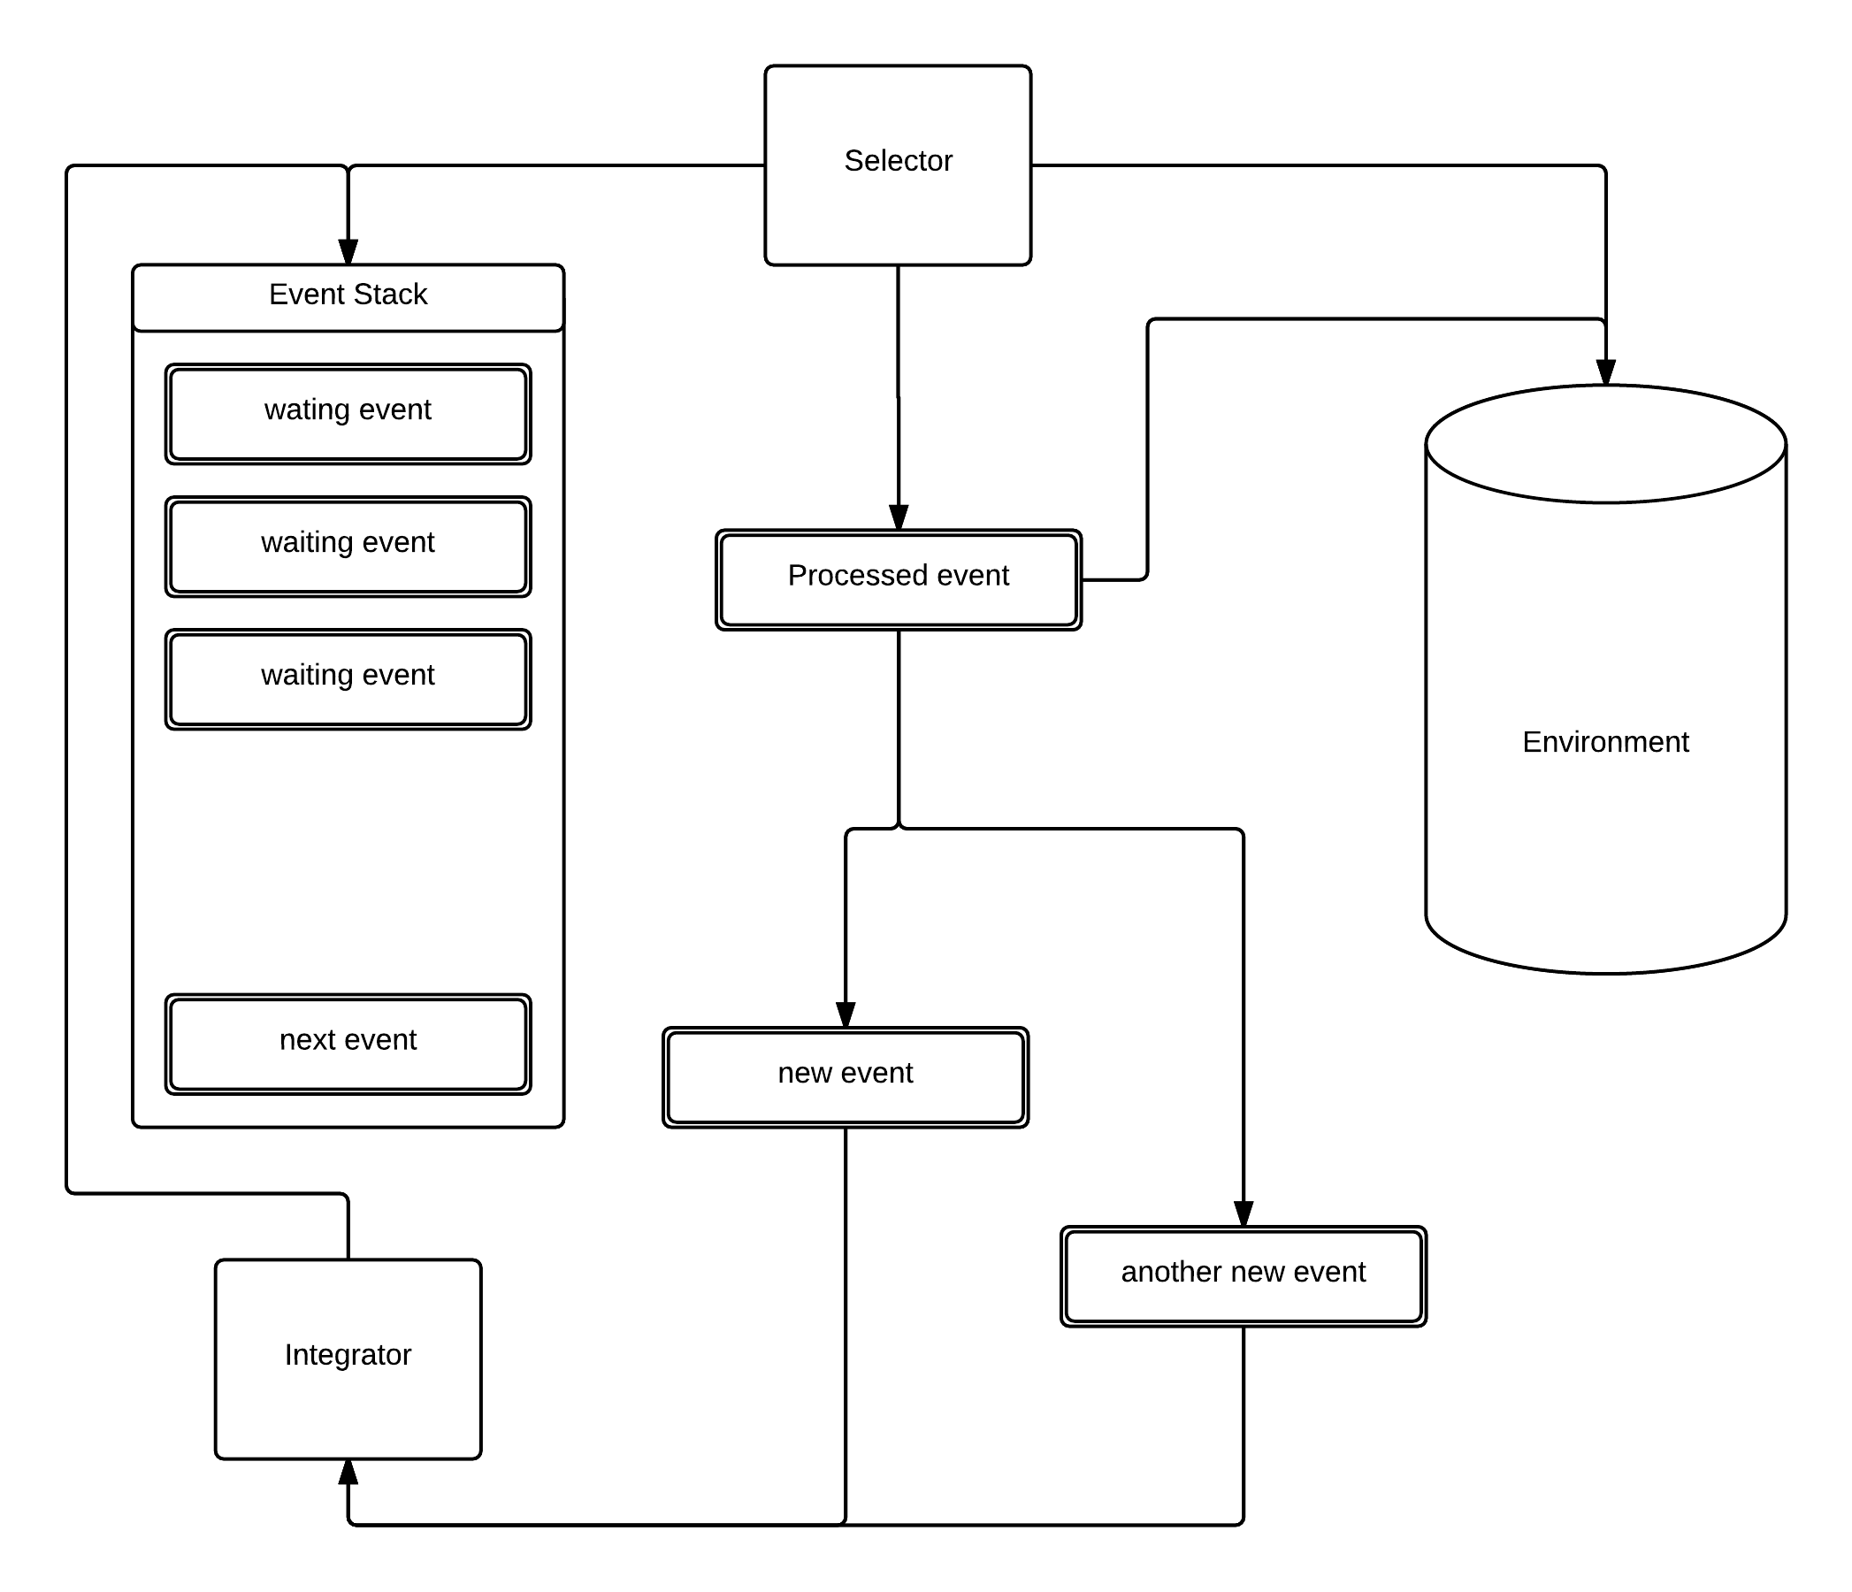
Figure 4. Event stack, Data Store and Environment interaction scheme
The state of the system is represented on the Environment. The Environment is a permanent memory register containing the system’s current status and information. All information exchanges must be made through the Environment. Therefore, Events are independent in the sense that they do not share information or functionalities between each other, Events are related only by the concepts of consequence and precursor. The Environment is composed of Actors. Each Actor belongs to a certain class of Actors and has a unique set of static parameters to differentiate it. The status of the system, however, is reflected in the Actor’s set of dynamic parameters. Events can modify Actor’s dynamic parameters, usually through an interface functions particular to each class of actor.

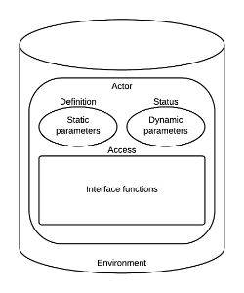
Figure 5. Environment and actors structure

Definition of layers
The ComplexityCosts model uses a multi-layer approach -elements of the modelled system are distributed into layers which operate similarly. Interaction between elements of a layer is modelled by a dynamic (random or deterministic) network -inner links. Layers are also interconnected by an influence model or outer links. The following table defines the layers used in the ComplexityCosts model, while the influence and dynamical models will be further elaborated in Section 4.1

Definition of parameters and indicators
Due to the stochastic nature of the ComplexityCosts model and its soft-computing implementation outputs of the model can only be of stochastic nature. This section describes the indicators produced by the model organized into different categories. Note that as random variables we can only hope to estimate statistics with a certain level of confidence after a sufficient large sampling via simulation runs. In some cases the full probability distribution function can be estimated but in general only statistics such as mean values, standard deviation, skewness, kurtosis, etc. can be obtained. For each of the indicators described below all statistics will be produced, when the confidence levels are met, so the actual number of model outputs can be from ten to thirty times the number of indicators described in this section.
Aircraft-centred metrics are classical metrics focused mainly on single-flight performance. They are useful on their own to compare with current literature and to determine non-passenger cost and trade-offs.

Table 1. Flight-centred metrics
Code | Name | Subcategory | Units | Description | Fully Supported | Comments
A.01 | Flight departure delay | delay | minutes | Actual - scheduled TOT
A.02 | Flight arrival delay | delay | minutes | Actual - scheduled AT
A.03 | Number of departure delayed flights | delay | flights | if delay > 5 min |  | Threshold may vary
A.04 | Departure delay of departure delayed flights | delay | minutes | delay > 5 min |  | Threshold may vary
A.05 | Number of arrival delayed flights | delay | flights | if delay > 5 min |  | Threshold may vary
A.06 | Arrival delay of arrival delayed flights | delay | minutes | delay > 5 min |  | Threshold may vary
A.07 | Turnaround buffer | buffer | minutes | Aircraft ready until boarding |  | Not planned but actual buffer
A.08 | Reactionary delay | delay | minutes | Caused by, e.g., late inbound aircraft or pax |  | Excludes additional turnaround delay
A.09 | Aircraft turnaround delay | delay | minutes | Late arrival until aircraft is ready |  | Only includes aircraft turnaround delay
A.10 | Loading/Boarding delay | delay | minutes | aircraft ready until ready to push-back ready |  | Incorporates delays caused by late connecting passengers
A.11 | At gate delay | delay | minutes | waiting time at gate
A.12 | ATFM on gate delay | delay | minutes | delay due to regulation | Either as input or output
A.13 | Departure queue | queue | flights | number of aircraft waiting to depart at runway
A.14 | Taxi-out | delay | minutes | from off-block until take-off |  | Deviation from the standard taxi time
A.15 | En-route (up to IAF) | delay | minutes | from take-off until IAF point is reached |  | Includes recovery (if any)
A.16 | Holding | delay | minutes | from expected landed since IAF reached until landed |  | Extra time from last expected landing time
A.17 | Taxi-in | delay | minutes | from landing to in-block time |  | Deviation from the standard taxi time
A.18 | Flight off-block difference | efficiency | minutes | scheduled off-block and actual off-block difference |  | total departure delay
A.19 | Flight in-block difference | efficiency | minutes | scheduled in-block and actual in-block difference |  | absolute arrival delay
A.20 | Load factors (in aircraft time weighted) | occupancy | minutes*passengers | number of passengers time expected route length in minutes
A.21 | Airport reactionary/primary delay ratio | efficiency | n/a | Reactionary delay (all causes) divided by departure delay (all causes)

Passenger-centred metrics, however, put passengers in the centre of the system. It has been shown (POEM) that some changes on the air transport system can only be determined by looking at passenger-centred metrics, because only those can capture features otherwise missed by more conventional flight-centred metrics. The following list contains the ComplexityCosts expected outputs from the passenger perspective.

Table 2. Passenger-centred metrics
Code | Name |  | Subcategory | Units | Description | Fully supported | Comments
B.01 | Passenger (final) arrival delay |  | delay | minutes | scheduled arrival versus actual arrival |  | Applies to last leg
B.02 | Passenger (initial) departure delay |  | delay | minutes | scheduled departure versus actual departure |  | Applies to first leg
B.03 | Accumulated passenger departure delay |  | delay | minutes | scheduled departure versus actual departure |  | Not a very clean metric, although frequently used in literature because it is easily related to flight delay
B.04 | Accumulated passenger arrival delay |  | delay | minutes | sum of arrival delay in each leg |  | Not a very clean metric, although frequently used in literature because it is easily related to flight delay
B.05 | Number of departure delayed passengers |  | delay | passengers | passengers affected by departure delay on their first leg only |  | for departure delay > 5 minutes
B.06 | Departure delay of departure delayed passengers |  | delay | minutes | severity of departure delay when delayed |  | for departure delay > 5 minutes
B.07 | Number of arrival delayed passengers |  | delay | passengers | passengers affected by arrival delay when reaching their final destination |  | for arrival delay > 5 minutes
B.08 | Arrival delay of arrival delayed passengers |  | delay | minutes | severity of arrival delay when delayed |  | for arrival delay > 5 minutes
B.09 | Passenger extra time before boarding |  | wait | minutes | from scheduled boarding to actual boarding time | Only when scheduled boarded time is specified
B.10 | Passenger arrival extra time/journey time ratio |  | journey length | minutes | delay on arrival divided by journey length |  | Time perception is different for passengers flight shorter journeys than those flying longer routes
B.11 | Passenger extra time on aircraft |  | journey length | minutes | extra time on aircraft |  | Added up for all flight leg taken
B.12 | Passenger extra time at airport or hotel |  | wait | minutes | counting from expected boarding time to actual boarding | Only when scheduled boarded time is specified
B.13 | Passenger missed connections |  | disruption | passengers | passenger original sequence of flights broken |  | Due to any reason, including cancellations. Only first connection missed is counted.
B.14 | Passenger forward re-accommodations |  | disruption | passengers | Successfully re-accommodated passengers
B.15 | Number of overnight |  | wait | passengers | when no possible re-accommodation was found
B.16 | Number of aborted journeys |  | disruption | journeys | when passengers decide to return (or stay) to their original departure airport |  | If departure delay > 5h passengers are given the option of abort trip.
B.17 | Number of extra flights taken | journey length | flights | passengers re-accommodated on longer than original routes. |  | Reaccommodation of a one-legged flight into a two-or-more-legged flight, and such.

Finally cost indicators reflect a different dimension from passenger or flight centred metrics, note that those metrics are here compiled just for section completeness, further explanation of cost models can be found in Section 4.4.

Table 3. Cost metrics
Code | Name | Subcategory | Units | Description | Fully supported | Comments
C.01 | Individual passenger soft costs | Indirect | Euros 2014 | Non-hard cost of delay on passengers |  | e.g. late rejection of flying with the same airline due to unpunctuality
C.02 | Individual passenger value of time | Indirect | Euros 2014 | Monetary value of delay for passengers
C.03 | Non-passenger related costs | Direct | Euros 2014 | All other cost related to aircraft operation
C.04 | Extra fuel cost | Direct | Euros 2014 | Fuel cost due to delays | Only simple estimations
C.05 | Extra gate time cost | Direct | Euros 2014 | Expenses incurred due to extra gate-time
C.06 | Extra taxi cost | Direct | Euros 2014 | Expenses incurred due to extra taxi-time | Only simple estimations
C.07 | Flight passenger hard costs | Direct | Euros 2014 | Direct cost of passenger delay |  | Re-accommodation tickets, compensation and care
C.08 | Direct flight costs | Direct | Euros 2014 | Addition of all non-passenger cost
C.09 | Direct flight cost per minute of delay | Direct | Euros 2014 | Direct flight cost divided between total arrival delay

Indicator representation
As a soft-computed simulator, the ComplexityCosts model can only produce partial or stochastic answers. In this sense the previously defined indicators cannot be given in a unique numerical form, but rather as one of two types of representation:
- Statistical inference, deducing properties of the underlying output distribution.
- Descriptive statistics, providing a quantitative analysis of the outputs.
For each of the previously defined indicator the following statistics will be inferred from the output sample:

Table 4. Statistics considered
Statistics | Output | Interpretation
Size |  | Size of the population or sample
Mean value |  | Centre of the distribution, not necessarily part of the population
Standard deviation |  | Basic measure for dispersion
Dispersion Index |  | Basic measure for dispersion range
Skewness |  | Measures asymmetry on the distribution
Kurtosis |  | Determined by the shape of the distribution
Extreme values |  | Minimum and maximum values
Low (1, 2, 3, 4 and 5) percentiles |  | Distribution of lower tail values
High (95, 96, 97, 98 and 99) percentiles |  | Distribution of high tail values
10th’s (10, 20, ...) percentiles |  | Histogram, rough distribution
Quartiles (incl. Median) |  | Rough uniform distribution
Interquartile range |  | Measure of dispersion
Absolute range |  | Complete range

Final mechanism selection

In ComplexityCosts, the benefits of implementing different mechanism will be analysed. This analysis will be defined in terms of resilience as defined in (Cook et al., 2014). The system performance metric considered in ComplexityCosts is the cost of the system due to delays/cancellations for flights and/or passengers (C_{u}(t) is the cost associated with a disrupted flight or passenger at time t). A disturbance (disruptive event) triggers system disruption which makes the system to enter a disrupted state, the performance is degraded (S_{d}). In response, resilience action is taken, which triggers system recovery, enabling the system to revert to a recovered state, S_{f} (which could be the same as, or different from, S₀).
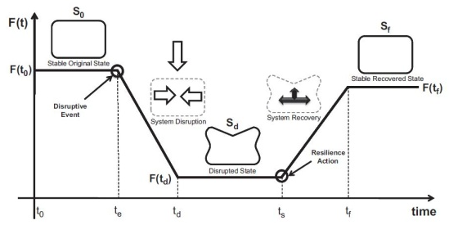
Figure 6. State diagram.
Source: adapted from (Henry and Ramirez-Marquez, 2012)

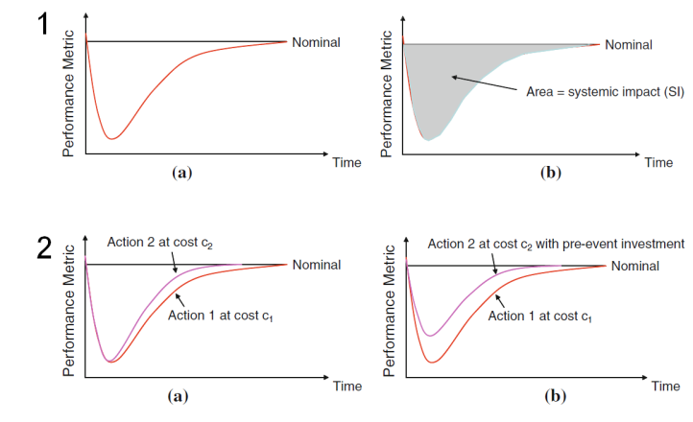
Figure 7. Resilience-enhancing investments.
Source: adapted from (Turnquist and Vugrin, 2013)

As presented in Figure 7, the total recovery effort (cost) represents the cumulative resources used in a given recovery. Varying strategies for recovery may affect the systemic impact and require different levels of recovery effort – see panel 2(a). Investment mechanisms implemented strategically would result in a reduction of the tactical magnitude of the disruption from a given disturbance, in addition to speeding up the system recovery – see panel 2(b). These expenditures are defined (Turnquist and Vugrin, 2013) as “resilience-enhancing investments”. Accurate effect of the mechanisms, in terms of how the performance of the system is modified, is required to model the variation of the performance metrics in the system when the mechanism is in place. Mechanisms are designed to afford resilience and/or robustness for one or more stakeholders during disruption.
Two types of mechanisms are considered:
- Nominal investment mechanisms increase the performance of the system during nominal situations, this improvement will reduce the impact of a given disruption but the mechanism is not developed to tackle particularly a given disruption type.
- Mitigation investment mechanisms can improve the system during nominal operations but also have a strong alignment with different disruptions, adding resilience to the system in disruptive situations.

As shown in Equation 1, we have previously defined a formulation for measuring the cost resilience of an investment mechanism with respect to the cost of the disturbance without such a mechanism. This comprises a component $\left(C_{u}\left(t\right)\right)$ expressing the cost of the disruption for flights and/or passengers in the absence of (a) mechanism(s), and a component $\left(C_{u}^{m}\left(t\right)\right)$ in the presence of (a) mechanism(s). $C_{m}\left(t\right)$ is the tactical cost associated with running the investment mechanism.

Equation 1. Cost resilience expression
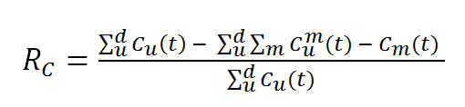

Source: Adapted from Cook et al. (2014).

Precise cost for the mechanisms are required at a strategic (investment) and tactical phase (operational) (C_{m}(t)), in order to be able to assess the cost resilience of a given mechanism and compare the efficiency of different mechanisms. If a given mechanism does not improve the system performance when a particular disturbance is present, there will be no improvement on the system and the resilience would be negative. Therefore, an alignment between mechanism and disturbances will allow us to identify which scenarios are interesting to analyse, and define which mechanism can be compared when a given disturbance affects the system.
In this section the alignment of the mechanism with their costs and disturbance types are presented. The different characteristics of the mechanism are also analysed as in ComplexityCosts a priority will be given to mechanisms with different characteristics. An important factor when selecting and modelling the mechanism is the stakeholders uptake. The mechanism will not be implemented homogeneously through the network and among all the stakeholders. A realistic stakeholder uptake is required to obtain meaningful results.

Alignment with mechanism costs and disturbance types
We require mechanism with different characteristics, from which an adequate level of costs at strategic and tactical level can be modelled. The mechanism should be aligned with the different disturbances that will be modelled to be able to compare the resilience improvement of the different mechanisms.
In order to identify the mechanism investment cost and functionalities, the pilot common project (PCP), defined in (SESAR, 2013) and approved in (European Commission, 2014f), has been considered. The PCP establishes different ATM functionalities (AF) with some sub-functionalities:
- AF 1: Extended AMAN and PBN in high density TMAs.
- AF 2: Airport integration and throughput functionalities.
- AF 3: Flexible airspace management and free route.
- AF 4: Network collaborative management (flow & NOP)
- AF 5: iSWIM: Ground-ground integration and aeronautical data management and sharing.
- AF 6: Initial Trajectory Information Sharing: air-ground integration towards i4D with enhanced Flight Data Processing performances.
This allows us to estimate the cost of implementing some of the mechanism defined for ComplexityCosts.

Cost alignment

Cost references per mechanism
(a) MEC.001 - Airport CDM
There are different studies of cost benefit analysis for airport CDM (EUROCONTROL, 2008; Deutsche Flugsicherung, 2010; Deutsche Flugsicherung, 2013). EUROCONTROL (2008), assumes a generic airport in 2006 with 280,000 yearly movements with an annual traffic growth of 4%. The estimation of the introduction of A-CDM is EUR 10.86 M spread over 10 years with operating costs of 7.03 M EUR spread over 10 years. Costs are disaggregated by partner (i.e., airport, ground handlers and airlines). Some companies develop systems that could be used to implement A-CDM. The overview of the implementation of A-CDM could be useful for the analysis of the uptake of the stakeholders (EUROCONTROL, 2009). EUROCONTROL (2015c) is the main reference for A-CDM implementation in Europe.
European projects such as TEN-T projects can be used to estimate expenses airports are doing to implement A-CDM in Europe (European Commission, 2014b).

(b) MEC.002 - AMAN / MEC.003 - AMAN/SMAN/ DMAN integration
Extended AMAN and PBN in high density TMAs (AF 1) is expected to have an investment of EUR ~0.2 bn. This reference can be used to estimate a cost per stakeholder and functionality involved. Airport integration and throughput functionalities (AF 2) could also be considered as part of an enhanced AMAN system. The cost of an full system implementation should be consulted with adequate industry (e.g. (Thales, 2013)).

(c) MEC.004 - ASPA capabilities
Some analysis has been found in the literature presenting the savings and cost of operating an ASPA capable system (Clari, 2000). Industry that provides systems that should be implemented to develop the ASPA capabilities have been identified but detailed cost not obtained (ACSS, 2008; GARMIN, 2015).

(d) MEC.005 - Complexity management (slot assignment based on sector complexity)
AF5, Initial system-wide information management, from the PCP, is a functionality that is required but not sufficient to implement MEC.005 (SESAR, 2013). Therefore no costs for implementing the mechanism have been found.

(e) MEC.006 - En-route capacity planning tools
Information regarding to investments in ACC centres are available. But it is difficult to establish the part of the investment devoted to en-route capacity management tools and to other general improvements. It might be possible to obtain this detailed breakdown from the ANSPs (European Commission, 2014c). Tobaruela et al. (2013) presents ideas to measure the capacity required and adjust the ATC capacity to the demand.

(f) MEC.007 - Enhanced DCB (demand and capacity balancing tools)
From PCP, AF 4, Network Collaborative Management, includes enhanced short term ATFCM measures among other activities. The full implementation of AF 4 is estimated in EUR 0.4 bn with investments divided between ANSPs (75%), the network manager (13%) and airports operators (12%) (SESAR, 2013). AF 6, Initial trajectory information sharing: air-ground integration towards i4D with enhanced flight data processing performances, will set the first steps towards 4D and controlled times of arrivals which will represent improved DCB tools (SESAR, 2013).

(g) MEC.008 - Improved flight planning and demand data
In order to improve the flight planning and demand data some performances from AF 5, iSWIM: ground-ground integration and aeronautical data management and sharing, and from AF6, initial trajectory and information sharing, will be required. In (SESAR, 2013) an estimation of the total investment to develop the functionality and the breakdown by stakeholder can be found.
In particular for the MEC.008, the following sub-systems are needed:
- Flow management & FPL (deployment 2016-2024): 8% of total investment.
- Aeronautical & Airspace (deployment 2016-2024): 22%
- Meteo (deployment 2016-2024): 39% of total investment
- SWIM Infrastructure & Administration (deployment 2016-2024): 2% of total investment.
- Flight object (deployment 2018-2024): 28%
Some projects have already introduced some of the functionalities required in some regions of Europe, e.g., data-link equipment (European Commission, 2013f; European Commission, 2014d; European Commission, 2014e)

(h) MEC.09 - Investment in new runways
The cost of investment in new runways can be obtained in the airport annual reports. Different airports around Europe have recently being involved in works to expand their capabilities (e.g., Fraport 2009-2014; Airports Commission, 2013; Heathrow Airport, 2014).
There is a high variability on costs when developing new infrastructures. These costs are highly location dependent.

(i) MEC.010 - Dynamic sectorisation and constraint management
Although extensive search no tangible information has been found for this mechanism. The implementation of an initial ASM tool is defined as the activity S.3.1.1 in the PCP. The cost for the whole AF 3, Flexible Airspace Management and Free Route, is EUR 0.7 b, but there is not a division by sub-activities (SESAR Deployment Alliance, 2014). (EUROCONTROL, 2013d) shows the principles to assess the capacity required and the planning of sectorisation for a given ACC.

(j) MEC.011 Time-based separation
A cost benefit analysis of TBFM for the FAA show results of positive return of investment of $480M (Flatirons Solutions, 2014). The budget allocated in 2011 by the FAA for the TBFM project supports the activities of replacement of existing traffic manager advisors hardware, re-architecture of the current system and expansion of the TMAs to additional sites that can benefit from time based metering operations (Bradford, 2012).

The FAA publishes information regarding to the costs of implementing the TBFM systems. For example, for the deployment phase, for the period 2008 to 2015, the project cost is $106.4 M; technology update are planned for the 2014 to 2022 period with an investment of $34.5 M (Federal Aviation Administration, 2014). In the period 2012-2016 the investment is $66.2 M and $29.3 M for the 2013-2017 period (Federal Aviation Administration, 2011; Federal Aviation Administration, 2012). Lockheed Martin acquired a contract from the FAA to implement TBFM for 5 years in 2010 with a total value of $202 M over 10 years (Lockheed Martin, 2010; ITDashboard, 2014). These values for the FAA are detailed at a year level.

In Europe the sub ATM functionality 2.3 (S-AF2.3) defined in the PCP is time-based separation for final approach. The budget allocated for the whole AF2 functionality (airport integration and throughput) is EUR 131.5 M (SESAR Deployment Alliance, 2014).

(k) MEC.012 - Runway occupancy time management
Some investment in infrastructure is possible to improve the occupancy time at the runway. For example, AF 2 from the PCP, airport integration and throughput functionalities, includes RWSL and airport safety net that could help to improve the throughput (SESAR, 2013).
Improvements can be done to the infrastructure to facilitate the exit of the runway; for example, a new taxiway with access to the runways constructed at Malta airport (European Commission, 2011d).
Another technology that can be used to improve the occupancy time and reduce the separation at arrival is systems to detect the vortices from leading aircraft. Wake vortices are one of the most constraining factors for runway throughput in major airports. LIDAR can be used for this purpose (Matayoshi, 2013; Morris et al., 2013; Lockheed Martin, 2013; Leosphere, 2013; Leosphere, 2014). The costs of these systems are however not directly available.
Other possibilities include new procedures to establish the runway exit strategy that will minimise occupancy time. New information about preferred exit taxiways has been included to assist pilots determine the most suitable exit based on the landing weight of the aircraft and prevailing conditions (Airservices Australia, 2012a; Airservices Australia, 2012b). The cost of implementing these new procedures is difficult to quantify.
Finally, it is possible to improve the braking system with technology such as Enhanced Braking Systems (automatic braking systems) to smoothly decelerate the aircraft to a predetermined point on a runway in preparation for exiting. Lower and more consistent ROT will be possible with greater certainty that the pre-determined exit will be used (Eriksen, 2012).

(l) MEC.013 - En-route slot trading
No tangible information has been found about costs for en-route slot trading.

(m) MEC.014 - Dynamic cost indexing
The cost references found are systems that could be used to implement DCI (e.g. electronic flight bags) but costs should be obtained by contacts within the industry (Boeing, 2003; Esterline, 2014; Navtech, 2014; NavAero ,2013a, 2013b; UTC Aerospace Systems, 2014a, 2014b).

(n) MEC.015 - Airlines investing in more fuel-efficient aircraft
The investment of airlines in new aircraft can be modelled based on the annual reports. Airlines have an important focus on modernising their fleets to reduce the environmental impact of aviation and therefore on fuel consumption and carbon taxes. Lufthansa, for example, has a fleet of an average age of 11.2 years and fuel efficiency has been achieved by replacing old B747-400 for the new B747-8i aircraft (Lufthansa, 2013a). Lufthansa developed burnFAIR project to minimise fuel consumption and improve environment impact in 2011. It involved an A321 operating with one engine half-fuelled with bio-synthetic kerosene for around six months between Hamburg and Frankfurt (Lufthansa, 2012). Aircraft ordered in 2013, to improve its environmental impact even further in the years ahead (Lufthansa, 2014).
IAG is modernising its fleet with new A380s and B787 Dreamliner. The introduction of these new aircraft is expected to deliver £150 million per annum of cost savings due to improved fuel efficiency by 2015 (IAG, 2014). In 2013 IAG introduced several new fuel efficient aircraft types, with the Boeing 787, Airbus A330 and Airbus A380 (IAG, 2014).
It is difficult to isolate specific full costs for this mechanism as it is difficult to define the driver for the investment in new aircraft (e.g., more fuel efficient aircraft, or need of new routes).

(o) MEC.016 Airlines investing in infrastructure in collaboration with airport
Airlines investing on infrastructures is more common in the North American market, e.g., investment of airlines in Washington airport (Flightglobal, 2014b), development of a terminal in Los Angeles with investment of airlines (Flightglobal, 2014c) or investment of Qantas in new terminal development in Los Angeles (The Sydney Morning Herald, 2014).
In Europe, this types of investments are not as common but there are examples such as Lufthansa investing in the Terminal 2 in Munich where the construction cost (EUR 650 M) was shared on a 60:40 basis between Munich airport and Lufthansa (Lufthansa, 2013a; Lufthansa, 2013b; Munich Airport, 2012).
Similar to MEC.09 Investment in new runways, there is a high variability as a function of infrastructure developed and its location.

(p) MEC.017 Airlines investing in ground handling services to improve turnaround processes
The cost of airlines in handling can be found on the airlines annual reports. Some airlines integrate the handling process in their infrastructure while others attempt to control airport access and service charges by focusing on airports that offer competitive prices. This latter is the strategy of Ryanair to negotiate favourable contracts. The strategy is to reduce handling costs by for example minimising bags carried by passengers or boarding pass process (Ryanair, 2013). In some airports where the movements are significant the airline provides its own handling service, for example at Dublin airport (Ryanair, 2013). In 2013 the airport and handling charges reported by Ryanair were 7.71 EUR per passenger. Airport and handling charges represented 611.6 M EUR in that year (Ryanair, 2013).
The handling services have a significant cost in the airlines that integrate it in their services. At the end of 2012, Iberia had a total of EUR 455 M on handling equipment (Deloitte, 2013). This equipment is estimated to have a useful life between 3 and 10 years (Deloitte, 2014). At the end of 2013, Vueling had an opening balance on handling equipment of 216 K EUR. The total ground handling service of Vueling in 2013 was EUR 135,492 K; in 2012 it was EUR 122,190 K (Deloitte, 2014).
The total handling charges, catering and other operating costs of the IAG group represented M 1,932 EUR (IAG, 2014).
Thretheway and Markhvida (2013) present the position of airports and their services in the aviation value chain.
It is difficult to define what is driven the ground handling investment. It is possible to get how much they invest on their own handling companies but difficult to establish the benefits.

(q) MEC.018 Merger of airlines
There are several examples of merges of airlines in the recent years. For example, LTU Group was acquired by Air Berlin in 2007, the same year Air Berlin acquired 49% of the shares of Belair Airlines AG (Air Berlin, 2007-2012). British Airways (IAG) acquired control of Vueling Airlines for EUR123.5 M increasing their share from 45.85% to 90.51% of Vueling (Bloomberg, 2013).
These are examples and it is difficult to stablish a trend to model this mechanism.

(r) MEC.019 - Changes to airline passenger re-accommodation policies
In order to operate an efficient system for re-accommodate passengers in flights, informatics systems need to be implemented such as Altéa Suite or IROPS developed by Amadeus and Sabre respectively (Amadeus, 2014; Sabre, 2011).

(s) MEC.020 - Airlines adding more buffer to schedule
In Section 4 the strategic and tactical cost of the delay are analysed.

(t) MEC.021 - Increasing ATCO hours in selected sectors

It is possible to obtain estimates of the cost of ATCO at different ANSPs, for example (NATS, 2015). However, the ATM Cost-Effectiveness (ACE) benchmarking reports are good sources of information at an European level.
In 2010 the ATCOs in operation had a cost of EUR 16,871 M, this value increased to EUR 17,208 M in 2011. In Europe, in general there is a need of 2.4 additional staff for every ATCO. The unit that is used to measure the delivery of the ATCOs is composite flight-hours (en-route flight hours + 0.27 * IFR movements) (EUROCONTROL, 2013a). Figure 8 presents the cost per composite flight-hour. As can be observed in Figure 9, the cost has a high variability per ANSP.
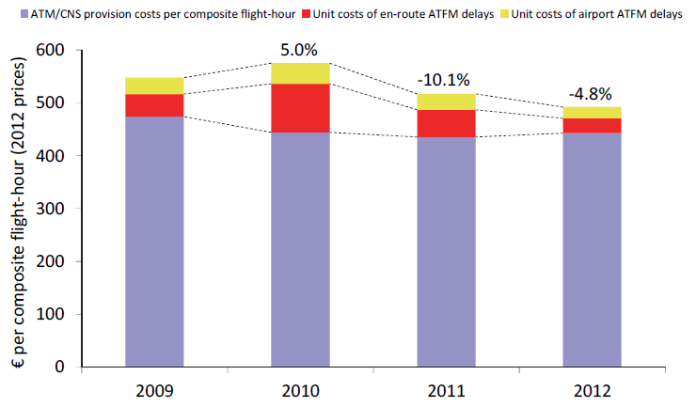
Figure 8. Cost per composite flight-hour
Source: (EUROCONTROL, 2014e)

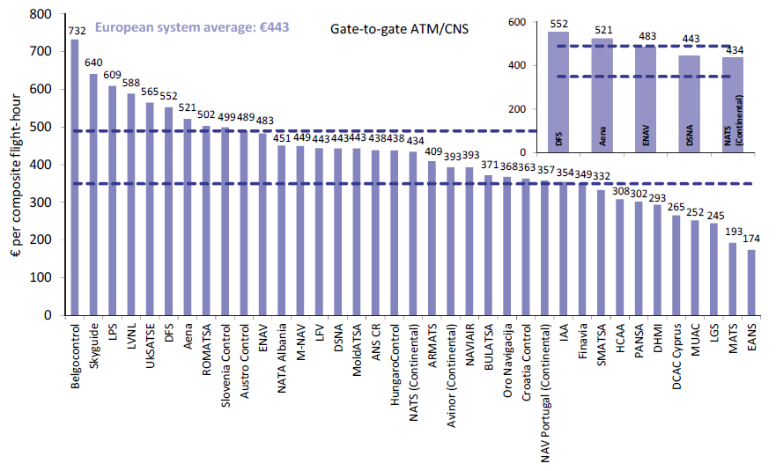
Figure 9. Cost per composite flight-hour per ANSP
Source: (EUROCONTROL, 2014e)

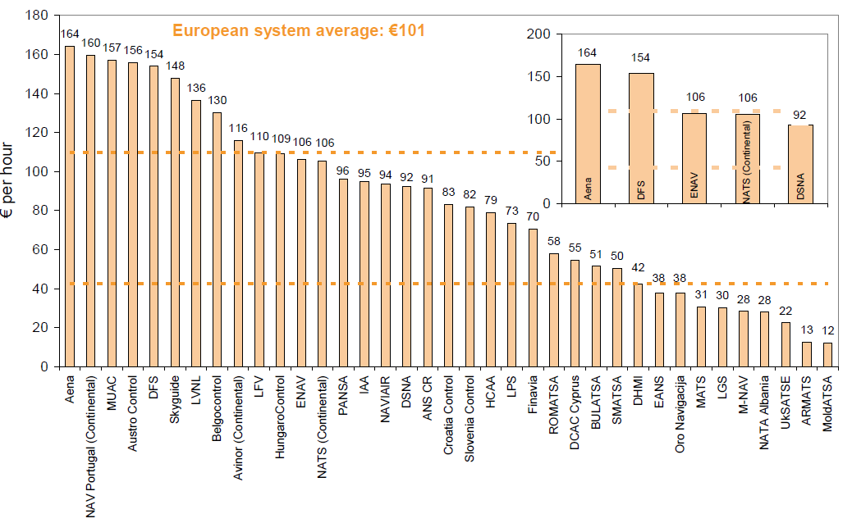
Figure 10. Cost per hour of ATCO on duty
Source: (EUROCONTROL, 2013a)

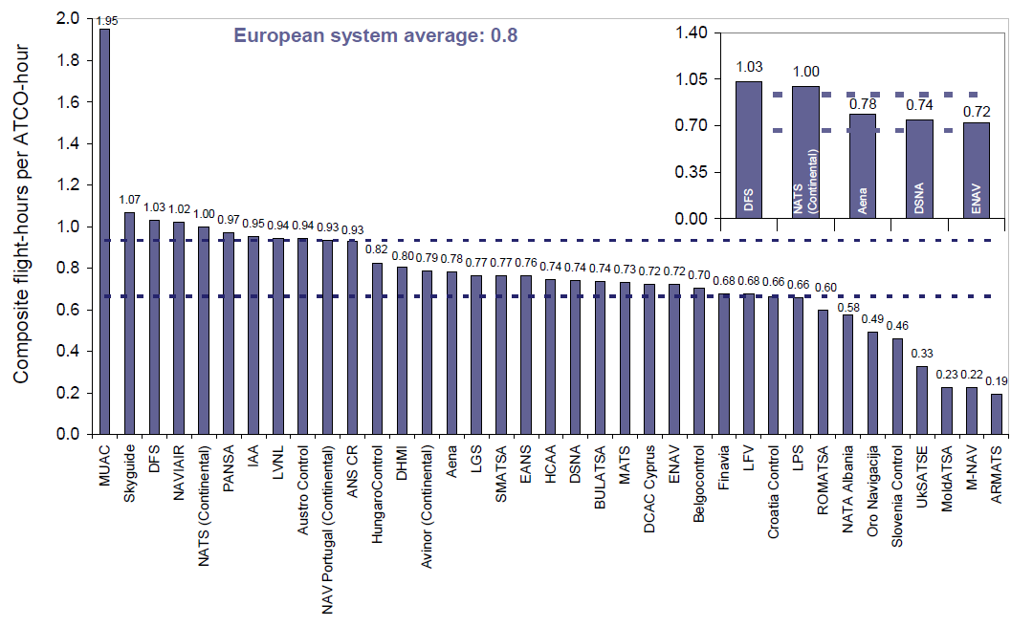
Figure 11. Composite flight-hours per ATCO-hour
Source: (EUROCONTROL, 2013a)

Figure 9 shows the cost per hour of ATCO on duty and Figure 11 the composite flight-hours per ATCO-hour. It would be possible to estimate the cost of extra ATCO in selected ACCs and how the demand that could be handled would increase. However, one has to be careful not to add staff on areas that are already being used at their maximum capacity. If an ACC do not have staff problems, adding ATCOs would only decrease the efficiency of the ACC but will not produce additional throughput of traffic. Only regions that have regulations due to staffing problems would benefit from this mechanism. These regions can be identified analysing the regulations imposed where the primary cause is ATC staff from the database of DDR2.
(EUROCONTROL, 2013d) presents the process and the trade-off involved when the capacity is provided at a given ACC. The document describes the European Network Management capacity planning process that supports local and network ATC capacity planning for en-route airspace and identifies the tools and methodologies used.

Mechanisms characteristics consolidation
Table 5 consolidates the main characteristics of the mechanisms from the previous deliverables into a single source adding a summary of the cost sources. The mechanism are ordered from a cost sources point of view and coded as:
- Green: Mechanisms that were selected in D1.3 and after the analysis of the sources their costs could be modelled.
- Yellow: Mechanisms that were not selected in D1.3, but where it might be possible to obtain costs to model them.
- Grey: Mechanisms that were selected in D1.3 as potential mechanism for ComplexityCosts, but for which obtaining costs would be difficult or not possible.
- Red: Mechanisms that were not selected in D1.3 and for which obtaining costs would be difficult or not possible.
Note that all the green and yellow mechanisms do not have the same degree of cost available.

Table 5.Mechanism main characteristics and cost availability
ID | Description | (A)dv. /(B)asic¹ | (S)ingle / (P)ackage | Flight phase | Type (T)echnol. (P)roced. (R)egul. | Modelling potential | Stakeholder | Poss. diff. stakehold. | Costs
MEC.020 | Airlines adding more buffer to schedule | B | S | Gate / Route | P | Marcro-level | Airline |  | Deliverable 1.2.
MEC.021 | Increasing ATCO hours in selected sectors | B | S | Gate/ Route | P | Micro-level | ANSP |  | Deliverable 1.2 and ACE reports.
MEC.019 | Changes to airline passenger reaccommodation policies | B | S | Gate | P, R | Macro-level, ABM | Airline |  | Systems needed identified. It might require to interact with uses to get costs.
MEC.014 | Dynamic cost indexing | A | S | Route | P | ABM | ANSP |  | Systems needed identified. It might require to interact with uses to get costs.
MEC.001 | Airport CDM | A | P | Gate | T, P | ABM | Airport |  | Information available from Eurocontrol documentation. Cost benefit analysis available. It might be difficult to model the benefit of the mechanism.
MEC.009 | Investment in new runways | B | S | Gate | T | Macro or micro level | Airport |  | Information available for different airports; but there is a high variability depending on the location. It is possible to estimate costs for individual airports.
MEC.011 | Time-based separation | A | S | Route | T | Not at macro-scale | ANSP |  | From the PCP, S-AF 2.3. where TBS is used for final approach. This is related with S-AF2.5.1. Investments available up to 2016. The costs of the implementation (investments) of TBFM by the FAA are available for 2012-2017 plans.
MEC.002 | AMAN | A | S | Route | T | Macro-level | Airport |  | From PCP, AF1 is the main source. The information of the cost of commercial systems is not directly available. The cost for AF1 can be estimated but they include other costs not only for AMAN.
MEC.003 | AMAN/SMAN/ DMAN integration | A | S | Gate/ Route | T | Micro-level | Airport |  | From PCP, AF2, S-AF2.1 and S-AF2.2. Same as with MEC.002, it might be difficult divide this two mechanisms in term of costs.
MEC.016 | Airlines investing in infrastructure in collaboration with airport | A | P | Gate | T, P | ABM | Airline |  | There are not many examples in Europe, it is more easily available in other markets (e.g. US). As with MEC.009, there is a high variability depending on infrastructure.
MEC.008 | Improved flight planning and demand data | A | S | Gate | T | Difficult to model realistically. | ANSP |  | From PCP, AF6 which include trajectory sharing, we could consider also the need of data-link to implement this, some data available (e.g. costs for Hungary).
MEC.007 | Enhanced DCB (demand and capacity balancing tools) | A | S | Multiple | T | Macro-level | ANSP |  | From PCP, AF4 costs estimated only up to 2016.
MEC.004 | ASPA capabilities | A | P | Route | T, P | Micro level | ANSP |  | The system needed to implement ASPA have been identified but costs are not directly available
MEC.005 | Complexity management (slot assignment based on sector complexity) | A | P | Route | T, P | Macro-level | Airport |  | Information sharing required for this mechanism, therefore SWIM is required (AF5). But the whole cost of SWIM should not be assigned to this mechanism.
MEC.006 | En-route capacity planning tools | A | S | Route | T | Macro-level | ANSP |  | Information not available. Difficult to divide investments in ACC between systems.
MEC.010 | Dynamic sectorisation and constraint management | A | S | Route | T | Micro-level | ANSP |  | From PCP, AF3, S-AF3.1.1. could be considered as they include ASM tools with FUA. The cost is only at aggregate level for the whole AF3.
MEC.012 | Runway occupancy time management | A | S | Gate | T, P | Micro-level | Airport |  | Some data cost for improving taxiways are available. However, the cost of the technology needed (e.g. wake turbulence sensors) is not directly available. The cost of applying new procedures not clear.
MEC.013 | En-route slot trading | A | S | Gate | T, P |  | N/A |  | No tangible information available.
MEC.015 | Airlines investing in more fuel-efficient aircraft | A | S | Multiple | T | Fuel consumption model | Airline |  | Difficult to distinguish the reason for the costs that have been incurred when buying new aircraft.
MEC.017 | Airlines investing in ground handling services to improve turnaround processes | B | S | Gate | P | ABM | Airline |  | It is possible to find costs of airlines in handling as a whole from their year financial reports. However, it is difficult to establish costs for higher investment and benefits in terms of turnaround process.
MEC.018 | Merger of airlines | B | S | Multiple | P | Macro-level | Airline |  | It is difficult to isolate specific full costs.
¹Advanced mechanism are SESAR essential operational changes and sub-components thereof (or equivalent advanced or supporting technologies/tools). Basic mechanism are non-advanced, does not centrally involve implementing new technologies/tools.

Only the first twelve mechanisms are further analysed (MEC.020, MEC.021, MEC.019, MEC.014, MEC.001, MEC.009, MEC.011, MEC.002, MEC.003, MEC.016, MEC.008 and MEC.007), as those are the ones from which costs can be obtained, note that not at the same level of detail.
The diagram presented in Figure 12 shows where the different mechanisms for which cost can be modelled are located with respect to the parameters of type (procedure, technical and regulation) and advance and basic mechanism.

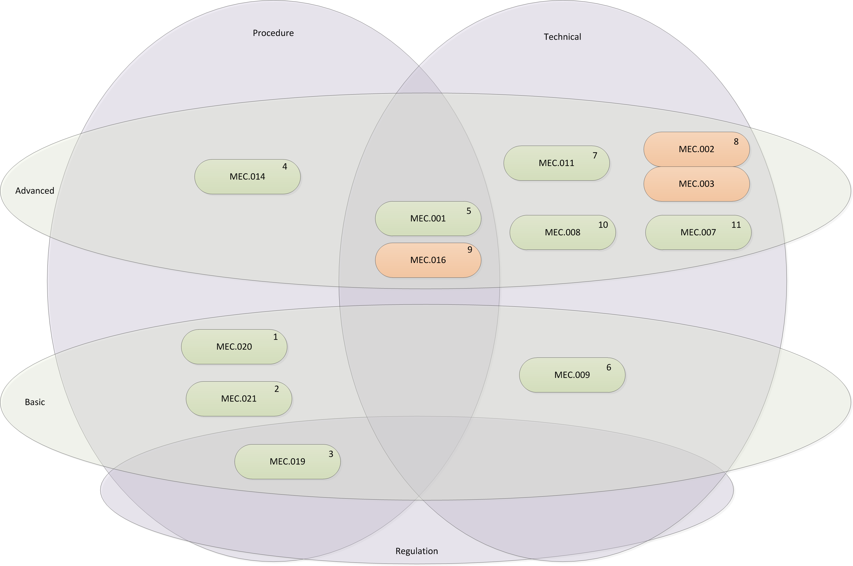
Figure 12. Characteristics of mechanism from which cost can be modelled.

Disturbances types alignment
The mechanism can be nominal investment mechanism which are primarily aimed at improving the nominal (according to plan) functioning of the system and/or mitigation investment mechanism that are aimed at mitigating the impacts of disturbances. In Table 6, the different mechanisms are aligned with the different disturbances that could be considered in ComplexityCosts. As it can be seen, some Mechanism are primarily aimed to mitigate a given type of disturbance even if they might help in other situations. For example, MEC.020, Airlines adding more buffer to schedule, would help to adsorb delay when an aircraft has a technical problem, but it would also help to reduce the propagation of any type of delay. Therefore, any disturbance that results in delay would benefit from this mechanism. While other mechanism, such as MEC.021, Increasing ATCO hours in selected sectors, would only benefit a particular type of disruption, ATFM restrictions (non-weather) in this case, where a lack of capacity could be solved with more staff.

Table 6.Disturbances alignment
Id | Description | Meteorological events |  |  | Strike actions |  |  | Technical failure |  |  | ATFM restriction (non-weather) | Passenger disruption |  |  | Military exercises
 |  | Local effect at airport | En-route effect | Widespread effect | ATC | Airline | Airport Services | Aircraft | ATC/ATM systems | Airport |  | Late check-in | Missed connections |  | Limits CDR routes | TSA with capacity drop
MEC.020 | Airlines adding more buffer to schedule
MEC.021 | Increasing ATCO hours in selected sectors
MEC.019 | Changes to airline passenger re-accommodation policies
MEC.014 | Dynamic cost indexing
MEC.001 | Airport CDM
MEC.009 | Investment in new runways
MEC.011 | Time-based separation
MEC.002 | AMAN
MEC.003 | AMAN/SMAN/DMAN integration
MEC.016 | Airlines investing in infrastructure in collaboration with airport
MEC.008 | Improved flight planning and demand data
MEC.007 | Enhanced DCB tools
disturbance will benefit primarily from the mechanism.
disturbance will benefit secondarily from the mechanism.

Mechanism characteristics summary
Table 7 contains a summary of the main characteristics for the mechanism where cost could be modelled. Information regarding to how the mechanism would be modelled in ComplexityCosts and how it align with resilience has been added.

Table 7.Summary of the characteristics of the mechanism
Id | Description | Disturbance type | Possibility model mechanism | Possibility model cost of the mechanism | Possibility model benefit of the mechanism | How does the mechanism aligns with resilience? | Stakeholder investment | Airlines types benefit
MEC.020 | Airlines adding more buffer to schedule | Any disturbance that generates delays would benefit from higher buffers to minimise the propagation of delay. | The modelling will be done by modifying the initial flight plans adding buffer between flights at their turnaround at the airport. This means that their departure time will be delayed on their initial schedule adding this extra-buffer for rotations.  Different algorithms can be considered in this modification of the flight plan departure times. For example, the additional buffer should consider the time of the day (early flights will require higher buffers to minimise the propagation of reactionary delays during the day) and/or the number of passengers that are connecting to a given flight (e.g. add more buffer to flights that will have high amount of passengers connecting to them). | Possibility to model based on costs from D1.2, Sections 4 and 5. This mechanism will imply an strategic cost for the airlines. The other stakeholders should not be affected in cost by the use of this mechanism. | The total amount of delay experience by passengers can be computed and monetised for the airlines based on passenger compensation costs. | The mechanism by itself will reduce the number of missed connections and the total amount of passengers delay for both nominal operations and in case of disturbance. This benefit can be analysed with local disturbances (e.g. a storm at a given airport) and with global impacts (e.g. ash cloud or ATC strike).  The resilience computation will be also different based on the airline type (carrier operating in a hub with high number of connections (benefit on passengers delay and on connections) versus point-to-point carrier (benefit only on passenger delay)) and the type of airport affected (hub or spoke). These particularities should be considered when defining the different scenarios where the mechanism will be tested. | Airlines | All of them, but mainly airlines operating a hub&spoke system.
MEC.021 | Increasing ATCO hours in selected sectors | ATFM restrictions due to staff problems. | In order to model this mechanism the airspace structure should be considered. Then an analysis can be carried to identify which areas of the airspace are adding delay in the system due to a lack of capacity (ATFM restrictions due to staff problems or, in some cases, lack of capacity due to use segregated airspace for military activities). This analysis of DDR2 regulations is required to identify in which areas the mechanism will provide a benefit.  The ATFM regulation should be modelled to assign delay to flights before and after the mechanism is in place. The mechanism could be modelled as an increment on airspace capacity that will lead to a lower amount of delay assigned to flights with the regulation.  From (EUROCONTROL, 2013a and EUROCONTROL, 2014e) values of composite flight-hours that are provided by ATCO hour can be obtained. These values could be used to model, at an aggregate level, an increment on airspace capacity based on an increment on ATCO hours. However, note that this is a very rough approximation. The values of ATCO efficiency from (EUROCONTROL, 2013a and EUROCONTROL, 2014e) are based on the realised data. If the ATCO is increased the efficiency might not increase linearly (e.g. airspace complexity might prevent the capacity to be increased even if the ATCO hours are increased). The efficiency (composite flight-hours with respect to ATCO hours) usually might be driven by the complexity of the airspace and in some cases by over-staffing (leading to low values of efficiency).  As stated in (EUROCONTROL, 2014e), “ATC capacity and staffing related delays [...] remain by far the main driver of en-route ATFM delays.”. However, the data is not disaggregated between capacity problems due to airspace complexity and lack of staff resources. In 2013 the most constraining ACCs were Nicosia, Warsaw, Barcelona and Canarias. 58% of the delays allocated in the Nicosia FMP were due to ATC capacity and ATC staffing. This is an example of an ACC that might benefit from extra staff resources. In Barcelona it is reported that the lack of staff availability on the weekends has a significant impact on the ACC performance. | The mechanims cost could be modelled based on the values from (EUROCONTROL, 2013a and EUROCONTROL, 2014e). It is possible to use a total system cost per composite flight. This value is available at a ANSP level. It could be possible to increase the cost based on the number of composite flight-hours that the ANSP is modelled to be increased. Using the total system cost instead of the ATCO is more accurate due to the extra costs associated of providing an increased ATCO service (e.g. on average there are 2.4 additional staff required for every ATCO). | The benefit of the mechanism can be modelled by computing the delay that is saved due to the increment in capacity in the selected sectors. | It would be possible to monetise the increase on capacity (i.e. more ATCO hours) and the benefit in delay saved (i.e. higher capacity); and therefore use those values to estimate the resilience. Note that this effect will be different in different airspace areas (there is a high variability on ATCO cost and efficiency) and depending how the increase in capacity is assumed to be we might not be considering the limitations due to airspace and traffic complexity. | ANSP | All
MEC.019 | Changes to airline passenger reaccommodation policies | Any disruption that generates delays/cancellations and requires passenger reaccommodation | This mechanism can be modelled in two different and complimentary manners:  Firstly a modification on regulation Regulation (EC) No 261/2004 (European Commission, 2004) can be added to the simulation platform (for example (European Commission, 2013b)). By doing so a set of rules to compute the compensation that the passengers are entitled in case of miss-connections will be added. The idea would be to translate delay and missed connections into cost based on this new set of rules.  Secondly, the policy used by airlines when reaccommodating passengers can be modified. In this case as with MEC.020 the new set of rules can be airline dependent and even time and flight dependent. | If the mechanism is just implemented as a modification of the regulation there would not be a direct cost associated to its implementation.  If the algorithm used by the airlines to reaccommodate passenger is modified then it is expected that this advanced-reacommodating systems should be implemented in the airlines organisations. It is possible to estimate that the cost would be similar to currently on the market systems such as the ones provided by Amadeus or Sabre (see (Amadeus, 2014) and (Sabre, 2011)). This costs are not directly available on the public domain but it might be possible to estimate them by contacting the providers and/or airlines. | As with MEC.020, the total amount of delay experience by passengers can be computed and monetised for the airlines based on passenger compensation costs. | As with MEC.020, the mechanism by itself will reduce the number of missed connections in case of disturbance. This benefit can be analysed with local disturbances (e.g. a storm at a given airport) and with global impacts (e.g. ash cloud or ATC strike).  As this mechanism is focussing on passenger reaccommodation the benefit is mainly limited to airlines operating in a hub and spoke system. Other airlines, such as low cost carriers, might benefit but only when flights are cancelled and they need to reaccommodate their passengers (e.g. global significant disruption in the system). | Airlines | Mainly airline operating a hub&spoke system.
MEC.014 | Dynamic cost indexing | Any disruption that generates delay. In particularity it will reduce the missed connections. | The mechanism can be modelled as a decision tool for the airlines to select the best cruise sped for a delayed flight. This can be upgraded with the optimisation of the waiting for passenger policy. | This mechanism has an infrastructure cost and an operation cost (fuel).  The infrastructure cost should consider: systems and algorithms required to optimise the cost index to be selected, data-link required to communicate optimum cost index to crew (although usually in place already), and training required.  The operation cost will be mainly due to the fuel consumption incurred due to speed variations. In order to model this with enough precision fuel consumption models will be required (e.g. BADA 4). | The benefits can be computed by monetising the passenger delay that is recovered thanks to the use of this mechanism. | Similar to MEC.019, the mechanism by itself will reduce the number of missed connections in case of disturbance. This benefit can be analysed with local disturbances (e.g. a storm at a given airport) and with global impacts (e.g. ash cloud or ATC strike).  The benefit of using extra-fuel to reduce delay is relevant when connections are not missed. Therefore airlines operating in a hub and spoke system are the ones who would benefit. | Airlines | Mainly airlines operating a hub&spoke system.
MEC.001 | Airport CDM | Technical failures at airport and meterological local events would have a lower impact. Any delay at the turnaround at the airport. | In ComplexityCosts we are modelling the network. A-CDM are processes that occur at a very local level. It might be difficult to predict how A-CDM is translated into delay recovery. A-CDM should help to do the airport processes (turnaround) smoother and help the different stakeholders to assign limited airport resources timely. The A-CDM could be modelled as an improvement on the turnaround time in case of delay. It can be assumed that if A-CDM processes are put in place then, in case of disruption (or delay in a given flight) the stakeholder at the airport will be able to prioritise the flights helping on reducing the delay at the turnaround phase. This modelling might be done at a high level based on literature review of the benefits expected from A-CDM. Therefore, it can be modelled as a reduction in the variability of taking-off times in case of non-disruption and a reduction of delay at turnaround in case of disruption. Further literature review will be needed to estimate this reduction on turnaround times. | As defined in D1.2 and D1.3 there are some values provided by EUROCONTROL. There is a CBA Template with values of costs for 2005 divided by stakeholder for a generic airport (EUROCONTROL, 2008). The cost include source information so it might be a good starting point to estimate accurate costs. | The benefit can be modelled as recovery of delay at turnaround and a lower variance on the departure time from airports incorporating A-CDM.  A-CDM could also lead to capacity increases in (the rare) cases where ground infrastructure is a limiting factor, and to increased cost efficiencies as ground infrastructure can be used more efficiently. | The delay recovered can be monetised to analyse the benefit of the mechanism. It should be possible to analyse the resilience per stakeholder. | All stakeholders involved at an airport level: Airlines, ANSP, Airport, ground handling. | All
MEC.009 | Investment in new runways | Nominal investment mechanism increase airport throughput. | The new runway can be modelled a a high level as an increment on the capacity of the airport where the runway is added. Literature review should be able to help establishing by how much the capacity should be increased. Note that if a new runway is developed an increment on the nominal number of operations at the airport should also be expected. | The research done so far show that the investment required to develop a new runway is highly dependent on the airport selected. It would be possible to generate an scenario for a given airport and estimate the cost of an airport extension, but results will be very local. | The mechanism benefit will be modelled as an increment on capacity. | The development of a new runway will also affect the nominal operations. It would be possible to monetise the reduction of delay. | Airport | All
MEC.011 | Time-based separation | Nominal investment mechanism increase airport throughput. | Time-based separation at arrivals might be modelled as a higher throughput at a terminal level. In this case only the disruptions due to ATFM restrictions will benefit of the mechanism as it would be expected that the restriction at a terminal level would be lower. The other restrictions will hardly benefit from the mechanism. It is a mechanism that will increase the throughput and make the system more efficient mainly on nominal conditions. | Some values available. | The benefit will be mainly at nominal conditions as a higher throughput. | The alignment with resilience is limited as in case of disruptions the mechanism is neither increasing the capacity nor reducing the delay. | ANSP, Airlines | All
MEC.002 | AMAN | Nominal investment mechanism increase airport throughput. | The mechanism can be modelled as MEC.011 as a higher throughput in terminal areas. | Some values in SESAR. Further literature review is required to estimate the cost of the systems. | The benefit will be modelled as a higher throughput at terminal areas. | MEC.002 will help in case of disruptions that decrease the capacity at a terminal area: local weather and/or ATFM capacity reduction. The idea is that an AMAN system will help to optimise the arrivals in case of low capacity and help to use this capacity to its maximum. Therefore the throughput will be higher and the delay reduced. This delay can be monetised to assess the resilience added by the mechanism | ANSP | All
MEC.003 | AMAN/SMAN/ DMAN integration | Nominal investment mechanism increase airport throughput. | The integration of the arrival, surface and departure managers can be modelled as a higher adherence of flights to intended arrival and departure times. It can be modelled as a more efficient airport infrastructure and therefore a reduction reactionary delay with shorter turnaround times and a lower variance on the departure times and turnaround. It would be similar to MEC.001 (A-CDM). | Some values in SESAR but not at the required level. Further literature review is required to estimate the cost of the system. | The benefit can be modelled as recovery of delay at turnaround and a lower variance on the departure time from airports incorporating AMAN/SMAN/DMAN infrastructure. | The delay recovered can be monetised to analyse the benefit of the mechanism. It should be possible to analyse the resilience per stakeholder. | ANSP | All
MEC.016 | Airlines investing in infrastructure in collaboration with airport | Technical failure of an aircraft or the airport infrastructure. A higher control of the airpor processes by the airline. | If airlines are investing in infrastructure with airports it is expected that those airlines will be investing in ground infrastructures (i.e. terminals) to have a better service. This could be modelled as shorter turnaround times and lower minimum connecting times. It would be expected for the airline doing the investment to increase their operations, but this is not necessary. | Some examples in Europe, many in the US. As with MEC.009 it is very location and infrastructure dependent. | The benefit can be modelled as a lower variability in departure times for the airline that does the investment as it has a higher control on the turnaround process. The number of passengers experiencing passenger disruptions should also decrease for that airline as it has better control of the transfer times of passengers in the airport. | The mechanism decreases the variability of departure time for the airline doing the investment and might decrease the delay in the turnaround process. It would also decrease the number of passengers missing their connections. It will reduce the passenger disruptions. | Airline | Airline doing the investment on operations to-from that airport (presumably their hub).
MEC.008 | Improved flight planning and demand data | ATFM regulations, more accurate demand forecast. | It can be modelled as higher capacity in case of disruption, as the system can have smaller buffers of capacity. It can also be modelled as shorter ATFM measures as when the demand will be reduced can be better estimated. | From PCP, AF6 which include trajectory sharing, we could consider also the need of data-link to implement this, some data available (e.g. costs for Hungary). | The benefit will be modelled as less delay due to regulations and therefore monetised into airline benefit. It could also be modelled as staff required at ATC centres and benefit for ANSP costs. | It will increase the system efficiency if the disruptions arise. It can tackle local or global disruptions types. | Network Operator | All and ANSPs
MEC.007 | Enhanced DCB (demand and capacity balancing tools) | ATF regulations (non-weather). | Similar as MEC:008, it can be modelled as higher capacity in case of disruption as the system can have smaller buffers of capacity. It can also be modelled as shorter ATFM measures as when the demand will be reduced can be better estimated. | From PCP, AF4 costs estimated only up to 2016. | The benefit will be modelled as less delay due to regulations and therefore monetised into airline benefit. It could also be modelled as staff required at ATC centres and benefit for ANSP costs. | It will increase the system efficiency if the disruptions arise. It can tackle local or global disruptions types. | Network Operator | All and ANSPs

Modelling stakeholder update
For each mechanism, we wish to differentiate the corresponding stakeholders by some likelihood of adopting it (as was discussed in Deliverable 1.2).
Indeed, whilst ANSPs might be identified by given uptake likelihoods for one mechanism (e.g. based on size and traffic densities), a different method of assigning likelihoods might be used for another mechanism (e.g. ANSP ownership constraints and position in investment cycle). Developing different categorisations for different mechanisms gives us extra freedom in the design of the model and extra power in the usefulness of the outputs.
The terminology of Rogers’ (1983) (Normal) uptake distribution for innovation adoption lifecycles is followed and stakeholders are categorised into groups of ‘early adopters’, ‘early majority’ and ‘late majority’ (see Figure 6). Such an approach allows to explore the effectiveness of a mechanism as a function of the distribution of the stakeholders between these categories, for example.

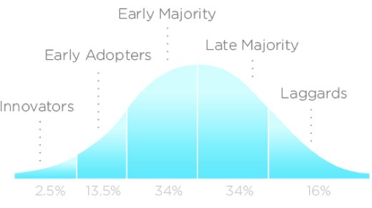
Figure 13. Innovation adoption lifecycle
Source: adapted from Rogers (1983).

Table 8 selects the mechanisms with the most promising cost data found to date; those with mechanisms shown in parentheses appear to have weaker cost data. The final column indicates mechanisms for which has been shown with regard to the stakeholder categorisation methodology introduced above. Mechanisms thus identified in bold show early potential for both appropriate cost data and stakeholder uptake modelling.

Table 8. Stakeholders uptake

Mechanism identifier | Description | Stakeholder adoption | Modelling potential | Level of maturity | Main stakeholder investor | Stakeholder uptake order
 |  |  |  |  |  | A. Early adopters | B. Early majority | C. Late majority
MEC.001 | Airport CDM | A-CDM procedures integrate all stakeholders; the actual status of the aircraft is forwarded to the destination airport in order to adapt resources there. The core element of A-CDM is the declaration of all airlines to meet a published target time. This target off-block time (TOBT) is distributed by the airport to all other airlines and serves as input for the ATC’s target start-up approval time (TSAT) and the calculated take-off time (CTOT). The CTOT is used by the Network Manager to shape the traffic flow. This mechanism is expected to be implemented at least at all hub airports in Europe. Medium-sized airports have also begun with the stepwise implementation of this operational change. | If selected, this mechanism can be modelled as a case study for single, or groups of, airports using an agent-based modelling approach. | Already installed in 12 airports. | Airports. Other stakeholders include airlines, ground handlers, and ATC. | Current level (12 airports) | Medium to high movement airports. | Medium to low movement airport may not need to implement it.
MEC.002 | AMAN | This mechanism is envisaged to be implemented in Europe’s top 25 airports, with high and very high capacity needs. In order to extend the AMAN horizon from 120 to 200 NM, it will be necessary to include approach and area control units in this new extended TMA. | If selected, this mechanism can be modelled from a macro perspective directly by establishing contact between the aircraft trajectory process and the airport arrival queue earlier. Different models applying speed changes have been developed already. | Basic AMAN is already implemented in some European States such as Belgium,  Denmark, France, and the United Kingdom.  - AF 1 from (SESAR, 2013b) is the “Extended AMAN and PBN in high density TMAs”. According to (SESAR, 2013b): “AMAN Data exchange should be deployed at FAB level in the main ANSPs by the end of 2014. However, the UK, Italy and France plan to deploy it respectively in 2015, 2017 and from 2015 to 2017”, also “Due to the current planning and state of implementation of the essential prerequisite AMAN en-route interface, the timely and successful deployment of AF # 1 is potentially at risk.”  The start and end of investment is expected by 2015 and 2023 respectively, and the deployment be between 2018 and 2023.  The different sub-system to consider are: AMAN system upgrade for E-AMAN, ATS system upgrade for E-AMAN and PBN Airspace/Procedures/ATS-System | Airports’ related ANSPs (IT infrastructure of tower and approach units) | High number of movements. | Medium to high movement airports. | Medium traffic airports.
MEC.003 | AMAN/SMAN/ DMAN integration | This mechanism impacts several airport types. It will affect the approach units responsible for the airports, regardless of their density and is intended to achieve better ground synchronisation.  NB. MEC.002 is a pre-requisite for MEC.003. | If selected, this mechanism would need to be scaled at the micro-meso level, for each group of airports affected. Implementation at a macro-scale would not capture the improvements. | Short term. Validation exercises taking place in 2014.  AF 2 from (SESAR, 2013b) is “Airport Integration and Throughput Functionalities” which includes A-SMGCS. There it is stated that A-SMGCS level 1 should be completed by 2014 and the full capability by 2017. | Airports’ related ANSPs (A-SMGCS) | High number of movements. | Medium to high movement airports. | Medium traffic airports.
MEC.004 | ASPA capabilities | The ability of TMA controllers to issue additional CPDLC instructions to flights to maintain time- or distance-based separation would increase capacity in the TMA. Since this improvement is expected at area and approach centres, all airline types would be affected if they fly through those sectors. Having equipped aircraft is critical in order for ASAS technology to create an impact on capacity. Hence, airline policies regarding retrofitting or acquisition of new aircraft will impact the way ASAS is deployed. The different airline classifications will imply, therefore, different adoption of the technology. | If selected, this mechanism could be modelled at a micro level in key TMAs to understand the increases in capacity, and at a meso-macro level with assumed increases in capacity in congested TMAs. | SESAR: validation in TMA environment with PRNAV structure of the two basic ASAS  sequencing and merging manoeuvres during 2012-2013 timeframe.  SESAR Project 05.06.06 ASPA-S&M: the objective of P5.6.6 – “ASAS Sequencing and  Merging” project is to contribute to the consolidation of the operational concept and to validate the “Airborne Spacing Sequencing & Merging Application” (ASPA S&M).  ? United States: plans are currently being developed to demonstrate the flight interval  management functionality in 2013 by NASA. The FAA is implementing the requirements for ground interval management-spacing (GIM-S) via two FAA automation programmes:  time-based flow management (TBFM) and en-route automation modernization (ERAM). The FAA has several airline partners prepared to support operational data collection and benefits measurement as the initial flight interval management – spacing (FIM-S) capabilities are established. The FAA supported the efforts of a joint RTCA/EUROCAE working group to develop the safety, performance and interoperability requirements (SPR) document for FIM-S (also known as ASPA-IM), which resulted in RTCA DO-328. RTCA SC-186 and  EUROCAE WG-51 have begun initial work on the MOPS material for FIM-S avionics. This effort is expected to conclude in late 2013. | Airlines and ANSPs | Airlines with newer fleet would have greater IT capabilities | As required by the ANSPs. Those airlines operating in high density approach sectors would be affected.
MEC.005 | Complexity management (slot assignment based on sector complexity) | Dedicated tools supporting airport slot monitoring (e.g. Stanly, AMON). This type of mechanism would be implemented at a network level and would affect high and very high density airports. | If selected, this mechanism could only be modelled through macro-scale modelling due to the network characteristic of the enabler. | The module provides for the optimization of the traffic flows and air navigation resources usage. It addresses the complexity within ATM due to the combination of higher traffic densities, more  accurate information on trajectories and their surrounding environment, closely interacting processes and systems, and the quest for greater levels of performance.  Regional or sub regional. Benefits are only significant over a certain geographical size and assume that it is possible to know and  control/optimize relevant parameters. Benefits mainly useful in the higher  density airspace | ANSPs | High traffic complexity and public ownership | Public ownership despite traffic complexity | Private ownership
MEC.006 | En-route capacity planning tools | Airspace management, capacity planning and flight planning tools for en-route ATM units. Adoption of this mechanism will depend on involvement of the ANSPs en-route control and particularly would heavily depend on the participation of a particular FAB and the roadmap of that FAB. | This mechanism could be modelled at the macro level, hypothesising an increase capacity on key routes.
MEC.007 | Enhanced DCB (demand and capacity balancing) tools | This enabler allows many operational capabilities. One of them is the ASM scenario management sub-system equipped with tools for assessing the impact of airspace changes on capacity. This enabler is related to the Network Manager. Due to the need of coordination across different ANSPs, only simultaneous involvement of several ANSPs together with the Network Manager would make this mechanism viable. | This mechanism could only be modelled through macro-scale modelling due to the network characteristic of the enabler. | Ongoing | ANSPs | High Traffic ANSPs | Medium traffic ANSPs
MEC.008 | Improved flight planning and demand data | Increased information on demand data and both capacity planning functions and scenario management, equipped with tools to identify the possible re-routed flights/flows, would provide (in principle) increased capacity. Any ANSP could benefit from this mechanism. SWIM-based tools may make this mechanism affordable for any ANSP, regardless of size. | The impact of pervasive information on capacity planning functions and scenario management is difficult to model realistically. An assessment of how re-routed flights influence potentially unused capacity would be required. Research on SWIM-data could provide information on unused slots at airports. |  | Network manager, ANSPs
MEC.009 | Investment in new runways | Directly increases airport throughput. This mechanism can affect any airport size and structure, however, airports with more than one runway are high traffic density airports, so the airport adding the runway would have at least ‘high’ traffic. This mechanism would require a large investment, hence ownership would play a key role when taking into account tax free investments for public airports, or the capacity growth commitments acquired by the operator when an airport concession is granted. | Could be modelled either by increasing nominal capacity in a macroscopic model or using an explicit runway model in a microscopic or mesoscopic model. | Implemented | Airports | Saturated airports with space available. | Very high traffic airports would be subject to such a mechanism
MEC.010 | Dynamic sectorisation and constraint management |  |  | Dynamic sectorisation requires the flight data processing functionality to be able to work  with different sector configurations and sector grouping/de-grouping functionality. This functionality is available in many systems today. | ANSPs | This mechanism is closely linked to free routing airspace, which is easier to implement in low traffic areas | Medium to high traffic ANSPs would be subject to such a mechanism
MEC.011 | Time-based separation | This mechanism is envisaged to be implemented in Europe’s top 25 airports. The main investments need to be made by airlines is on-board equipment. For an increase in capacity this will need to be mandatory, affecting those airlines operating at major airports (i.e. particularly the full-service carriers). | This mechanism cannot be modelled as a macro-scale model, because it is an enabler for airspace users to fly into managed airspace where special operations like free routing or advanced operations can be applied. | Most complex - establishment of time-based separation criteria between pairs of aircraft extends the existing variable distance re-categorization of existing wake turbulence into a conditions specific time-based interval.  This will optimize the inter-operation wait time to the minimum required for wake disassociation and runway occupancy. Runway throughput is increased as a result. | This new ANSP procedure will need automation support in providing the required  time-based aircraft-to-aircraft wake separations to its air traffic controllers.  Airborne equipment is still to be defined. | Airlines with newer fleet would have greater IT capabilities | Those airlines operating in high density approach sectors would be affected.
MEC.012 | Runway occupancy time management | This mechanism allows airports to increase runway throughput by maximising use.  This improvement addresses enhancements of the operating practices of airlines with respect to the runway occupancy time. Saving just one second on every movement could result in one slot gain every two hours (SESAR, 2012b). | This should be modelled at a micro-scale using an explicit runway model. Impact on network can be studied at a macro level. | Medium term | Airports, ANSPs. |  | Medium to high density airports would be most affected.
MEC.013 | En-route slot trading |  |  | Medium-long term | Airlines |  | All types of airlines would find benefit from this mechanism regardless of their nature.
MEC.014 | Dynamic cost indexing | Dynamic cost indexing allows airlines to recover delay en-route, trading off against arrival delay costs. It may subsequently free gate resources and reduce reactionary delay. Full-service carriers (driven by connectivity costs) are most likely to adopt. | Could be modelled using an agent-based approach. | Ongoing | Airlines | Full-service carriers | Regional and LCC | Rest
MEC.015 | Airlines investing in more fuel-efficient aircraft | Since the price of fuel is the most dominant operating cost of many airlines, they strive to operate fuel-efficient aircraft. This is done also in order to avoid CO₂ charges. Airlines with higher liquidity and those in cycles of fleet replacement/expansion are placed to invest. LCCs would be included. | Airline fuel consumption can be easily calculated with our current tools. A CBA of new aircraft acquisition can be carried out at any scale. | Ongoing | Airlines | Airlines with higher liquidity and those in cycles of fleet replacement/expansion | LCCs | rest
MEC.016 | Airlines investing in infrastructure in collaboration with airport | Airlines seek benefits from operating parts of terminals, for example through gate allocation. Airlines in / tied to major alliances would benefit most from this mechanism (full- service and regional airlines). | This mechanism should be explored with case studies of a specific airport and alliance, with passenger connection information. This could be modelled using an agent-based platform. | Short term | Airlines, Airports | Long term and stable airlines | Full service carriers | Rest
MEC.017 | Airlines investing in ground handling services to improve turnaround processes | This mechanism would allow airlines to shorten turnaround times, increasing RPKs per day. Full-service and regional airlines could find this mechanism beneficial. LCCs are known for negotiating special conditions with airports with available capacity rather than investing to increase capacity at existing airports. | Agent-based modelling elements could be incorporated to model this mechanism. | Ongoing. | Airlines | Full-service airlines, | Regional and LCC | Rest
MEC.018 | Merger of airlines | Form of investment to reduce risks for airlines, which also affect airports. Thus, the airline market is characterised by strategic investment in airlines. In a more liberated market, it could be assumed that full mergers would take place. Full-service and regional airlines would be affected by this mechanism. | It is necessary to explore previous mergers to identify trends in the airlines’ market networks. This needs to be done at a macro-scale level. It is, however, a very challenging task. | Ongoing | Airlines | legacy and some regional airlines | Regional airlines | Some full-service airlines
MEC.019 | Changes to airline passenger re-accommodation policies | This mechanism would affect connecting passenger airlines, which tend to be full-service airlines and some regional airlines. Changes in this regulation would require airlines to vary the buffer times between flights, and consider the new costs of delay, for example. The actual impact of this will be different depending on the type of airline as some already offer passenger solutions better than those required by law. | The impact of this mechanism can be calculated at a macro-scale level. This could be modelled using an agent-based platform. | Ongoing | Airlines | Full-service | Regional | Rest
MEC.020 | Airlines adding more buffer to schedule | This mechanism will impact airports and airlines, affect their economic results and capacity. It is considered under the airline stakeholder because they are the stakeholders making the investment (through an opportunity cost). All airline types are subject to turnaround costs and may thus implement (increased) buffer, particularly on key legs. | This can be modelled at a macro-scale level, changing the turnaround times accordingly. | Ongoing | Airlines | Strong hub-and-spoke structure airlines, multiple hubs. | Singled hub network structured airlines. | Hardly hub-and-spoke network structures.
MEC.021 | Increasing ATCO hours in selected sectors | This mechanism will affect any type of ANSP, although likely to be approached differently by public or private providers. Its application would increase capacity up to a certain point, considering geographical and complexity characteristics of the sector. | This could be modelled at a micro scale, although, assuming uncertainties, could be extrapolated to many sectors (meso scale). | Ongoing. According to (Bujor and Ranieri, 2014), there is a relationship between the size of the ANSP and the probability of having a high or a low ATC cost per flight hour as a function of the number of total hours flown in the ANSP airspace.  It is stated that “ANSPs controlling smaller airspace and low traffic tend to be in general less economically efficient.” They also state “Smaller ANSPs have in general spare capacity, [...] by increasing traffic the probability of having a high ATCO cost per flight hour diminishes. On the other hand, for larger ANSPs these economies of densities seem to be already exploited, since by increasing traffic (flight hours), the probability of having a high ATCO cost per flight hour increases.”, and “ANSP with spare capacity (small ANSP in our case) may accommodate additional traffic without changing the network structure (the same number of sectors).” | ANSPs | Large sized ANSPs yet to be optimised, in terms of size and total hours flown in the ANSP airspace. | Medium sized ANSPs yet to be optimised in terms of size and total hours flown in the ANSP airspace. | Small sized ANSPs yet to be optimised in terms of size and total hours flown in the ANSP airspace.

Selected mechanisms
After analysing the characteristics of the different mechanism considered, three have been selected to be modelled in ComplexityCosts:

(a) MEC.021. Increasing ATCO hours in selected sectors
ANSPs provide information of their costs to EUROCONTROL that analyse the information and publishes it in the ATM Cost-Effectiveness (ACE) Benchmarking Reports.
It is a mechanism that is basic and based on procedures. It can be seen as a nominal investment mechanism that increases the capacity of the ACCs in general. However, the reality is that the capacity of the ACCs can hardly be increased by adding ATCOs as the system is already at the maximum number of sectors possible. This means that, in general, adding ATCO hours do not increase the capacity but reduce the performance of the ANSPs. For this reason, we can see this mechanism as a mitigation investment that is aiming to solve a particular type of disturbance (i.e., ATFM regulation where the primary cause is ATC staff). Therefore, an analysis of DDR2 data and of CODA reports is required to see which areas are lacking ATCO hours and would benefit from the mechanism.
The stakeholder realising the investment are the ANSPs.

(b) MEC.014. Dynamic cost indexing
The cost of dynamic cost indexing can be assessed thanks to fuel model computations and industry contacts to estimate the cost of implementation and usage of such a system.
The mechanism is advanced and based on procedures. It is a nominal investment mechanism as it is not aimed to a particular disturbance type. It will improve the performance in terms of delay propagation to any regulation that imposes delay.
The stakeholder realising the investment are the airlines and for the uptake first full service carriers and some regional airlines might implement this system. It is worth noticing that the dynamic cost indexing strategy can be implemented in a set of routes.

(c) MEC.001 A-CDM + MEC.019 Changes to airline passenger reaccommodation policies
Finally, we have considered that MEC.001 and MEC.019 could be implemented conjointly. This will allow us to have a mechanism that joins a basic and an advanced functionality and covers the implementation that has not been addressed by MEC.021 and MEC.014. It is based on regulation, procedures and technical solutions. MEC.001 is a nominal mechanism that improves the turnaround operations at the airport in nominal conditions, but also mitigates the problems when there are disturbances affecting the infrastructure (e.g., technical problem or meteorological events). In its turn, MEC.019 is a nominal mechanism as it does not tackle a particular disturbance.
A-CDM is already implemented in some airports and the future evolution of which airports would be incorporated can be forecast.
Investments will be realised by all the stakeholders.

Table 9 summarises the characteristics of the selected mechanism. As it can be observed, the three mechanism to be implemented cover the different aspects that have been considered in the analysis of the mechanism for ComplexityCosts. As there is an overlap on disturbances that are tackled by the different selected mechanism, this will allow us to compare the resilience added to the system for the same disturbance by different mechanism.

Table 9. Summary of selected mechanisms

 | (A)dvanced/(B)asic | Type (T)echnol. (P)roced. (R)egul. | (N)ominal / (M)itigation | Disturbance | Stakeholders
MEC.021.Increasing ATCO hours in selected sectors | B | P | M | ATFM staff regulation | ANSP
MEC.014. Dynamic cost indexing | A | P | N and M | Disturbance that add delay | Airlines
MEC.001 A-CDM and MEC.019 Changes to airline passenger re-accommodation policies | A  B | P and T  P and R | N and M  N | Local disturbance at airports  All | All

Model Integration

Conceptual model description

Simulation framework
The ComplexityCosts Air Traffic simulation model draws elements from Complex Theory, Layered networks, statistics, soft-computing and event driven programming. In this section we cover the design of the simulator, describing more in detail the concepts previously introduced. The simulation framework is composed of four elements:
- Data Store
- Event-stack manager
- Environment
- Events
The first two elements are of a more general nature and less domain specific and will be explained in this section, while the last two elements will be described in the subsequent sections as they are much more domain specific and require a more thoughtful explanation.
The Data Store is a permanent data base that contains all the simulator definitions and parameters that define the simulation environment and the scenarios. All the static parameters do not change in execution time and define the actors of the model, parameters such as names, types, location, fare, etc. Also the scenarios are defined in the Data Store, containing the number of actors of each type, their configuration, and their initial status. The Data Store is the first element to be considered when initializing the simulator.
Additionally, the Data Store contains all pre-computed and pre-loaded values. For some task instead of repeating the same data process in each simulator run, the data is transformed and prepared to produce pre-computed values, in other cases this is done to avoid overload of the simulator and simplify some of the task. For instance, pre-computed values are used for estimating flight cost beyond the second jump, otherwise the costs of the whole propagation tree should be re-computed each time.
The event-stack manager drives the execution flow of the model. It consists of an ordered sequence of events. Each event has a time stamp associated with it, which determines its position in the stack. The event-stack organizes and manages the sequence of events using a series of domain-independent methods. Once the event stack is implemented, one can abstract to a design layer defining the events and letting the model flow naturally, managed by the stack.
Model execution then follows in a series of steps. First, the event stack is initialised at the beginning of the simulation drawing parameters from the Data Store. One the stack is initialized, the event with the smallest time stamp becomes active and the process defined by it begins. New events can be inserted into the stack during the event execution, but the event-manager always preserves the ordered structure. The process repeats until the stack is empty, in which case the simulation run is over.
In order to correctly manipulate the stack the manager has to implement the following methods:

Table 10. Methods to be implemented by the stack-manager

name | input
display | n/a | show the current stack (debug purposes only)
isempty | n/a | check if the stack is empty (simulation is over)
add | event type, trigger id and timestamp | create a new event
init | n/a | initialises event stack with flight plans extracted from the Data Store
delete | event locator | removes an event from the stack
executeNext | n/a | locates next event and runs it
searchNext | event type | returns the location of the next event of a given type
setTime | event locator, timestamp | change the timestamp of an existing event
getTime | event locator | returns timestamp of a given event
current time | n/a | Current simulation time

Each simulation begins by loading the static parameters and the scenario definition from the Data Store. Due to the random nature of the soft-computing methodology it is not always possible to determine the number of runs required to compute the output's statistics, so an initial number of cores or machines are now set up to execute the runs. Each run starts by initializing the Event-Stack, introducing the first events from the scenario definition and static parameters from the Data Store. Once the event-stack is initialized, events are processed as described previously in an ordered manner letting the model flow naturally. Each event execution is independent from the rest and the changes produced by then are only reflected in the Environment (i.e. dynamic parameters of the actors) or new events in the stack. The run finishes when the stack is empty and the simulation ends when the output indicators can be statistically estimated. If so, they are inferred and stored in a secondary data base for further analysis.

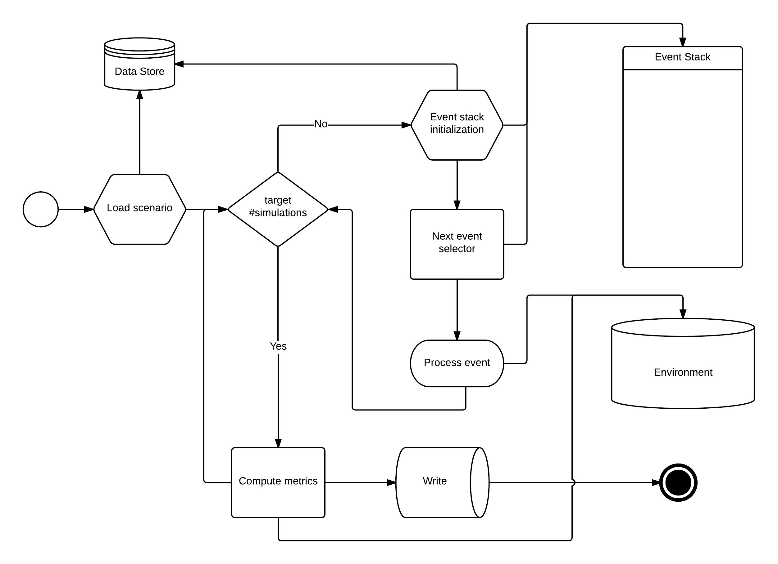
Figure 14. Main simulator loop

Environment definition
The environment is the common interface for the events to interact with the rest of the model or future events and modify the status of the system. The environment is composed of one or several instances of classes of actors. A class of actor is an empty abstraction of a real entity. An actor is an instance of a class of actors. Actors are defined by the static parameters, those are defined in the Data Storage. The number of actors and the initial values for their dynamical parameters form the scenario definition, information also obtainable from the Data Storage.

Table 11. List of environment actor classes for ComplexityCosts model

# | Name | Instances |  | Notes
1 | Network Manager | 0-1 |  | Implementing Rule (EU N° 677/2011) lists at Article 4 the tasks to be performed by the Network Manager in pursuit of the functions. However, In the ComplexityCosts model the Network Manager tasks would be limited to balancing demand and capacity profiles.
2 | Air Navigation Services Provider | 30-50 |  | Provides the service of managing the aircraft in flight or on the manoeuvring area of an and which is the legitimate holder of that responsibility (ECTL, GoT)
3 | Airport | 150-500 |  | In the ComplexityCosts model airports operations are limited to passenger boarding, aircraft off-block and in-block, taxi procedures, take-off and landing.
4 | Airline Operator | 100-2,000 |  | Entities holding a valid AOC to operate Commercial Air Transport. In the context of ComplexityCosts airlines are mainly restricted to flight operations and passengers transportation.
5 | Flight | 20,000-30,000 |  | Operated by AOC holders and managed by ANSPs and the Network Manager.
6 | Passengers | 2,000,000-3,000,000 |  | Full itineraries, individual flight tickets and fares are considered in the ComplexityCosts model.

Actors are composed of two elements: parameters and actions. There are two types of parameters: static and dynamic, static parameters define the instance class of actor while dynamic parameters change through execution to reflect changes in the state of the actor. Actions on the other hand, reflect procedures or functions unique to that class of actor. There are two types of actions (e.g. functions): hard and soft functions. Hard functions are deterministic functions (i.e. classic concept of function, output is uniquely determined by inputs) and soft functions (i.e. stochastic functions producing different outputs regardless of the input). In other words soft functions cope with the uncertainty associated with certain actions, for instance expected arrival times or estimated sector capacities.
Both hard and soft functions should have access to static and dynamic parameters, but never to events. Actions on classes should never trigger new events, but rather let the events be triggered by other events depending on the results of those actions. This allows to separate the semantics between events and actor’s actions. This separation facilitates the communication and the abstraction, e.g. one can modify the event tree structure without modifying the actors and the simulation flow will change but still ensured to continue working and vice-versa, the actors can be modified/expanded without worrying about the particular event tree structure. This is a powerful abstraction tool that enables exploration of different scenarios and configurations in a sound and simple way.
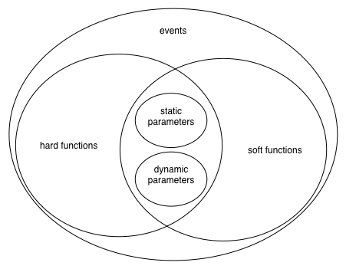
Figure 15. Languages enrichment and hierarchy

Despite of conceptual differentiation all actors share a basic set of common meta-actions that allows the setting up of the simulation environment and controls the debugging and execution of the simulations:

Table 12. List of meta actions

name | type | comment/description
full id | static parameter | unique representation
create | hard function | actor constructor
delete | hard function | terminates an actor
display | hard function | shows current actor status (debug only)
reset | hard function | loads default data from Data Store

The main objective of the Network Manager in the ComplexityCosts model is to balance demand and capacity on a tactical level. Network Manager can impose flights a regulation when the expected capacity of any sector in the requested route is expected to be exceeded. In this case airline operators can still continue operations normally, proceed to boarding and send a ready message hoping for a slot to be freed in the meantime. Also the Network Manager processes delay messages sent by the airlines when their original flight plans can no longer be met. The following table contains the actions to be implemented in the Network Manager actor:

Table 13. List of Network Manager actor actions

name | type | comment/description
name | static parameter | Usually there is only one Network Manager, in EU it is implemented by EUROCONTROL and the CFMU.
regulate flight | hard function | A regulated flight is forced to be delayed by a determined amount of minutes. This delay is assigned before departure, when a capacity overload is expected, so that most of the delay is absorbed on ground.
expected sector occupancy | soft function | Considering the current flight plans and the expected sector capacity the expected occupancy of each sector can be determined. A sector is considered to be overloaded if expected capacity is over 100%
acknowledge ready message | hard function | Allow the airlines to send a ready message. When a flight is regulated airlines can decide whether to board all passengers and stay ready for any opportunity slots.
acknowledge delay message | hard function | Allow the airlines to send a delay message if it’s expected to be delayed more than 15 minutes. In this case the Network Manager can compute the new sectors occupancy and decide whether to accept the new delay or regulate the flight.
analyse flight plan | hard function | Flight plans are analysed to determine the occupancy of each sector and help to balance capacity and demand.

The Air Navigation Services Providers (ANSPs) manage air traffic in flight or in the manoeuvring area. Most ANSPs are organized by country and have a 3 dimensional region of the Controlled Airspace under their responsibility. The main functions within the ComplexityCosts model are aircraft separation and routing, maximum sector capacity declaration for the Network Manager and sector configuration.
The following list contains all the actions to be implemented by any Air Navigation Service Provider actor in the ComplexityCosts model:

Table 14. List of ANSPs actors actions

name | type | comment/description
name | static parameter | Identifier for the instance class.
country | static parameter | ANSPs are usually government dependent
time zone | static parameter | ANSP’s country time zone
coverage | static parameter | Limits of the ANSPs domain
capacity | dynamic parameter | Maximum capacity (i.e. number of flights) of each sector that can be handled. This number could vary hourly, especially during night in some regions (e.g. noise restrictions, low traffic and reduced personnel).
sectors | dynamic parameter | Air traffic control is separated into different sectors, both horizontally and vertically. This parameters contains the definition of each sector by given the polygonal description by its boundary points.
declared capacity | hard function | When a sector is affected by severe adverse weather, reduced staff or any other situational disruption maximum capacity can be lessen and the effective movements number that the sector can handle is reduced. As important as the declared capacity is the time in which this information is known, so declared capacity is really a two arguments function f(t, s), if t is current time and s is future time, f(t,s) represents the declared capacity at time s when the prediction is made at time t.

In the context of the ComplexityCosts model, airports have two main functionalities: they serve as the connecting point between passengers and flights and they limit the throughput of aircraft, sometimes being the main limitation to the capacity of the air transportation system. Each airport has a unique location and declared capacity. The declared capacity may vary according to weather, staff or other situations and it can be know in advance or suddenly. For this reason special attention is put for the runway(s) modelling, each aircraft take-off or arrival is modelled independently and depending on the class of preceding aircraft their a minima separation to ensure a proper wave vortex separation. Also distance from the IAF point and averages taxi times (in and out) are considered explicitly.
Regarding the passengers, the airport has a minimum connecting time (i.e. minimum time ensuring a passenger can connect to an outbound flight gate-to-gate at the same airport) and a waiting for re-accommodation lists. Passengers that missed a connection and failed to be re-accommodated are added to a waiting list, hoping for a free slot on a similar route.
The following list contains all the actions to be implemented by any Airport actor in the ComplexityCosts model:

Table 15. List of Airport actor actions

name | type | comment/description
name | static parameter | ICAO airport name
location | static parameter | geographical position
time zone | static parameter
declared capacity | hard function | Similarly to the ANSPs capacity is not constant. In the airport case capacity refers to the number of movements (departure and arrival) per hour. Again is a two function parameter f(t,s), where t is current time and s future time.
independent runways | static parameter | The number of available runways determines the declared capacity and affects arrival and departure ratio.
runway configuration | hard function | If there is more than one configuration, this function returns the current configuration, which in turn affects the declared capacity as well.
taxi-out estimation | soft function | Taxi-out process covers the ground movement from starting push-back at the gate (or start of movement if stand is remote) until reaching the holding point for departure, including any holding in between that might occur due to traffic.
taxi-in estimation | soft function | Taxi-in process covers the ground movement from vacating the runway until reaching the stand. The time interval from aircraft stop until opening of doors is not included in the taxi-in process.
IAF distance | hard function | Distance from the IAF (initial approach fix) to the airport, used to calculate the arrival time.  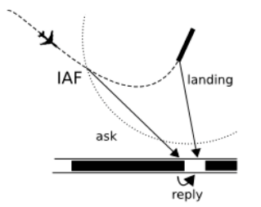
runway in use/clear | dynamic parameter | As soon as aircraft at the holding point report being ready for departure, air traffic controllers will search for a window, in between the arrival sequence, where the following two conditions must be satisfied:  1. There must be statutory separation between departed aircraft when airborne. Problems arise when faster aircraft overtake slower ones, which departed earlier, which is to be avoided. There is also statutory separation that must be achieved due to wake turbulence of preceding aircraft.  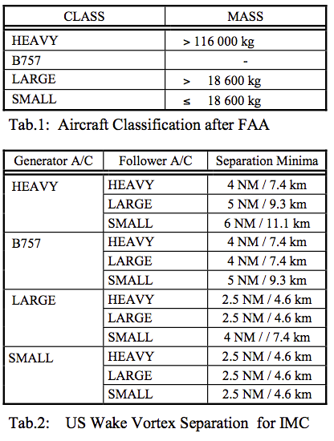  2. If a departure is still at the holding point (not lined up), minimum required time for the arrival estimate over the threshold is 2 minutes. Depending on Runway Occupancy Times, 1 minute and 30 seconds to threshold would be the safety limit for departure clearances to aircraft that have not lined up yet.
add to/extract from departure/arrival queue | hard function | The departure/arrival queue is composed of the flights that are ready to depart or arrive. The Base Scenario will consider a first-come first-served criterion as it is established in current operations. This will be maintained also in case of holding taking place at the airport, and a change of priority will only take place in case an aircraft is reaching too much delay and we consider it declares a short of fuel emergency.
expected queue length | soft function | Determined by the number of queued operations, the type of aircraft and the type of operation (i.e. departure or arrival). Note that queue length can only be estimated, but not determined, until the current time is reached. Even if there is an “expected” queue given by the Network Operations Plan, the inherent uncertainty of the Air Traffic system, makes it impossible to determine the queue length with total confidence in advance.
add to/extract from passenger waiting list | hard function | Each airport keeps a waiting list of passengers that, after missing a connection, couldn’t be successfully re-accommodated. Whenever a flight departs with seats, waiting passengers at the airport are tried to be re-accommodated.
minimum connecting time | hard function | Minimum time for a passenger to reach the gate of the next flight when connecting at an airport. It may depend on the terminal and the type of outbound flight (e.g. connecting to a long-haul may require a longer minimum connecting time due to additional security checks).  Given that a very deep model on MCTs goes beyond the scope of this project and would require much bigger amounts of effort, using MCT standard values with a variable component would work as a good alternative for most airports considered.

In the ComplexityCosts model airline operators serve as interface between passengers and flights. Main functions include boarding of passengers, waiting for connecting passengers and sending ready or delay messages when appropriate, re-accommodation of passengers, compensation, caring and overnight costs when passengers are delayed and even flight cancellations. There are three different airline classes and each class implements the cost estimation functions and passenger waiting re-accommodation rules differently. However, since inputs and outputs are standardised, the events can use those functions without knowing the exact implementation, just using the outputs, this abstraction allow great flexibility when designing the simulation system.
Airline costs estimation is a cornerstone of the ComplexityCosts model and they are further explained in Section 4.3. Costs estimation include soft and hard passenger costs, as well as non-passenger related costs, such as extra taxi time, extra gate time or en-route additional fuel consumption.
The following list contains all the actions to be implemented by any Airline actor in the ComplexityCosts model:

Table 16. List of Airline actor actions

name | type | comment/description
name | static parameter | defines the AO’s name
type | static parameter | follows AO’s categorisation
alliance | static parameter | defines the AO’s alliance
soft and hard cost per pax | soft function | Section 4.4 and appendix A
value of time per pax | soft function | The ‘Value of time’ is a concept widely used in cost-benefit analyses, particularly in transport economics. It is an opportunity cost that corresponds to the monetary value associated with a traveller/passenger during a journey. We will only evaluate value of time as a function of delay at the final (airport) destination and has a different value depending on the flight ticket type, varying from 30€/hour to 50€/hour.
non pax cost | soft function | Section 4.4
estimate cost of delay arrival/departure | soft function | Cost estimation of a flight departing/arriving late based on current network status and forecast. This costs include soft and hard passenger costs, as well as non-passenger costs for the current flight and subsequent delayed flights (i.e. reactionary delay). Reactionary delay costs are further explained in Section 4.4.5
cancel flight | hard function | Passenger booked in a cancelled flight will be re-accommodated following the airline’s policies. Usually inside the same airline or alliance.
estimate flight cancellation cost | soft function | Cost estimation of a flight being cancelled based on current network status and forecast. This costs include soft and hard passenger costs, as well as non-passenger costs for the current flight and subsequent delayed/cancelled flights (i.e. reactionary delay) Reactionary delay costs are further explained in Section 4.4.5
ticket range | hard function | Used when computing soft cost, this function returns the values or the tickets for a single flight.
passenger waiting thresholds | hard function | Assuming the airline has awareness of its connecting inbound passengers, this function estimate the maximum waiting time for a flight to wait a late gate arriving passenger.
search passenger re-accommodation | soft function | search for a new passengers itinerary when a connection is missed  Includes, one and multiple step re-accommodation or next day flight otherwise

Flights move passengers (or cargo) from one airport to another. They are regulated by the Network Manager, assigning on-ground delays by regulations before departure and by the ANSPs during flight phase. Decisions regarding the flight are usually taken by the airline operator. In case of non-cargo, flights also contain a list of all passengers with full itineraries, number of seats and occupation. Also flights are interconnected by sharing resources (e.g. aircraft, passengers or crew) those resources need an extra time at the airport (e.g. passengers need at least the minimum connecting time to reach the gate of an outbound flight, aircraft need a minimum turnaround time to be ready for the next flight).
The following list contains all the actions to be implemented by any Flight actor in the ComplexityCosts model:

Table 17. List of Flight actor actions

name | type | comment/description
registration | static parameter | defines flight’s registration
type | static parameter | aircraft model
regulated | dynamic parameter | ask whether the flight has any regulations on it
reset times | dynamic parameter(s) | resets all flight times
cancelled | dynamic parameter | ask whether the flight was cancelled
passenger list | hard function | passenger list based on current network status
original passenger list | hard function | passenger list based on AO’s original planning
total seats | static parameter | Maximum number of passengers
occupancy | dynamic parameter | Current number of passengers
free seats | dynamic parameter | Available seats (e.g. re-accommodation)
add/remove passengers from flight | dynamic parameter | When passengers do not show or they miss a flight they are removed from the flight and added when re-accommodated into a new flight.
incoming passengers | hard function | list of incoming connecting passengers booked the flight
outgoing passengers | hard function | list of outgoing connecting passengers booked in a flight
get/set/update flight times | dynamic parameters | Performs the operations get/set/update on any of the following flight times:  Scheduled* Estimated Calculated Actual  Off-Block Time SOBT EOBT COBT AOBT  Runway hit Time CRWR ARWR  Take-off time STOT ETOT CTOT ATOT  Approx Fix point CPTI APTI  Time of arrival STA ETA CTA ATA  In-Block Time SIBT EIBT CIBT AIBT  *Belongs to the Data Store, therefore it cannot be modified. Modifiable copy under “Estimated” values
get/set previous flight | dynamic parameter | previous flight using same aircraft
get/set next flight | dynamic parameter | next flight leg for the same aircraft
get/set aircraft ready time | hard function | When the crew is available and the aircraft is ready for boarding the aircraft ready time is set.
get/set minimum turnaround time | soft function | Minimum time required for an aircraft to be ready for the next flight segment.  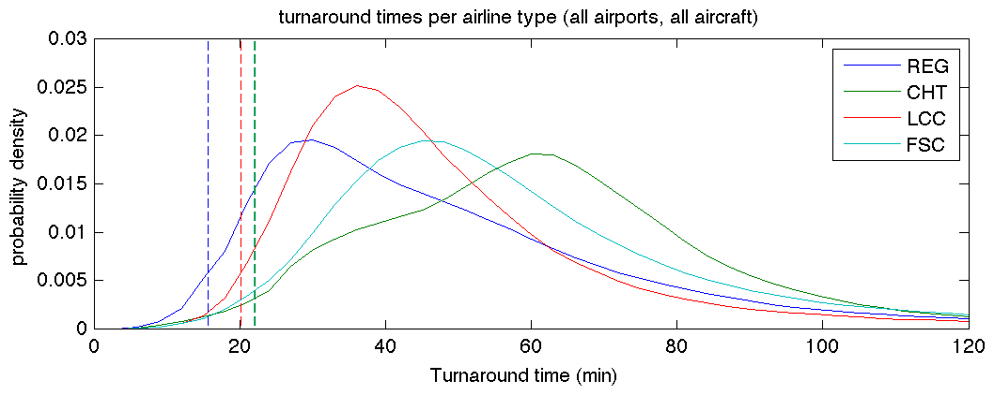  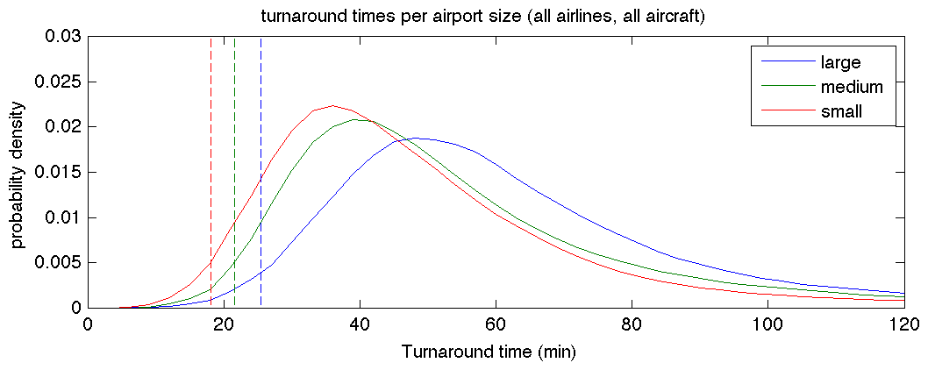  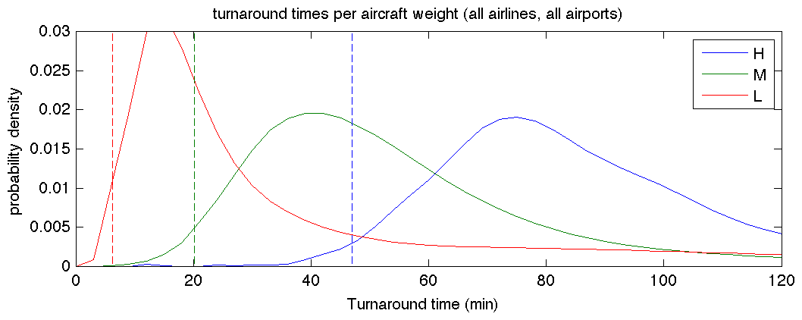
current route nominal length | dynamic parameter | Uncertainty not considered, just the nominal length of the route.
cargo | static parameter | Flag reserved for cargo flights only

In the ComplexityCosts model each passenger has an associated flight ticket, with a booked itinerary with an associated category and a buying price. Two categories are considered: flex and inflex tickets. Flex tickets are equivalent to first class or business tickets, while inflex tickets represent tourist or economy class. There is a number of reasons considered in the ComplexityCosts model for passengers missing an outbound flight. Despite of the small chance of no-show passengers, the model also considers late gate arrivals when the incoming flight was delayed and the outgoing flight decided not to wait. When this happens the airline tries to re-accommodate passengers according to their ticket value. If no re-accommodation is possible they remain in a waiting list or incur in an overnight in a nearby hotel.
The following list contains all the actions to be implemented by any Passenger actor in the ComplexityCosts model:

Table 18. List of passenger actor actions

name | type | comment/description
fares | static parameter | Paid fare
ticket category | static parameter | Ticket categorisation (flex and inflex)
number | static parameters | number of passenger flying this route with same fare and ticket type.
original O/D | static parameter | original origin and destination
original route | static parameter | original booked route
current O/D | dynamic parameter | passenger origin and destination based on current network status
current route | dynamic parameter | passenger route based on current network status
next flight | hard function | next flight leg
previous flight | hard function | previous leg flown
singelton | static parameter | single-leg passengers
miss connection | hard function | triggers AO re-accommodation process
sequence broken | dynamic parameters | true if passengers missed a connection
estimate arrival time | soft function | estimates arrival time using current network status and forecast
re-accommodate | hard function | reflects a re-accommodation process on passenger itinerary
estimate gate arrival time | soft function | estimates gate arrival for the next flight leg, if any, using current network status  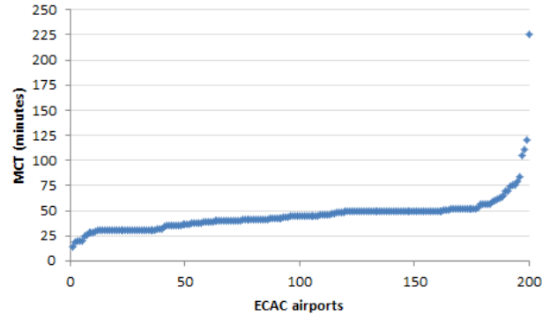
waiting list for re-accommodation | dynamic parameter | sets whether the passengers are in the airport’s waiting list trying to be re-accommodated to their final destination, before incurring in overnight stop and next’s day flight.

Events description
The concept of event was introduced in Section 2. In this section the ComplexityCosts events are described and analysed. They make use of the functions provided by the environment described in the previous section. Events are handled by the event stack as it was described at the beginning of Section 4.1
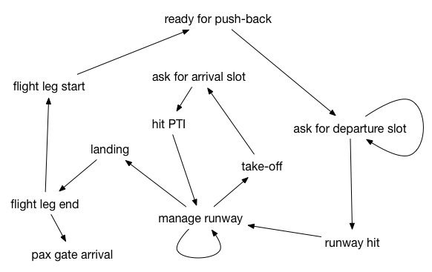
Figure 16. Consequence and precursor events scheme

The “ask for departure slot” event first checks the current airport and if there is a current regulation applied to the flight by the Network Manager. If flight is regulated a new “ask for departure slot” is inserted in the stack until regulation is over. When the flight is not regulated the departure queue is estimated, if the length is too large then again a new “ask for departure slot” is added to the stack, otherwise the Actual Off-Block Time is set and a new “runway hit” event is introduced in the stack after taxi out time.
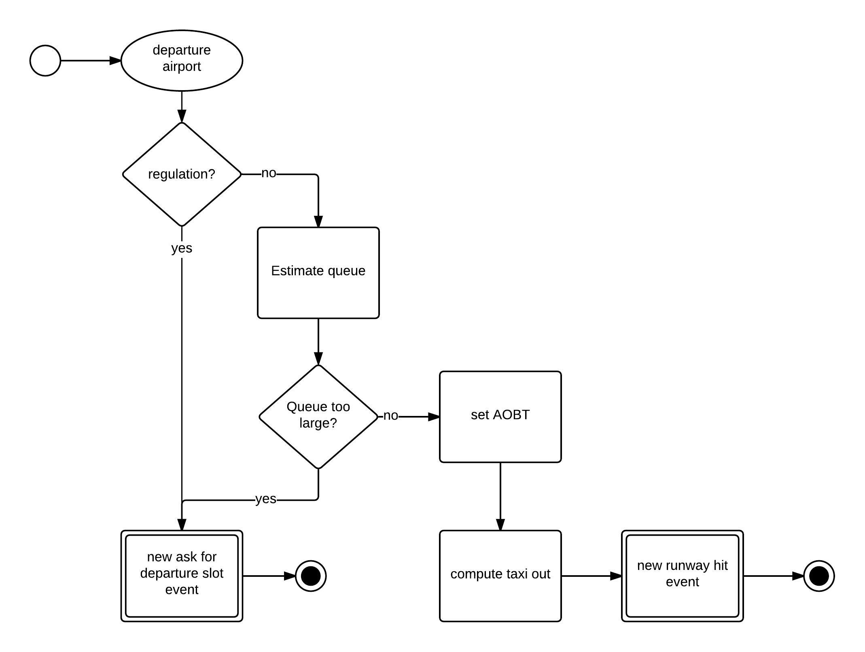
Figure 17. Flow diagram for the Ask For Departure Slot event

The “ask for arrival slot” event, determines when the en-route flight phase is over and the flight is making the approach. It is only after the flight have reached the PTI that it can be delayed intentionally due to capacity overload at the airport. First, the distance to the IAF is asked to the airport, and the estimated time to reach it is computed. A new “hit PTI” event is introduced into the stack at that time.

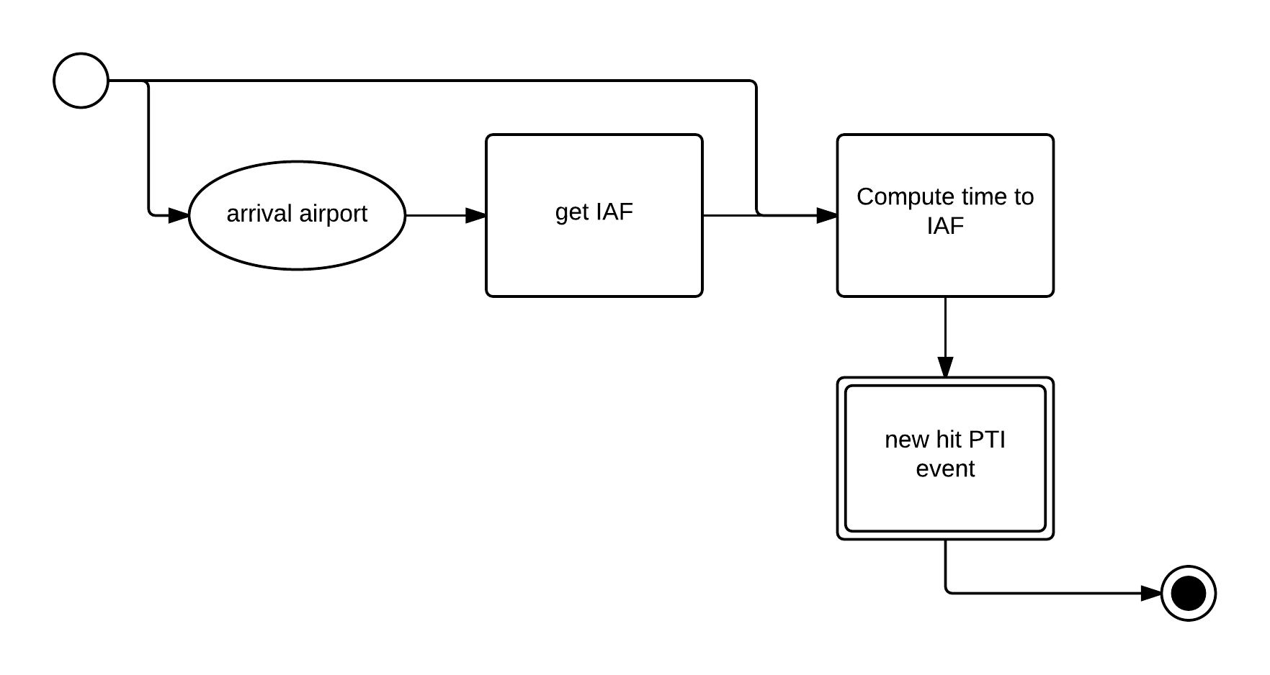
Figure 18. Flow diagram for the Ask For Arrival Slot event

In a “flight leg end” event, first the Actual In-Block Time is set to the current time. Then, if there is a next flight scheduled for the same aircraft, the Aircraft Ready Time is estimated using minimum turnaround times and a random component, an a new “flight leg start” event is introduced into the stack. Either if there is a next flight or not, all passengers in the flight are now considered. If passengers are reaching their final destination, metrics are computed, otherwise time to the next gate is estimated using the airport’s minimum connecting times and a new “pax gate arrival” event is introduced into the stack.

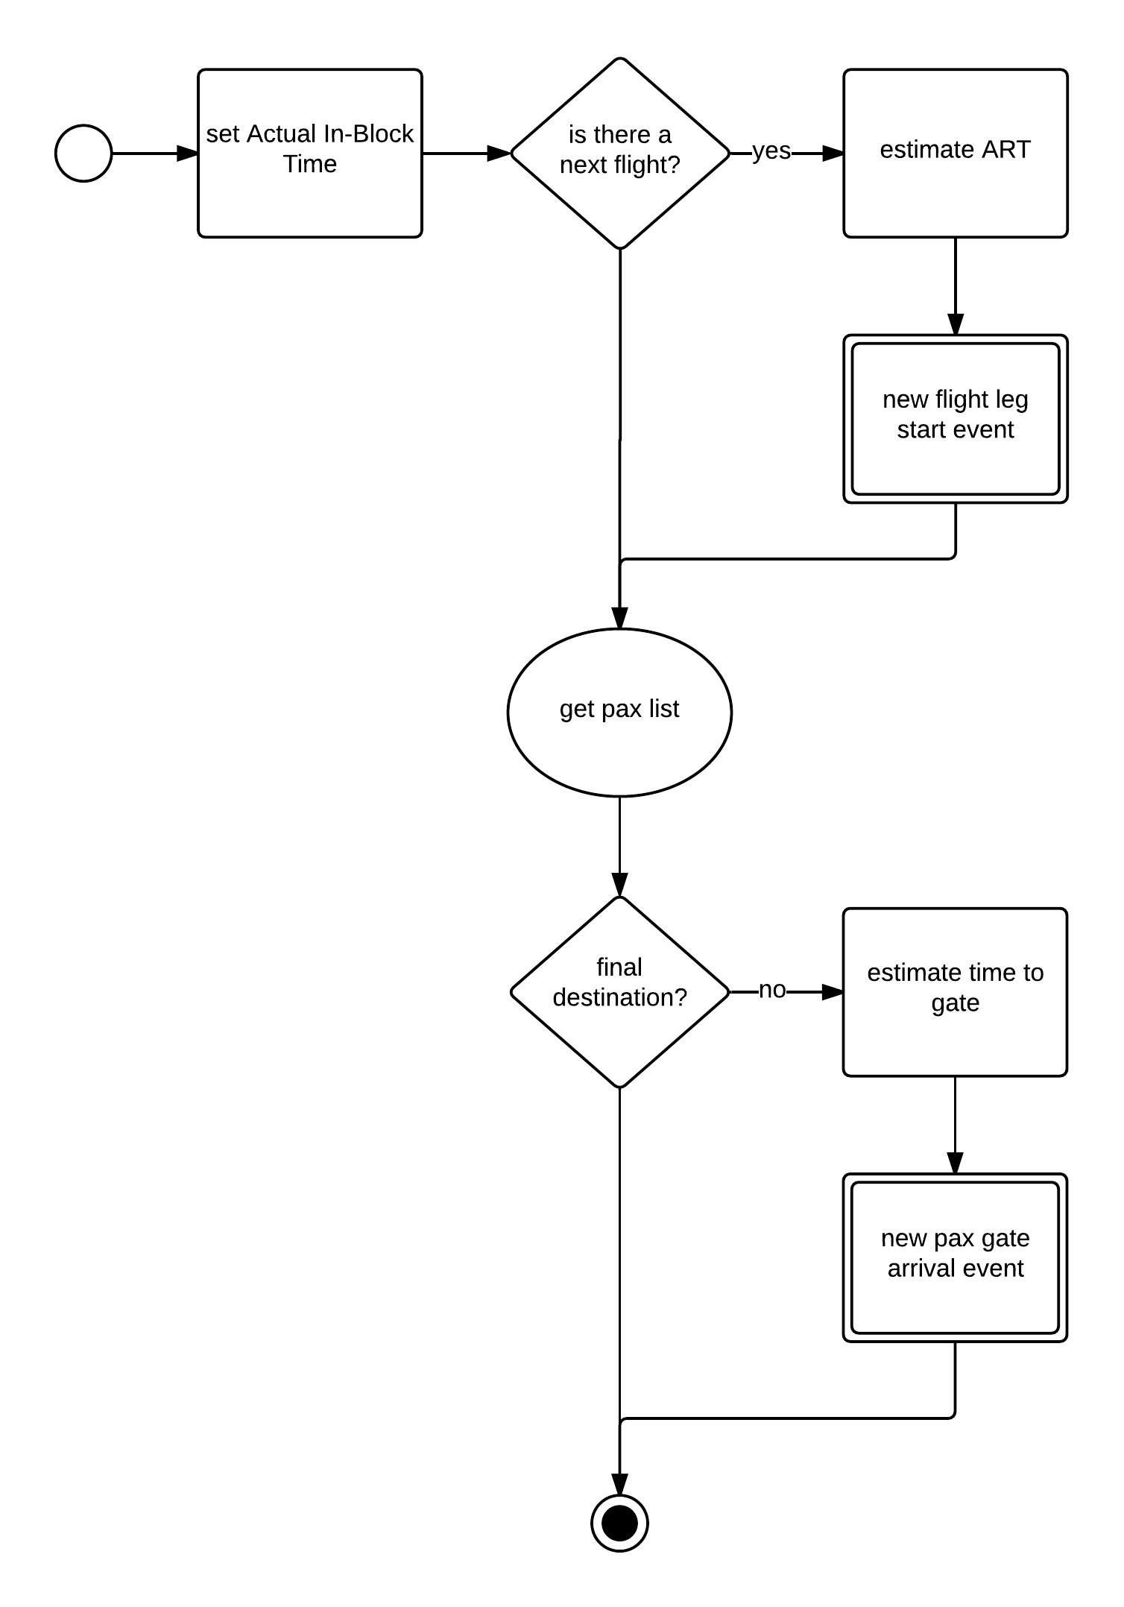
Figure 19. Flow diagram for the Flight Leg End event

The “flight leg start” event is the first event in the flight processes and the stack’s initializing event. First, it is checked whether the flight was cancelled, if so passengers are re-accommodated according to the airlines policies and a new “ready for push-back” event is introduced into the stack for any next flight in the aircraft sequence, if any. For the non-cancelled flights, the location and status of the previous aircraft should be determined. If there is no previous aircraft, the Aircraft Ready Time is set and a new “ready for push-back” event is introduced in the stack. Finally, when there is a previous flight for the aircraft, the Actual Ready time is calculated using the Minimum Turnaround time and the Calculated In-block time and adding a new “ready for push-back” event into the stack.

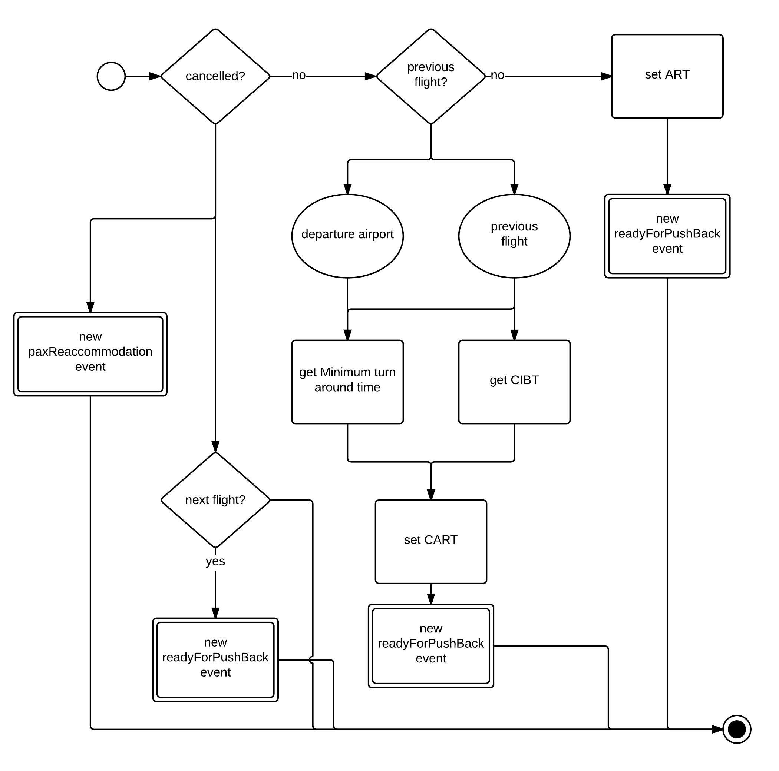
Figure 20. Flow diagram for the Flight Leg Start event

The “landing” event is the previous to the last event in the flight sequence. Starts by setting the Actual Arrival time for the flight, and continues by calculating the In-Block time after the taxi-in time. Finally a new “flight leg end” event is introduced into the event stack.

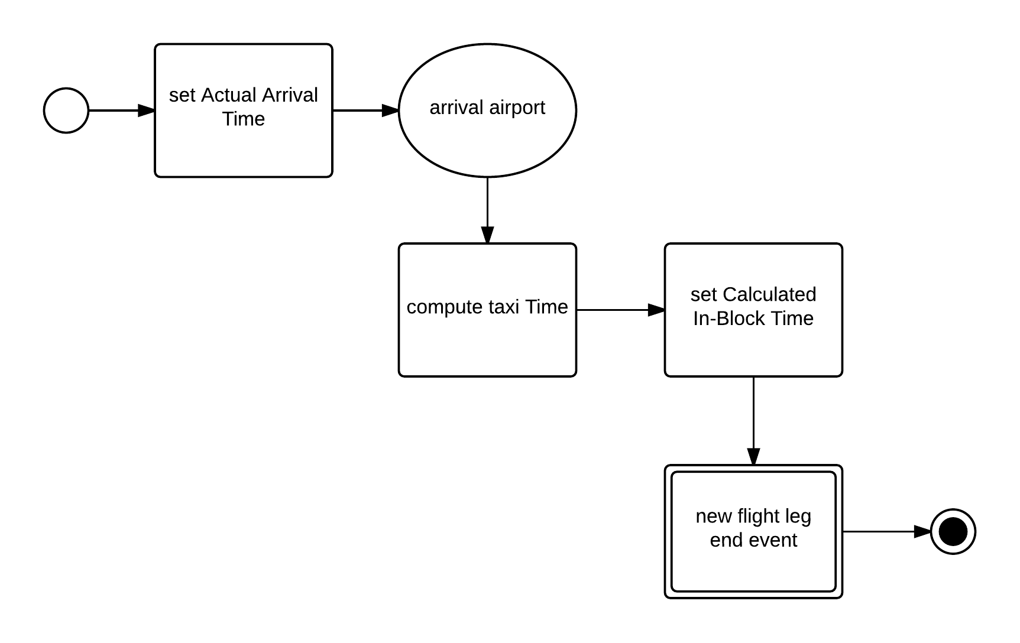
Figure 21. Flow diagram for the Landing event

In the “take-off” event the Actual take-off time is set, then if there is a considerable departure delay there could be a en-route recovery which is now estimated. In any case, flight departure delayed or not, the Arrival Time is estimated and a new “ask for arrival slot” event is introduced into the stack.
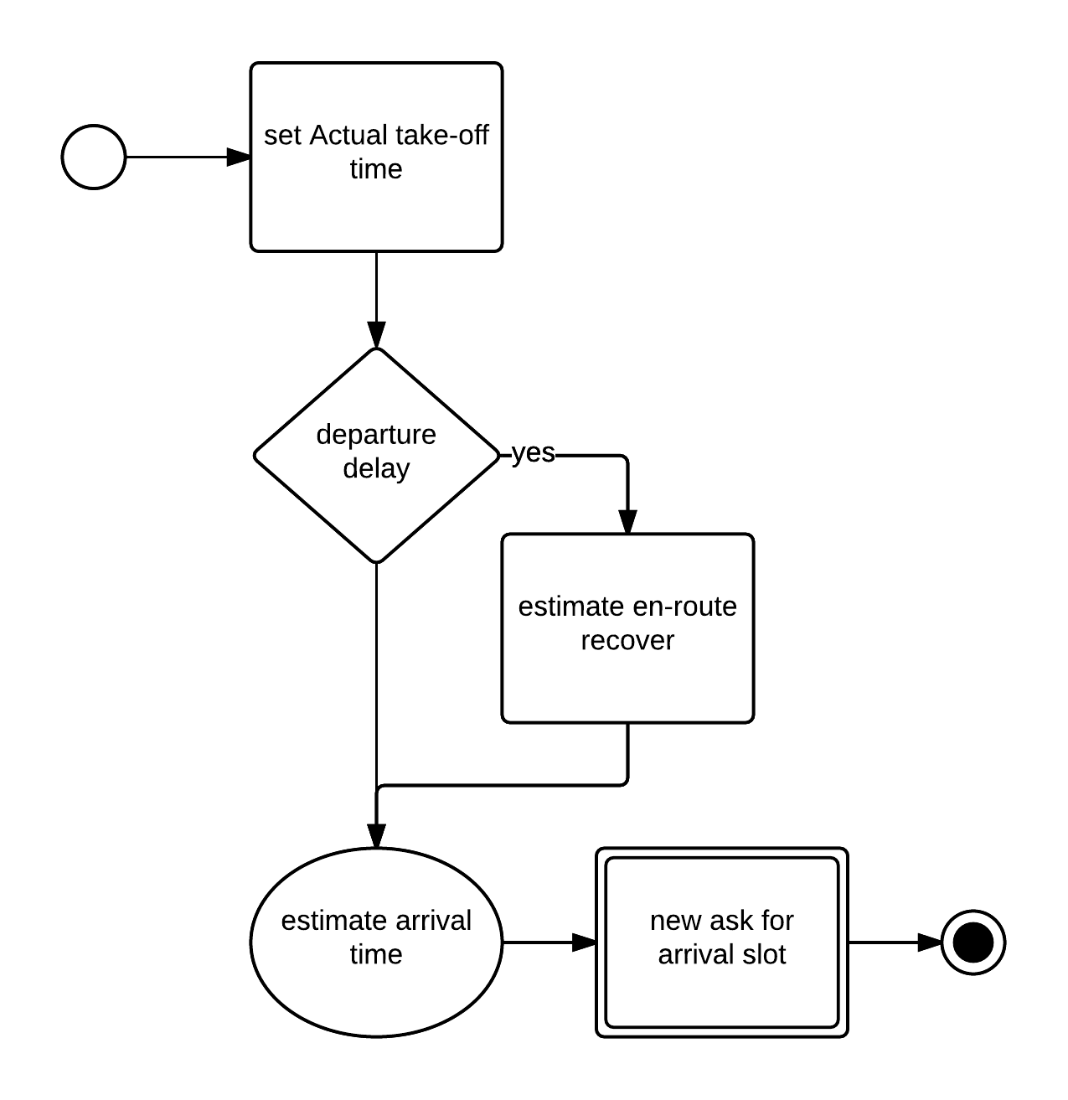
Figure 22. Flow diagram for the Take-off event

The “runway hit” event starts by setting the Actual Runway Hit time, now if the runway is clear a new “manage runway” event is introduced into the stack, otherwise the flight is added to the departure queue. The length of the queue is estimated and the Calculated Take-off Time is updated accordingly.

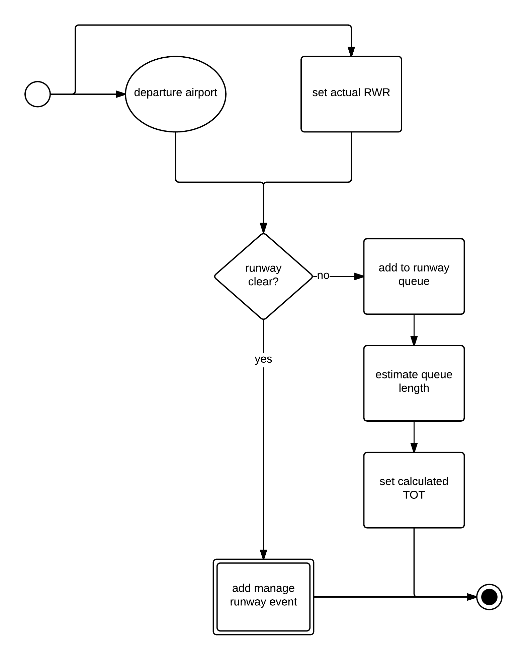
Figure 23. Flow diagram for the Runway Hit event

First, during the “hit PTI” event the Actual PTI time and the Calculated Time of Arrival are computed and updated for the current flight. Next, the flight is added to the airport’s arrival queue, waiting for arrival when there is an available slot. Finally if the runway is clear a new “manage runway” event is added into the stack, otherwise the flight is set to wait on holding.

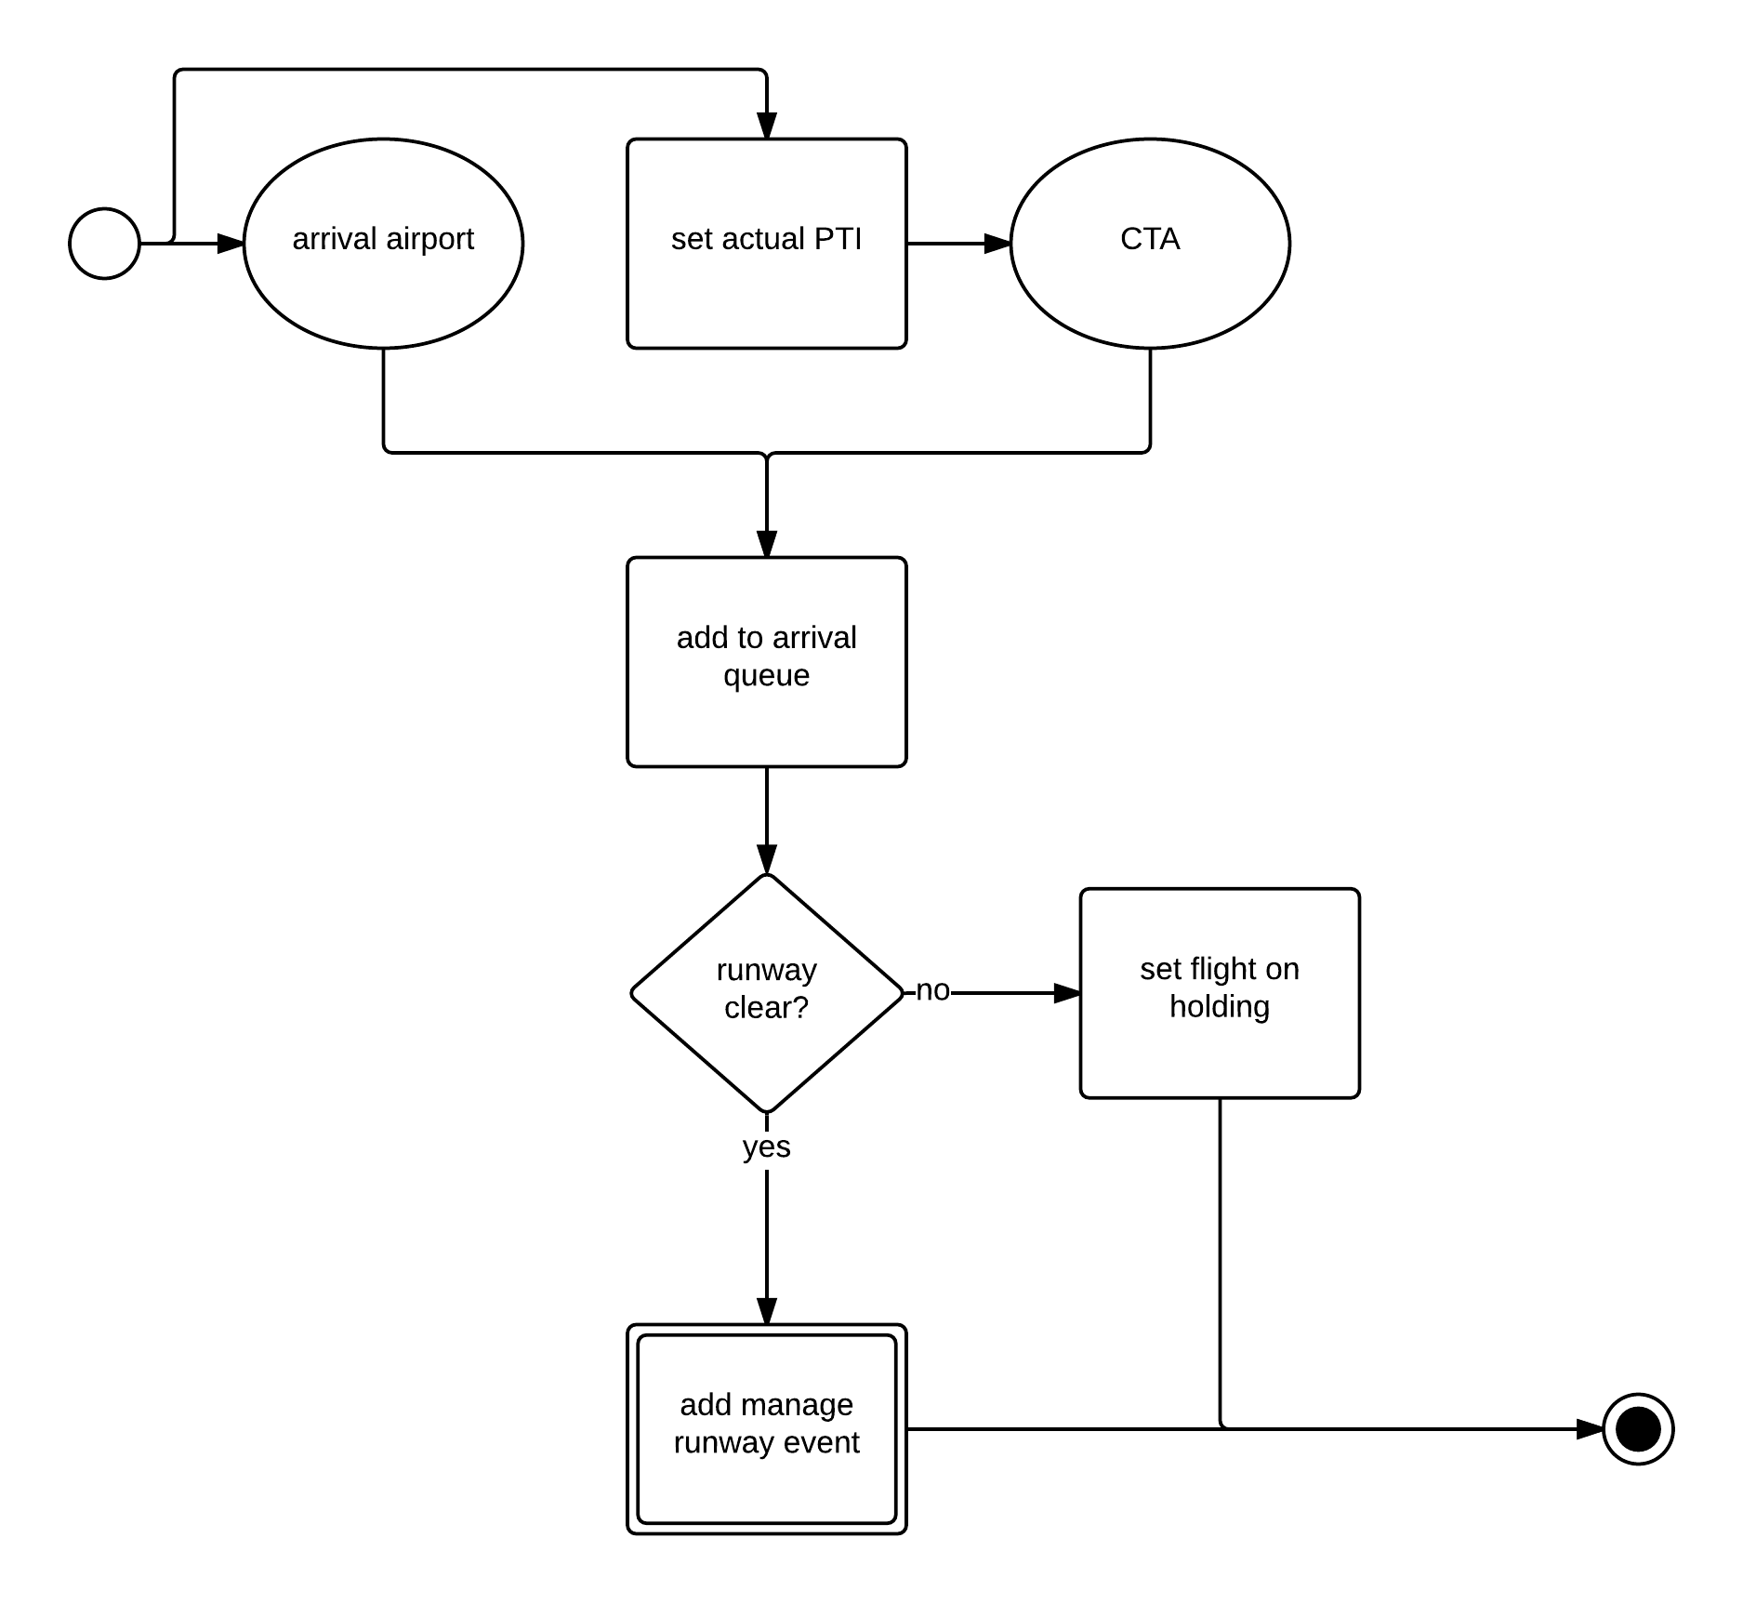
Figure 24. Flow diagram for the Hit PTI event

The “ready for push-back” event first checks for any late passengers. If the flight decides to wait for those passengers, the Off-Block Time is estimated using their Calculated Pax Gate Arrival Time, and a new “ready for push-back” event is introduced into the stack. Passengers left behind, if any, are then re-accommodated. Finally waiting passengers at the airport are tried to be re-accommodated in any of the flight’s free seats and a new “ask for departure” slot is added to the stack.

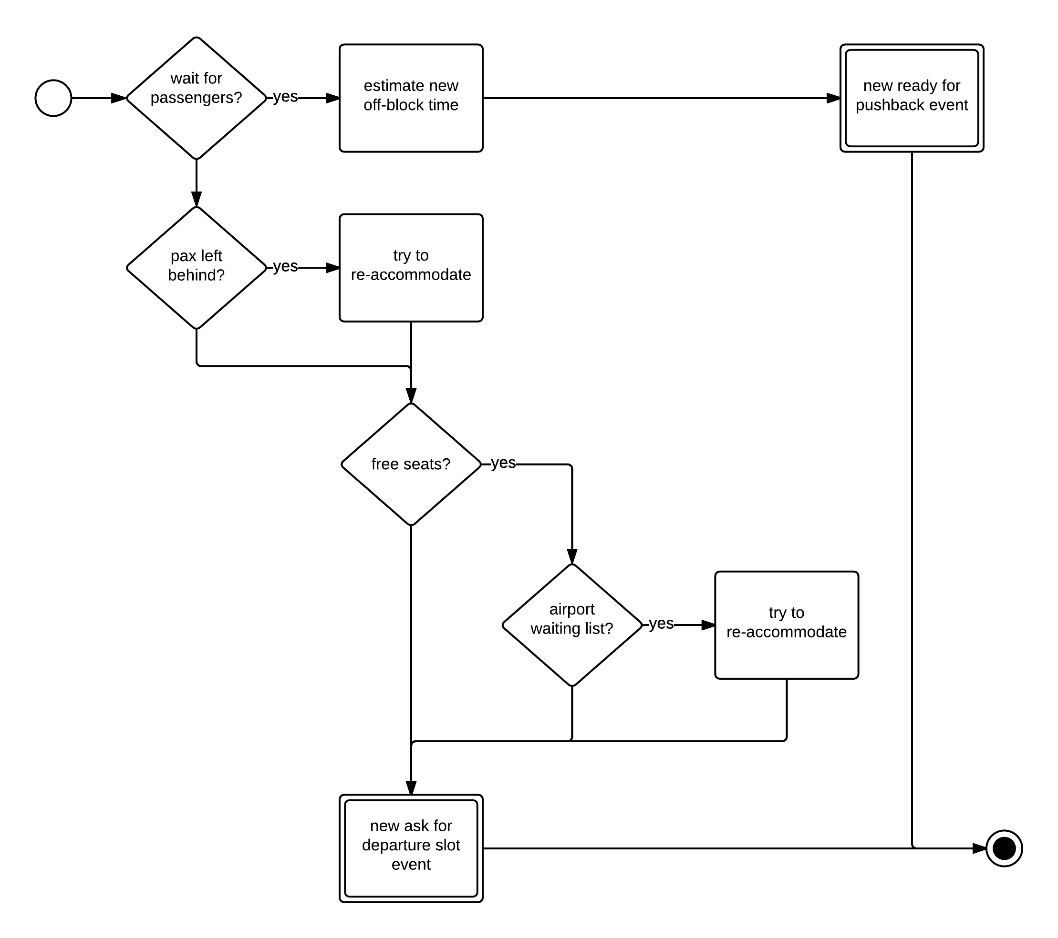
Figure 25. Flow diagram for the Ready for Push Back event

The “pax gate arrival” event starts by setting the Actual Gate Arrival Time for the passengers. If boarding for the next flight is still possible passengers are boarded and the event finishes. Otherwise, passengers are re-accommodated by the airline. Itineraries are updated for successfully re-accommodated passengers, whilst passengers that couldn’t be re-accommodated are added to the airport’s waiting list until a free seat is available in a further flight or first flight next day after an overnight stay.

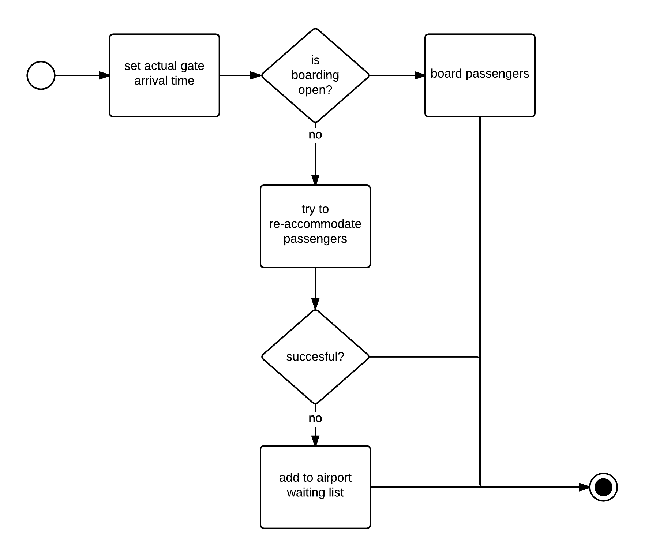
Figure 26. Flow diagram for the Pax Gate Arrival event

The “runway management” or “manage runway” event starts by checking if the runway is currently ready, if not next runway clearance is estimated and a new “runway management” event is added to the stack. If the runway is clear, a flight is selected for arrival or landing for the respective queues. If a departure flight is selected a “take-off” event is introduced into the stack, otherwise a “landing” event is added to the stack.

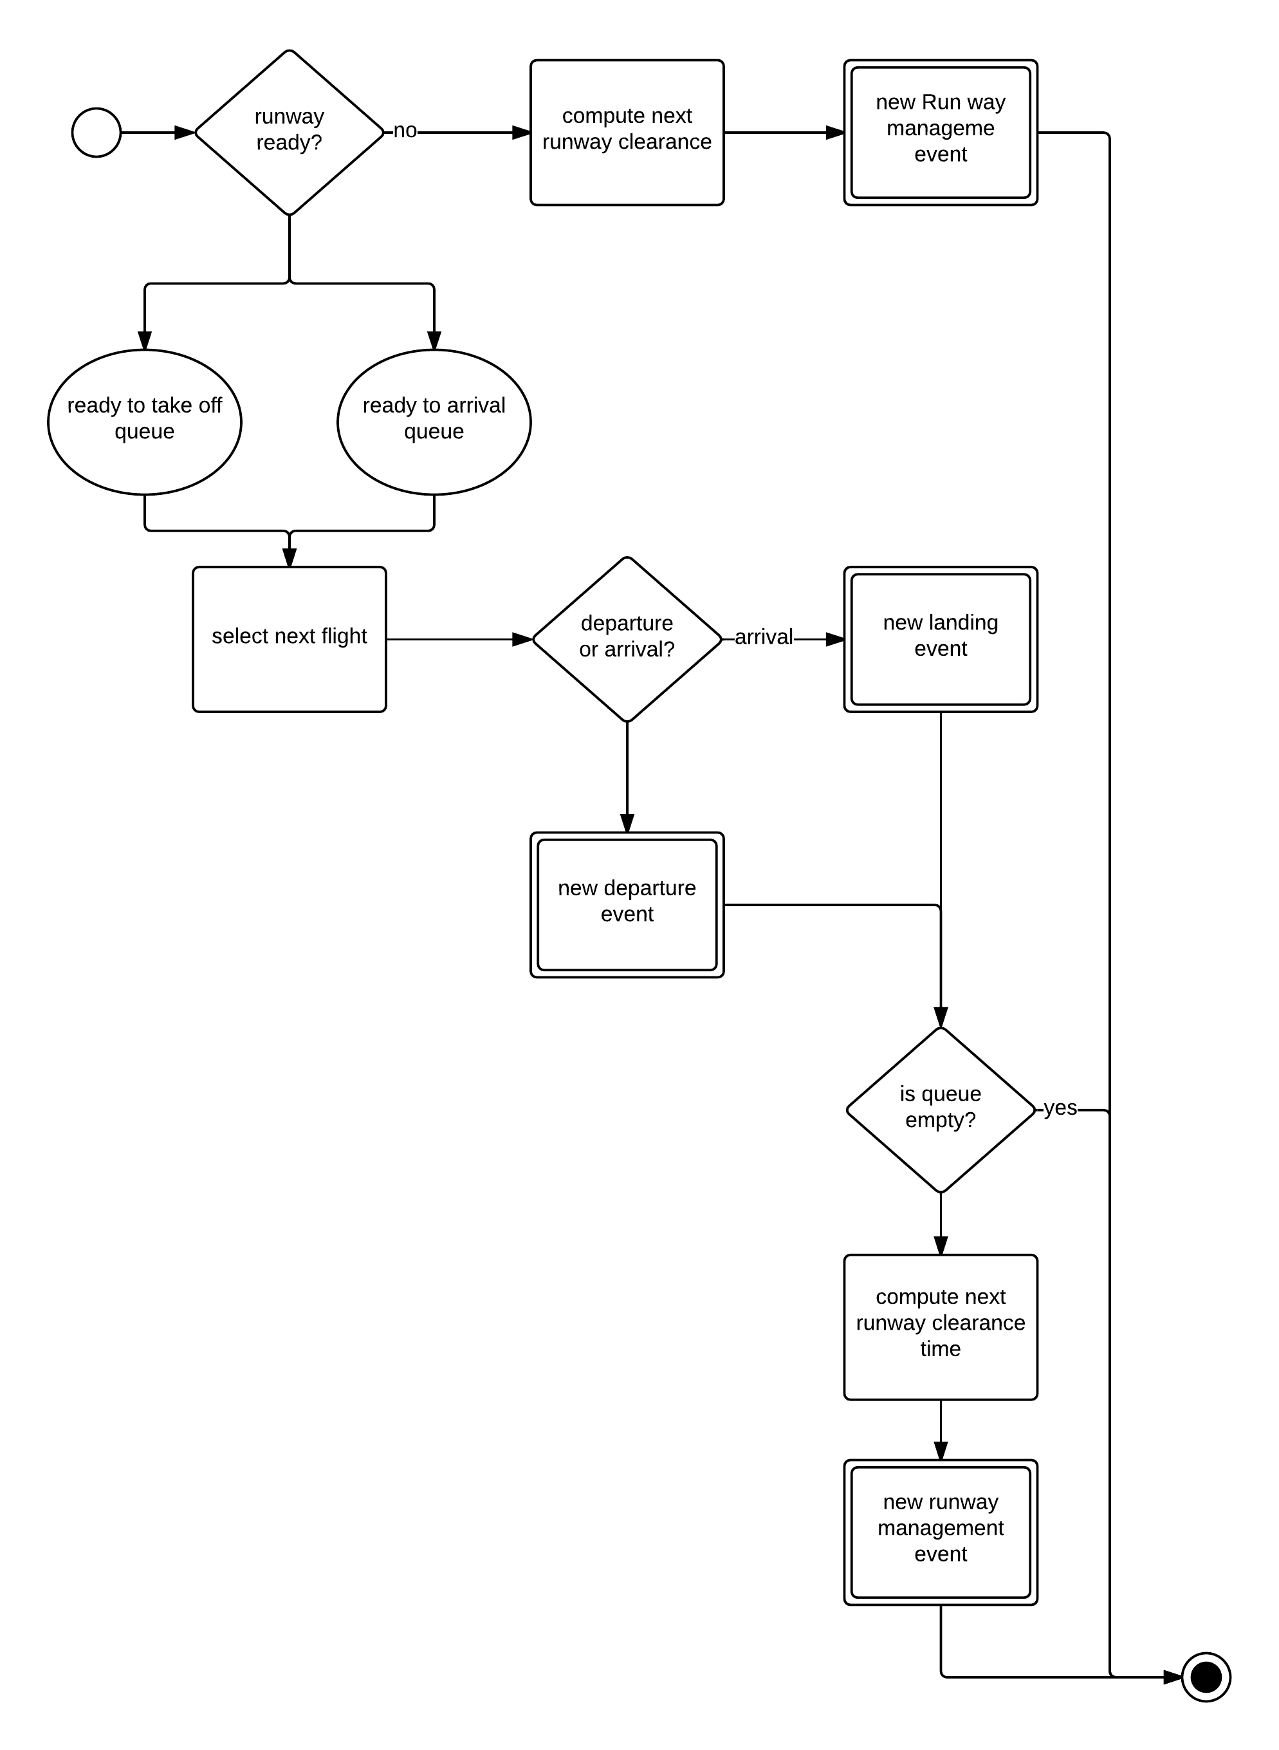
Figure 27. Flow diagram for the Runway Management event

Passenger and traffic models

Temporal and spatial scope of the passenger and traffic model
In Deliverable 1.2, we stated in Section 3.1.2.2 that the traffic and passenger data for the model is anticipated to be focused on a busy day in 2014. We are thus not planning on modelling future traffic scenarios, but rather to examine the implications of various investment mechanisms using 2014 traffic. The primary strength of the project lies in the methodology applied rather than the traffic base per se to which it is applied. We therefore prefer to use actual traffic data rather than forecast values, although the methods developed could of course be applied to any sample.
We therefore propose the selection of Friday 12SEP14 as the modelled (baseline) traffic day, due to:
- The requirement for a high degree of similarity with the existing passenger dataset (Friday 17SEP10), i.e. 17SEP10 passenger itineraries will be assigned to 12SEP14 flights;
- Fridays in 2014 continuing to be the busiest traffic day each week (analysis of DDR2 data, see Table 19);
- The three other Fridays (out of four) in SEP14 experiencing disruption caused by major airline strikes (Lufthansa and Air France);
- Friday 12SEP14 being the second busiest day in SEP14 and the fourth busiest day of 2014 (analysis of DDR2 data, see Table 19).

Table 19. Top 10 busiest traffic days in 2014
Rank (year) | Rank (month) | Date | Total flights | Total ATFM delay minutes | Total ATFM strike delay minutes | Total ATFM weather delay mins | Commentary
1 | 1 | Fri 27JUN14 | 34 537 | 41 766 | 0 | 7 827 | Preceded by French/Belgian ATC strike (see below)
2 | 1 | Fri 29AUG14 | 34 124 | 43 647 | 0 | 5 435 | Lufthansa/Germanwings strikes
3 | 1 | Fri 05SEP14 | 34 047 | 26 575 | 0 | 7 688 | Lufthansa strike
4 | 2 | Fri 12SEP14 | 33 810 | 29 164 | 0 | 9 707 | Selected baseline day
5 | 2 | Thu 26JUN14 | 33 769 | 41 939 | 5 169 | 7 457 | French/Belgian ATC strike
6 | 2 | Fri 01AUG14 | 33 577 | 40 080 | 0 | 1 516
7 | 1 | Fri 25JUL14 | 33 575 | 87 228 | 0 | 56 394 | Bad weather reported
8 | 2 | Fri 11JUL14 | 33 546 | 70 096 | 0 | 35 044 | Bad weather reported
9 | 3 | Thu 28AUG14 | 33 526 | 38 704 | 0 | 1 013
10 | 3 | Fri 13JUN14 | 33 503 | 31 632 | 145 | 7 987
Source: number of flights from DDR2; ATFM delay from NM ATFCM daily briefings (EUROCONTROL, 2014f); total ATFM strike delay minutes combines ATC and non-ATC strike delays.

Table 19 also illustrates that flight cancellations (and their associated disruption) are not always captured by standard Network Manager reporting, e.g. no ATFM strike minutes are reported for 29AUG14 and 05SEP14 despite strikes by Lufthansa and Germanwings.
In addition to using this busy day (12SEP14), an alternative traffic scenario will be applied on the ComplexityCosts model. The characteristics of the second traffic scenario are yet to be finalised, however the choice includes a day with:
- Widespread disruption covering Europe, e.g. due to a major airline strike;
- National disruption covering a country, e.g. due to an ATC strike;
- Localised disruption covering a region or airport/airport group, e.g. due to weather.
Rather than modelling a new day, the baseline traffic dataset will be adjusted to reflect the scale of the disruption, including the removal of cancelled flights and delaying disrupted flights (and the ‘knock-on’ effects that result, e.g. due to out-of-position aircraft).
In Deliverable 1.3, we presented the anticipated flight, airspace and airport coverage. No further updates are anticipated with regard to this. Note that aircraft seats, load factors and passenger numbers are discussed in Appendix A (Annex 3).

Update on passenger allocation method
As introduced in the previous section, the selected baseline traffic day requires a high degree of similarity with the original passenger dataset, such that the new mapping of passengers onto the 2014 flights is reasonably robust. To recap on the passenger allocation method (outlined in Deliverable 1.3), the existing passenger dataset was developed in-house to assign aggregated passenger itineraries from IATA’s PaxIS dataset to individual flights supplied by EUROCONTROL’s PRISME data service. In respecting load factor targets per route, maximum seats per aircraft, airline schedules and various other parameters, the overall target passenger total for 17SEP10 was calculated to be 2 868 522 passengers (from the 14 272 unique airline-routes). Of these 2 868 522 passengers, 80% were allocated to direct flights, 18.75% had one connection (i.e. two flight legs) and the remaining 1.25% had two connections (i.e. three flight legs). These proportions were consistent with overall connections observed in the PaxIS dataset over the whole month.
The overall steps in the calculation of the new 2014 itineraries are anticipated to be as follows. For a typical Friday in SEP14:
- Calculate the total increase in passengers over the whole network from 2010 to 2014. Assign this value to a ‘balancing pool’ (of reserve passengers). These data will be sourced from Eurostat, verified with other sources including AEA, ACI EUROPE and GDS data (anonymised sample supplied by a large GDS).
- Calculate a network seat capacity difference map (2014 – 2010), per (airline) route-leg. Most of such legs will probably have the same seats as per 2010 (i.e. the difference will be zero); many legs will have a positive difference (due to additional flights and/or upgauging); some legs will have fewer seats (a negative difference) – due to fewer flights and/or downgauging.
- Assign new passengers in (1) to new capacity in (2), using the existing rules described.
- If step (3) works to within 5% (i.e. 95% of the balancing pool is allocated), allocate the residual 5% of the balancing pool stochastically across all direct flights (respecting the load factor rules). If step (3) fails in this respect, it will be revised.
Although the resulting 2014 passenger dataset will probably have some additional imperfections relative to the 2010 dataset, such shortcomings are not injurious to the modelling as a major requisite here is that each model run is based on the same traffic-passenger baseline day, thus rendering comparative analyses valid. Furthermore, this 2014 dataset will be unique: to the best of our knowledge, no similar dataset, with comparable geographical scope, exists.
Passenger statistics covering 2014 have yet to be published. Although 2013 saw average daily IFR flights in Europe decrease by 0.8% (compared with 2012), load factors and average aircraft size continued to increase leading to a growth in passenger numbers (EUROCONTROL, 2014a). With regard to the passenger increase anticipated from 2010 to 2014, Figure 28 shows passenger growth of 8.2%-10.4% from 2010 to 2013, i.e. with the most recent full years’ data from AEA and Eurostat.

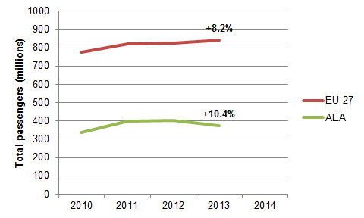
Figure 28. Total passengers per year
Source: EU-27 total passengers carried (Eurostat, 2014); AEA total scheduled passengers (AEA, 2014)

Neither source perfectly satisfies the objectives. The Eurostat EU-27 data does not exactly correspond with the ECAC states (some are not included in the Eurostat data), and the AEA data covers scheduled passengers from around 30 airlines (the exact number depending on the year in question) and may include passengers carried between non-ECAC states. A third source of 2014 passenger numbers will be available in AUG14 when ACI EUROPE finalise their reporting statistics.

Sourcing of schedule data
Deliverable 1.3 identified the sourcing of flight schedule as a likely data requirement. To recap the problem, airline departure and arrival schedule times are unavailable through DDR2 (or other EUROCONTROL channels), and need to be purchased. Table 20 and Table 21 summarise the key requirements for the data purchase made with Innovata (now part of Reed Business Information).

Table 20. Schedule data requirements – overview
Description | Requirement
Validity period | SEP14
Geographical coverage | all flights in/out/within ECAC
Carriers | all carriers
Code shares | Yes

Table 21. Schedule data requirements – standard data fields
Description | Requirement
Flight ID | flight number
Carrier | carrier code and name
Aircraft | aircraft type
Origin | airport code
Destination | airport code
Departure time | time
Arrival time | time
Service days | each day flights operate 1234567
Arrive day | same day or +1/-1
Stops | number of stops before arrival
Duplicate | flag duplicate flights due to code shares
Stop locations | airport codes
Effective date | schedule validity from and to dates

The Global Directs file has now been received by the University of Westminster. Next steps relate to preparing the schedule data for matching with individual flights. Preparation tasks include the recoding of airline/airport codes from IATA to ICAO format and converting local times to UTC.

Disturbance models
In “regular years” (i.e. without major disruptions like the ash cloud crisis in 2010): on average less than 1.5% of passengers are affected by delays of more than two hours and less than 1% by cancellations, but such events have a significant impact for the affected passengers and their frequency may suddenly increase during exceptional events (European Commission, 2013e). Note that more than half of the primary delays in 2013 (52%) were due to issues with the turnaround phase caused by airlines, airport operators, ground handlers and other parties (EUROCONTROL, 2014a).
In order to assess the benefit of the different mechanism, disturbances that generate a degradation of the system performances in term of flights and/or passenger delays (C_{u}(t)) should be considered. These disruptions must be established over realistic behaviour in a temporal and spatial evolution. This will allow us to model the effect of the disruptions to the network over time and assess how the mechanism facilitate the recovery and improve the cost resilience.
In this section the main characteristics of the different disturbances considered in Complexity Cost are presented with information regarding how they could be modelled and the data sources available. Some disruptions have been selected to be considered to be modelled considering the impact of the disturbances, the possibility to model them and their alignment with the different mechanism.

Types of disturbances
There are six main categories of disruptions identified for ComplexityCosts, as shown in Table 22.

Table 22.Mechanism main characteristics and cost availability
Type of disturbance | Manifestation and impact | Discussed in
Meteorological events | Meteorological events can be local or widespread. Significant meteorological events will reduce the capacity of infrastructure leading to regulations that will in their turn generate delay, cancellations and re-routing. The capacity reduction can be at an airport or at an airspace level. | Section 4.3.1.1
Strike actions | Industrial actions at different levels:  - Airport services: leading to longer turnaround times and therefore delays at the affected airport.  - Airline: leading to cancellations and delays within the airline affected.  - ATC: a reduction in capacity due to lack of staff would be produced in the areas affected by an ATC strike. This will lead to ATFM regulations being in place and, therefore, to delays, cancellations and re-routings. | Section 4.3.1.2
Technical failure | The failure of ATC/ATM systems will lead to a reduction in capacity and presumably to an ATFM regulation.  Technical failure might occur to individual aircraft (e.g. technical failure detected prior departure). This will lead to the delay and/or cancellation of the affected flight. | Section 4.3.1.3
ATFM restrictions (non-weather) | An ATFM restriction will be imposed when there is a mismatch between capacity and demand. In this particular category the regulations due to capacity demand imbalance not covered by the previous disturbances would be considered. | Section 4.3.1.4
Passenger disruption | This disruption is responsible for flights that are delayed, which the primary cause of the delay is the passenger behaviour, such as, late arrival to check-in, no boarding when bag has been checked in or missed connections even if there is enough time at the hub to theoretical do the connection. | Section 4.3.1.4
Military exercises | Military activities represent a reduction of the airspace and routes available. This leads to longer routes. | Section 4.3.1.5

Meteorological events
Aviation is highly weather dependent; main area concerns are approach, departure and ground operations (Muehlhausen, T. and Kreuz, M., 2012). As defined in (European Commission, 2011c), the critical meteorological events having an impact on efficiency and safety of air traffic are:
- Thunderstorms and lightning,
- Low visibility, associated with cloud, mist, fog, snow or sand storms,
- In-flight icing, ground icing,
- Wind, gusts and wind shear,
- Heavy precipitation including snow and ice as well as surface contamination (standing water, ice, or snow on take-off, landing and manoeuvre surfaces),
- Turbulence (in clouds or clear air),
- Volcanic ash, and,
- Sandstorms.
Meteorological events impact aviation at two different levels:
- Airport disturbance: As weather conditions deteriorate, separation requirements generally increase and runway throughput is reduced and therefore delays are generated. However, there is a high variability on the impact of weather (visibility, wind, convective weather, etc.) on operations at an airport and hence the disruptions can vary significantly by airport. Several factors impact the effect of the weather on the infrastructure, such as ATM and airport equipment (instrument approach system, radar, etc.), runway configurations (wind conditions), and procedures (EUROCONTROL, 2014a). As expected, capacity reductions at airports operating close to their maximum capacity can lead to significant disruptions (Muehlhausen, T. and Kreuz, M., 2012). Thus, weather phenomena even at a low level (e.g. wind, rain, snow) might significantly affect the infrastructures (European Commission, 2010b).
- Airspace disturbance: Convective weather might have an impact on the capacity of en-route sectors. However, there is no evidence to show that the reduction in declared en-route capacity is based on objective rather than subjective criteria with the result that it is seen as being haphazard (EUROCONTROL, 2014a). Moreover, as these regulations are implemented in a reactive manner, there is some traffic affected that is already in the air requiring tactical re-routings (EUROCONTROL, 2014a).
Figure 29 shows how the different weather phenomena impact the air transport operations. As previously mentioned, the interest on modelling the meteorological phenomena is to see how it affects traffic (e.g., increasing aircraft separation (lower airport capacity), closing airports/runways or imposing operational restrictions). The effect in traffic will lead to delays, cancellations and/or re-routings. In general, meteorological events can be modelled as flights delays (airborne and/or on-ground), flight cancellations and/or flights extensions (avoiding low capacity areas).
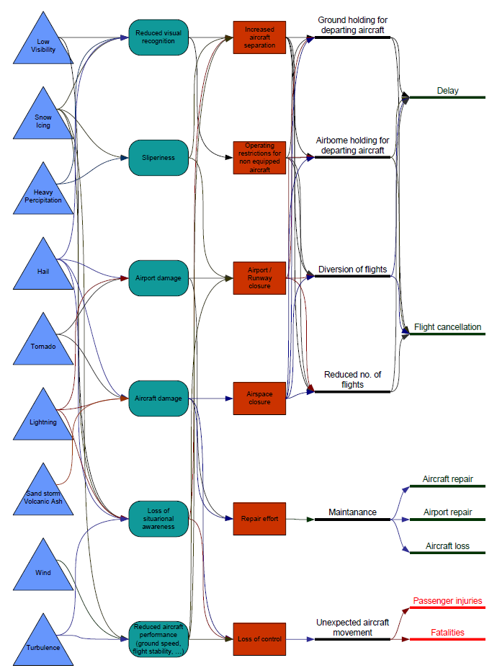
Figure 29.Causal weather diagram for aviation
Source: (European Commission, 2010b)

In 2013, 14.3% of the total en-route ATFM delays were due to weather (EUROCONTROL, 2014a). Weather was the primary cause of 13% of the regulations of the AIRAC 1409 (21th August to 17th September 2014), being the fourth most common cause for a regulation after ATC capacity, ATC routing and aerodrome capacity. However note that airport throughput is usually affected by meteorological conditions and weather represents by far the main reason for Airport Arrival ATFM Delay, followed by capacity/staffing related issues (EUROCONTROL, 2014a).
The probabilities of having a given meteorological event are not evenly distributed through Europe. As presented in Figure 30, six different climatological regions have been identified (European Commission, 2012c). In general, the Northern European and mountainous regions are more prone to winter extremes, such as snowfall and storms, while heat waves are more probable in Southern Europe; extreme winds and blizzards are more common over the Atlantic coast line; heavy rainfalls might affect the whole continent; and low visibility conditions have decline over the last years at the main European airports (European Commission, 2012c). The infrastructures at all the different weather regions (Scandinavia, Temperate, Alpine, Mediterranean and Maritime) could be affected by low temperature, snowfall, wind gusts, fog and heavy precipitation phenomena (European Commission, 2010b).

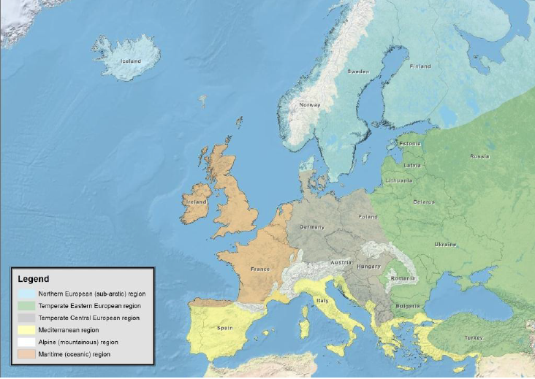
Figure 30.European climate regions based on selected climatic extremes.
Source: (European Commission, 2012c)

(European Commission, 2012c) presents a forecast of the evolution of the main meteorological phenomena for the different European meteorological regions on the 2050 framework. The phenomena that will become more probably to affect aviation should be included in ComplexityCosts. The main trends of adverse and extreme weather events probability evolution for each extreme climate region are shown in Figure 31. However, the effect of climate change for air traffic can be hardly foreseen, as there are many overlapping effects (e.g., a reduced number of fog situations, but an increased number of thunderstorms which results in more temporary closure of airspace or airport or sandstorms in the Mediterranean region reduce the visibility). The main evolution of meteorological events on the different region are:
- Temperate Central European region: Wind gusts over 17 m/s will be the most likely event to disrupt aviation. Fog and cold waves, even 1cm/day snow, are events that will persist on the region. Extreme snowfalls combined with non-existing extra capacity of runways might have a quick and serious impact. However, it is expected in the future, that cold waves will decrease.
- Temperate Eastern European region: The weather phenomena that most likely will disturb aviation are snowfalls and cold waves.
- Oceanic region: The British Isles will be prone to blizzards, extreme cold spells and heavy snowfalls and wind gusts. This might affect hub airports such as London Heathrow or Paris Charles de Gaulle.
- Mountainous region: The most likely series of events to harm aviation seems to start from snowfalls or wind gusts. These extreme weather events have significant influence on the performance at airports such as Zurich and Munich.
In general, the effect of meteorological events on aviation is expected to increase in the future as traffic grow (European Commission, 2012c).
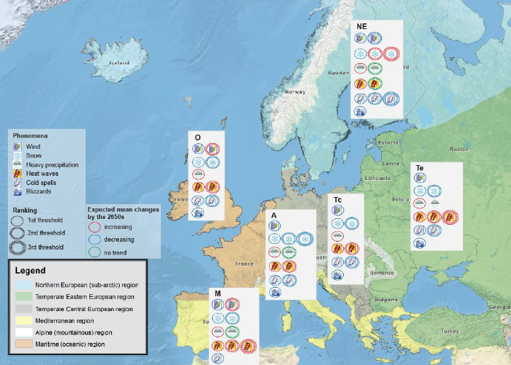
Figure 31.Classification of climate regions for the 2050s.
Source: (European Commission, 2012c)

Some degree of climate change is now inevitable due to inertia in the climate system as depicted in Figure 32. Some weather resilience need to be implemented to deal with potential changes in the infrastructure and the network (EUROCONTROL, 2013c).

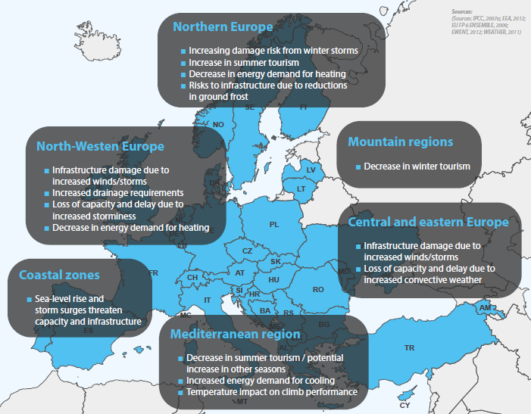
Figure 32.Potential climate change aviation impact
Source: (EUROCONTROL, 2103c)

The following weather phenomena are described in detail: wind, snow, low temperature, blizzard, thunderstorms, heavy precipitation and lightning strikes, fog and volcanic ash. Table 23 presents the impact and consequences for aviation for those phenomena, as defined in (European Commission, 2011c).
Table 23.Threshold values for aviation
Phenomena | Threshold | Impact | Consequences
 |  |  | Delays | Diversion | Cancellations | Re-routing
Wind | Head wind Vhead<Vmin | Reduced ground speed
 | Tail wind 10 kt for 4 km runway | Reduced lift / moderate take-off, landing
 | Cross wind/gust aircraft dependent | Stabilisation of aircraft / moderate in landing
Snow | Location dependent | Low visibility  Higher separation between aircraft
Low temperature | Temperature < 3°C,  Temperature < 15°C when the aircraft airborne more than 3 hours and time at ground is very short | Need of de-icing procedures at airport
Hail | Diameter higher than 2.0 cm | Airport closure  Loss of situational awareness
Heavy precipitation | 30 mm/1h | Runway closed  Loss of situational awareness
 | 60mm/6h | Airport limited infrastructure
 | 90 mm/12h | Airport limited infrastructure  Total airport closure
 | 150 mm/24h | Airport limited infrastructure  Total airport closure
Lightning | Airport within 5 km radius | Airport ground operations interupted
Low visibility | CAT I | Separation between aircraft increased
 | CAT II | Separation between aircraft further increased
 | CAT IIIa | Separation between aircraft further increased
 | CAT IIIb | Separation between aircraft further increased
 | CAT IIIc | Airport closure
Volcanic ash | 0.2-2 mg/m3 | Airspace closure

Based on (European Commission, 2011c), (European Commission, 2010b)

(a) Wind
Geographically the Atlantic region is the one affected the most by wind gusts (i.e. British Isles, Iceland and the coastal area). In (European Commission, 2012c) it was reported that between 40-80 days a year those regions experience wind gusts over 17 m/s. Most of the continent experiences between 10 to 20 days of strong wind gust and extreme wind gusts events (>25 m/s) occur rarely and sporadically (European Commission, 2012c). With the limited data availability (22 years) analysed in (European Commission, 2010b), no trend has been computed on the evolution of number of days of extreme wind situations.
It is difficult to stablish a limit on wind that leads to a suspension of a runway, as it varies from airport to airport (it is wind and airport dependent). Annex 3 of ICAO defines that a runway should have an expected 95% of the time operation with less than 20 knots of cross-wind. Even if for each aircraft type different wind tolerance limits are defined, each airfield sets a rule to regulate the use of runways depending on the exact wind measurements (European Commission, 2012d).

(b) Snow
Snow events impact practically the entire continent with an increase in probability toward Northern, Eastern Europe and the Alpine region, where the frequency of days with snow varies between 100-140 days/year (European Commission, 2012c). Heavy snowfall (≥20 cm/24 h) is frequent over Northern Europe (Norway and Iceland) and the Alps: 10-25 cases/year. Dense snowfall (≥10 cm/24 h) occurs only sporadically over Western, Southern and most of Central Europe (max. 5 days/year). If a low 1cm snowfall threshold is analysed a wide area in Europe might be affected. This thin snow cover may cause disruption, particularly in the regions where snow probability is low as infrastructures and procedures might not be adequate (European Commission, 2012c).
For air traffic, snowfall is translated to three different effects: low visibility, slippery runways and icing. As presented in Figure 29, low visibility leads to higher separation required and therefore delays; slippery runways results in longer runway occupancy times and therefore in higher separation requirements; and finally, de-icing process increase the turnaround time. In the event of high disruptions, the snowfall might result in a closure of the airport infrastructure (European Commission, 2012d).
Low visibility and slippery at the runways might led to the closure of the airport and/or high delays and cancellations. The de-icing procedures start at temperatures of 3°C, which can be in extreme cases rise up to 15°C when the aircraft was airborne more than 3 hours and time at ground is very short, as overcooled fuel might be in the wings and could lead to icing at critical parts of the aircraft wing (European Commission, 2010b).
According to (European Commission, 2010b), in average de-icing procedures take about 10 min at the de-icing pads/de-icing area or about 20 min when the aircraft is at its position. The main parameters affecting these values are:
- the number of employees per de-icing pad,
- the number of de-icing vehicles available at the same time and
- the consistency of snow
Some examples of the effect of snow on aviation are the snowstorms of Athens airport on January 5th to 7th of 2002, on February 14th to 16th 2004, on January 24th to 26th 2006 and on February 16th and 17th of 2008. These episodes lead to Athens to update their procedures and measures to prevent the customers’ services problems that arouse in the first episodes (European Commission, 2012d). The 7cm per hour snow fall that affected London Heathrow in December 2010 led to a cancellation between 7% to 95% of departures in the period of 16th to 21st of December and the rest of the flights where highly delayed (European Commission, 2010b).

(c) Low temperature
In the event of low temperature, some processes at airport become more complex and longer (e.g. need of de-icing). Most of the continent is free of very extreme cold spells (< -20°C) with the exception of Scandinavia and the North-East part of Europe (which experience between 5-30 days/year below that threshold). The frequency of frost days varies from 100 to 200 per year in Scandinavia and decreases southwards, to about 20 days per year (European Commission, 2012c).

(d) Blizzard
A blizzard is defined as a severe storm with low temperature, sustained wind or frequent wind gust and considerable precipitating or blowing snow. In (European Commission, 2012c) a blizzard is considered to occur when the following criteria are met: snowfall exceeding 10 cm/24 hours, wind gust ≥ 17 m/s and daily mean temperature below 0°C.
There is a relatively low frequency of blizzards in Europe; the areas more prone to this meteorological phenomena are the Alps and Northern Europe (30-40 cases in 30 years). Due to the coarse resolution of the ERA-Interim data used in analysis performed by (European Commission, 2012c) and the difficulties in wind gust predictions, the total number of blizzard events might be underestimated (European Commission, 2012c).
For aviation, the impact would be similar as wind, snow and fog: low visibility and reduced infrastructure capacity leading to delays and cancellations.
(e) Thunderstorms
In the same area, or close by, where there are thunderstorms, microbursts, strong wind shear, turbulence, icing, heavy rain, lightning strokes and hail might exists, which could be hazardous for aviation (European Commission, 2011c). This might lead to re-routing, airport partially closure.
(f) Heavy precipitation and lightning strikes
As indicated in (Vajda et al., 2011), intense precipitation events lasting only few hours or even less can cause adverse impacts to the transport system; however, this events are limited. The probability of heavy rainfall exceeding 30 mm/24 hour over the European continent is 2%. The frequency of days with 30 mm is higher in the Alps and on the western cost of the British Isles, the Iberian Peninsula and Scandinavia (Vajda et al., 2011). In its turn, Vajda et al., 2011, account that extreme rainfall events (≥ 100 mm/day) are rare, in general 10-20 cases in 30 years over Western Norway, parts of the Mediterranean, Alps and sporadically over Eastern Europe.
Heavy precipitation will lead to a reduction of airport capacity (i.e. higher separation) and in some cases to the total closure of the airport. If the airside is flooding then the airport would be closed. If lightning stroke has been observed within a 5 km radius around the airport, airport ground operations have to be terminated (European Commission, 2011c).
(g) Fog
When low visibility is present airports must operate with a higher ILS landing category leading to higher separation and therefore a reduction on the infrastructure capacity (European Commission, 2010b). Table 24 shows the different categories with their horizontal (runway visual range) and vertical (ceiling) requirements.

Table 24.ILS-Categories
Category | RVR | Ceiling [*100ft]
Non-precision approach | Visibility > 1500 m and RVR > 1450 m  800 ≤ RVR ≤ 1450 m | 300 ≤ C ≤ 1450 ft
CAT I | 440 ≤ RVR ≤ 750 m | 200 ≤ C ≤ 250 ft
CAT II | 350 ≤ RVR ≤ 500 m | 100 ≤ C ≤ 150 ft
CAT III | ≤ 325 m | ≤ 50ft

Even if climate affects the geographical distribution of fog over Europe, local conditions play an important role, thus some airports are more fog-prone than others. METAR reports were analysed in (European Commission, 2011b) during the period 1975-2009 to identify the amount of low visibility periods experienced at European airports and its evolution during time. Figure 33 shows the occurrence of low visibility at 24 major European airports for the period 2000 to 2009. With the exception of Milan, located in the fog-prone Po-Valley, the Mediterranean zone does not experience these sort of low visibility episodes. Milan, in its turn has more than double the hours of less than 200m visibility (requiring CATIIIb/c) than any other European airport. Other airports with a notable problem (> 20 hours) with such dense fog are Manchester, London Gatwick, Copenhagen, Brussels, Geneva, Zurich, Munich and St. Petersburg. Some airports have many hours with moderate visibility problems (CATII, CATIIIa) like Oslo and Stockholm, yet the most severe CATIIIb/c situations are rare at these locations (European Commission, 2011b). Figure 34 presents the distribution of different visibility categories at different European airports during the winter months of the 1997 to 2010 period.

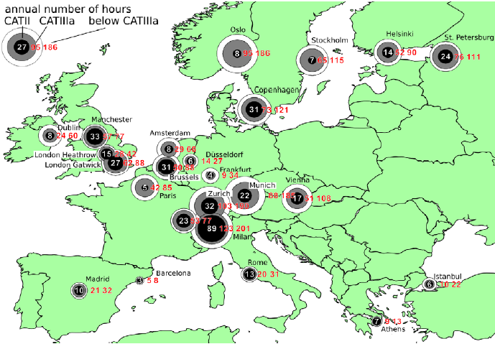
Figure 33.Annual number of hours that CATII ,CATIIIa and CATIIIb/c conditions occurred.
Source: (European Commission, 2011b)

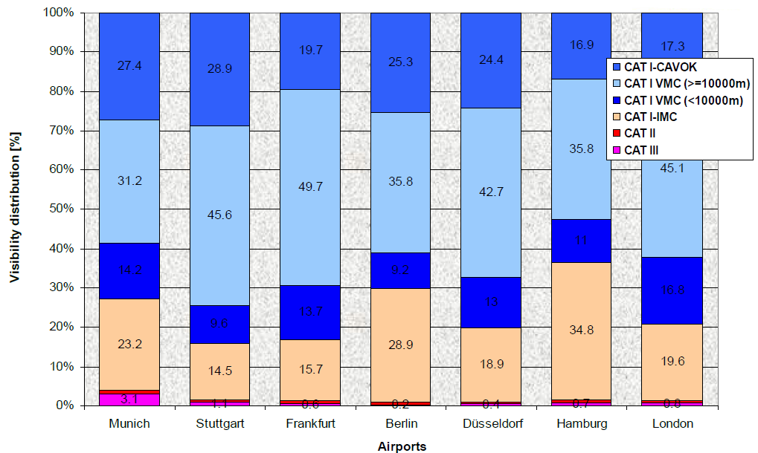
Figure 34.Visibility during winter month at European Airports.
Source: (Muehlhausen, T. and Kreuz, M., 2012)

Recent studies suggest that then number of very low visibility conditions phenomena are declining in Europe (European Commission, 2011b). This might be related with a decrease in aerosol emissions over Europe; this reduction on number of events is expected to improve as the quality of air continues to improve, although the trend may level off at longer time scales (European Commission, 2012c). This pan-European improvement can be seen in Figure 35, which shows that the average hours of CATII or worse conditions has reduced by about a factor four. When considering the individual categories, it can be seen that the duration of CATII has decreased much less (by a factor of 2.5) compared with that of the CATIIIb/c conditions (by a factor 5). Note that the CATII conditions may additionally be caused in part by heavy snowfall or very heavy rain, which are probably less sensitive to changes in aerosol content (European Commission, 2011b). Thus, very dense fog conditions have diminished all over Europe, even becoming non-existent at some airports. For example, at Oslo Gardemoen airport, in the four years of 2006, 2007, 2008 and 2009 the combined visibility below 200 m occurred less than 10 hours. For the same airport there were annually 121 hours of visibility between 200 and 500 metres (European Commission, 2011b). In order to predict the occurrence of visibility over the next decades, climate models are of little help due to their limited modelling of aerosol emissions and its chemistry (European Commission, 2011b). In fog-prone airports, such as Milan Malpensa, frequent reduced visibility episodes due to fog still exist. At other European airports this is, and will be the case in the coming decades, albeit to a lesser extent (European Commission, 2011b). Figure 36 shows the annual number of hours with reduced visibility at three selected European airports.

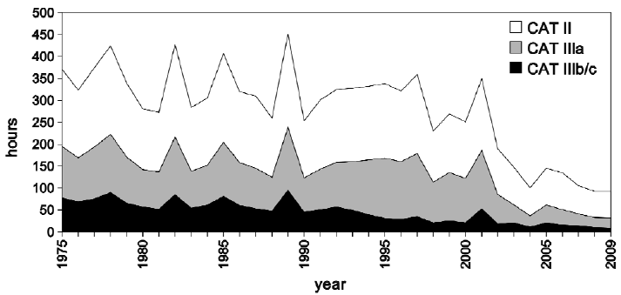
Figure 35.Annual numbers of hours with particular visibility conditions averaged over 24 airports.
Source: (European Commission, 2011b)

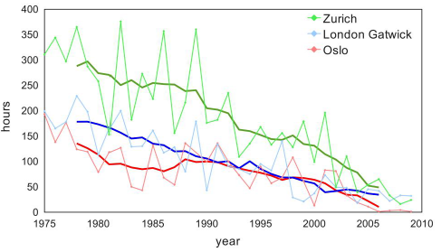
Figure 36.Annual numbers of hours with visibility <200 m.
Source: (European Commission, 2012c)

(h) Volcanic Ash Over Europe
The effects of volcanic ash are not local but can affect a wide area. In Europe there are volcanoes located in Iceland (e.g. Katla, Eyjafjallajökull, Hekla, Krafla), Spain (e.g. La Palma, Tenerife, El Hierro), Portugal (Azores), Italy (Vesuvius, Campi Flegrei, Etna), Greece (Nisyros, Santorini), and Turkey (e.g. Kula, Arrarat, Nemrut Dagi). Volcanism in Germany (Eifel) and in continental France (Massif Central) is considered geologically likely, although not reported historically, hence being highly uncertain (European Commission, 2011c).
The systemic impact of airspace contamination on a dense air traffic network was underestimated until the 2010 Eyjafjallajökull eruption (Bolić and Sivčev, 2011). The adequate modelling of the dispersion of the ash cloud is needed in order to model the impact of a volcanic eruption (Folch, 2012). The evolution of the ash cloud will affect airports that will be closed. Flights will be affected in different manners (Scaini et al., 2014):
- some flights would be affected due to airport disruptions;
- others would face in-flight encounter with the ashes;
- and finally some flights would be able to potentially re-route to avoid the cloud.
As reported in (Scaini et al., 2015), aviation groups are interested in receiving updates of ash dispersal forecasts and retrievals at time intervals of less than 1 h. This shows their willingness to operate during the disruption period as feasible.
A volcanic ash over Europe is a relatively low probability event, however, its effects are very significant. For example, the ash cloud generated during the Eyjafjallajökull episode and the subsequence closures of the airspace led to the disruption of some 100,000 flights and 10 million passenger journeys. Between the 15h and the 22nd of April 104,000 flights were cancelled (48% of the traffic expected for those days), see Figure 37 (EUROCONTROL, 2010). Moreover, an episode similar to the Eyjafjallajökull eruption as the risk reached orange level on August 2014 when a set of earthquake affected the Bárðarbunga volcano region in Iceland (IMO, 2014). As reported by (Baldwind, 2014), Bárðarbunga is Iceland’s fourth most active volcano and, on average, a volcano erupts in Iceland every five years.

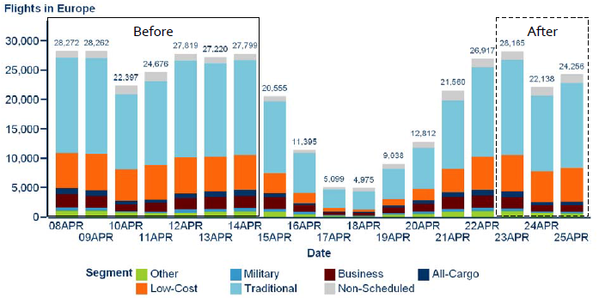
Figure 37.Traffic in Europe before and during the April crisis.
Source: (EUROCONTROL, 2010)

A model similar to the presented in (Scaini et al., 2014) would allow us to model the different flights affected in the different categories and the evolution of the disruption over time.

Strike actions
In the AIRAC 1409 (21th August to 17th September 2014) there were 42 regulations of traffic due to industrial actions and 3 due to industrial actions not related with ATC.
There are different levels of strike actions:
- strikes actions at airport services (e.g. handling service), leading to longer turnaround and delay at airport operations;
- at airline level (e.g. crew), resulting in delays and cancellations at the airline affected; and
- at ATC level (e.g. ATCOs strike), where results are similar to a shortage of staff, i.e., lower airspace capacity leading to regulations which generate delays and cancellations. In some cases, airlines might decide to re-route to avoid the affected areas, meaning that longer routes are flown (i.e. higher aircraft operator costs (e.g. fuel, crew) and delays).

Technical failure
Technical failure might lead to disruptions (delays and/or cancellations) on the operation of one or several flights. Within technical failure a distinction should be done between ATC-ATM systems failure (e.g. radar coverage failure, airport equipment) and aircraft operator failure (e.g. aircraft technical problems at ramp), which are defined by IATA delay codes 41-48. In the first case all the flights using the airspace and/or the infrastructure affected by the failure would be disturbed (as an example, during the AIRAC 1409 (21th August to 17th September 2014), 107 regulations (3% of the total) were defined due to ATC equipment), while in the latter disruption would be confined to a particular airline and flight.

(a) Aircraft technical failure
Aircraft technical failures can lead to delays and/or cancellations. IATA delay codes 41 to 48 indicate maintenance and aircraft defects as the primary cause of delayed flights. Those codes are grouped under airline in the CODA primary delay cause analysis.

(b) ATC-ATM System failure
The probabilities of disruptions due to ATC/ATM infrastructure failure (e.g. radar coverage failure or loss of ATC systems) are low, but not non-existent. For example, on the 23th April 2015 there was an electrical problem which led to a lack of radar information at LEMG. This in its turns generated a regulation (regulation Id LEMGA23) from 9h30 to 13h00 which affected arrival traffic to the airport (nine flights were diverted to nearby airports) (EUROCONTROL, 2015a; Malaga Hoy, 2015). As presented in Figure 38, LEMG was one of the areas of Europe which generated the maximum delay on that day. There were 11,695 minutes of delay at airports (56% of the total delay generated during the day) and aerodrome capacity generated 7,285 minutes being the higher contributor of delay of the day (35% of the total) (EUROCONTROL, 2015a). If the radar is not operative, the air traffic controllers ensure the separation based on procedures which reduces the airspace/airport capacity.

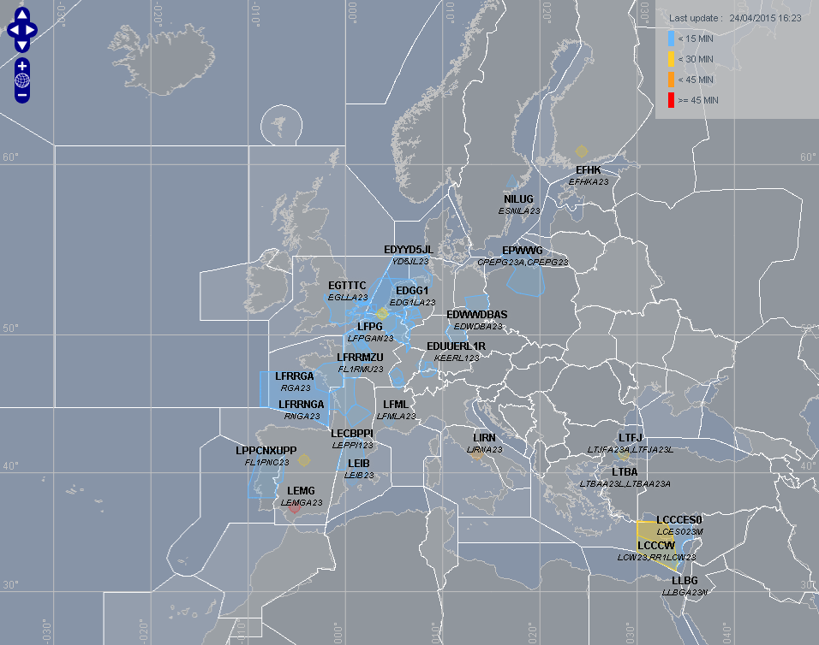
Figure 38.ATFCM network situation 23/05/2015.
Source: (EUROCONTROL, 2015a)

A similar incident happened in Delhi airport in 2013, where an electricity cut led to a loss of radar information for 45 minutes (NDTV, 2013); in Calcutta a similar problem with the radar systems was reported in 2013 (The telegraph India, 2013); and in Soekarno-Hatta International Airport in 2012 (The Jakarta post, 2012). All these incidents led to delay as procedural separation had to be used.

In Europe, another example are the over one hundred flights cancellations and many significantly delayed at Munich airport in the afternoon of the 6th July 2012 when the radar system had a failure for a period of 2 hours and 15 minutes (between 12h45 and 15h00) (The Munich Eye, 2012). The situation was worsened as Frankfurt airport had limited capacity and had to cancel twenty seven flights due to heavy storm (Euronews, 2012).

(c) Airport failure
The examples presented in the previous case, (b) ATC-ATM system failure, have a significant impact on airport infrastructures, they are affecting the control system for managing arrivals at airports. Other failures that can lead to a reduced capacity at the airport, or in extreme situations to its closure, are failures that are generated directly at the airport infrastructure. Example are programmed or un-programmed maintenance, taxiway closures or problems at some gates. If programmed the information is published as NOTAM. Depending on the infrastructure affected the airport capacity can be reduced or some process at the airport can be longer than under nominal situations (e.g. longer turnaround times due to longer taxi times).

ATFM restrictions (non-weather)
In some cases ATFM regulations are put in place for reasons other than weather. If there is a mismatch between demand and capacity the ACC might require a regulation of the traffic. This excess of demand can be due to several reasons, for example: abnormal high demand, staff shortage, technical failures or industrial actions.
Delays generated due to ATC en-route demand/capacity imbalance and ATC staff and equipment are coded by IATA as delay code 81 and 82 respectively; at airport infrastructures code 83 and 88 are used for ATFM restrictions; at destination airport, 89 is used for restrictions at departure and/or destination airport with or without ATFM restrictions. In the CODA reports, codes 81 and 82 are grouped under En-route delays and 83, 88 and 89 grouped with 87 (airport facilities) under the Airport category.
According to (EUROCONTROL, 2014c), ATFCM restrictions at airports was the third most common primary cause of delays during 2012 and 2013, with 0.61 minutes of delay per flight in both years. ATFCM restrictions en-route accounted for 0.38 minutes per flight in 2013 and 0.44 minutes per flight in 2012, being the fifth primary cause of delay.
As indicated in (EUROCONTROL, 2014a), the investigation into the specific classification of ATFM delay presents inconsistency in how delays are assigned in terms of location and causal factor. This means that the analysis of the impact of ATFM restriction is complex.
The delay is not generated uniformly around the network, in 2013, there were four ACCs that experience more than 30 days at delay levels above one minute per flight: Nicosia (198), Warsaw (62), Barcelona (40), and the Canarias (37). These four ACCs accounted for 28% of total en-route ATFM delay in 2013 whilst handling 6.9% of the traffic (EUROCONTROL, 2014a). ATC Capacity and staffing accounted for 59% of the en-route ATFM delay generated in Nicosia ACC, 54% in Warsaw, 84% of Barcelona and 66% of Canarias ACCs.
As an example, during the AIRAC 1409 (21th August to 17th September 2014), 77% of the regulations that were defined could be considered within the category of ATFM restrictions (non-weather): 32% due to ATC capacity, 26% due to ATC routing, 14% due to aerodrome capacity and 5% due to ATC staffing issues.

Passenger disruption
Passenger disruptions define the delays where the primary cause of the delay (for flights or passenger) are the passenger arriving late at check-in or passengers that, even if the time they have at the airport is longer than the minimum connecting time (MCT), miss their connection.
The delays are defined under the IATA delay code 11, 12, 13 and 15 (late check-in, check-in error and boarding). In the current publication of delays by CODA all these codes are grouped among others within the airline cause category. Therefore, it is not possible for us to identify which percentage of delays are currently caused due to passenger disruptions. It would be possible in ComplexityCosts to estimate these values and, even, slightly increase them considering than in the future passengers might tend to arrive to the airport later and/or MCT might be reduced leading to more passengers missing their connection.

(a) Late check-in
As defined in (Parrk and Ahn, 2003), the arrival passenger distribution prior to schedule time of departure (STD) at an airport is airport and flight dependent (charter, scheduled, international, national, time of the day, etc.) and can be obtained from passenger surveys; Figure 39 presents this flight dependency. A variability on the passengers arrival time at the airport can be observed as a function of the time of the day of the flight: passengers tend to arrive later than the statistical average for flights scheduled to depart early in the morning (Chun and Wak, 1999). Figure 40 present this variability based on time on the day and passenger type (first/business or economy). A passenger doing a late check-in might have a higher probability of not arriving to the gate, if a bag has been check-in this might delay the flight. The arrival to the airport distributions are airport dependent, but the presented results might be used to model discrepancies on number of passengers doing late check-in based on passenger type and flight time.

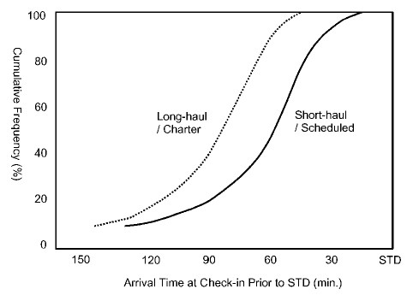  - Arrival difference by flight type | 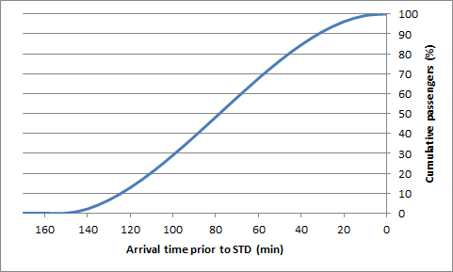  - Seoul Gimpo International Airport
Figure 39.Typical passenger arrival distribution at check-in counters
Source: (Park and Ahn, 2003)

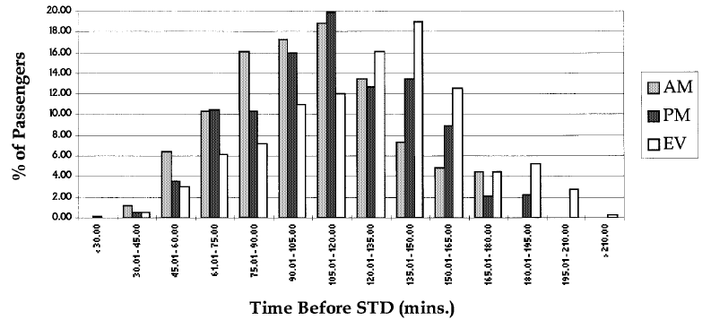
- Arrival pattern for all passenger types
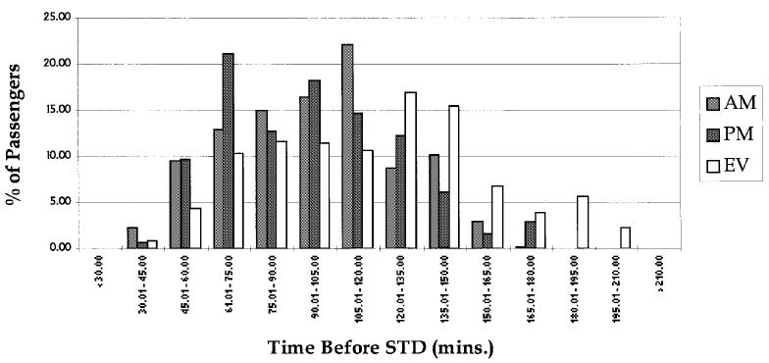
- Arrival pattern for first class passengers
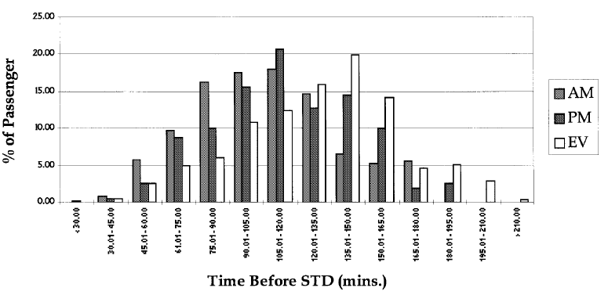
- Arrival pattern for economy class passengers
Figure 40.Typical passenger arrival patterns.
Source: (Chun and Wak, 1999)

(b) Transfers
According to the study presented in (Theis et al., 2006), passengers feel a risk when short connections are planned and are not willing to book flights with short connecting times between then. The risk and rush aversion appears to be a factor in the evaluation of transfer times (Theis et al., 2006). For this reason, the number of passengers with a connection time equal or shorter than MCT is very small. If the inbound flight is delayed, on the other hand, the probability of having passenger missing their connections can be very high (flight and airport dependent). However, that type of missed connections would be covered by other primary delay causes (e.g. weather or ATFM restrictions), therefore not counted in this Passenger disruption category. Only passengers that, even if with a delayed inbound flight, arrive to the airport with more time between connections than the MCT but still miss the connection should be considered.

Military exercises

Since the introduction of the flexible use of airspace (FUA) concept, the airspace is no longer civil or military but used according to the demand (European Commission, 2005). Regulation 2150/2015 gives a framework for civil and military cooperation regarding to the flexible use of airspace (European Commission, 2005).This means that there are different routes which use is conditional to availability (CDR). As defined in (EUROCONTROL, 2014d), a CDR is an ATS route that is only available for flight planning and use under specified conditions. Category I (CDR1 routes) are available for flight planning and published in the national AIPs. Category II (CDR2) are non-permanent plannable in accordance with the daily public restrictions. Finally, category III (CRD3) are not available for flight planning but ATC may tactically issue clearances on such route segments. As depicted in Figure 41, the military sectors in the Europe cover a significant part of the airspace. Therefore, close civil military cooperation and coordination is a crucial enabler to improve capacity and flight efficiency performance (EUROCONTROL, 2014a). Even if more research is required to better understand all the contributing factors, route availability and changes in military activity appear to be contributing factors to the gap between filed and actual flight trajectory (EUROCONTROL, 2014a).

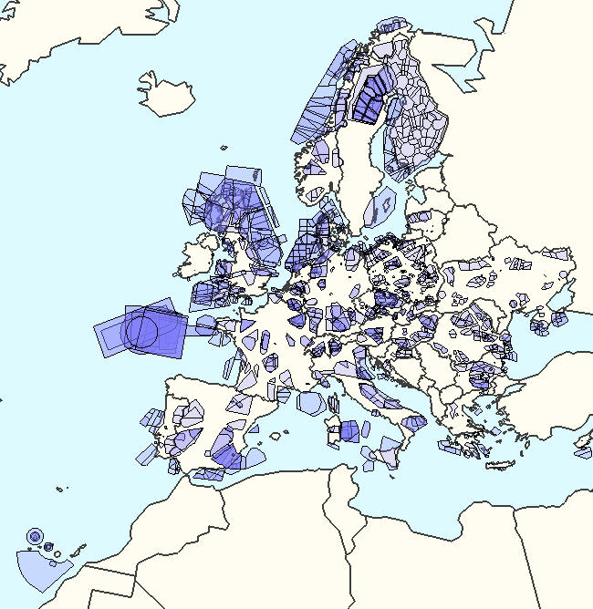
Figure 41.Military sectors in Europe as 12th September 2014
Source: (EUROCONTROL, 2015a)

To maximise the use of the airspace by civil flights, airspace restrictions should be based on actual use and cancelled when not required (EUROCONTROL, 2014a). However, as presented in Table 25 there is still a significant amount of the time when the airspace is segregated but not used, there is scope for improvement. For example, in the Nicosia ACC 33% of the delay generated was primarily accounted to Others, which include special events and military activities; in Warsaw ACC that cause accounted for 35% of the total delay generated (EUROCONTROL, 2014a).

Table 25.Ratio of time airspace was used vs. allocated (pre-tactically)
State | Albania | Belgium | Czech Republic | Denmark | Finland | FYROM | Italy | Netherlands | Norway | Romani | Slovakia | Sweden
Used/Allocated | 75% | 47% | 35% | 95% | 22% | 76% | 42% | 83% | 46% | 49% | 14% | 100%
Source: (EUROCONTROL, 2014a)

Finally, note that in AIRAC 1409 (21th August to 17th September 2014), 51 regulations (1% of the total) were accounted to military activities.

Disturbance modelling and data sources
The effect of all the different disturbances can be modelled in ComplexityCosts by adding delay, cancellations and/or re-routing flights. These effects should be modelled and tuned to ensure that reproduce the realistic behaviour in a spatial and temporal frame. Different data sources are required to be obtained and analysed in order to create this disturbance models.

(a) Modelling
All the disturbances considered have an impact on the flights in four non-exclusive different ways: delays, cancellations, diversions and re-routings. In ComplexityCosts delays, cancellations and diversions can be explicitly modelled; re-routing in its turn can be modelled as longer flight times and higher fuel consumptions. Therefore, all the disturbances can be modelled as one or several of these main effects. Table 26 presents the different disturbance types with their particularities and the effect on the flights. Using the different data sources available and after processing and analysing them it will be possible to assign to the affected flights the impact of the disruptions (i.e., delays, cancellations, diversion and re-routing) for each one of the modelled disturbances.

Table 26.Disturbance types and their modelled effects on flights
Disturbance type | Disturbance particularities | Sub-category effect | Model of effect on flights
Meteorological events | Meteorological events have a temporal and spatial dimension that evolve during time. | Local effect at airport | Flights operating to-from the affected airport would be delayed, cancelled and/or diverted
 |  | En-route effect | Flight using the airspace affected would suffer delay, cancellation and possible re-routing.
 |  | Widespread effect | Widespread effect are expected from phenomena such as volcanic ash. Wide areas are affected with airports closed leading to delays, cancellations and re-routing.
Strike actions | Strike actions are confined to the system that is under the industrial action; there is no spatial evolution and the duration is usually defined. | ATC | Significant part of the airspace affected. Flight operating to-from the area under strike and using that airspace would be affected with delays, cancellations and potential re-routing.
 |  | Airline | Problem limited to a given airline which will experience cancellations and delays on its flights.
 |  | Airport services | The flights operating in that infrastructure will suffer from longer turnaround times leading to delays.
Technical failure | Generally are non-planned problems, even that in some cases they might be scheduled (e.g., planned maintenance at some airport infrastructure). | Aircraft | The affected flight will be delayed and/or cancelled.
 |  | ATC/ATM systems | Flight using the infrastructure will be affected with delays, cancellations and/or diversions.
 |  | Airport | Delays in flights using the infrastructure.
ATFM restrictions (non-weather) | Usually there is no spatial evolution. The restrictions are due to capacity demand imbalance due to several reasons such as staff, high demand or lack of capacity. | ATFM regulation where primary cause is not weather | Flights using that airspace will be affected with delays and possible cancellations. In some cases flight might select longer routes to avoid congested area.  ATFM slots are modelled using an inverse lambda distribution. This distribution will need to be fitted with new data available.
Passenger disruptions | Spread through the network. Late check-in can affect any airline, passenger missing connections only at hub airport for network carriers. | Late check-in | Delay in flights affected by passengers arriving late after checking in.
 |  | Missed connections | For passengers missing connections need to re-book them in following flights.
Military exercises | Generally are scheduled operations with limited scope in space and time. | Limites the availability of CDR routes | CDR2 routes might not be available to plan a flight plan as military operations are planned in that area. This can be modelled by detecting the flights using that CDR and replacing their flight plan for a different route.
 |  | TSA leading to a drop in capacity | If TSA are reserved for military activities this might have an impact on the total traffic a given area can handle as the air traffic controller will have a smaller area of the airspace where to divert flights in the even of other disruptions (such as bad en-route weather).

(b) Data sources and analysis
From DDR2 database it is possible to obtain for a given AIRAC cycle information regarding to the regulations that were implemented. For each regulation, among other information, the following data are available: location, opening time, closing time, capacity, reason, total delay, list of regulated flights before and after the regulation with the most penalising regulation per flight and the amount of delay assigned per flight.
The different reasons for the regulations can be mapped with the different disturbances considered as shown in Table 27. Using that relationship, it is possible to analyse the different regulations that have been imposed to model the impact on flights in terms of delay assigned per flight, duration and location of the regulations. The information can be used also to estimate the probability of having more than one regulation in place at the same time. Data from the flights (e.g. aircraft type, airline type, time of the day) can be used to model the delay assigned to flights and their behaviour (e.g. cancellations or re-routings). Figure 42 shows an example of a regulation in NEST with data from DDR2 AIRAC 1409.
Table 27.Mapping between disturbances and DDR2 regulations reasons
Disturbance type | Regulation reason
Meteorological events | Weather  De-icing
Strike actions | Industrial action  Industrial action not ATC
Technical failure | Equipment ATC  Equipment not ATC
ATFM restrictions (non-weather) | Aerodrome capacity  ATC capacity  ATC routing  ATC staffing
Passenger disruptions | -
Military exercises | Military activity
Non considered as disturbance type | Accident/incident  Environmental issue  Other reason  Special event  Unknown reason
Meteorological events | Weather  De-icing

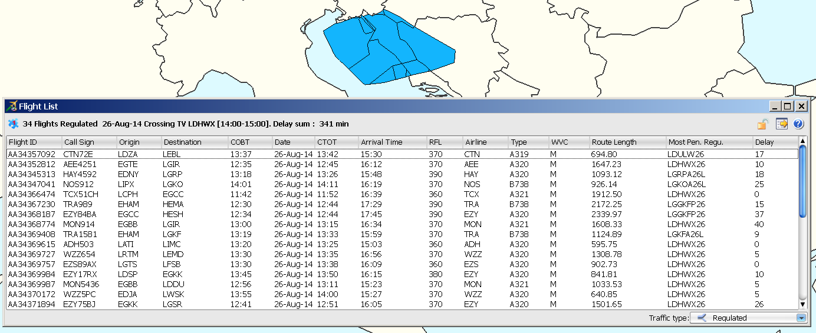
Figure 42.Example of regulation with traffic affected from DDR2.

For some disturbances it is important to model the probabilities of having worst case scenarios. For example, it is interesting to model a situation where different airports are affected by meteorological phenomena at the same time. The DDR2 analysis can help to model the impact of a drop in capacity at a given airport, but the duration of the event and the impact of a given meteorological scenario at an European level will require an analysis of meteorological data as well. If all ATFM delays are considered ATC capacity is the main cause of delay (see Figure 43), but as presented in Figure 44, weather is the main cause of delays generated at airports. Therefore modelling the airport weather phenomena adequately is paramount to obtain significant results from the simulations in ComplexityCosts.

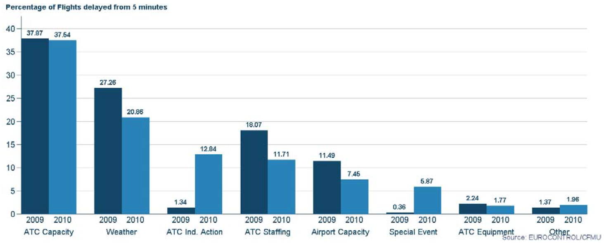
Figure 43.Causes of ATFCM delay in 2009 and 2010
Source: (EUROCONTROL, 2011)

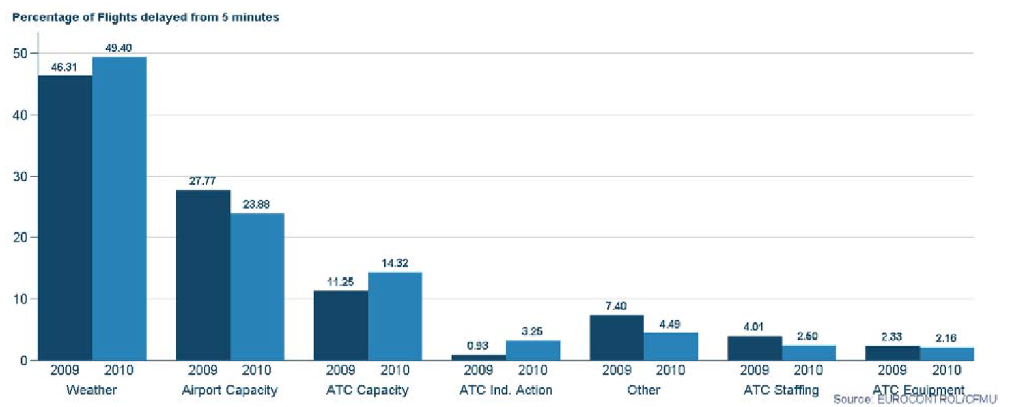
Figure 44.Causes for ATFM delays at airports
Source: (EUROCONTROL, 2011)

General meteorological data can be obtained from the European Climate Assessment and Dataset (ECA&D) which collects and published 12 meteorological variables from 7,848 meteorological stations in 62 countries (ECAD, 2013). E-OBS dataset contains a gridded observational dataset for the period (1950-2013) of precipitation, temperature and sea level pressure. This data was analysed on EWENT project (European Commission, 2011b), used in this report to identify the different European regions and meteorological phenomena that could affect aviation (http://ewent.vtt.fi/index.htm). RegioExAKT project (http://www.pa.op.dlr.de/RegioExAKT/) analysed the regional risk of convective extreme weather events.
The European Severe Weather Database (http://www.eswd.eu/) contains a collection of reports of individual severe weather events and is managed by the European Severe Storms Laboratory (ESSL) (http://www.essl.org/). The events contained in the database are typically of a local and short-lived nature, and many of them are associated with severe thunderstorms (European Commission, 2011b).
Hourly meteorological reports (METAR) are generated at airports. These reports can be accessed and analysed to identify weather related situations at the vicinity of the infrastructures. Weather data will be extracted from them, prepared, and a basic statistical analysis will be performed with regard to potential disturbance of airport traffic and capacity. For this purpose specific weather data from the periodic (30 min) reports for a selection of 25 European high-traffic airports (according to the EUROCONTROL PRR (Performance Review Commission)) over 5 years will be extracted and analysed. The data are selected according to their relevance for inducing traffic/capacity disturbance and corresponding potential for disruption of performance. The four meteorological categories that will be analysed, after discussion with domain experts concerning their relevance for airport disturbance are: fog (vertical visibility below 100m), wind (higher than 10-15 kn), thunderstorm and snow/hail.
The statistical weather data analysis will consists of three steps:
- raw data extraction from (METAR) data bank for each airport and year with (limited) data cleaning / correction and preparation of textfiles for further processing;
- processing of textfiles per airport per year for basic graphical and tabular output;
- basic statistical analysis of weather disturbance time series per airport per year (e.g. 5 year average disturbance level interval and duration mean & standard deviations per category per airport).
Figure 45 depicts an initial test example for basic graphical presentation of uncleaned category 1 data =fog(vertical viewing dist. < ca.100 m) from pre-processed raw data at Frankfurt airport (EDDF) during 2014. The figure shown the disturbance duration with respect to the start time of the disturbance (Dt = 30 min), including one false data point.
Frequently errors are observed (missing & false data) in the raw data (e.g. “duration” < 0 in Figure 45) partly due to manual input into data bank, dependent on the procedures at respective airports. Within the given resources only minimum effort is possible for writing specific automatic error detection code and for manual corrections. This limits the significance of statistical parameters (e.g. central moments of distributions / probability densities).

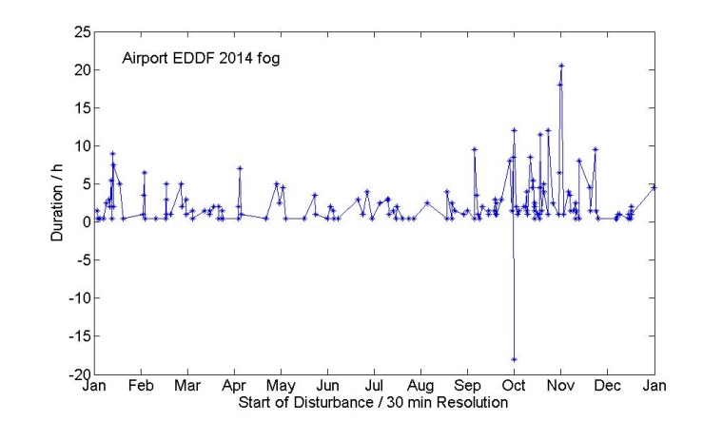
Figure 45.Initial test example for fog (vertical visibility < 100m) analysis for EDDF in 2014.

For other disruptions, there is no information that can be extracted directly from the DDR2 data, as is the case for passenger disruption type (see Table 27). The probability of having a primary delay due to this type of disruption (i.e., a passenger check-in in late delaying the flight) are only possible to be analysed using the IATA delay codes 11 to 19, which include the passenger and baggage causes. As we do not have access to this data, it is only possible to estimate the amount of passengers in this situation, and also passengers missing connections when they have enough time to do it, based on literature review (Chun and Wak, 1999, Park and Ahn, 2003 and Theis et al., 2006). However, in general these reports are airport and case dependent.
Finally, for other disturbances such as military exercises information from the RAD and the CDRs that are available from the AIRACs (DDR database) could help to determine the effect of the use of airspace by the military beyond the need of potential regulations. As reported in (EUROCONTROL, 2014b), there is a significant amount of flight that could have planned a CDR route but do not do it (39% of the flights that could have planned a CDR2 route in the first quarter of 2014 did not planned it).
As summarised in Table 28 the main sources of data that could be used to model the different disturbance types are the DDR2 database, with the information regarding to the regulations, and the CODA data published in their different reports (EUROCONTROL, 2011; EUROCONTROL, 2013b; EUROCONTROL, 2014c; EUROCONTROL, 2015b).

Table 28.Disturbance types and their modelled effects on flights
Disturbance type | Sub-category effect | Example of data sources | Notes
Meteorological events | Local effect at airport | DDR2 | DDR2 regulation analysis will help to assess probability of same effect affecting different locations and the impact of the regulations on the traffic in terms of delays
 |  | METAR | METAR analysis will help to model the probabilities of different significant meteorological phenomena at airports
 |  | CODA | Analyse the scenarios that could be representative of worst case scenarios in terms of meteorology.
 | En-route effect | DDR2 | Regulations at DDR2 will help to model the probability same effect at different locations and their impact on the traffic
 |  | CODA | Analyse the scenarios that could be representative of worst case scenarios in terms of meteorology
 | Widespread effect | Simulation models | To model the dispersion of the phenomena (i.e., ash cloud) and the area affected (airport/airspace)
 |  | Historic analysis, CODA | To analyse previous scenarios
Strike actions | ATC | DDR2 | DDR2 regulations analysis where primary cause is defined as industrial action ATC
 | Airline | Historical traffic data | Analyse days where industrial actions at airlines have been realised to see the impact on that airline in terms of delays/cancellations
 | Airport services | DDR2 | DDR2 regulations analysis where primary cause is defined as industrial action not ATC
Technical failure | Aircraft | - | -
 | ATC/ATM systems | DDR2 | DDR2 regulations analysis
 | Airport | DDR2 | DDR2 regulations analysis
ATFM restrictions (non-weather) | ATFM regulation where primary cause is not weather | DDR2 | DDR2 regulations analysis
 |  | CODA | Analyse worst case scenarios
Passenger disruptions | Late check-in | (Chun and Wak, 1999)  (Park and Ahn, 2003) | Academic literature review of arrival to airport curves
 | Missed connections | (Theis et al., 2006) | Academic literature review
Military exercises | Limits the availability of CDR routes | DDR2  RAD | DDR2 routes available and selected
 | TSA leading to a drop in capacity | DDR2 | Regulations analysis where primary cause is military activity

Conclusions on disturbance types and corresponding data sources
As presented in Section 3.1.2 there is a relationship between mechanism and disturbances. Some disturbances are adding an effect in the system but are not tackled directly by any mechanism. These disturbances are interesting from the point of view that would add a network effect and realism to the model and simulations. However, the resilience of the system should not be affected as the mechanism are not tackling the problems generated by them. In some cases the effect is very small in comparison with other disturbances. This is the case of the passenger types disturbances or military exercises. Passengers checking in late or missing connections when they have time at the hub and becoming the primary cause of the delay is relatively small and evenly spread through the network. Military exercises represent a reduce amount of disturbance and none of the mechanism we are consider tackle the problem of reduced capacity due to military activities or longer routes. For this reason those disturbances will not be modelled.
Other phenomena such as meteorological events can represent a high amount of disruption in the system (delays, cancellations). A realistic scenario through the network needs to be generated. This means that values should analysed at an airport level, but also at an European level to be able to generate worst case scenarios that are realistic.
With these considerations, the disruptions that are suggested to be modelled in ComplexityCosts are: meteorological events with local effects at the airport, strike ATC actions and ATFM restrictions (non-weather). The data sources that will be analysed to generate the models include METAR information to model the airports environment, and then DDR2 and CODA data to be able to model the areas that are affected by regulations and the impact of those regulations on the traffic. The analysis of DDR2 and CODA data will allow us to define realistic worst case scenarios.
These disruptions are in alignment with the mechanism selected in 3.3 to be implemented in ComplexityCosts.

Delay cost models

Introduction to the delay cost modelling
In order to be able to assess the mechanisms of Section 3 under the disturbances of Section 4.3, it is necessary to model the corresponding cost impacts. These are modelled as costs of delay to the airline, across a range of delay durations, according to ‘low’, ‘base’ and ‘high’ cost scenarios, for the year 2014. The cost models comprise 15 aircraft, thus adding three new aircraft to the previously modelled set. The rationale for the selection of the three new aircraft is presented.
The main costs of delay to the airline are comprised of passenger, fuel, maintenance, crew and (strategically) fleet costs. We examine these below, in addition to the cost of carbon, and further develop quantitative models for them, in part building on previous work and commenting on major changes in assumptions or outputs. Although the passenger cost of delay is often a dominating delay cost for operators, there remains limited evidence supporting the calculation of such costs. Other costs, relating to fuel, maintenance, crew and fleet provisions are more readily quantifiable from (published) data sources, as we demonstrate.
Another major component of this work is the production of a model for the passenger costs. This has been developed as an independent airline consultation document and is presented in Appendix A. It includes a detailed review of Regulation 261, which establishes the rules for compensation and assistance to airline passengers in the event of denied boarding, cancellation or delay, and derives a fully new hard cost model based on the Regulation. Subsequent case law and planned future regulatory changes are assessed, which have existing and potential impacts on airline costs. Supporting aircraft seat, load factor and passenger number calculations are also included in this Appendix.
These costs will be used explicitly in the ComplexityCosts simulation model. In addition, and partly funded through the project work effort, these costs will be used in parallel statistical models to produce a separate, stand-alone reference publication with a user ‘how-to’ guide.

New aircraft to be included in the model
We are extending the set of aircraft types used by the cost models by a further three aircraft. The process of shortlisting aircraft types was discussed in detail in Deliverable 1.3, to recap:
- the coverage of the current twelve aircraft was found to still account for over 50% of flights within the ECAC region;
- the usage of some of the older aircraft types (e.g. AT72 and B735) is declining;
- forecast trends of future aircraft requirements offer a mixed picture;
- ten candidate aircraft types were initially considered based on their proportion of flights in 2012 (the choice of candidates has since been validated using 2014 flights);
- the proportion of flights (comparing data for September each year from 2010 to 2013) among the ten candidate aircraft types showed a considerable increase in the number of flights operated by the A332, E170 and E190/E195 fleets;
- three aircraft types were shortlisted from the ten candidates;
- feedback on the shortlisted aircraft was sought via consultation with industry.
Table 29 lists the candidate aircraft types (note the greyed-out column shows the proportions originally used to make the shortlist before the 2014 data became available), with Table 30 summarising the rationale for shortlisting three aircraft.

Table 29. The ten candidate aircraft types
ICAO aircraft designation | Aircraft | Proportion of flights in 2012ª | Proportion of flights in 2014^{b} | Shortlisted
DH8A | Bombardier Dash 8 Q100 | 1.1% | 0.9%
DH8D | Bombardier Dash 8 Q400 | 3.1% | 3.0%
CRJ9 | Bombardier CRJ-900 | 1.6% | 1.5%
B737 | Boeing B737-700 | 2.5% | 2.3%
B772 | Boeing B777-200 | 1.1% | 1.1%
E170 | Embraer ERJ 170-100 | 1.3% | 1.5%
E190 | Embraer ERJ 190-100 | 1.5% | 3.2%^{c}
E195 | Embraer ERJ 190-200 | 1.2% | N/A^{c}
AT75 | ATR 72-500 | 1.5% | 1.2%
A332 | Airbus A330-200 | 1.4% | 1.5%
ª Flights in the ECAC area (EUROCONTROL, 2013e).
^{b} Flights in the CFMU area (personal communication, 2015).
^{c} E190 and E195 flights are combined in the 2014 dataset.

Table 30. The three shortlisted aircraft types
ICAO aircraft designation | Fleet facts¹ | Rationale for adding to the current aircraft types
DH8D | Entered service in 1999 and still in production; European AOs include: Air Baltic, Flybe, Olympic Air, Tyrolean Airways, Widerøe.  In service: 425 (global), 135 (European AOs). On order: 35 (global), 3 (European AOs). | Bombardier Dash 8 Q400: accounts for approximately 3% of ECAC flights and is the highest ranked aircraft type not currently included in the cost models; adds a third turboprop, helping to offset the decrease in AT43/AT72 flights; adds a new OEM (Bombardier).
E190 | Entered service in 2005 and still in production; future developments: second generation E190 E2 (e.g. new engine, larger wing) scheduled to enter service in 2018; European AOs include: BA City Flyer, Finnair, KLM Cityhopper, Lufthansa CityLine.  In service: 485 (global), 100 (European AOs). On order: 41 (global), 3 (European. AOs). | Embraer ERJ 190-100: rapid growth in number of ECAC flights operated by E190; approximately four times as many aircraft orders for E190 compared with E195; adds a new OEM (Embraer); adds a regional jet to the set (also consider diminishing use of B735).
A332 | Entered service in 1998 and still in production; competitor of B763 and newer B788; European AOs include: Air France, Air Berlin, KLM, TAP Portugal, Turkish Airlines.  In service: 480 (global), 117 (European AOs). On order: 50 (global), 0 (European AOs). | Airbus A330-200: continued growth in number of ECAC flights operated by A332; adds a third widebody aircraft.
¹ In service/order statistics exclude stored aircraft, July 2014 (Flightglobal, 2014a).

An industry-focused consultation was conducted during AUG14 and SEP14, requesting feedback on the preferred additional aircraft types from the three shortlisted aircraft. The University of Westminster contacted airlines via its dedicated airline Working Group and others directly, plus a number of EUROCONTROL units (e.g. PRU and CODA). Of the respondents who stated a preference, the A332 and E190 were the most popular choices. Initially, two of the three shortlisted aircraft were going to be included in the cost models, however all three have now been added.
Table 31 shows the updated list of aircraft types, with typical seating ranges (excluding outliers) and MTOWs (weighted by flights during 2010-2014). Good fits have been previously obtained (Cook and Tanner, 2011) between √MTOW and both the strategic and tactical costs of delay. This is useful for estimating cost data for aircraft not included explicitly in the model.

Table 31. Updated core aircraft types in airline cost of delay models
ICAO aircraft designation | Aircraft | Typical seat range¹ | MTOW (tonnes)²
B733 | B737-300 | 116-148 | 60.4
B734 | B737-400 | 134-168 | 65.4
B735 | B737-500 | 96-132 | 55.6
B738 | B737-800 | 144-189 | 74.6
B752 | B757-200 | 160-232 | 107.8
B763 | B767-300ER | 192-270 | 181.5
B744 | B747-400 | 275-436 | 392.8
A319 | A319 | 118-156 | 67.1
A320 | A320 | 136-180 | 74.0
A321 | A321 | 169-220 | 86.7
AT43 | ATR42-300 | 42-50 | 16.8
AT72 | ATR72-200 | 62-72 | 22.2
DH8D | Dash 8 Q400 | 70-78 | 29.1
E190 | ERJ 190-100 | 93-106 | 48.8
A332 | A330-200 | 211-303 | 230.5
¹ Typical seat range for the global fleet 2010; aircraft with unusual seat configurations excluded (Innovata).
² Weighted average MTOW of flights in the CFMU area 2010-2014 (personal communication, 2015).

Fuel (and carbon), maintenance, crew and fleet costs

Fuel
The high, base and low fuel into-plane prices have been updated to 2014 reference values using published fuel spot prices and airline financial reports. Figure 46 plots the world average spot price per month (USD) with average prices paid by a range of European airlines per year (converted to USD) per US gallon.
Although the average Jet A-1 fuel spot prices (Figure 46) and calculated into-plane prices (Figure 47) have reduced during 2014, the price paid by airlines remains relatively unchanged (based on a review of airline financial reports and the average fuel prices paid). Note the almost flat average prices paid by a regional, a full-service and a low-cost carrier over the last two years. This time lag between the market price and the price paid by airlines can be explained by their forward fuel-buying practices. Airlines with fuel hedging policies are not benefiting from this price reduction (i.e. cost of crude oil has more than halved between JUN14-DEC14, with JAN15 prices the lowest since MAY09) while under contract to pay an agreed price per tonne.

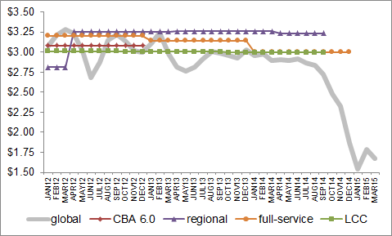
Figure 46. Average Jet A-1 fuel spot prices paid by airlines ($/US gallon)
Source: global average based on median of Europe/Singapore cargo and US pipeline spot prices (Airline Business, February 2012 – May 2015).
CBA 6.0 shows the 2012 average fuel price used as a standard input for cost benefit analyses (EUROCONTROL, 2013e).
Regional, full-service and LCC show the average fuel prices paid by three airlines over the given time periods (company financial reports).

Figure 47 shows the average unhedged into-plane EUR price per month (developed in-house). The blue curve includes estimates for additional fuel charges and fees paid by airlines. The three fuel cost scenarios covering 2014 are also plotted.

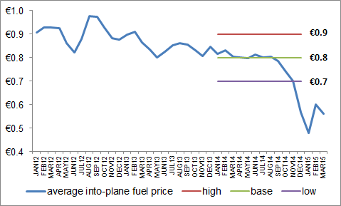
Figure 47. Average into-plane Jet A-1 fuel price by three 2014 fuel cost scenarios (EUR/kg)
Source: average into-plane fuel price derived from global average spot price in Figure 46.

Table 32 shows the cost of fuel adopted for the three cost scenarios. Now based on fuel prices for the full year, the three cost scenarios are lower than the earlier costs proposed in Deliverable 1.2 (1.0, 0.9, 0.8 EUR/kg) which were based on data to FEB14. Compared with our earlier studies, the cost range has narrowed, for example, the 2010 fuel cost range calculated in Cook and Tanner (2011) covered 0.4 to 0.8 EUR/kg. Industry commentators continue to speculate that the current average fuel price is in a dip, with market prices already increasing in 2015.

Table 32. Cost of fuel
Scenario | Cost of fuel / kg (EUR)
High | 0.9
Base | 0.8
Low | 0.7
Source: global average spot price (see Figure 46). High, average and low fuel prices January 2012 to December 2014 (Airline Business, February 2012 – May 2015).

Table 32 fuel costs are used for both the strategic and tactical cost calculations. The cost of fuel is now included in the at-gate calculations, capturing APU usage on the ground. Note that although not all turboprop aircraft are equipped with an APU (e.g. optional equipment for AT43 and AT72 aircraft), most are able to generate power independently by using one of their main engines. ATR aircraft can operate in ‘Hotel Mode’, with the right engine providing air and power on the ground without the propeller spinning.

Carbon
- Regulation
The Directive 2003/87/EC of the European Parliament (European Commission, 2003) established the scheme for greenhouse gas emission allowance trading within the Community. This first regulation did not apply to the aviation sector. In 2008 the European Parliament approved the Directive 2008/101/EC which included aviation activities in the EU Emissions Trading System (EU ETS) (European Commission, 2009). This directive included all traffic flying to-from airports within the Members States. The historical aviation emissions, defined as the mean average of the annual emissions in the calendar years 2004, 2005 and 2006, were computed. From 2012, 97% of these historical emissions were allocated as allowances to airlines. This allocation is based on a benchmark computed on the total amount of tonne-kilometre flown by the airlines within the EU during a period of reference. 82% of the allowances are freely assigned to the airlines, 15% should be auctioned and 3% reserved for new entrants and particularly fast growing markets. From 2013, the total amount of allowances will be reduced yearly starting at 95% of the historical reference emissions value.
The benchmarking process, which measured the tonne-kilometre value per operator, was done in 2010. During this period airlines had to report their tonne-kilometre computed as great circle distance between origin and destination plus 95 km times the payload carried; and their emissions based on the total fuel consumed (including APU) and an emission factor from the IPCC. This airlines’ benchmark was approved by the Commission in the Decision 2011/638/UE (European Commission, 2011a).
The inclusion of third countries in the EU ETS encountered strong international opposition and in 2013 the ICAO Assembly adopted a roadmap to global market based mechanisms (MBM) to deal with aviation carbon emissions worldwide by 2020. To facilitate the negotiations during the ICAO meeting, the EU adopted the “stop-the-clock” decision No. 377/2013/EC to temporarily defer the enforcement of the EU ETS compliance obligations for flight to and from most of third countries (European Commission, 2013a). Allowances were not required to be surrendered until January 2014 for non-EU flights, the allowances that were already assigned to airlines based on the tonnes-kilometres flown by those flight had to be returned to the commission.
Regulation No 421/2014 of the European Parliament modified the scope of the EU ETS to align it with the ICAO resolution (ICAO, 2013). With this regulation, flights between the aerodromes in the EEA are fully covered by the EU ETS, except for flights from an outermost region in the EU (as defined in the Article 349 TFEU (European Commission, 2012a)) and other regions (European Commission, 2014a). Therefore, flights between an aerodrome in the EEA and an aerodrome in a country or territory outside the EEA are currently excluded from the emission mechanisms. A proposal for a Directive was created in 2013 to include non-EEA flights but it has not yet been incorporated in the legislation, as agreed within the International Civil Aviation Organization Assembly in October 2013 to develop a global market-based mechanism addressing international aviation emissions by 2016 and apply it by 2020 (European Commission, 2013b).
- Mechanism
Airlines are assigned a given number of allowances (right to emit a tonne of CO₂) for free based on the benchmark of tonnes-kilometres flown during the monitoring period of 2010. The total amount of allowances is based on the emission reference period. The Decision 2011/638/EU (European Commission, 2011a) established 0,6422 allowances per 1,000 tonne-kilometre flown for the period from 1 January 2013 to 31 December 2020. With the reduction of the geographical scope introduced with the Regulation No 421/2014 (European Commission, 2014a) a new assignment of allowances was required. For example, the Spanish government assigned yearly 771,416 allowances for free to Iberia for the period 2013-2016 (Consejo de Ministros, 2014); or the United Kingdom assigned to easyJet 2,942,618 allowances (Department of Energy & Climate Change, 2014).
In general 82% of the allowances are granted for free to aircraft operators and 15% are auctioned (European Commission, 2013d). The remaining balance of 3% is held in a special reserve for later distribution to fast growing aircraft operators and new entrants in the market.
Airlines must provide an emission and monitoring plan, and measure their emissions for each of their flights (European Commission, 2012b). In order to compute the emissions a relationship has been established between tonnes of fuel and CO₂ emissions: 3.15 tCO₂/t fuel Jet A1 and Jet A. This value is defined in The Commission Decision 2007/589/EC (European Commission, 2007) and in the Commission regulation No 601/2012 (European Commission, 2012b). The fuel considered for a flight should also include the fuel consumed by the APU. At the end of the year the aircraft operators should surrender the allowances required based on their total year emission. Aircraft operators can also surrender up to 15% of the number of allowances they are required to surrender in CERs (Certified Emission Reductions) and ERUs (Emission Reduction Units) based on Article 11a of the EU ETS Directive (European Commission, 2009). The European Commission Regulation No 1123/2013 limited the CERs and EURs that can be used during the period 2013-2020 to 1.5% of the verified emissions (European Commission, 2013c).
If an aircraft operator emits less than 25,000 tonnes of CO₂ per year it is considered a small emitter and could choose to verify its emissions based on a small emitters tool approved under Commission Regulation No 606/2010 (European Commission, 2010a). These tools estimate the emissions based on aircraft model and flight plan distance.
- Carbon cost
As presented in Table 33 the value of an EU Emission Allowance (EUA) of CO₂ was in average EUR 5.94 tCO₂ in 2014, with a range of EUR 3.06 tCO₂, see Figure 48 (European Energy Exchange, 2014a). During the period 2013-2014 the minimum value was EUR 2.66 tCO₂, the maximum was EUR 9.06 tCO₂ and the average was EUR 5.29 tCO₂ (European Energy Exchange, 2014a). The Aviation allowances (EUAA) in the secondary market are fixed in January 2015 at EUR 6.47 tCO₂, and in the primary market they are expected to be exchanged at EUR 6.90 tCO₂. These values are aligned with the average price reported by airlines such as Vueling in their annual reports (EUR 5.88 per allowance during 2012 and EUR 6.36 per allowance during 2013).
According to the regulation it is possible to surrender CERs and EURs up to 1.5% of the allowances required (European Commission, 2013c). The value of CERs has sharply being reduced (from EUR 20 tCO₂ in 2008 to EUR 0.40 tCO₂ in 2013); this is due to an oversupply of CERs (the financial crisis reduced the demand), and regulatory changes (i.e., Commission Regulation No 1123/2013) limiting the use of international credit entitlements (Michał Głowacki, 2014, CDC Climat Research, 2012, European Commission, 2013d). In phase III of the EU ETS, CERs and EURs are no longer directly surrender but exchanged for allowances. The value of CERs and ERUs has remained very small during 2014 and it is not expected to be increased in the near future (see Table 33 and Figure 49).

Table 33.Cost of a CO₂ allowance (1 tonne of CO₂) 2014
EU Emission Allowance (EUA) during 2014 (European Energy Exchange, 2014a) |  |  | EU Aviation Allowances (EUAA) / Secondary Market (European Energy Exchange, 2014b) | EU Aviation Allowances (EUAA) / Primary Market Auction (European Energy Exchange, 2014c) | Emission Reduction Units Futures (ERU). Settle Price. Cal-15. (European Energy Exchange, 2014d) |  | Certified Emission Reduction Futures (CER). Settle Price. Cal-15. (European Energy Exchange, 2014e)
Min | Avg | Max | 2013-2020 | Phase 3 | Min | Max | Min | Max
31-03-14 | - | 23-12-14 | 09-01-15 | 26-11-14 | 31-12-14 | 06-04-14 | 29-05-14 | 30-11-14
€ 4.18 | € 5.94 | € 7.24 | € 6.47 | € 6.90 | € 0.03 | € 0.46 | € 0.25 | € 0.59

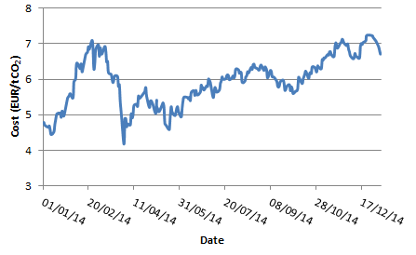
Figure 48.EU Emission Allowance price 2014
Source: (European Energy Exchange, 2014a)

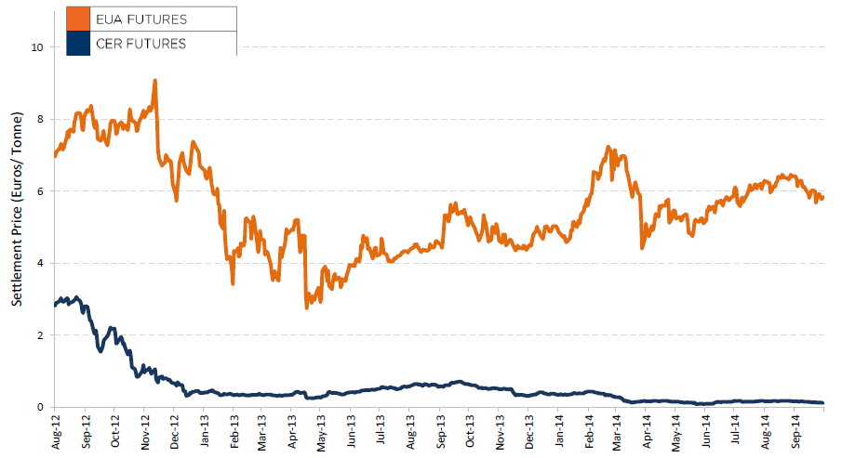
Figure 49.EUA & CER futures historical
Source: (Intercontinental Exchange, 2014, 2014)
- Impact on airlines
Since 2012 airlines need to account for their emissions. In order to minimise the effect on their operations some airlines account for the carbon using swaps, this allow them to predict their expenses and allocate the emissions cost to their fuel consumption costs (Vueling, 2013, Ryanair, 2014).
During 2012 Ryanair, Lufthansa and easyJet were the three biggest CO₂ emitters with 7.5 Mt CO₂, 6.2 Mt CO₂ and 5.1 Mt CO₂ respectively (Carbon Market Data, 2013). Airlines need to surrender allowances for their verified emissions. As described previously airlines get for free a given amount of allowances (Ryanair 5.5M, Lufthansa 14.5M and easyJet 4M, these values are before the modification of the EU regulation which excluded extra-EU flights) (Carbon Market Data, 2013). For the emissions that are not accounted on their free allowance, aircraft operators need to buy allowances in the market.
As described previously, the cost of CERs and ERUs is significantly lower than the cost of Aviation Allowances, for this reason a considerable amount of CERs and ERUs were surrendered in 2012 (see Table 34. The three airlines having surrendered the biggest quantity of ERUs for 2012 compliance are Lufthansa (900 thousand ERUs), SAS (550 thousand ERUs) and KLM (280 thousand ERUs) (Carbon Market Data, 2013).

Table 34.Airlines having surrendered the largest amounts of CERs in 2012
Airline | Surrendered CERs 2012 (thousand) | Free allowances 2012 (thousand) | Verified emissions 2012 (thousand tCO₂)
Ryanair | 1,100 (14.6% of the total verified emissions) | 5,500 | 7,500
easyJet | 750 (14.7 % of the total verified emissions) | 4,000 | 5,100
British Airways | 380 (15.2% of the total verified emissions) | 10,300 | 2,500
Source: (Carbon Market Data, 2013)

The percentage of CERs surrendered in 2012 was considerable higher than the 1.5% that will be allowed after 2013 with European Commission Regulation No 1123/2013 (European Commission, 2013c) (see Table 34). This means that in since 2013 the amount of EUAA required by airlines has increased, increasing also the total cost of emissions for airlines.
The amount of the provisions Vueling has for carbon emissions are calculated based on the monthly fuel consumption by the company and the average allowance price for each month, adjusted by the last quoted price of the allowance. In 2012 Vueling had to purchase a total of 595,000 allowances at an average price of EUR 5.88/allowance (Vueling, 2013), in 2013 740,000 allowances were needed at an average price of EUR 6.36/allowance (Vueling, 2014). Air France had a provision of EUR 14M for emissions for the 2013 period (Air France, 2014); and Lufthansa had a provision for emissions certificates of EUR 35M for 2013 and EUR 42M. Its provisions for fuel were EUR 17,510M and EUR 17,946M for 2013 and 2012 respectively. In 2013 a total of EUR 89M were borrowed for emissions certificates (EUR 19M in 2012) (Lufthansa, 2014).
In 2013 easyJet total carbon emission were 5.6 million tonnes (5,551,338 CO₂ from flying activities (verified as part of the ETS reporting requirements), and 1,382 CO₂ from facilities). In 2013 £1,183 M were used in fuel (easyJet, 2014). Ryanair emitted 7,549,120 tonnes CO₂ in 2013, which equates to 0.094 tonnes CO₂ per passenger (Ryanair, 2014). In the fiscal year 2014, Ryanair had a cost of EUR 2,013.1 million on fuel; this value includes the EU emissions trading costs. In order to manage the risks associated with the fluctuation in the price of carbon emission credits, Ryanair entered into swap arrangements to fix the cost of a portion of its forecast carbon emission credit purchases. By doing this, Ryanair is able to forecast its requirement for carbon credits as they are directly linked to its consumption of jet fuel. This leads to an average cost of EUR 2.45 per gallon of fuel in 2014 (Ryanair, 2014).
The cost of the carbon emissions for the aircraft operators remains a reduced percentage of the total fuel expenses. Iberia had a total expense of EUR 1,213M on fuel and EUR 6M on emission allowances during 2013 (0.49% of the fuel cost) and EUR 1,527M on fuel and EUR 12M on allowances in 2012 (0.79% of the year fuel cost) (Ernst & Young, 2014). The BA group used approximately 5.6 million tonnes of fuel in 2013 with a total cost of £3,755 M including £6 M due to CO₂ allowances. Therefore, CO₂ allowances represent 0.16% of the fuel cost (British Airways, 2014). In 2013, Finnair had a total of 741,833 tonnes of fuel consumed and generated 2,336,930 tonnes of CO₂. These emissions are computed based on monitoring systems and actual consumption, and as part of the EU emission trading system they are verified by an external party. The total carbon cost that Finnair incurred is included in their fuel cost, which in total was EUR 689.9M. The direct cost incurred by Finnair from emissions trading totalled approximately EUR 2.6 million in 2013 (Finnair, 2014). In average the price Finnair paid for a tonne of CO₂ was 1.11 EUR/tonne CO₂. This value, however, is an under-estimation of the cost of an allowance as only European flights (and their emissions) are considered in the ETS. Carbon emissions represent a total of 0.38% of the total fuel cost for Finnair in 2013.
Some airlines are trying to improve their emissions levels to reduce as much as possible their carbon footprint and costs. Lufthansa Group is also active in the field of alternative fuel using biofuels. In 2013, the Lufthansa Group’s total CO₂ emissions fell to 27.6 tonnes, which represents an improvement of 1.3 percent with respect to the previous year (Lufthansa Group, 2014). This is achieved by using modern aircraft and high load factors.
In general, airlines are concerned with the regulation changes and the variability of the market which complicates the estimation of carbon provisions. The Lufthansa Group is concerned by the changes on the European legislation regarding the EU emissions trading scheme and the impact in terms of competition among different airlines and regions (Lufthansa Group, 2014). Finnair states that the “direct costs of emissions trading in the coming years are difficult to estimate due to potential regulatory changes” (Finnair, 2014).
- Tactical cost on delay
Based on the amount of fuel consumed by minute of delay during cruise, it is possible to compute the amount of CO₂ generated according to regulation No 601/2012: i.e, 3.15 tCO₂/t fuel. Table 35 presents the maximum and minimum value for the allowances per aircraft type under study. The table with all the possible values for CO₂ allowance during 2014 are presented in Appendix C. These computations are presented for the cruise phase where incurring in delay represents a higher amount of fuel consumption. Therefore they are a bound of the maximum emissions per minute of delay.

Table 35.CO2 emitted by minute of flight at typical cruise and cost in carbon allowances for 2014
Aircraft Type | Typical cruise emissions  65% Load  [CO₂/min] | EU Aviation Allowances (EUAA) / Primary Market Auction (European Energy Exchange, 2014c) | EU Emission Allowance (EUA) during 2014 (European Energy Exchange, 2014a)
 |  | Max  [EUR] | Min  [EUR]
 |  | 23-12-14 | 31-03-14
 |  | € 7.24 | € 4.18
A319 | 0.12 | 0.87 | 0.00
A320 | 0.12 | 0.87 | 0.00
A321 | 0.15 | 1.09 | 0.00
A340-300 | 0.34 | 2.46 | 0.01
AT720 | 0.03 | 0.22 | 0.00
AT721 | 0.03 | 0.22 | 0.00
ATR 42 | 0.02 | 0.14 | 0.00
B737-300 | 0.13 | 0.94 | 0.00
B737-400 | 0.13 | 0.94 | 0.00
B737-500 | 0.12 | 0.87 | 0.00
B737-800 | 0.14 | 1.01 | 0.00
B747-400 | 0.51 | 3.69 | 0.02
B757-200 | 0.17 | 1.23 | 0.01
B767-300 ER | 0.25 | 1.81 | 0.01

Considering that airlines are given for free only a percentage of the allowances that they need to surrender, we can consider that delay will always represent an increase on the fuel consumed and therefore on the cost due to the emissions. As presented in Table 35, the minimum value per allowance is achieved with the ERU and CER allowances which represent at total cost of less than EUR 0.02 per minute of delay. However, these allowances will be valid only for a small percentage of the total allowances required (1.5% maximum) (European Commission, 2013c). Therefore, the value of a minute of delay will be bounded by a value between EUR 3.69 and EUR 0.87 depending on the aircraft type (value of the emissions of one minute of delay surrendered with maximum EUA value of 2014). Using the average value paid by Vueling in 2014 (EUR 6.36/allowance), a minute of delay will cost between EUR 0.13 (ATR 42) and EUR 3.24 (B747-400).

Considering that aircraft operators will have a limited amount of CERs and ERUs that can be surrendered, it is possible to assume that in their normal operations (i.e. without delay) all their freely assigned allowances and their potential CERs and ERUs will be used. Therefore, any extra-delay will incur in extra carbon emissions, i.e. extra-fuel consumption, that will be surrendered as EU Allowances. With the values of the EUA during 2014 and of the EUAA in the primary and secondary market as in January 2015, it is possible to establish a cost of low 5.5 EUR/tone CO₂, medium 6.4 EUR/tone CO₂, and high 7.5 EUR/tone CO₂, see Table 36. As 1 kg of fuel generates 3.15 kg of CO₂, the consumption of one extra kilogram of fuel is translated into CO₂ allowance cost. The highest ratio of carbon cost with respect to fuel cost (high scenario carbon, low scenario fuel), means that carbon emissions increase the cost of fuel in 3.4%; and in the base scenario the increase is of 2.5%.

Table 36.Cost of carbon
Scenario | Cost of carbon / tone CO₂ [EUR] | Cost of carbon / kg fuel [EUR]
High | 7.5 | 0.024
Base | 6.4 | 0.020
Low | 5.5 | 0.017

The values found show that for small aircraft the cost due to a minute of delay on CO₂ emission is below 0.25 EUR/min, for medium size aircraft is below 0.95 EUR/min and for heavy aircraft below 3.7 EUR/min. If translated in cost per kg of fuel is below 0.024 EUR/kg fuel. Many airlines consider the cost of emissions within their cost of fuel, and as presented below considering a high cost for emissions and a low cost for fuel, the carbon emissions represent only 3.4% of the cost of fuel, being in the average scenario around 2.5% of the cost. Therefore, for the cost of delay the cost of carbon emissions could be safely neglected as other costs are significantly higher.

Maintenance
Maintenance costs are incurred by aircraft whether on the ground (for example waiting at the gate) or en-route, although the accrued expense varies by workload. Strategic (and tactical) at-gate maintenance costs are low compared with other more intensive phases, such as take-off, as there is limited wear and tear on the airframe and the engines are off for most of the time on-block. Consequently, strategic maintenance costs need to be proportionally allocated across flight phases: at-gate, taxi and ‘airborne’, the latter combining cruise and arrival management.
Deliverable 1.2 described the reassessment of the previous 2010 reference values (Cook and Tanner, 2011) and their update to 2014 costs. After reviewing the trend in maintenance block-hour costs as reported to ICAO (ICAO, 2014) and a cross-section of European airline financial returns, we have adopted a 15% increase on maintenance block-hour costs to adjust the previous reference values to 2014 values, across all scenarios and aircraft types. This is a provisional adjustment that will be reviewed when more up-to-date data become available.
The provisional 2014 strategic maintenance costs (per hour) for the 15 aircraft types are shown in Appendix B, by at-gate, taxi and airborne phases.
Tactical (per minute) maintenance costs are derived from these strategic values, with the fixed costs (such as the overhead burden) removed leaving the time-based costs to be apportioned across flight phases. Updated tactical costs are also provisionally 15% higher than their corresponding 2010 tactical costs (tables not shown).

Crew
Flight crew salaries increase by size of aircraft whereas cabin crew salaries are more consistent across all aircraft types. Total cabin crew numbers are driven by the maximum number of seats available, irrespective of the passenger load factor.
The previous 2010 crew reference values (Cook and Tanner, 2011) were reviewed in Deliverable 1.2. Crew pay agreements since 2010 have also been examined, revealing modest pay rises (typically 5% 2010-2014) alongside examples of pay cuts and pay freezes.
Based on this scoping review, the crew block-hour costs for the three cost scenarios have been separately updated to provisional 2014 values. No change has been made to the base cost scenario (compared with the 2010 reference values), the high cost scenario has been increased by 5% and the low cost scenario has been reduced by 5%. The provisional 2014 strategic crew costs (per service hour) for the 15 aircraft types are shown in Appendix B.
Flight and cabin crew tactical costs are based on the cost of crewing for additional minutes over and above those planned at the strategic phase. In Europe it is possible for marginal crew costs to be zero, resulting in no additional costs to the airline. For example, an airborne delay will have no effect on the cost of crew paid by sectors flown as this payment mechanism is cycles-based (a large proportion of the crew’s pay would be fixed as basic salary).
Tactical crew costs are derived from the strategic crew block-hour costs, provisionally updated to 2014 values. The low cost scenario is assigned zero cost. The base cost scenario is unchanged from the previous 2010 values, with the high cost scenario increasing by 5%. These provisional 2014 marginal crew costs apply to ground and airborne phases (tables not shown).

Fleet
Fleet costs refer to the full cost of fleet financing, based on a combination of ‘DRL’ cost categories: aircraft depreciation, rentals and leases of flight equipment. These costs are determined as service hours rather than block-hours. As aircraft utilisation has only a very small effect on fleet costs, these costs are wholly allocated to the strategic phase.
A review of airline financial literature (reported in Deliverable 1.2) showed that whilst the values of older, less popular aircraft types continues to decline, in-demand aircraft (e.g. A320 and B738) have experienced stable values. Unlike the flat adjustment to maintenance costs and the narrow range applied to crew costs, a more varied range of cost changes has been adopted for the new fleet costs. These range from a 30% reduction in fleet costs applied to the older 737 Classics (B733, B734 and B735) to a 10% increase for the B738 and A320/A321. These fleet costs adjustments should still be considered as provisional, and under review. The 2014 strategic fleet costs (per service hour) for the 15 aircraft types are shown in Appendix B.

Passenger cost allocations
These are presented in Appendix A.

Reactionary cost model
On the day of operations, original delays caused by one aircraft (‘primary’ delays) cause ‘knock-on’ effects in the rest of the network (known as ‘secondary’ or ‘reactionary’ delays). Reactionary delays are generally worse for longer primary delays and for primary delays that occur earlier in the operational day (when the knock-on effects in the network are greater). They also depend on the airline’s ability to recover from the delay, for example due to the extent of schedule padding (buffering). Primary delays not only affect the initially delayed (‘causal’) aircraft on subsequent legs (rotational reactionary effect), but also other aircraft (non-rotational reactionary effect).
There are two contrasting considerations regarding the calculation of reactionary delay costs. In the ComplexityCosts simulation model itself, these will be explicitly calculated on a flight-by-flight basis, as the reactionary delays occur. Indeed, unlike in many actual operational contexts, we will be able to track these costs back to the causal flight, even through multiple propagation waves.
In contrast, for the delay cost tables that we will publish in parallel for wider reference (see Section 4.4.1), statistical estimates of such reactionary costs will be required. These will be based on established, in-house models dedicated for each tactical cost type (i.e. fuel, maintenance, crew and passenger costs), for both rotational and non-rotational reactionary effects. These values will be derived from statistics for 2014 published in May 2015 in EUROCONTROL’s annual Performance Review Report, and will also draw on CODA data for the same year. These high-level statistics will also be used to calibrate the ComplexityCosts model.

Next steps and look ahead

The document has established the design and requirements of the ComplexityCosts simulation model. The next step is the actual model implementation, specifically to:
- determine new elements and functionalities missing in the current model;
- expand the data storage;
- formalise the concept of the environment into the model, reorganising current classes;
- define new classes of actors and new actors’ instances;
- update the cost models;
- ensure the mechanisms, disturbances and metrics are appropriately captured;
- run a series of validation and verification tests.

The next tasks, specifically regarding the mechanisms and disturbances are to:
- complete the assimilation of the cost sources for the adopted mechanisms;
- integrate the implementation and running costs of the mechanisms into the model;
- identify the spatial and temporal locations of the mechanisms and disturbances;
- refine and implement the stakeholder uptake methodology.

Regarding the delay cost models, the final steps are to:
- circulate the airline consultation document and adapt the costs if necessary;
- obtain some missing airline, (newly modelled) aircraft and network performance data;
- update the statistical reactionary models and publish the reference values.

The next major deliverable is D2.2 (Model implementation), currently re-scheduled for 28AUG15.

References
Amadeus, 2014. Altéa Suite. http://www.amadeus.com/airlineit/solutions/sol_1altea.html#overview (accessed April 2014)
Association of European Airlines, 2014. AEA Traffic and Capacity Data, annual data, 28 July 2014.
Association of European Airlines, 2015. Monthly Monitor – AEA Monthly Traffic Update (historical data available in current file, accessed April 2015).
Air Berlin 2007-2012. Annual reports 2007-2012, Berlin, Germany.
AirFrance, 2014. Registration document 2013. Including the annual financial report.
Airline Business, 2012-2015. ISSN 0268-7615, Reed Business Information, Colchester, 28(1) - 31(4).
Airservices Australia, 2012a. Perth Airport, runway occupancy time, airport capacity enhancement. Tech. report. pp. 1-4
Airservices Australia, 2012b. Airport Capacity Enhancement (ACE) Program. Corporate Communication. November 2012.
Airports commission, 2013. Interim report.
Baldwin, M., 2014. Another Icelandic volcano could blow, Talking point, MRO Network news, 20th August, 2014.
Bloomberg, 2013. British Airways Parent IAG Wins Control of Spain’s Vueling. April 2013. http://www.bloomberg.com/news/2013-04-23/british-airways-parent-iag-acquires-control-of-spain-s-vueling.html (accessed June 2014)
British Airways, 2014. Annual Report and Accounts Year ended 31 December 2013. Press Release. 15/07/2013.
Boeing, 2003. AeroBoeing, Electronic Flight Bag, Third-Quarter 2003-July, No 23, pp. 16-27.
Bolić, T. and Sivčev, Ž., 2011. Eruption of Eyjafjallajökull in Iceland. Transp. Res. Record: J. Transp. Res. Board 2214, pp.136–143.
Bradford, S., 2012. 2012 FAA Budget briefing to industry, presentation 7 May 2012.
Bujor A., Ranieri A., 2014. Assessing ATM performance interdependencies through Bayesian Networks, preliminary applications and results. International Conference on Research in Air Transportation, ICRAT 2014, Istanbul, May 2014.
Carbon Market Data, 2013. Carbon Market Data publishes the ETS Aviation Company Ranking 2012.
Chun, H.W. and Wak, R.W.T., 1999. Intelligent resource simulation for an airport chek-in counter allocation system. IEEE Transactions on systems, man, and cybernetics - Part C: Applications and reviews, Vol. 29, No. 3, pp. 325-335
Consejo de Ministros, 2014. Acuerdo de Consejo de Ministros por el que se aprueba la modificación de la asignación individualizada de derechos de emisión de gases de efecto invernadero correspondiente a los años 2013 a 2016 reconocida a los operadores aéreos mediante Acuerdo de Consejo de Ministros de fecha 16 de diciembre de 2011 y corrección de fecha 13 de julio de 2012. 7/11/2014.
CDC Climat Research, 2012. ClimateBrief. Will there still be a market price for CERs and ERUs in two years time?, No13, May 2012.
Cook, A., Tanner, G., 2011. European airline delay cost reference values, for EUROCONTROL Performance Review Unit, March 2011.
Cook, A., Tanner, G. and Anderson, S., 2004. Evaluation the true cost to airlines of one minute of airborne or ground delay, for EUROCONTROL Performance Review Commission, May 2004.
Cook, A., Delgado, L., Cristóbal, S. and Blanch, A., 2014. What cost resilience?, 4th SESAR Innovation Days, Madrid, November 2014.
Deloitte, 2013. Informe de auditoría de cuentas anuales de Iberia líneas aéreas de España, S.A., cuentas anuales del ejercicio 2012 e informe de gestión - Annual accounts and management report for the full year 2012.
Deloitte, 2014. Auditors' report on financial statements of Vueling airlines S.A as at 31 December 2013 - Annual accounts and management report for the full year 2013.
Department of Energy & Climate Change, 2014. Introduction to the EU Emissions Trading System including how the cap-and-trade System works, how free allowances are allocated, details on complying, the inclusion of aviation in the System and the UK’s opt-out scheme for small emitters and hospitals. https://www.gov.uk/participating-in-the-eu-ets#aviation-in-the-eu-ets (accessed January 2015)
Deutsche Flugsicherung, 2010. Airport CDM Munich. Results 2009.
Deutsche Flugsicherung, 2012. Airport CDM Munich. Results 2012.
easyJet, 2014. Annual report and accounts 2014.
ECAD, 2013. European Climate Assessment and Dataset flyer, November 2013.
Eriksen, P., 2012. The SESAR Airport Concept. 19th Colloquium air traffic, Aviation - Intelligent infrastructures for the 21st century, Techniche Universitat Darmstadt. August 2012.
Ernst & Young, 2014. IBERIA – IB Opco Holding, S.L. and Subsidiaries, Consolidated Financial Statements and Management Report for 2013.
Esterline, 2014. Enabling connectivity in the cockpit.
EUROCONTROL, 2008. Airport CDM cost benefit analysis. Ed. 1.4.
EUROCONTROL, 2009. Overview of Airport CDM implementation progress. November 2009.
EUROCONTROL, 2010. Ash-cloud of April and May 2010: Impact on Air Traffic. STATFOR7Doc394 V1.0.
EUROCONTROL, 2011. CODA Digest - Delays to air transport in Europe – Annual 2010.
EUROCONTROL, 2013a . ATM Cost-Effectiveness (ACE) 2011 Benchmarking Report with 2012-2016 outlook.
EUROCONTROL, 2013b. CODA Digest - Delays to air transport in Europe – Annual 2012.
EUROCONTROL, 2013c. Challenges of Growth 2013. Task 8: Climate change risk and resilience.
EUROCONTROL, 2013d. Capacity assessment and planning guidance document,Ed. 2.8.
EUROCONTROL, 2013e. Standard inputs for EUROCONTROL cost benefit analyses, Ed. 6.0, Brussels.
EUROCONTROL, 2014a. Performance Review Report (PPR2013). An Assessment of Air Traffic Management in Europe during the Calendar Year 2013.
EUROCONTROL, 2014b. European Route Network Improvement Plan/ERNIP Implementation Monitoring, Monitoring report AIRAC 1404, 03 April 2014 - 30 April 2014.
EUROCONTROL, 2014c. CODA Digest - Delays to air transport in Europe – Annual 2013.
EUROCONTROL, 2014d. European Route Network Improvement Plan (ERNIP), Part 3, Airspace management guidelines - The ASM handbook - Airspace management handbook for the application of the concept of flexible use of airspace, Ed. 5.1.
EUROCONTROL, 2014e. ATM Cost-Effectiveness (ACE) 2012 Benchmarking Report with 2013-2017 outlook.
EUROCONTROL, 2014f. NM ATFCM Daily Briefing, Network Manager Directorate, various editions, 2014.
EUROCONTROL, 2015a. Network Operations Portal, Post-Operations 3/04/2015. https://www.public.nm.eurocontrol.int/PUBPORTAL/ (accessed April 2015)
EUROCONTROL, 2015b. CODA Digest - All-causes delay and cancellations to air transport in Europe - Quarter 1 2014.
EUROCONTROL, 2015c. European airport CDM. http://www.euro-cdm.org/ (accessed May 2015)
Euronews, 2012. Radar failure sparks delays at Munich airport. http://www.euronews.com/2012/07/07/radar-failure-sparks-delays-at-munich-airport/ (accessed April 2015)
European Commission, 2003. Directive 2003/87/EC of the European Parliament and the Council of 13 October 2003 establishing a scheme for greenhouse gas emission allowance trading within the Community and amending Council Directive 96/61/EC. Official Journal of the European Union, L.275/32-L.275/46.
European Commission, 2004. Regulation (EC) No 261/2004 of the European Parliament and of the Council of 11 February 2004 establishing common rules on compensation and assistance to passengers in the event of denied boarding and of cancellation or long delay of flights, and repealing Regulation (EEC) No 295/91, 17 February 2004, 1-7.
European Commission, 2005. Commission Regulation (EC) No 2150/2005 of 23 December 2005 laying down common rules for the flexible use of airspace. Official Journal of the European Union, L.342/20-L.324/25.
European Commission, 2007. Commission Decision of 18 July 2007 establishing guidelines for the monitoring and reporting of greenhouse gas emissions pursuant to Directive 2003/87/EC of the European Parliament and of the Council (notified under document number C(2007) 3416). Official Journal of the European Union, L.229/1-L.229/85.
European Commission, 2009. Directive 2008/101/EC of the European Parliament and the Council of 19 November 2008 amending Directive 2003/87/EC so as to include aviation activities in the scheme for greenhouse gas emission allowance trading within the Community. Official Journal of the European Union, L.8/3-L.8/21.
European Commission, 2010a. Commission Regulation (EU) No 606/2010 of 9 July 2010 on the approval of a simplified tool developed by the European organisation for air safety navigation (EUROCONTROL) to estimate the fuel consumption of certain small emitting aircraft operators. Official Journal of the European Union, L.175/25-L.175/26.
European Commission, 2010b. D3.4: Consequences of extreme weather. EWENT - project (Extreme weather impacts on European networks of transport, Grant Nr 233919).
European Commission, 2011a . Commission Decision of 26 September 2011 on benchmarks to allocate greenhouse gas emission allowances free of charge to aircraft operators pursuant to Article 3e of Directive 2003/87/EC of the European Parliament and of the Council.
European Commission, 2011b. D2.1: Probabilities of adverse weather affecting transport in Europe: climatology and scenarios up to the 2050s. EWENT - project (Extreme weather impacts on European networks of transport, Grant Nr 233919).
European Commission, 2011c. D1: Extreme weather impacts on transport systems. EWENT - project (Extreme weather impacts on European networks of transport, Grant Nr 233919).
European Commission, 2011d. Malta International Airport: modifications to taxiways to improve capacity of existing facilities, Trans-European transport network executive agency (TEN-T), 2005-MA-92501-P.
European Commission, 2012a. Consolidated version of the Treaty on the Functioning of the European Union. Official Journal of the European Union, C.326/47-C.326/390.
European Commission, 2012b. Commission Regulation (EU) No 601/2012 of 21 June 2012 on the monitoring and reporting of greenhouse gas emissions pursuant to Directive 2003/87/EC of the European Parliament and of the Council. Official Journal of the European Union, L.181/30-L181/104.
European Commission, 2012c. D6: European Extreme Weather Risk Management - Needs, Opportunities, Costs and Recommendations. EWENT - project (Extreme weather impacts on European networks of transport, Grant Nr 233919).
European Commission, 2012d. D5.1: Weather hazards and vulnerabilities for the European transport system - a risk panorama. EWENT - project (Extreme weather impacts on European networks of transport, Grant Nr 233919).
European Commission, 2013a. Decision No 377/2013/EU of the European Parliament and of the Council of 24 April 2013 derogating temporarily from Directive 2003/87/EC establishing a scheme for greenhouse gas emission allowance trading within the Community. Official Journal of the European Union L.113/1-L.113/4.
European Commission, 2013b. Proposal for a Directive of the European Parliament and of the Council amending Directive 2003/87/EC establishing a scheme for greenhouse gas emission allowance trading within the Community, in view of the implementation by 2020 of an international agreement applying a single global market-based measure to international aviation emissions. COM(2013) 722, 2013/0344 (COD). Brussels, 16/10/2013.
European Commission, 2013c. Commission Regulation (EU) No 1123/2013 of 8 November 2013 on determining international credit entitlements pursuant to Directive 2003/87/EC of the European Parliament and of the Council. Official Journal of the European Union. L.299/32-L.299/33.
European Commission, 2013d. The EU Emissions Trading System (EU ETS), Fact sheet, ML-03-13-549-EN-C. doi: 10.2834/55480
European Commission, 2013e. Commission staff working document – impact assessment, Brussels, 13 March 2013.
European Commission, 2013f. Airborne Datalink Equipment, European Economic Recovery Plan, TEN-T Executive Agency, 2009-EU-40068-E.
European Commission, 2014a. Regulation (EU) No 421/2014 of the European Parliament and of the Council of 16 April 2014 amending Directive 2003/87/EC establishing a scheme for greenhouse gas emission allowance trading within the Community, in view of the implementation by 2020 of an international agreement applying a single global market-based measure to international aviation emissions. Official Journal of the European Union, L.129/1-L.129/4.
European Commission, 2014b. Airport collaborative decision making (A-CDM) deployment and integration into the Network, TEN-T multi-annual programme, 2013-EU-40007-P.
European Commission, 2014c. Establishment of a new ATM centre for enhancement of operational safety and capacity at HungaroControl Pte. Ltd. Co., TEN-T European economic recovery plan, 2009-HU-40043-E.
European Commission, 2014d. New European common services provision for PENS2 and DLS, TEN-T multi-annual programme, 2013-EU-40002-S.
European Commission, 2014e. Controller Pilot Data Link Communications Implementation, TEN-T multi-annual programme, 2013-HU-40005-P.
European Commission, 2014f. Commission implementing regulation (EU) No 716/2014 of 27 June 2014 on the establishment of the Pilot Common Project supporting the implementation of the European Air Traffic Management Master Plan. Official Journal of the European Union, L.190/19-L190/44.
European Energy Exchange, 2014a. Ecarbix History 2014. http://cdn.eex.com/document/152288/ECarbix_history_2014.xls (accessed January 2014)
European Energy Exchange, 2014b. EU Aviation Allowances, Secondary Market. https://www.eex.com/en/market-data/emission-allowances/spot-market/european-aviation-allowances#!/2015/01/09 (accessed January 2014)
European Energy Exchange, 2014c. EU Aviation Allowances, Primary Market Auction. https://www.eex.com/en/market-data/emission-allowances/auction-market/european-aviation-allowances-auction#!/2014/11/26 (accessed January 2014)
European Energy Exchange, 2014d. Emission Reduction Units Futures. Settle Price. Cal-15. https://www.eex.com/en/market-data/emission-allowances/derivatives-market/european-aviation-allowances-futures#!/2015/01/09 (accessed January 2014)
European Energy Exchange, 2014e. Certified Emission Reduction Futures. Settle Price. Cal-15. https://www.eex.com/en/market-data/emission-allowances/derivatives-market/certified-emission-reductions-futures#!/2015/01/09 (accessed January 2014)
Eurostat, 2014. Air passenger transport by reporting country (total passengers carried), ‘avia_paoc’ dataset, 11 December 2014.
Federal Aviation Administration, 2011. National Airspace System Capital Investment Plan FY 2012-2016.
Federal Aviation Administration, 2012. National Airspace System Capital Investment Plan FY 2013-2017.
Federal Aviation Administration, 2014. Exhibit 300: Capital Asset Summary, Part I: Summary information and justification, Investment FAA, 603: Time Based Flow Management (TBFM) and Traffic Management Advisor Single Cntr (TMA). Unique investment identifier 021-613828465.
Finnair, 2014. Finnair annual report 2013.
Flatirons Solutions, 2014. Portfolio Planning: Time-Based Flow Management (TBFM): U.S. Federal Aviation Administration. http://www.flatironssolutions.com/resources/case-studies/time-based-flow-management-tbfm-u-s-federal-aviation-administration/ (accessed April 2014)
Flightglobal, 2014a. World Airliner Census 2014, Flight International special report based on Ascend Online Fleets database (July 2014), Flightglobal Insight, Sutton.
Flightglobal, 2014b. Washington airports operator plans $1bn investment in National. http://www.flightglobal.com/news/articles/washington-airports-operator-plans-1bn-investment-in-405975/ (accessed May 2015)
Flightglobal, 2014c. Domestic terminal developments at LAX. http://www.flightglobal.com/blogs/airline-business/2014/01/domestic-terminal-developments-lax/ (accessed May 2015)
Folch, A., 2012. A review of tephra transport and dispersal models: Evolution, current status, and future perspectives. Journal of Volcanology and Geothermal Research, Vol. 235–236, pp. 96–115, 2012.
Fraport, 2009-2014. Annual Reports 2009-2014, Frankfurt, Germany.
Heathrow Airport, 2014. A new approach, Heathrow's options for connecting the UK to growth, January 2014.
Henry, D. and Ramirez-Marquez, J.E., 2012. Generic metrics and quantitative approaches for system resilience as a function of time, Reliability Engineering & System Safety, Vol. 99, pp.114–122, 2012.
IAG, 2014. 2013 Annual report and accounts - Strengthening International Airlines Group.
ICAO, 2013. Assembly – 38th Session, Report of the Executive Committee on agenda item 17. A38-WP/430, P/44, 3/10/2013.
ICAO, 2014. ICAO DATA+, http://www.icao.int/dataplus/ (accessed April 2014)
ITDashboard, 2014. FAA 603: Time Based Flow Management (TBFM) and Traffic Mgmt Advisor Single Cntr (TMA). https://itdashboard.gov/investment?buscid=371 (accessed April 2014)
IMO, 2014. Icelandic Meteorological Office - Bárðarbunga 2014 - August events - http://en.vedur.is/earthquakes-and-volcanism/articles/nr/3000 (accessed May 2015)
Intercontinental Exchange, 2014. ICE Futures Europe, Monthly Utilities Report, September 2014.
International Air Transport Association, 2015. Air Passenger Monthly Analysis, December 2014, Montreal & Geneva, 05 February 2015.
Leosphere, 2013. Windcube 400S-AT, 3D Wind Doppler LIDAR.
Leosphere, 2014. Windcube 100S/200S/400S, 3D Wind Doppler LIDAR.
Locheed Martin, 2010. Lockheed Martin Selected to Prime FAA's Time Based Flow Management Program, ROCKVILLE, Md., June 2010. http://www.lockheedmartin.com/us/news/press-releases/2010/may/LockheedMartinSelectedPri.html (accessed April 2014)
Lufthansa Group, 2012. Balance - Key data on sustainability within the Lufthansa Group, Issue 2012.
Lufthansa Group, 2013a. Annual Report 2012.
Lufthansa, 2013b. Topping out ceremony for Terminal 2 satellite. http://www.lufthansagroup.com/en/themen/satellite-muc.html (accessed June 2014)
Lufthansa Group, 2014. Annual Report 2013.
Malaga Hoy, 2015. Un corte de luz en la torre de control de obliga a desviar nueve vuelos. http://www.malagahoy.es/article/malaga/2013727/corte/luz/la/torre/control/obliga/desviar/nueve/vuelos.html (in Spanish, accessed April 2015)
Matayoshi, N., 2013. Reduced wake vortex separation using weather information, Third ENRI International Workshop on ATM/CNS (EIWAC2013), Tokyo.
Michał Głowacki, 2014, CERs and ERUs market as from 2013, http://www.emissions-euets.com/cers-erus-market-as-from-2013 (accessed January 2015)
Morris, C., Peters, J., Choroba, P., 2013. Validation of the Time Based Separation concept at London Heathrow Airport, Tenth USA/Europe Air Traffic Management Research and Development Seminar, Chicago, IL., June 2013.
Muehlhausen, T. and Kreuz, M., 2012. Aviation and Extreme Weather: Findings from Extreme Weather Impacts on European Networks of Transport Project and Other European Projects. Proceedings of the Transportation Research Board Meeting.
Munich Airport, 2012. Official ground breaking ceremony for Terminal 2 satellite facility. April 2012. http://www.munich-airport.de/en/general/presse/pm/2012/q2/grundsteinlegung/index.jsp (accessed June 2014)
NATS, 2015. Trainee Air Traffic Controllers - Benefits. http://www.nats.aero/careers/trainee-air-traffic-controllers/benefits/ (accessed May 2015)
Navtech, 2014. Navtech Electronic Flight Bag, 2014.
NavAero, 2013a. Integrated EFB Systems and Technologies.
NavAero, 2013b. Tablet EFB Systems.
NDTV, 2013. Delhi airport's radar failure: Workers had accidentally shut off power. http://www.ndtv.com/delhi-news/delhi-airports-radar-failure-workers-had-accidentally-shut-off-power-512800 (accessed April 2015)
Park, Y. and Ahn, S.B., 2003. Optimal assignment for check-in counters based on passenger arrival behaviour at an airport. Transportation Planing and Technology, Vol. 26 No.5, pp. 297-416.
Ryanair, 2013. Annual report and finances 2013.
Ryanair, 2014. Ryanair annual report 2014.
Sabre, 2011. Ascend Magazine, Passengers Come First, Passenger reaccomodation platform solves irregular operations issues, 2011, Issue No. 2, pp.76-78.
Scaini, S., Folch, A., Bolić, T. and Castelli, L., 2014. A GIS-based tool to support air traffic management during explosive volcanic eruptions. Transportation Research Part C, Vol. 49, pp. 19-31, 2014.
Scaini, S., Bolić, T., Folch, A. and Castelli, L., 2015. Civil aviation management during explosive volcanic eruptions: A survey on the stakeholders' perspective on the use of tephra dispersal models. Journal of Volcanology and Geothermal Research, Vol. 294, pp. 25-36, 2015.
Thretheway, M., Markhvida, K., 2013. Airports in the Aviation Value Chain: Financing, Returns, Risk and Investment. International Transport Forum. 22-24 May Leipzig, Germany.
SESAR, 2013. Proposal on the content of a pilot common project, Ed. 1.
SESAR Deployment Alliance, 2014. SESAR Deployment Framework Partnership - Preliminary Deployment Programme V0 (PDP V0).
Thales, 2013. Maestro - Collaborative arrival (AMAN) and departure (DMAN) management solution.
The Munich Eye, 2012. Radar failure at Munich airport. http://www.themunicheye.com/news/Radar-Failure-at-Munich-Airport-1619 (accessed April 2015)
The Sydney Morning Herald, 2014. Qantas to invest $US30m in LAX hub. http://www.smh.com.au/business/qantas-to-invest-us30m-in-lax-hub-20141104-11gll9.html (accessed May 2015)
The Telegraph India, 2013. Radar failure at airport. http://www.telegraphindia.com/1130201/jsp/calcutta/story_16507916.jsp#.VTpqTCHjK_4 (accessed April 2015)
The Jakarta post, 2012. Radar failure ‘horrifying’. http://www.thejakartapost.com/news/2012/12/18/radar-failure-horrifying.html (accessed April 2015)
Theis, G., Adler, T., Clarcke, J-P and Ben-Akiva, M., 2006. Risk averseness regarding short connections in airline itinerary choice,Transportation Research Record: Journal of the Transportation Research Board, Vol 1951/2006 Airlines, Airports, and Airspace: Economics and Infrastructure Analysis, pp. 28-36.
Tobaruela, G., Majumdar, A., Ochieng W.Y., Schuster, W. and Hendricks, P., 2013. Enhancing Cost-Efficiency and Reducing Capacity Shortages: Strategic Planning and Dynamic Shift Management. Tenth USA/Europe Air Traffic Management Research and Development Seminar (ATM2013)
Turnquist, M. and Vugrin, E., 2013. Design for resilience in infrastructure distribution networks, Environmentalist, 33(1), 104–120, 2013.
UTC Aerospace Systems, 2014a. Electronic Flight Bag, Tablet-compatible Systems.
UTC Aerospace Systems, 2014b. Electronic Flight Bag, Aircraft interface device.
Vajda A., Tuomenvirta H., Jokinen P., Luomaranta A., Makkonen L., Tikanmäki M., Groenemeijer P., Saarikivi P., Michaelides S., Papadakis M., Tymvios F. and Athanasatos S., 2011. Probabilities of adverse weather affecting transport in Europe: climatology and scenarios up to the 2050s. FMI Reports 2011.
Vueling, 2013. Vueling Airlines Annual Accounts for the year ending 31 December 2012 and Management Report, together with the Auditors' Report.
Vueling, 2014. Vueling Airlines Annual Accounts for the year ending 31 December 2013 and Management Report, together with the Auditors' Report.

- The cost of passenger delay to airlines

The cost of passenger delay to airlines in Europe

Consultation document

Summary and objectives
This document updates previously reported estimates of the cost of passenger delay on European airline operations. It draws on various sources of evidence, with a particular focus on the impact of Regulation (EC) No 261/2004, which establishes the rules for compensation and assistance to airline passengers in the event of denied boarding, cancellation or delay. We review major rulings on the Regulation in order to be able to assess the cost impacts on airlines. We also consider changes to the Regulation being considered by the European Commission, in order to ensure that our cost framework is sufficiently adaptable to such changes and to gain an insight into the likely future regulatory emphasis, particularly where this has a financial implication for airlines. The objective is to produce cost references values for industry use, which accurately reflect airline costs. These are produced for 15 aircraft types, across a range of delay durations, according to ‘low’, ‘base’ and ‘high’ cost scenarios for the year 2014.
The Regulation 261 revision process remains far from complete. The European Parliament will negotiate with the European Council (EU member states), after the latter has reached agreement on a common position; meanwhile industry views are amongst those being taken into consideration and adoption of the revised Regulation is expected in 2015 at the earliest.
Endogenous factors in scope thus include changes to the regulatory context, both those effected through settled case law since the implementation of the Regulation and planned changes to the rules in coming years, and also changes in the rate of complaints. Increasing awareness of Regulation 261 is likely to drive up claim rates to airlines and thus increase the cost of a given disruption. Studies regarding the enforcement of the Regulation have shown gradual but slow improvements over time, although many member states still do not enforce the Regulation effectively. Exogenous factors in scope include aircraft seating densities and load factors, inflation and changes in air transport market conditions.
Since the objective is to model the cost of delay for given aircraft delays, changes in performance (e.g. regarding delays) are out of scope, although these affect net airline costs. Court rulings that are likely to generate retrospective claims are not specifically modelled, as these do not directly impact future delay costs (apart from indirect, strategic effects). Similarly, the extent to which airlines absorb such costs strategically is not quantified, although these effects may be considerable and may need to be accounted for in future.
Although the passenger cost of delay is often a dominating delay cost for operators, there remains limited evidence supporting the calculation of such costs. Other costs, relating to fuel, maintenance, crew and fleet provisions are more readily quantifiable from (published) data sources, and these are being assessed separately. The combined results will be used to develop European reference values for use by industry and academia, updating previous published values adopted by EUROCONTROL.
Where available, the calculations presented herein draw on empirical evidence. Feedback on the delay cost values presented at the end of this document is invited, particularly from airlines. Since it is intended that this methodology, and these values, will be taken forward for use in operational contexts (such as dynamic cost indexing for delay recovery), it is equally important that the delay costs neither under- or over-estimate actual airline costs, to the best possible extent. Whilst the values presented here are statistical (probabilistic) results, suitable for use as reference values, in parallel we are using explicit, fully costed models based on European-level simulations with full passenger itinerary and traffic data.

1 The cost of passenger delay to European airlines
1.1 Overview of cost types
Three types of passenger costs of delay may be considered:
- ‘hard’ costs: borne by the airline (measurable, bottom-line costs such as re-booking and compensation);
- ‘soft’ costs: borne by the airline (such as loss of market share due to passenger dissatisfaction);
- ‘internalised’ costs: borne by the passenger, not passed on to the airline (e.g. potential loss of business due to late arrival at meeting; partial loss of social activity.
We are concerned here only with costs impacting the airline, i.e. the first two types, although it should be noted that compensation due to passengers for delays and cancellations is, in principle, designed to offset the third type of cost (European Commission, 2013c). A fuller discussion of these cost types may be found in our previous reporting for EUROCONTROL (Cook and Tanner, 2011). This report will focus mostly on the calculation of hard costs.
1.2 The European regulatory context
Regulation (EC) No 261/2004 (European Commission, 2004) establishes the rules for compensation and assistance to airline passengers in the event of denied boarding, cancellation or delay. This Regulation came into effect on 17 February 2005. The implementation of the Regulation across Europe is not consistent. Case law has a decisive impact on the interpretation and application of Regulation 261. European Court of Justice rulings are legally binding from the date that the relevant Regulation came into force, and all airlines are legally obliged to respect them (European Commission, 2013c). A number of national rulings have also impacted the interpretation and application of the Regulation, also mostly in terms of extending the scope in favour of the passenger. For a review, set also in a wider international context, see Correia and Rouissi (2015).
Social and political priorities in Europe have shifted to further support passenger rights, as evidenced by high-level position documents such as ‘Flightpath 2050’ (European Commission, 2011b) and the European Commission’s 2011 White Paper (European Commission, 2011c). Several problems with regard to the implementation and scope of Regulation 261/2004 have been identified, with a roadmap for the revision of the Regulation published in late 2011 (European Commission, 2011d).
1.2.1 Regulation 261 – original provisions, February 2005
Figure 1 shows passenger entitlements as a function of delay duration, in a simplified form. The length of haul terminologies are specified here for simplicity. Where ‘short haul’ is denoted in this report, the Regulation refers to flights of ≤ 1500 km; ‘medium haul’ relates to intra-EU flights of > 1500 km and other flights of 1500-3500 km; ‘long haul’ relates to all other flights – i.e. non-intra-EU and > 3500 km. The delays refer to departure delay. Hotel accommodation is also required if a delay necessitates an overnight stay. The right to care (e.g. provision of meals) also applies – as in cases of denied boarding or flight cancellation (but then only when the passenger pursues the delayed travel and opts for re-routing). Care is due even if the disruption is caused by “extraordinary circumstances”, since these only exempt operators from paying compensation (Rouissi and Correia (2014); European Commission (2013c)).

Haul |  | Delay duration
 | ≥ 90 mins | ≥ 2 hours | ≥ 3 hours | ≥ 4 hours | ≥ 5 hours | ≥ 8 hours
Short haul |  |  | €250 | €250 | €250
Medium haul |  |  | €400 | €400 | €400
Long haul |  |  | €600 | €600 | €600
Key
Care (e.g. reasonable meals and refreshments)
Reimbursement of ticket

Figure 1. Original provisions of Regulation 261

We review major rulings on the Regulation in order to be able to assess the cost impacts on airlines. We also summarise changes to the Regulation being considered by the European Commission, in order to ensure that our cost framework is sufficiently adaptable to such changes and to gain an insight into the likely future regulatory emphasis, particularly where this has a financial implication for airlines.

1.2.2 Court of Justice ruling, November 2009
In November 2009, the Court of Justice of the European Union (CJEU) gave its ruling in the joined cases of Sturgeon and Böck (CJEU, 2009). In these decisions, passengers arriving at the destination three hours or more after the scheduled arrival time were considered entitled to compensation unless the carrier could prove that the flight delay was caused by ‘extraordinary’ circumstances which could not have been avoided even if all reasonable measures were taken (Commission for Aviation Regulation, 2010). The CJEU’s judgment in the cases of TUI Travel and Nelson (CJEU, 2012a) handed down in October 2012 confirmed the ruling in the Sturgeon and Böck cases; therefore, a right to compensation when flights are delayed (not expressly set out in Regulation 261) as well as cancelled has been defined in Europe, as a matter of settled law (Commission for Aviation Regulation, 2013). The Court of Justice found that passengers experiencing delay flights should be treated in the same way as those whose flights are cancelled, as regards their right to compensation (CJEU, 2012b), since the impacts of arrival delay on the passenger are not substantially different.

Haul |  | Delay duration
 | ≥ 90 mins | ≥ 2 hours | ≥ 3 hours | ≥ 4 hours | ≥ 5 hours | ≥ 8 hours
Short haul |  |  | €250 | €250 | €250
Medium haul |  |  | €400 | €400 | €400
Long haul |  |  | €300* | €600 | €600
Key
Care (e.g. reasonable meals and refreshments) black: 2005
Reimbursement of ticket blue: 2009
€ Compensation (refers to arrival delay)
* For delays of 3 to 4 hours (see Paragraph 63 of CJEU ruling in Annex 1)

Figure 2. Improved passenger rights as a function of delay duration
Unlike the original Regulation 261 provision, these compensation rights refer to arrival delay. The compensation values shown in Figure 2 are as cited in European Commission (2014b) and are aligned with Article 7 of Regulation 261 (European Commission, 2004).
The continuing lack of clarity regarding exactly which circumstances may be deemed ‘extraordinary’ is reflected in a non-binding, draft list of such circumstances posted by the European Commission (2013a) following a National Enforcement Bodies meeting in April 2013, and in national rulings such as a case concerning Jet2, confirming that technical faults, such as component failure caused by wear and tear, did not count as ‘extraordinary’ and were not exempt from the Regulation (England and Wales Court of Appeal (Civil Division) Decisions, 2014a). Jet2 was later refused appeal by the United Kingdom’s Supreme Court (UK Supreme Court, 2014).

1.2.3 Court of Justice ruling, September 2014
In September 2014, the Court of Justice (CJEU) made a ruling on Case C‑452/13 regarding the definition of the arrival time of a flight. The ruling was made that: “Articles 2, 5 and 7 of Regulation (EC) No 261/2004 of the European Parliament and of the Council of 11 February 2004 establishing common rules on compensation and assistance to passengers in the event of denied boarding and of cancellation or long delay of flights, and repealing Regulation (EEC) No 295/91, must be interpreted as meaning that the concept of ‘arrival time’, which is used to determine the length of the delay to which passengers on a flight have been subject, refers to the time at which at least one of the doors of the aircraft is opened, the assumption being that, at that moment, the passengers are permitted to leave the aircraft.” (CJEU, 2014). This resolved previous ambiguities, and established arrival time as significantly later than other options considered, such as touchdown or in-block time.
1.2.4 UK Supreme Court ruling, October 2014
The England and Wales Court of Appeal, in a case concerning Thomson, ruled in June 2014 that compensation should be made available for delays to flights within a period of up to six years after the event (England and Wales Court of Appeal (Civil Division) Decisions, 2014b.) The legal issue was whether the applicable limitation period for bringing a claim for compensation under the Regulation should be two years (pursuant to the Montreal Convention), or six years (pursuant to the Limitation Act 1980). An appeal from Thomson was rejected by the United Kingdom’s Supreme Court (UK Supreme Court, 2014). This prompted media speculation that airlines would experience a substantial number of retrospective claims (Toogood, 2014.). This does not impact these calculations, however, where the objective is to assign delay costs to (future) aircraft delays.
1.2.5 Regulation 261 – planned revisions
The European Parliament identified a need for enhanced legal certainty and a more uniform application of European regulations in terms of passenger rights. A consultation on the potential revision of Regulation 261 was completed in March 2012, though with little consensus on the way forward, with responses from airlines and consumer/passenger organisations often directly opposed (European Commission, 2012b). On 29 March 2012, the European Parliament made a resolution on the functioning and application of established rights of people travelling by air (2011/2150(INI); European Parliament, 2012a) trying to maximise passenger awareness of their rights and simplify and facilitate the complaint process. This resolution was followed by another on the 23 October 2012 on passenger rights in all transport modes (2012/2067(INI); European Parliament, 2012b).
2011/2150(INI) (ibid.) advocates a greater improvement of passenger knowledge of the Regulation (i.e. implementation of effective complaint systems; information detailing passenger rights communicated by air carriers and tour operators, in the language used during the booking of the ticket; continuing the information campaign launched in 2010 to raise passengers’ awareness of their rights and to update all sources of information that set out the rights of passengers, such as websites, documents and brochures). 2012/2067(INI) (ibid.) extends this passenger awareness to all transport modes (i.e. it welcomes the Commission’s decision to maintain its information campaign on passenger rights up to 2014 and recommends that national consumer protection authorities and travel agencies should be involved in the campaign, suggesting that the list of rights common to all modes should be circulated widely, in a concise form and in all official EU languages; it also calls on carriers to provide information on passenger rights on travel tickets, especially contact details for help and assistance).
On 30 May 2012, the Commission and the European Economic and Social Committee co-organised a conference presenting the main results of its consultation, giving stakeholders the opportunity to respond to the results (European Commission, 2013c). Consumer and passenger representatives mainly focused on inadequate enforcement (especially in the case of the rights to financial compensation in case of delay) and poor compliance. Regarding airlines and their associations (ibid.), these bodies:
[…] mainly considered that the financial cost of the Regulation is excessive, particularly that airlines face unlimited liability for incidents which are not their fault (e.g. volcanic ash cloud crisis in April 2010). The airlines heavily criticised the consequences of the Sturgeon judgement – i.e. the right to financial compensation in case of long delay – on the grounds of alleged incompatibility with international law and excessive economic "burden".
In March 2013, a memo was released by the Commission (European Commission, 2013b) detailing the key proposed changes to clarify legal grey areas and introducing new rights. In February 2014, the following proposed strengthening of air passenger rights passed its first reading in the European Parliament (European Commission, 2014a):
- Enforcement: strengthening the oversight of airlines by national and European authorities, with more effective sanctions;
- Right to care: introduction of a right to care for passengers after a delay of two hours, for all flights irrespective of distance (thereby removing the current dependency on flight distance);
- Complaint handling: the introduction of a common complaint form; ensuring that passengers have a right to receive an acknowledgement within a week and a response to their complaint within two months (currently no time limit);
- Right to information: ensuring passengers have a right to information about their situation 30 minutes after a scheduled departure (currently no time limit); contact points in airports to inform passengers on the circumstances of their travel disruption and their rights;
- Re-routing: ensuring passengers have a right to be re-routed by another airline or transport mode in case of cancellation when the carrier cannot re-route on its own services; Parliament additionally suggested a lower limit of 8 hours compared with 12 hours proposed by the Commission;
- Connecting flights: clarifying that rights to assistance and compensation apply if connecting flights are missed because the previous flight was delayed by at least 90 minutes;
- Other rights: the right for passengers to correct spelling mistakes in their name without charge and giving national authorities enforcement powers over lost luggage rules.
The European Parliament’s proposals also go further than those proposed by the Commission in strengthening air passenger rights (ibid.):
- Compensation for delays (short and medium flights): the Parliament proposes a three hour delay threshold for compensation. In contrast, the Commission considers a five hour threshold to be in passengers’ best interests, with a longer delay threshold reducing the financial incentive on airlines to cancel delayed flights to avoid paying compensation, and instead make every effort to repair technical problems and operate flights.
- Extraordinary circumstances: the Parliament backs the Commission’s proposal to clearly define extraordinary circumstances (e.g. strikes, storms and operational problems) which are outside an airline’s control, so excluding any compensation obligation. However, unlike the Commission’s proposal, the Parliament proposes that technical faults can almost never be exempt. In addition, Parliament proposes an exhaustive list for exceptional circumstances, while the Commission argues for an ‘open’ list to take account of future unforeseen circumstances.
- Liability limit: currently there is no limit to liability placed on airlines, even in extraordinary circumstances (e.g. the 2010 Eyjafjallajökull eruption). The Commission proposes liability should be limited to three nights, giving airlines some predictability when budgeting for passenger rights, however the Parliament proposes a limit of five nights.
- Bankruptcy: the Parliament proposes to impose an obligation on airlines to take insurance in case of bankruptcy (insolvency), ensuring that passengers would be reimbursed the cost of their tickets and stranded passengers would be repatriated. However, the Commission is concerned that such a systemic measure would double the cost of the current Air Passenger Regulation for airlines, and that these costs would then get passed on to passengers through increased ticket prices.

Haul |  | Delay duration
 | ≥ 90 mins | ≥ 2 hours | ≥ 3 hours | ≥ 4 hours | ≥ 5 hours |  | ≥ 8 hours
Short haul | © | © | © €250 | © €250 | © €250 |  | +®
Medium haul | © | © | © €400 | © €400 | © €400 |  | +®
Long haul | © | © | © €300* | © €600 | © €600 |  | +®
Key
Care (e.g. reasonable meals and refreshments)
Reimbursement of ticket
€ Compensation (refers to arrival delay)
© Rights re. missed connecting flights black: 2005
® Better rights re. re-routing on other airlines blue: 2009
* For delays of three to four hours red: 2016-17(est.)

Figure 3. Current, proposed and planned passenger rights as a function of delay duration

These effects are captured in Figure 3. The current rules regarding compensation for a missed connection are the same as for flight delays. As the UK CAA details, passengers may be entitled to compensation if they miss a connection. The flight must be either be departing from an EU airport (and operated by any airline), or arriving at an EU airport and operated by an EU airline. This applies to through tickets only and the airline must be responsible for the cause of the missed connection. The right to claim compensation depends on how late the passenger arrives at the final destination.
Examining the General Conditions of Carriage for British Airways, it is stated in Clause 9(b)(3) that, if the operator causes the passenger to miss a connecting flight on which they hold a confirmed reservation, a choice of one of three remedies is available:
Remedy 1 - We will carry you as soon as we can to the destination shown on your ticket on another of our scheduled services on which a seat is available in the class of service for which you have paid the fare. If we do this, we will not charge you extra and where necessary, will extend the validity period of your ticket.
Remedy 2 - We will carry you to the destination shown on your ticket in the class of service for which you have paid the fare at a later date at your convenience and within the validity period of your ticket on another of our scheduled services on which a seat is available. If we do this, we will not charge you extra.
Remedy 3 - We will give or obtain for you an involuntary fare refund. We will give you additional assistance, such as compensation, refreshments and other care and reimbursement, if required to do so by any law which may apply. We will have no further liability to you.
The General Conditions of Carriage for Lufthansa, in Clause 10.2 on involuntary refunds, states that:
If we cancel a flight, fail to operate a flight reasonably according to schedule, fail to stop at your destination or Stopover, or cause you to miss a connecting flight which you hold a reservation, the amount of the refund shall be:
10.2.1.1. if no portion of the Ticket has been used, an amount equal to the fare paid,
10.2.1.2. if a portion of the Ticket has been used, the refund will be not less than the difference between the fare paid and the applicable fare for travel between the points for which the Ticket has been used.
The General Conditions of Carriage for KLM, on the other hand, do not explicitly mention missed connections, although the website search result for “missed connection” states that: “If you miss your connecting flight, we will automatically rebook you to the next available flight.” Thus, no compensation or care per se is formally offered. Whilst airlines generally provide rerouting and assistance in cases of missed connections, this remains airline-dependent and is not universal (European Commission, 2013c).
The potential revision to Regulation 261 regarding the obligations for connecting flights would represent a new requirement on airlines. The revision process, overall, remains far from complete. The European Parliament will negotiate with the European Council (EU member states), after the latter has reached agreement on a common position; meanwhile industry views are amongst those being taken into consideration and adoption of the revised Regulation is expected in 2015 at the earliest, with the rules becoming law by 2016-17 (European Regions Airline Association, 2014).
1.2.6 Regulation 261 – passenger awareness
This section reports on passenger awareness of Regulation 261. Increased awareness is likely to drive up claim rates to airlines and thus increase the cost of a given disruption. Although evidence is mixed, it generally points to increasing awareness. In parallel, studies regarding the enforcement of the Regulation have shown gradual but slow improvements over time, although many member states still do not enforce the Regulation effectively and some are therefore deemed unlikely to do so in future, either (European Commission, 2013c). National Civil Aviation Authorities and the European Parliament have taken action to raise awareness of the Regulation. An example of this is the directions against Ryanair and Aer Lingus issued by the Irish Commission for Aviation Regulation in 2008 to ensure the display of the Regulation at check-in (Commission for Aviation Regulation, 2009). Passenger awareness and claim rates are also increased both through the Commission’s passenger rights app and commercial sites helping passengers to make claims. Potentially, in some member states, provisions allowing collective action to claim compensation on the part of a group of passengers may be introduced (European Commission, 2013c).
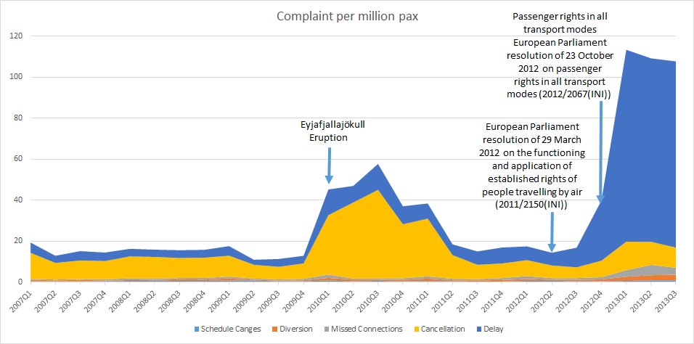
Figure 4. Complaints per million passengers reported to the UK CAA
The eruption of the Icelandic volcano Eyjafjallajökull in 2010 resulted in over 100 000 flight cancellations and affected more than 10 million passengers (EUROCONTROL, 2010). This disruption is illustrated in Figure 4. The number of complaints in the United Kingdom increased significantly due to the high amount of delays and cancellations; the Commission for Aviation Regulation of Ireland received in 2010 more than double the number of complaints than the previous year (Commission for Aviation Regulation, 2011). This major disruption also helped in the dissemination of passenger rights information and it might be one of the reasons for the higher number of complaints in the following year (2011 and beginning of 2012) with respect to the pre-eruption period (2007-2009). No worsening of the aggregate system performance that could otherwise justify this increment in complaints has been found (e.g. the average en-route ATFM delay per flight has been constant or even decreased in recent years (2011-2013 period) (EUROCONTROL, 2014).
Table 1. Complaints received by European NEBs, 2010- 2012
Year | Total complaints | Re. long* delays | Re. cancellations | Re. denied boarding
2010 | 91 726 | 16 334 | 50 461 | 3 140
2011 | 52 675 | 18 893 | 18 160 | 3 751
2012 | 56 478 | 21 710 | 21 330 | 3 757
* Of at least 2 hours, as defined to be in scope by the Regulation.
Table 1 shows the total number of complaints and the distribution thereof with regard to the Regulation (European Commission, 2014b) received by European National Enforcement Bodies (NEBs). Wider trends regarding total complaints are shown in Figure 5, and the distributions are plotted in more detail in Figure 6. Specific overall trends are difficult to identify, as so many factors affect the number of complaints received, including specific national events (such as the bankruptcy of a major airline, strikes, or changes in NEB reporting) and international events. Clearly, a major factor in 2010 was the Eyjafjallajökull eruption, although the exact number of complaints specifically associated with this is unknown. 2010 also saw numerous industrial actions and severe weather conditions. Notwithstanding the exceptional events of 2010, two observations are clear from Table 1: complaints regarding delays show a clear upward trend and those regarding denied boarding are relatively flat.

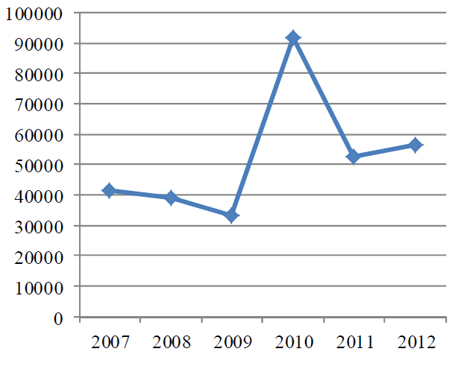
Figure 5. Total number of complaints received by European NEBs, 2007-2012
Source: European Commission (2014b).
At a high level, Figure 7 shows that: (a) all types of long delay frequencies fell from 2010, in 2011 and 2012; (b) long delay frequencies were relatively stable from 2011 to 2012. European traffic across this period was relatively stable between 2010 (9.49 million flights) and 2012 (9.55 million flights), with a modest increase in 2011 (9.78 million flights), still below 2008 levels (10.1 million flights) when the economic crisis started (EUROCONTROL: 2011, 2012, 2013). Although these figures are fairly crude they nevertheless underline an increase in delay complaints set in a context of improving or stable performance - i.e. the increase in delay complaints is indeed apparently not driven by worsening performance.

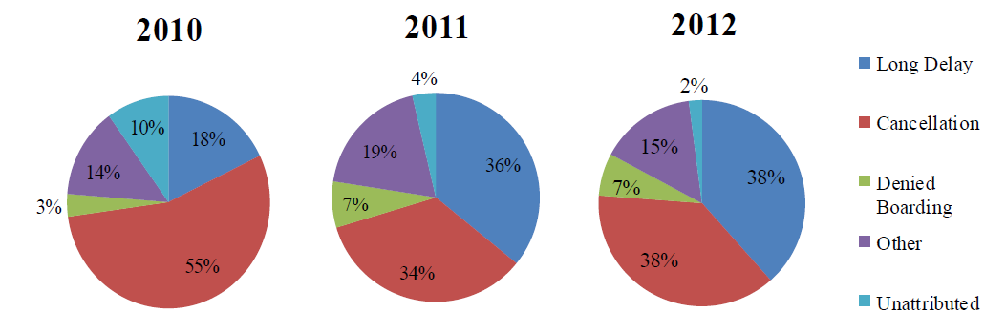

Figure 6. Distribution between grounds for lodging complaints, 2010-2012
Source: European Commission (2014b).
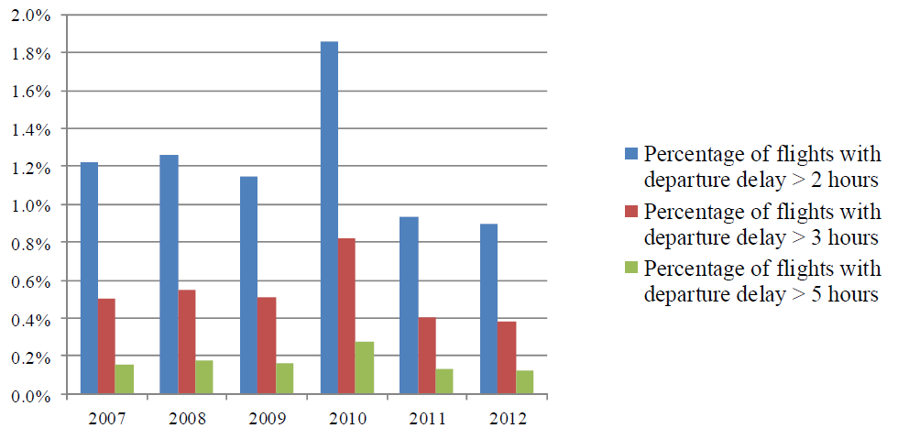
Figure 7. Crude distribution of flight delays by duration, 2007-2012
Source: European Commission (2014b).
Regarding direct survey evidence on passenger awareness, in a report commissioned by the European Commission (2014c) reporting on fieldwork undertaken in September 2014 across the 28 member states with some 28 050 respondents, respondents were evenly divided regarding air passenger rights: 37% agreed that passengers were well informed by airlines about their rights, whereas an equal percentage disagreed. It is also reported (ibid.) that in the 2009 Special Eurobarometer on air passengers’ rights, a similar question was asked. Although it is not possible to make rigorously direct comparisons due to changes in the question structures, the results in 2014 were pretty similar to those in 2009, i.e. no overall substantial increase in awareness was apparent. There was wide variation between the member states, however. Surveys carried out in Germany, Denmark and the UK show that 75% of surveyed passengers facing problems for delays or cancellations were offered re-routing, but that care was offered in less than 50% of cases (European Commission, 2013b). It is further stated that the German survey showed that where passengers did complain, over 20% of them did not receive a response from the airline. The European Commission (2013c) reports that data from airlines indicate that 5-10% of passengers entitled to compensation (in cases of cancellation or long delay) actually claim it. The Commission (ibid.) assumes that the claim rate will slowly increase over time, as a function of factors indentifed above. The total cost to airlines is predicted to increases slowly as a share of airline revenue, from 0.6% (over 2007-2009), to 0.7% in 2025. In assessing policy options, both ‘low’ (current, adopted claim rate of 10% for 2012, assumed to increase by 0.5% each year) and (theoretical) ‘maximum’ (all entitled passengers claiming) compensation claim rate impacts are explored (ibid.). A survey of 500 UK air travellers conducted on behalf of IRN Research during October 2014 (IRN Research, 2014) found that around 40% of air passengers with grounds to claim showed a reluctance to do so. It was concluded, however, that current trends suggest a moderate increase in claims in 2014, albeit with a “much higher rate of conversion. As the awareness grows that the claims process is easier this will stimulate more direct claims to airlines […]” (ibid.). These limited quantitative data will be taken forward in our delay hard cost models presented in Section 3.

2. Wider market considerations and soft passenger costs
2.1 Previous calculations on the soft cost of delay
In general, passengers’ and airlines’ interests are relatively well aligned where airlines are operating in a well-functioning competitive market; if airlines do not offer prices and services attractive to customers they will lose market share.
However, as airlines try to maximise their profits at the expense of passengers’ convenience, in some cases, such as when airlines have market power, there might be a misalignment of interest (Cambridge Economic Policy Associates, 2010). This may apply to disruptions, i.e. delays, cancellations, diversions and reschedulings.
The passenger soft cost of delay is often a dominant component in the economics of airline unpunctuality. Nevertheless, it remains poorly understood, with almost no quantitative costs published. Soft costs can only be properly understood through market research. The relationship between airline unpunctuality and passenger tolerance, airline market share and corporate performance, has been discussed in our previous reporting for EUROCONTROL (Cook and Tanner, 2011).

For distributing the soft costs of delay, a logit function was used to describe passenger dissatisfaction against various levels of delay. This curve is used to distribute the soft cost as a function of delay duration, and may be thought of as a proxy for the propensity of a passenger to switch from a given airline, to some other choice, after trips with given delay experiences.

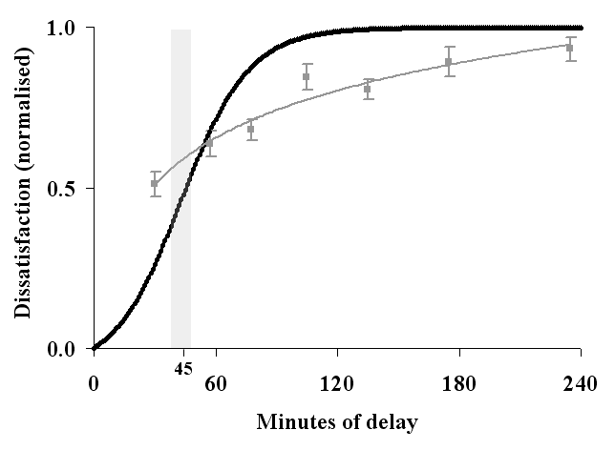
Figure 8.

Figure 8. Passenger dissatisfaction as a function of delay duration

This is plotted in Figure 8 (black curve) and has the desirable characteristics of maintaining a low value for some time, then rapidly increasing through a zone of ‘intolerance’, before levelling off. Quantification of the saturation of delay inconvenience and crossovers in Kano customer satisfaction ‘requirements’ contributed towards the model. Relationships between market share, punctuality and customer satisfaction were also examined (ibid.).

Since soft costs refer to a loss in revenue to one airline as a result of a delay on one occasion, this loss may be considered to be largely the gain of another airline, gaining a passenger who has transferred their custom. When scalable costs (multiplied over a period of time or a network) are assessed, only some net loss to the airlines of the soft costs is likely (e.g. due to trip mode substitution, trip consolidation, trip replacement (e.g. teleconference) or cancellation). This is accounted for by using a reducing scalar (ibid.) We next examine whether there is any evidence of fundamental changes to the assumptions made in these previous calculations.

2.2 Passenger satisfaction and market share
It is generally challenging to identify clear links between passenger satisfaction and bottom-line impact, particularly in a market which is increasingly price-dominated, which is especially true on short-haul routes and with LCC penetration (Pearson and Merkert, 2013). Airlines with high customer satisfaction may achieve poor margins and vice versa (ibid.). Furthermore, in Europe, there is some degree of blurring between previously distinct airline business models. Differences between full-service airlines and LCCs is changing, as the former are adopting aspects of the latter, such as separate charges for seat choice, baggage or meals. Some charter airlines also operate a mixture of the two models, and sell seats as part of package holidays and on a seat-only basis (Cambridge Economic Policy Associates, 2010).

However, passengers not only consider fare levels when purchasing their ticket, but also other factors such as quality of service (as an example of a relatively recent discussion, see Yang et al. (2012)). Expectations of service quality are a significant predictor of complaint rates, and passengers are more likely to complain if actual service quality falls below their expectations (Forbes, 2008a). Dresner and Xu (1995) found that three measures of customer service (mishandled baggage, ticket over-sales and on-time performance) were all positively related to customer complaints. A significant correlation between complaints and actual service quality was detected in an analysis of Air Travel Consumer Report data in the period 1988 and 2000 (Forbes, 2008a). A similar analysis by Steven et al. (2012) confirmed this relationship. As shown in Figure 9, the number of complaints tends to decrease as the percentage of on-time flights increases, whereas Figure 10 presents a linear relationship between cancellation and complaints. Steven et al. (ibid.) also found that this nonlinear relationship between customer service variables and customer satisfaction can be used to estimate the optimal levels of customer service that can be provided by airlines to maximise profitability.

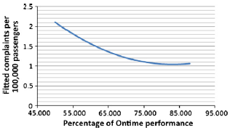
Figure 9. Relationship between on-time performance and complaints
Source: Steven et al. (2012).
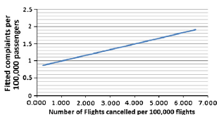
Figure 10. Linear relationship between flight cancellations and complaints
Source: Steven et al. (2012).
Also using Air Travel Consumer Report data and data from the Bureau of Transport Statistics to perform a regression analysis, Wittman (2014) shows that a one per cent increase in ‘on-time’ performance is associated with a reduction in the flight problem complaint rate of 0.028 complaints per 100 000 passengers, controlling for time and airline fixed-effects. (Based on the data sources, this is presumably counting flights on-time if operated less than 15 minutes after the scheduled time.)

The expectation of LCC passengers regarding quality of service may be lower because they pay less for their tickets. Passengers selecting LCCs primarily consider the fare, whilst passengers select full-service carriers partially for the additional product services they provide (O’Connell and Williams, 2005). It has been shown by Bhadra (2009) that air travellers may trade-off rights to complain in return for lower fares, even when faced with the same or higher levels of delays.
According to Lubbe and Victor (2012), only 24.3% of the corporate population could be considered frequent travellers, but they represent 63.5% of the substantial flight delays experienced; these frequent flyers are usually passengers flying on business. Different types of airline will experience different consequential impacts: travellers who assign a higher value to quality of service will be more willing to defect if the service falls below expectation (i.e. generating higher soft costs), even if this effect can be compensated for to some extent such as through frequent flyer program (FFP) benefits. However, in recent years more business travellers are using the services of low-cost carriers. A recent survey shows that almost 29% of Ryanair passengers were travelling on business (Cambridge Economic Policy Associates, 2010). Passengers selecting full-service carriers present a range of reasons for selecting such airlines (service reliability, quality, schedules, frequent flyer programs, etc.), whilst more than 75% of respondents stated that fare level was the main reason to select a LCC (O’Connell and Williams, 2005). LCC passengers are often far more sensitive to price than service (see, for example, a Chinese study (Chiou and Chen, 2010), based on 968 valid questionnaires disseminated in March 2007 to passengers flying Spring Airlines, the first LCC in China).
In some markets, airlines may try to compensate for the effect of market loss, due to passenger dissatisfaction, with economic tactics. Thus, prices may fall as flight delays increase, particularly in competitive markets. According to a study by Forbes (2008b), prices fall by USD 1.42 on average for direct passengers and by USD 0.77 on average for connecting passengers for each additional minute of delay. On competitive routes, the reduction can be up to USD 2.44 per minute of delay for direct passengers. This is strategic cost effect, rather than a tactical impact, however.
Ferrer et al. (2012) analysed 29 months of a major international airline’s operations, including data from 348 468 passengers. The sample was partitioned into ten sub-periods, nine of three months long and the tenth of two months, and segmented chronologically as periods 1 to 10. The passengers who experienced delay greater than 60 minutes in the third period of the sample, but no delay in the rest of the data, were selected. Those passengers were grouped and compared with similar passengers who may or may not have experienced delay. The results show that delays have a negative impact on passenger behaviour (ibid.):
- passengers who experienced delays during the third period flew less than passengers in the control group (see Table 2);
- multiple delays have a more negative impact than a single delay (see Table 2);
- the marginal effect of additional delay is negative and convex (results show that the first delay has a greater impact on non-members of the FFP and a similar effect on FFP members with respect to the second);
- the negative effect of delays persists during the entire period studied;
- the negative financial effects of flight delays are stronger for members than for non-members, even though the relative effect of delays on the number of flights is the same for both groups.

Table 2. Trip reduction by passenger delay experience and FFP membership
FFP members |  | Non-members
1 delay | 2 delays | 1 delay | 2 delays
-0.58 | -1.14 | -0.17 | -0.24
Source: Ferrer et al. (2012).

2.3 Updated soft cost of delay

Notwithstanding the foregoing discussion, we conclude that there is no substantive evidence to change the assumptions made in previous soft cost of delay calculations. Arguably, increasing passenger information and awareness of Regulation 261 rights (inter alia) could drive up sensitivities to performance, and hence soft costs. On the other hand, claim rates remain low, and airline competition high. Ideally, a substantive and dedicated research effort could be used to further quantify these costs and the parameters driving them. Until such time, we monitor the literature for new empirical insights and continue to use the methodology previously deployed for EUROCONTROL (Cook and Tanner, 2011), using here a simple inflationary increase (see Annex 2) on the 2010 costs to yield the 2014 values shown in the table below. These values use the fit of Figure 8 and seat, load factor and passenger allocations described in Annex 3.

Table 3. Soft costs by delay duration and aircraft type (base scenario)
Delay (mins) | 5 | 15 | 30 | 60 | 90 | 120 | 180 | 240 | 300
B733 | 1 | 16 | 90 | 480 | 950 | 1 340 | 2 030 | 2 710 | 3 380
B734 | 2 | 18 | 100 | 550 | 1 080 | 1 520 | 2 310 | 3 090 | 3 860
B735 | 1 | 14 | 80 | 430 | 840 | 1 190 | 1 800 | 2 400 | 3 000
B738 | 2 | 20 | 110 | 620 | 1 220 | 1 710 | 2 600 | 3 470 | 4 330
B752 | 2 | 24 | 140 | 750 | 1 480 | 2 090 | 3 170 | 4 220 | 5 280
B763 | 3 | 30 | 170 | 940 | 1 840 | 2 590 | 3 920 | 5 240 | 6 540
B744 | 4 | 49 | 280 | 1 510 | 2 970 | 4 170 | 6 330 | 8 450 | 10 560
A319 | 1 | 16 | 90 | 510 | 1 000 | 1 410 | 2 140 | 2 860 | 3 570
A320 | 2 | 19 | 110 | 590 | 1 150 | 1 620 | 2 460 | 3 290 | 4 110
A321 | 2 | 23 | 130 | 710 | 1 400 | 1 970 | 3 000 | 4 000 | 5 000
AT43 | 0 | 5 | 30 | 160 | 320 | 450 | 680 | 910 | 1 140
AT72 | 1 | 8 | 40 | 230 | 460 | 650 | 990 | 1 320 | 1 640
DH8D | 1 | 8 | 50 | 260 | 510 | 710 | 1 080 | 1 440 | 1 800
E190 | 1 | 11 | 60 | 350 | 680 | 960 | 1 460 | 1 950 | 2 430
A332 | 3 | 34 | 190 | 1 050 | 2 060 | 2 900 | 4 400 | 5 870 | 7 330
Euros (2014).

3 Hard costs of passenger delay
3.1 Deriving hard costs from Regulation 261 principles
The objective of this section is to derive hard cost of delay values by delay duration, drawing on the earlier discussion of Regulation 261, since this drives airline hard costs of passenger delay.

Table 4. Delay duration by current Regulation 261 estimated costs
Haul | Delay duration
 | ≥ 2 hours | ≥ 3 hours | ≥ 4 hours | ≥ 5 hours | ≥ 10hours ≥8
Short haul |  | €250 | €250 | €250 | (accommodation)
Medium haul |  | €400 | €400 | €400 | (accommodation)
Long haul |  | €300 | €600 | €600 | (accommodation)
Key
Care (e.g. reasonable meals and refreshments)
Reimbursement of ticket
€ Compensation (refers to arrival delay)

Table 4 reproduces the data captured earlier in Figure 2, further indicating the potential requirement of providing accommodation for passengers who cannot be rebooked/conveyed to their destination or returned to their origin during the operational day. In Table 5 and Table 6 these are fully converted into departure delay costs, making a number of assumptions. The former table assumes that the passengers associated with these costs wait for an onward flight (be that the delayed flight or as a rebooking). The latter table assumes the associated passengers abandon their trip and are refunded. To produce an overall cost estimate (by combining the tables), estimates of the ratios of these passenger types need to be made.

Table 5. Departure delay duration base scenario estimated costs – 80% of passengers wait for flight
Haul |  | Departure delay duration
 |  | ≥ 2 hours |  | ≥ 3 hours | ≥ 4 hours | ≥ 5 hours | ≥ 10 hours ≥8
Short haul |  | €6^{80%} |  | €6^{80%} €250^{11%} | €6^{80%} €250^{11%} | €265^{10%} €15^{80%} €250^{11%} | €265^{50%} €21 €250^{11%} €65
Medium haul |  |  |  | €6^{80%} €400^{11%} | €6^{80%} €400^{11%} | €345^{10%} €15^{80%} €400^{11%} | €345^{50%} €21 €400^{11%} €65
Long haul |  |  |  | €300^{11%} | €6^{80%} €600^{11%} | €1170^{10%} €15^{80%} €600^{11%} | €1170^{50%} €21 €600^{11%} €65
 |  |  | Key: Care, rebooking, compensation, accommodation

Table 6. Departure delay duration base scenario estimated costs – 20% passengers opt for refund

Haul |  | Departure delay duration
 |  | ≥ 2 hours |  | ≥ 3 hours | ≥ 4 hours | ≥ 5 hours | ≥ 10 hours ≥8
Short haul |  | €6^{80%} |  | €6^{80%} €250^{11%} | €6^{80%} €250^{11%} | €265^{90%} €15^{80%} €250^{11%} | €265^{90%} €21 €250^{11%} €65
Medium haul |  |  |  | €6^{80%} €400^{11%} | €6^{80%} €400^{11%} | €345^{90%} €15^{80%} €400^{11%} | €345^{90%} €21 €400^{11%} €65
Long haul |  |  |  | €300^{11%} | €6^{80%} €600^{11%} | €1170^{90%} €15^{80%} €600^{11%} | €1170^{90%} €21 €600^{11%} €65
 |  |  | Key: Care, reimbursement, compensation, accommodation

Regulation 261 allows for a reimbursement to be made when the delay is at least five hours, according to Article 8(1)(a). It is assumed in our calculations that there is no delay recovery (or worsening) across the thresholds, e.g. a 4.5-hour departure delay does not result in an arrival delay of less than 4 hours or more than 5 hours. This is not always entirely authentic, especially during more complicated situations relating to passenger itineraries involving connecting flights and for passengers who return to their origin and accept a refund. However, it allows us, at this aggregate level, to assign reasonable delay costs by departure delay duration, which is the objective of the calculations.

In 2012, a study was finalised by Steer Davies Gleave (SDG) in support of a Commision Impact Assessment (European Commission, 2013c), which studied the prevalent market situation, quantitatively assessing the impacts of numerous policy measures. In this section, we use several of these cost estimates, based on assumptions and calculations made by SDG. Our objective is to draw on these values to build a cost of delay: (i) by delay duration, and; (ii) producing low, base and high cost estimates, whereas the objective of the SDG calulation was more focused on calculating total costs. The mapping of SDG costs into our required framework has required further simplifications and assumptions in some respects, although some additional complexity is introduced in other respects.

The superscript values in the tables indicate the assumed uptake (or claim rate) of the various costs. These are explained on a category-by-category basis. Where absent, a 100% value is assumed, or the rate is already included in the estimate. The Euro cost shown is without the discount. These vary across the low, base and high cost scenarios. The base scenario is considered first.

Article 9 (a) of Regulation 261 stipulates the provision of meals and refreshments “in a reasonable relation to the waiting time”. As per the SDG assumptions, it is assumed that a refreshment is offered at the first stipulated threshold, and every five hours thereafter. Meals are offered after five hours of delay, and every subsequent five hours. To simplify the calculations somewhat, we have used an upper band of ≥10 hours of delay. In this band, a further refreshment and meal is assumed. These costs are based on 2012 airport averages calculated by SDG, inflated to 2014 prices according to the inflation values of Appendix 2, and rounded to the nearest whole Euro. It assumed that uptake rates are 80% for the base scenario, whereas 20% of passengers either do not claim (or are not offered) the care (some of whom may be in invited lounges, with such provision available). At the highest delay threshold, it is assumed that the entitlement is taken up by all passengers.

The SDG assumption is that hotel accommodation is triggered at 12 hours. As a small departure from this, our assumption is that this is triggered by 10 hours of departure delay on average. This is partly to simplify the tables. (It is expected that further in-house simulation modelling will allow us to quantify this statistically more accurately in future.) A single room is assumed to be required for business purpose trips and a room to be shared for leisure purpose trips. It is assumed to be not required at all for passengers visiting friends and relatives and at the destination of the original journey. Connecting passengers and those stranded at their destination are assumed to require accommodation, whereas 50% at their origin are assumed to return home. Based on these assumptions, and journey purpose by carrier type cross-tabulations, statistical (probabilistic) accommodation charges were derived, to which we have added the same, common average local transport cost, and inflated the values as previously described to 2014 values, yielding: regional (EUR 65), ‘traditional scheduled’ (EUR 72), LCC (EUR 53), charter (EUR 47).

The unweighted average of these values and the mean of the highest and lowest values, both gives EUR 60. The room sharing and non-requirement rates applied judgmentally may be a little conservative, however, such that we adopt the ‘regional’ value as our base scenario cost at EUR 65. (To be used in later tabulations, we also round the upper estimate to EUR 75 for the high cost scenario and the lower estimate to EUR 50 for the low cost scenario.) Since these values are already probabilistic, no percentage take-up rate is associated with them. We assume these costs apply to all passenger waits above 10 hours (whether for an onward flight, or associated with a refund and return to origin: although this latter situation would less often put the passenger in a situation experiencing over 10 hours of delay, the associated accommodation and care costs would be triggered in such eventualities).

In contrast, we do not include the EUR 3.38 average communication cost. This SDG value is mostly derived from an assumption of just over EUR 5 for 50% of passengers wishing to send an e-mail. Instead, we take the view that most passengers would either internalise this cost, use (free) wifi or not require to notify anybody regarding their disruption. Reducing roaming charges for phone calls within the EU are likely to contribute to this effect. A Danish survey (ibid.) cited only 2% of delayed passengers being offered such communications, although diverse assumptions are possible here. Regarding baggage delay, our assumptions concur with the airline interviews (ibid.) reporting that compensation for delayed baggage is rarely paid under the Montreal Convention.

The cost of ticket reimbursements have have been calculated by SDG as assumed to be the cost of the ticket purchased by the passenger, computed using airline financial data and combining the yield per passenger kilometre and the average distance, to produce average ticket prices for each route length and carrier type. Adopting a different approach, and based on previous in-house modelling (SESAR, 2013) using 2.9 million passenger itineraries for September 2010, we have modelled the likely reimbursements due to flight delays, assuming that delays of over 5 hours on early legs would trigger full ticket refunds. These values are inflated to 2014 values (as per Annex 2), and shown in Table 7. These are averaged across all fare types (i.e. including higher class fares) and assess costs for full itineraries (whereas the SDG calculations do not explicitly include connections). The values shown are thus rather higher than the SDG values. In our base cost scenario, 80% of passengers are assumed to wait for the delayed flight or accept a rebooking at delays of 5 hours or more, whilst 20% opt for reimbursement, and these ratios are delpoyed to produce the aggregate costs required, i.e. to combine Table 5 and Table 6. (The SDG ratios of 90%:10% are used in our low cost scenario – see Annex 4.)

Table 7. Average per passenger total reimbursements due by length of haul
Length of haul | Average total reimbursement due (EUR)
Short haul | 265
Medium haul | 345
Long haul | 1170

For rebooking, we assume that most passengers are rebooked on the same carrier or using a within-alliance reciprocal agreement, for delays of less than 10 hours, with only 10% of passengers thus generating a rebooking fee for the carrier (i.e. 10% of the reimbursement values of Table 7 are applied as a cost). For delay durations greater than this, across all lengths of haul, in the base cost scenario it is assumed that after such high durations (and with an overnight assumed), 50% of passengers are booked on the same carrier, such that only half the reimbursement value is applied as a cost to the airline. (These fares are transferred through IATA proration rules.) Where the fares are reimbursed to the passenger (Table 6), we assume that the fares of Table 7 are repaid, but that the airlines recover some of the taxes. Taxes, fees and carrier charges vary very greatly as a percentage of the ticket price. Whilst they are typically fixed on a given route, they will usually comprise a much lower percentage of bookings made close to the travel date, since the airline fare is usually much higher. It is difficult to establish clear patterns by length of haul, although they may comprise 75% or more of the total ticket price on long-haul routes. Across all haul types, notwithstanding the substantial variability, we have assumed 20% as an approximate average value, and that one half of this (10%) is not consumed, and thus recoverable (e.g. from the destination airport). The 20% may also hold for LCC flights (whereby the airport charges are lower, but so are the fares), although these may even be below 5% on some routes.

For LCCs, reciprocal agreements are less common and it is likely that rebooking onto another carrier would cost more than a fare reimbursement. We have assumed that this would be off-set by LCCs more persistently pursuing rebookings on their own flights and, unlike the SDG report, we have neither reflected higher rebooking costs for LCCs nor assumed 50% of passengers are rerouted on other carriers.

Finally, compensation is assumed to be claimed by 10% of passengers in the SDG report, with an increase of 0.5 percentage points per year, rendering a value of 11% for 2014, which has been adopted as the baseline value here.

3.2 Updated hard cost of delay
Evaluating the cells in Table 5 and Table 6 (multiplying the costs by the percentage ‘rates’) and combining these tables (80:20%, as explained) yields the costs of Table 8. The minimum time trigger points are used in the cost estimates (column headings).

Table 8. Departure delay duration per passenger costs by length of haul (base scenario)
 | 2 hours  (120 mins) | 3 hours  (180 mins) | 4 hours  (240 mins) | 5 hours  (300 mins) | 10 hours  (600 mins)
Short haul | 5 | 32 | 32 | 108 | 267
Medium haul | 0 | 49 | 49 | 146 | 330
Long haul | 0 | 33 | 71 | 382 | 831
Euros (2014).

A particularly important step follows. It will be noted that these costs are highly ‘stepped’, with very low or zero costs even assigned at two hours of delay. Experience suggests that this is not the case in practice and that even small delays are likely to produce, statistically speaking, small costs. For example, even a 15 or 30 minute delay could, on occasion, cause a passenger to miss a connection. We therefore ‘smooth’ the delays shown in Table 8 across the full range of delay values used in Table 3. Next, using the seat, load factor and passenger allocations described in Annex 3, and 2010 distributions of aircraft movements by length of haul (data not shown), the values of Table 9 are furnished (shown to nearest 10 Euros, except first column).

Table 9. Hard costs by delay duration and aircraft type (base scenario)
Delay (mins) | 5 | 15 | 30 | 60 | 90 | 120 | 180 | 240 | 300
B733 | 48 | 160 | 340 | 810 | 1 400 | 2 120 | 3 920 | 6 230 | 9 040
B734 | 60 | 190 | 420 | 990 | 1 690 | 2 550 | 4 690 | 7 410 | 10 710
B735 | 42 | 130 | 300 | 700 | 1 220 | 1 850 | 3 430 | 5 460 | 7 940
B738 | 70 | 220 | 490 | 1 140 | 1 960 | 2 950 | 5 430 | 8 570 | 12 370
B752 | 106 | 350 | 780 | 1 880 | 3 330 | 5 100 | 9 640 | 15 510 | 22 710
B763 | 124 | 420 | 1 010 | 2 660 | 4 950 | 7 880 | 15 660 | 26 000 | 38 910
B744 | 198 | 700 | 1 720 | 4 720 | 8 990 | 14 550 | 29 490 | 49 540 | 74 710
A319 | 50 | 160 | 360 | 850 | 1 470 | 2 230 | 4 150 | 6 600 | 9 590
A320 | 62 | 200 | 440 | 1 030 | 1 780 | 2 690 | 4 970 | 7 870 | 11 400
A321 | 81 | 260 | 560 | 1 320 | 2 260 | 3 400 | 6 250 | 9 860 | 14 240
AT43 | 14 | 40 | 100 | 240 | 420 | 640 | 1 200 | 1 930 | 2 830
AT72 | 20 | 60 | 140 | 340 | 600 | 920 | 1 740 | 2 800 | 4 090
DH8D | 22 | 70 | 160 | 380 | 660 | 1 010 | 1 910 | 3 060 | 4 480
E190 | 31 | 100 | 220 | 530 | 920 | 1 410 | 2 640 | 4 230 | 6 160
A332 | 138 | 480 | 1 150 | 3 070 | 5 760 | 9 220 | 18 460 | 30 780 | 46 180
Euros (2014).

Table 10 compares the costs for 15 minutes and 300 minutes of delay, with those produced for 2010 in previous reporting for EUROCONTROL (Cook and Tanner, 2011). (Values for 2010 for the DH8D, E190 and A332 have been calculated retrospectively, using the previous methodology, for comparison purposes, since these aircraft were not included in the original set of aircraft evaluated.)

We note that values for 15 minutes of delay are often very similar, despite the different approaches used. It is also to be noted that this is the region of peak delay distribution, i.e. where most delays are encountered. The main difference in the new approach presented here, compared to the previous method, is the use of far more explicit Regulation 261 data. Despite an increase in passenger numbers per flight (see Annex 3), the new costs at higher delay durations are considerably lower than the earlier estimates. These higher values are used (in wider modelling) as cost caps, so this effect would have other cost-lowering implications.

Table 10. Hard costs compared with previous reporting (base scenario)
Delay (mins) | 15 | 300
B733 | 71% | 20%
B734 | 77% | 20%
B735 | 69% | 19%
B738 | 79% | 21%
B752 | 101% | 32%
B763 | 100% | 44%
B744 | 102% | 52%
A319 | 70% | 20%
A320 | 75% | 20%
A321 | 80% | 21%
AT43 | 59% | 18%
AT72 | 60% | 18%
DH8D | (60%) | (18%)
E190 | (63%) | (19%)
A332 | (100%) | (46%)

For given care and accommodation costs, and fixed fare reimbursement values (Table 7), the costs are particularly sensitive to the assumed:

- rates of compensation paid;
- distribution between rebooked and reimbursed passengers;
- proportions of passengers causing airline rebooking fees to be incurred.

These assumptions are varied in the low and high cost scenarios presented in Annex 4.

3.3 Total cost of passenger delay to the airline

Table 11 presents the total costs of passenger delay to the airlines, by delay duration and aircraft type, for the base scenario. It is the sum of Table 3 (soft costs) and Table 9 (hard costs), shown to the nearest 10 Euros (except the first column).

Table 11. Total cost of passenger delay by delay duration and aircraft type (base scenario)

Delay (mins) | 5 | 15 | 30 | 60 | 90 | 120 | 180 | 240 | 300
B733 | 50 | 170 | 430 | 1 290 | 2 350 | 3 450 | 5 950 | 8 940 | 12 420
B734 | 62 | 210 | 520 | 1 540 | 2 780 | 4 070 | 7 000 | 10 500 | 14 570
B735 | 43 | 150 | 370 | 1 130 | 2 060 | 3 030 | 5 240 | 7 870 | 10 940
B738 | 72 | 240 | 600 | 1 760 | 3 180 | 4 660 | 8 020 | 12 030 | 16 710
B752 | 108 | 370 | 910 | 2 640 | 4 810 | 7 180 | 12 810 | 19 740 | 27 990
B763 | 126 | 450 | 1 180 | 3 590 | 6 780 | 10 460 | 19 580 | 31 240 | 45 450
B744 | 202 | 750 | 2 000 | 6 230 | 11 960 | 18 720 | 35 820 | 57 990 | 85 270
A319 | 52 | 180 | 450 | 1 360 | 2 470 | 3 640 | 6 290 | 9 460 | 13 160
A320 | 64 | 220 | 550 | 1 620 | 2 940 | 4 310 | 7 430 | 11 160 | 15 510
A321 | 83 | 280 | 690 | 2 030 | 3 670 | 5 370 | 9 240 | 13 860 | 19 230
AT43 | 14 | 50 | 130 | 400 | 740 | 1 090 | 1 890 | 2 840 | 3 970
AT72 | 20 | 70 | 190 | 580 | 1 070 | 1 570 | 2 730 | 4 110 | 5 730
DH8D | 22 | 80 | 200 | 630 | 1 170 | 1 730 | 2 990 | 4 500 | 6 280
E190 | 32 | 110 | 280 | 880 | 1 610 | 2 370 | 4 100 | 6 170 | 8 600
A332 | 141 | 510 | 1 340 | 4 120 | 7 820 | 12 120 | 22 860 | 36 650 | 53 520

References
Association of European Airlines, 2015. Monthly Monitor – AEA Monthly Traffic Update (historical data available in current file), accessed April 2015.
Bhadra, D., 2009. You (expect to) get what you pay for: A system approach to delay, fare, and complaints. Transportation Research Part A, 43, 829-843.
Cambridge Economic Policy Associates (CEPA), 2010. The extent to which airlines’ interests are aligned with those of passengers. Report commissioned by the Department for Transport.
Chiou, Y.C., Chen, Y.H., 2010, Factors influencing the intentions of passengers regarding full service and low cost carriers: A note. Journal of Air Transport Management, 16, 226-228.
Commission for Aviation Regulation, 2009. Report on Passenger Rights Complaints for year ended 31st December 2008.
Commission for Aviation Regulation, 2010. Report on Passenger Rights Complaints for year ended 31st December 2009.
Commission for Aviation Regulation, 2011. Report on Passenger Rights Complaints for year ended 31st December 2010.
Commission for Aviation Regulation, 2013. Report on Passenger Rights Complaints in 2012.
Cook, A., Tanner, G., 2011. European airline delay cost reference values. Commissioned by EUROCONTROL Performance Review Unit, Brussels.
Correia, V., Rouissi, N., 2015. Global, regional and national air passenger rights – does the patchwork work? Air & Space Law, 40 (2), 123-146.
Court of Justice of the European Union, 2009. Case C-402/07: Christopher, Gabriel and Alana Sturgeon v. Condor Flugdienst GmbH and Case C-432/07: Stefan Böck and Cornelia Lepuschitz v. Air France SA.
Court of Justice of the European Union, 2012a. Case C-581/10 and Case C-629/10: Emeka Nelson and Others v. Deutsche Lufthansa AG (C-581/10) and TUI Travel plc and Others v. Civil Aviation Authority (C-629/10).
Court of Justice of the European Union, 2012b. Judgment in Joined Cases C-581/10 Nelson and Others v. Deutsche Lufthansa AG and C-629/10 TUI Travel and Others v. Civil Aviation Authority, Press release No 135/12, Luxembourg, 23 October 2012.
Court of Justice of the European Union, 2013. Judgment in Case C-11/11, Air France SA v. Heinz-Gerke Folkerts and Luz-Tereza Folkerts.
Court of Justice of the European Union, 2014. Case C‑452/13: Germanwings GmbH v. Ronny Henning.
Dresner, M., Xu, K., 1995. Customer service customer satisfaction and corporate performance in the service sector. Journal of Business Logistics 16 (1), 23-40.
England and Wales Court of Appeal (Civil Division) Decisions, 2014a. Neutral Citation Number: [2014] EWCA Civ 791, Case No: B2/2013/3277/CCRTF, Royal Courts of Justice, Strand, London, WC2A 2LL, 11th June 2014.
England and Wales Court of Appeal (Civil Division) Decisions, 2014b. Neutral Citation Number: [2014] EWCA Civ 845, Case No: B2/2013/2478, Royal Courts of Justice, Strand, London, WC2A 2LL, 19th June 2014.
EUROCONTROL, 2010. Ash-cloud of April and May 2010: Impact on Air Traffic. STATFOR/Doc294 V1.0.
EUROCONTROL, 2011. Performance Review Report 2010: an assessment of air traffic management in Europe during the calendar year 2010, EUROCONTROL Performance Review Commission, Brussels.
EUROCONTROL, 2012. Performance Review Report 2011: an assessment of air traffic management in Europe during the calendar year 2011, EUROCONTROL Performance Review Commission, Brussels.
EUROCONTROL, 2013. Performance Review Report 2012: an assessment of air traffic management in Europe during the calendar year 2012, EUROCONTROL Performance Review Commission, Brussels.
EUROCONTROL, 2014. Performance Review Report 2013: an assessment of air traffic management in Europe during the calendar year 2013, EUROCONTROL Performance Review Commission, Brussels.
European Regions Airline Association, 2014. Passenger rights, update 24/11/2014.
http://www.eraa.org/policy/passenger-rights/passenger-rights (Accessed January 2015)
European Commission, 2004. Regulation (EC) No 261/2004 of the European Parliament and of the Council of 11 February 2004 establishing common rules on compensation and assistance to passengers in the event of denied boarding and of cancellation or long delay of flights, and repealing Regulation (EEC) No 295/91, 17 February 2004, 1-7.
European Commission, 2011b. Flightpath 2050: Europe’s Vision for Aviation, report of the High Level Group on Aviation Research, ISBN 978-92-79-19724-6, Brussels, 1-28.
European Commission, 2011c. White Paper: Roadmap to a Single European Transport Area – Towards a competitive and resource efficient transport system, COM(2011) 144 final, Brussels,28 March 2011, 1-30.
European Commission, 2011d. Possible revision of Regulation (EC) 261/2004 on denied boarding, long delays and cancellations of flights, Roadmap Version 1, November 2011, 1-5.
European Commission, 2012b. Public consultation on the possible revision of Regulation 261/2004 – results, report prepared by Steer Davies Gleave, 2012, 1-114.
European Commission, 2013a. Draft list of extraordinary circumstances following the National Enforcement Bodies (NEB) meeting held on 12 April 2013 - understanding between NEB–NEB on a non-exhaustive and non-binding list of extraordinary circumstances for the application of the current Regulation (EC) 261/2004.
http://ec.europa.eu/transport/themes/passengers/air/ (Accessed January 2015)
European Commission, 2013b. Air passenger rights revision (memo), Brussels, 13 March 2013.
European Commission, 2013c. Commission staff working document – impact assessment, Brussels, 13 March 2013.
European Commission, 2014a. European Parliament votes on air passenger rights, Press Release IP/14/119, Brussels, 5 February 2014, 1-4.
European Commission, 2014b. Commission staff working document – complaint handling and enforcement by member states of the air passenger rights regulations.
European Commission, 2014c. Special Eurobarometer 420, Passenger rights.
European Parliament, 2012a. Resolution of 29 March 2012 on the functioning and application of established rights of people travelling by air (2011/2150(INI))
http://www.europarl.europa.eu/sides/getDoc.do?type=TA&language=EN&reference=P7-TA-2012-99
(Accessed January 2015)
European Parliament, 2012b. Resolution of 23 October 2012 on passenger rights in all transport modes (2012/2067(INI))
http://www.europarl.europa.eu/sides/getDoc.do?pubRef=-//EP//TEXT+TA+P7-TA-2012-0371+0+DOC+XML+V0//EN
(Accessed January 2015)
Ferrer, J-C., Rocha e Oliveira, P., Parasuraman, A., 2012. The behavioral consequences of repeated flight delays, Journal of Air Transport Management, 20, 35-38.
Forbes, S. J., 2008a. The effect of service quality and expectations on customer complaints, The Journal of Industrial Economics, 56 (1), 190-213. DOI: 10.1111/j.1467-6451.2008.00338.x
Forbes, S. J., 2008b. The effect of air traffic delays on airline prices, International Journal of Industrial Organization, 26, 1218-1232.
International Air Transport Association, 2015. Air Passenger Monthly Analysis, December 2014, Montreal & Geneva, 05 February 2015.
IRN Research, 2014. Air travellers likely to go direct to an airline for compensation rather than use a law firm or claim company, press release, 4th November 2014, Coventry, UK.
Lubbe, B., Victor, C., 2012. Flight delays: Towards measuring the cost to corporations, Journal of Air Transport Management, 19, 9-12.
Maibach, M., Schreyer, C., Sutter, D., van Essen, H.P., Boon, B.H., Smokers, R., Schroten, A., Doll, C., Pawlowska, B., Bak, M., 2008. Handbook on estimation of external costs in the transport sector, produced within the study: internalisation measures and policies for all external cost of transport (IMPACT), Version 1.1. Delft, February 2008.
http://ec.europa.eu/transport/sustainable/doc/2008_costs_handbook.pdf
O’Connell, J. F., Williams, G., 2005. Passengers’ perceptions of low cost airlines and full service carriers: A case study involving Ryanair, Aer Lingus, Air Asia and Malaysia Airlines, Journal of Air Transport Management, 11, 259-272.
Pearson, J., Merkert, R., 2013. Does airline customer satisfaction matter? Linking customer satisfaction with airline financial performance. 17th Air Transport Research Society (ATRS) World Conference, Bergamo.
Rouissi, N., Correia, V., 2014. Airline passenger protection regulations: does the patchwork work? A legal perspective. 18th Air Transport Research Society (ATRS) World Conference, Bordeaux.
SESAR, 2013. POEM (E.02.06) Deliverable 6.2 - Final Technical Report, Sep. 2013.
Steven, A. B., Dong, Y., Dresner, M., 2012. Linkages between customer service, customer satisfaction and performance in the airline industry: Investigation of non-linearities and moderating effects, Transportation Research Part E, 48, 737-754.
Toogood, C., 2014. Am I entitled to compensation for a delayed flight? Travel Supermarket, November 2014.
http://www.travelsupermarket.com/blog/am-i-entitled-to-compensation-for-a-delayed-flight/ (Accessed January 2015)
UK Supreme Court, 2014. Jet2.com Limited (Appellant) v. Huzar (Respondent) (Neutral Citation Number: [2014] EWCA Civ 791, Case No: B2/2013/3277/CCRTF) and Thomson Airways Limited (Appellant) v. Dawson (Respondent) (Neutral Citation Number: [2014] EWCA Civ 845, Case No: B2/2013/2478), The Supreme Court, Parliament Square, London SW1P 3BD, 31 October 2014.
Wittman, M., 2014. Are low-cost carrier passengers less likely to complain about service quality?, Journal of Air Transport Management, 36, 64-71.
Yang, K.-C., Hsieh, T.-C., Li, H., Yang, C., 2012. Assessing how service quality, airline image and customer value affect the intentions of passengers regarding low cost carriers. Journal of Air Transport Management, 20, 52-53.

Annex 1. CJEU, Joined cases C-402/07 and C-432/07.
[Extract from Court of Justice of the European Union ruling; non-source emboldening of text.]

Judgment of the Court (Fourth Chamber) of 19 November 2009.

Christopher Sturgeon, Gabriel Sturgeon and Alana Sturgeon v Condor Flugdienst GmbH (C-402/07) and Stefan Böck and Cornelia Lepuschitz v Air France SA (C-432/07).

References for a preliminary ruling: Bundesgerichtshof - Germany and Handelsgericht Wien - Austria.
Air transport - Regulation (EC) No 261/2004 - Article 2(l) and Articles 5, 6 and 7 - Concept of flight ‘delay’ and ‘cancellation’ - Right to compensation in the event of delay - Concept of ‘extraordinary circumstances’.

Joined cases C-402/07 and C-432/07.
European Court Reports 2009 I-10923•ECLI identifier: ECLI:EU:C:2009:716

Summary of the Judgment

1. Transport – Air transport – Regulation No 261/2004 – Common rules on compensation and assistance to passengers in the event of denied boarding and of cancellation or long delay of flights
(European Parliament and Council Regulation No 261/2004, Arts 2(l), 5 and 6)
2. Transport – Air transport – Regulation No 261/2004 – Common rules on compensation and assistance to passengers in the event of denied boarding and of cancellation or long delay of flights
(European Parliament and Council Regulation No 261/2004, Arts 5, 6 and 7)
3. Transport – Air transport – Regulation No 261/2004 – Compensation and assistance to passengers in the event of cancellation of flights
(European Parliament and Council Regulation No 261/2004, Art. 5(3))

1. Articles 2(l), 5 and 6 of Regulation No 261/2004 establishing common rules on compensation and assistance to passengers in the event of denied boarding and of cancellation or long delay of flights must be interpreted as meaning that a flight which is delayed, irrespective of the duration of the delay, even if it is long, cannot be regarded as cancelled where the flight is operated in accordance with the air carrier’s original planning.

A flight is delayed for the purposes of Article 6 of that regulation if it is operated in accordance with the original planning and its actual departure time is later than the scheduled departure time, whilst, according to Article 2(l) of that regulation, flight cancellation is the result of non-operation of a flight which was previously planned.
(see paras 32-33, 39, operative part 1)

2. Articles 5, 6 and 7 of Regulation No 261/2004 establishing common rules on compensation and assistance to passengers in the event of denied boarding and of cancellation or long delay of flights must be interpreted as meaning that passengers whose flights are delayed may be treated, for the purposes of the application of the right to compensation, as passengers whose flights are cancelled and they may thus rely on the right to compensation laid down in Article 7 of the regulation when they suffer, on account of a flight delay, a loss of time equal to or in excess of three hours, that is, where they reach their final destination three hours or more after the arrival time originally scheduled by the air carrier. Such a delay does not, however, entitle passengers to compensation if the air carrier can prove that the long delay was caused by extraordinary circumstances which could not have been avoided even if all reasonable measures had been taken, namely circumstances beyond the actual control of the air carrier.
(see para. 69, operative part 2)

3. Article 5(3) of Regulation No 261/2004 establishing common rules on compensation and assistance to passengers in the event of denied boarding and of cancellation or long delay of flights must be interpreted as meaning that a technical problem in an aircraft which leads to the cancellation or delay of a flight is not covered by the concept of ‘extraordinary circumstances’ within the meaning of that provision, unless that problem stems from events which, by their nature or origin, are not inherent in the normal exercise of the activity of the air carrier concerned and are beyond its actual control.
(see para. 72, operative part 3)

[…]

Judgment of the court (Fourth Chamber)

[…]

63. It is important to point out that the compensation payable to a passenger under Article 7(1) of Regulation No 261/2004 may be reduced by 50% if the conditions laid down in Article 7(2) of the regulation are met. Even though the latter provision refers only to the case of re-routing of passengers, the Court finds that the reduction in the compensation provided for is dependent solely on the delay to which passengers are subject, so that nothing precludes the application mutatis mutandis of that provision to compensation paid to passengers whose flights are delayed. It follows that the compensation payable to a passenger whose flight is delayed, who reaches his final destination three hours or more after the arrival time originally scheduled, may be reduced by 50%, in accordance with Article 7(2)(c) of Regulation No 261/2004, where the delay is – in the case of a flight not falling under points (a) or (b) of Article 7(2) – less than four hours.

~*~
Article 7 of Regulation (EC) No 261/2004

Right to compensation

1. Where reference is made to this Article, passengers shall receive compensation amounting to:

(a) EUR 250 for all flights of 1500 kilometres or less;

(b) EUR 400 for all intra-Community flights of more than 1500 kilometres, and for all other flights between 1500 and 3500 kilometres;

(c) EUR 600 for all flights not falling under (a) or (b).

In determining the distance, the basis shall be the last destination at which the denial of boarding or cancellation will delay the passenger's arrival after the scheduled time.

2. When passengers are offered re-routing to their final destination on an alternative flight pursuant to Article 8, the arrival time of which does not exceed the scheduled arrival time of the flight originally booked

(a) by two hours, in respect of all flights of 1500 kilometres or less; or

(b) by three hours, in respect of all intra-Community flights of more than 1500 kilometres and for all other flights between 1500 and 3500 kilometres; or

(c) by four hours, in respect of all flights not falling under (a) or (b),

the operating air carrier may reduce the compensation provided for in paragraph 1 by 50%.
Annex 2. Average European inflation rates.

The table below shows the annual average rate of inflationary change (%) for the European Union (changing composition), for 2010 to 2014. The value cited is the Harmonised Index of Consumer Prices (HICP), designed for international comparisons of consumer price inflation. It is used by the European Central Bank for monitoring inflation in the Economic and Monetary Union and is sourced from eurostat:
http://ec.europa.eu/eurostat/tgm/table.do?tab=table&init=1&language=en&pcode=tec00118&plugin=1 (accessed 01MAY15)

Average European inflation rates
Year | Inflation rate (%) | 2014 compound  rate on 2012 (%) | 2014 compound  rate on 2010 (%)
2010 | 2.1
2011 | 3.1
2012 | 2.6
2013 | 1.5
2014 | 0.6 | 3.1 | 8.8

Source: eurostat (2015).

For the compound rates (used in the main text), half the total annual values are used for the base and target years, as a crude method of producing mid-year estimates.
Annex 3. Seat, load factor and passenger allocations.

Aircraft seats for the 15 supported aircraft have been reviewed using Innovata global seats file (2010 data). The typical seating ranges (excluding outliers) are shown in the table below.

Typical seat range and allocated aircraft seats by scenario

ICAO aircraft designation | Typical seat  range¹ |  | Allocated seats
 |  | Low² | Base³ | High⁴
B733 | 116-148 | 148 | 134 | 134
B734 | 134-168 | 168 | 152 | 152
B735 | 96-132 | 132 | 119 | 119
B738 | 144-189 | 189 | 171 | 171
B752 | 160-232 | 232 | 209 | 209
B763 | 192-270 | 270 | 243 | 230
B744 | 275-436 | 436 | 393 | 371
A319 | 118-156 | 156 | 141 | 141
A320 | 136-180 | 180 | 162 | 162
A321 | 169-220 | 220 | 198 | 198
AT43 | 42-50 | 50 | 45 | 45
AT72 | 62-72 | 72 | 65 | 65
DH8D | 70-78 | 78 | 71 | 71
E190 | 93-106 | 106 | 96 | 96
A332 | 211-303 | 303 | 273 | 258
¹ Typical seat range for the global fleet 2010 (Innovata); aircraft with unusual seat configurations excluded.
² Low cost scenario seats allocated using 100% of the maximum typical number of seats.
³ Base cost scenario seats allocated using 90% of the maximum typical number of seats.
⁴ High cost scenario seats allocated using 90/85% (narrow/wide-bodies) of the maximum typical number of seats

Small differences are observed between the previous reporting for EUROCONTROL (Cook and Tanner, 2011) and the updated typical seat ranges. These changes can be explained by a new more rigorous selection process, i.e. excluding a greater number of unusual configurations (e.g. disregarding B734 ‘quick change’ and B744 ‘combi’ airframes fitted with only 72 and 275 seats respectively), and intervening airline fleet composition changes. The notable changes consist of an increase in the minimum number of A319, A320 and A321 seats (an additional 36, 26 and 20 seats respectively) and a decrease in the maximum number of B763 and B744 seats (reduced by 58 and 38 seats).
Low, base and high cost scenario seats have been allocated using the maximum typical number of seats per aircraft type; the low cost scenario having the maximum number of seats to reflect a single-class cabin configuration. From this, 90% of the maximum number of seats has been allocated to the base and high cost scenarios to allow for business- and economy-class seating. The widebody high cost seating scenario has been allocated using 85% of the maximum number of seats (i.e. three-class layout). (In contrast, the previous (ibid.) seat allocation was based on 100%, 85% and 85%/75% for low, base and high cost scenarios.) It should also be noted that in some cases, a change in the number of allocated seats has an effect on the modelled crew costs carried out in parallel (requiring ±1 flight attendant if the cabin crew to seat threshold is crossed).

Low, base and high cost scenario passenger loadings have been allocated using scenario-specific load factors. The starting point is an 80% average load factor covering 2014. This average is based on industry load factors published by AEA (80.4% derived from ‘total scheduled’ monthly average load factors) and IATA (79.7% ‘total market’) (AEA, 2015; IATA, 2015). Passengers have been allocated to the low cost scenario using a load factor of 65% (an increase from the 60% used with the previous (ibid.) delay cost model) and to the high cost scenario using 95% (up from 90% previously). Narrowbody base cost scenario passengers have been allocated using the industry average 80% with the corresponding widebody passengers from an 85% load factor (both up from 75% and 80% previously). The table below shows the final allocation for each aircraft type.

Allocated passenger loadings by scenario

ICAO aircraft designation |  | Allocated passengers
 | Low¹ | Base² | High³
B733 | 96 | 107 | 127
B734 | 109 | 122 | 144
B735 | 86 | 95 | 113
B738 | 123 | 137 | 162
B752 | 151 | 167 | 199
B763 | 176 | 207 | 219
B744 | 283 | 334 | 352
A319 | 101 | 113 | 134
A320 | 117 | 130 | 154
A321 | 143 | 158 | 188
AT43 | 33 | 36 | 43
AT72 | 47 | 52 | 62
DH8D | 51 | 57 | 67
E190 | 69 | 77 | 91
A332 | 197 | 232 | 245
¹ Low cost scenario passengers allocated using 65% load factor.
² Base cost scenario passengers allocated using 80% (narrowbodies) or 85% (widebodies) load factor.
³ High cost scenario passengers allocated using 95% load factor.

Annex 4. Low and high cost scenario tabulations.

Low cost scenario assumptions

Departure delay duration low scenario estimated costs – 90% of passengers wait for flight

Haul |  | Departure delay duration
 |  | ≥ 2 hours |  | ≥ 3 hours | ≥ 4 hours | ≥ 5 hours | ≥ 10 hours ≥8
Short haul |  | €6^{50%} |  | €6^{50%} €250^{5%} | €6^{50%} €250^{5%} | €265^{0%} €15^{50%} €250^{5%} | €265^{10%} €21 €250^{5%} €50
Medium haul |  |  |  | €6^{50%} €400^{5%} | €6^{50%} €400^{5%} | €345^{0%} €15^{50%} €400^{5%} | €345^{10%} €21 €400^{5%} €50
Long haul |  |  |  | €300^{5%} | €6^{50%} €600^{5%} | €1170^{0%} €15^{50%} €600^{5%} | €1170^{10%} €21 €600^{5%} €50
 |  |  | Key: Care, rebooking, compensation, accommodation

Departure delay duration low scenario estimated costs – 10% passengers opt for refund

Haul |  | Departure delay duration
 |  | ≥ 2 hours |  | ≥ 3 hours | ≥ 4 hours | ≥ 5 hours | ≥ 10 hours ≥8
Short haul |  | €6^{50%} |  | €6^{50%} €250^{5%} | €6^{50%} €250^{5%} | €265^{90%} €15^{50%} €250^{5%} | €265^{90%} €21 €250^{5%} €50
Medium haul |  |  |  | €6^{50%} €400^{5%} | €6^{50%} €400^{5%} | €345^{90%} €15^{50%} €400^{5%} | €345^{90%} €21 €400^{5%} €50
Long haul |  |  |  | €300^{5%} | €6^{50%} €600^{5%} | €1170^{90%} €15^{50%} €600^{5%} | €1170^{90%} €21 €600^{5%} €50
 |  |  | Key: Care, reimbursement, compensation, accommodation

Key assumption changes relative to base cost scenario

Setting | Low cost assumption | Base cost assumption
Rates of compensation paid | 5% | 11%
Passengers waiting for flight (instead of refund) | 90% | 80%
Passengers rebooked on other carrier at 5-10 hours | 0% | 10%
Passengers rebooked on other carrier beyond 10 hours | 10% | 50%
Care provision at 2-10 hours | 50% | 80%
Statistical accommodation cost (see main text) | €50 | €65
Passengers on-board scenario (see Annex 3) | Low | Base

Departure delay duration per passenger costs by length of haul (low cost scenario)

 | 2 hours | 3 hours | 4 hours | 5 hours | 10 hours
Short haul | 3 | 16 | 16 | 44 | 131
Medium haul | 0 | 23 | 23 | 59 | 153
Long haul | 0 | 15 | 33 | 143 | 312
Euros (2014).

Average cost relative to base scenario = 42%.

High cost scenario assumptions

Departure delay duration high scenario estimated costs – 75% of passengers wait for flight

Haul |  | Departure delay duration
 |  | ≥ 2 hours |  | ≥ 3 hours | ≥ 4 hours | ≥ 5 hours | ≥ 10 hours ≥8
Short haul |  | €6^{85%} |  | €6^{85%} €250^{15%} | €6^{85%} €250^{15%} | €265^{15%} €15^{85%} €250^{15%} | €265^{60%} €21 €250^{15%} €75
Medium haul |  |  |  | €6^{85%} €400^{15%} | €6^{85%} €400^{15%} | €345^{15%} €15^{85%} €400^{15%} | €345^{60%} €21 €400^{15%} €75
Long haul |  |  |  | €300^{15%} | €6^{85%} €600^{15%} | €1170^{15%} €15^{85%} €600^{15%} | €1170^{60%} €21 €600^{15%} €75
 |  |  | Key: Care, rebooking, compensation, accommodation

Departure delay duration high scenario estimated costs – 25% passengers opt for refund

Haul |  | Departure delay duration
 |  | ≥ 2 hours |  | ≥ 3 hours | ≥ 4 hours | ≥ 5 hours | ≥ 10 hours ≥8
Short haul |  | €6^{85%} |  | €6^{85%} €250^{15%} | €6^{85%} €250^{15%} | €265^{90%} €15^{85%} €250^{15%} | €265^{90%} €21 €250^{15%} €75
Medium haul |  |  |  | €6^{85%} €400^{15%} | €6^{85%} €400^{15%} | €345^{90%} €15^{85%} €400^{15%} | €345^{90%} €21 €400^{15%} €75
Long haul |  |  |  | €300^{15%} | €6^{85%} €600^{15%} | €1170^{90%} €15^{85%} €600^{15%} | €1170^{90%} €21 €600^{15%} €75
 |  |  | Key: Care, reimbursement, compensation, accommodation

Key assumption changes relative to base cost scenario

Setting | High cost assumption | Base cost assumption
Rates of compensation paid | 15% | 11%
Passengers waiting for flight (instead of refund) | 75% | 80%
Passengers rebooked on other carrier at 5-10 hours | 15% | 10%
Passengers rebooked on other carrier beyond 10 hours | 60% | 50%
Care provision at 2-10 hours | 85% | 80%
Statistical accommodation cost (see main text) | €75 | €65
Passengers on-board scenario (see Annex 3) | High | Base

Departure delay duration per passenger costs by length of haul (high cost scenario)

 | 2 hours | 3 hours | 4 hours | 5 hours | 10 hours
Short haul | 5 | 43 | 43 | 140 | 312
Medium haul | 0 | 65 | 65 | 189 | 389
Long haul | 0 | 45 | 95 | 498 | 976
Euros (2014).

Average cost relative to base scenario = 123%.

- Provisional, strategic delay cost values for 2014
Appendix B tables provide the latest strategic delay cost values for maintenance, crew and fleet costs, updated to 2014 Euro values. The task of including three additional aircraft in the cost models is work in progress, hence these 2014 costs are provisional.

(1) Maintenance costs

TableB1. Provisional at-gate, strategic maintenance costs
Aircraft | Low scenario | Base scenario | High scenario
B733 | 50 | 110 | 180
B734 | 60 | 120 | 190
B735 | 50 | 100 | 160
B738 | 40 | 90 | 170
B752 | 70 | 140 | 220
B763 | 100 | 180 | 340
B744 | 200 | 250 | 360
A319 | 50 | 120 | 190
A320 | 60 | 110 | 200
A321 | 70 | 130 | 210
AT43 | 30 | 50 | 80
AT72 | 30 | 60 | 100
DH8D | 30 | 60 | 90
E190 | 40 | 80 | 120
A332 | 100 | 190 | 360
All costs are EUR per hour (2014) and include overheads.

TableB2. Provisional taxi, strategic maintenance costs
Aircraft | Low scenario | Base scenario | High scenario
B733 | 300 | 650 | 1 050
B734 | 360 | 710 | 1 120
B735 | 310 | 620 | 970
B738 | 260 | 540 | 1 020
B752 | 420 | 830 | 1 310
B763 | 570 | 1 050 | 1 960
B744 | 1 140 | 1 450 | 2 070
A319 | 320 | 690 | 1 120
A320 | 340 | 670 | 1 230
A321 | 390 | 770 | 1 210
AT43 | 180 | 350 | 560
AT72 | 210 | 420 | 660
DH8D | 190 | 380 | 600
E190 | 230 | 460 | 730
A332 | 590 | 1 100 | 2 050
All costs are EUR per hour (2014) and include overheads.

TableB3. Provisional airborne (en-route), strategic maintenance costs
Aircraft | Low scenario | Base scenario | High scenario
B733 | 390 | 850 | 1 380
B734 | 460 | 910 | 1 440
B735 | 390 | 780 | 1 240
B738 | 340 | 710 | 1 330
B752 | 520 | 1 040 | 1 640
B763 | 720 | 1 340 | 2 500
B744 | 1 480 | 1 880 | 2 680
A319 | 420 | 920 | 1 480
A320 | 430 | 850 | 1 550
A321 | 510 | 1 010 | 1 600
AT43 | 200 | 400 | 630
AT72 | 250 | 500 | 790
DH8D | 230 | 450 | 710
E190 | 290 | 590 | 930
A332 | 760 | 1 410 | 2 630
All costs are EUR per hour (2014) and include overheads.
Airborne maintenance costs commonly apply to en-route and arrival management phases,
although strategic arrival management costs are not considered in this deliverable.

(2) Crew costs

TableB4. Provisional crew costs per service hour by aircraft type (ground or airborne)
Aircraft | Low scenario | Base scenario | High scenario
B733 | 180 | 330 | 580
B734 | 180 | 340 | 620
B735 | 160 | 310 | 570
B738 | 200 | 400 | 730
B752 | 260 | 450 | 750
B763 | 360 | 650 | 1 370
B744 | 460 | 870 | 1 750
A319 | 190 | 310 | 540
A320 | 200 | 360 | 630
A321 | 230 | 370 | 640
AT43 | 90 | 160 | 280
AT72 | 110 | 180 | 330
DH8D | 110 | 180 | 330
E190 | 150 | 260 | 500
A332 | 400 | 710 | 1 150
All costs are EUR (2014). On-costs included. Base and high scenarios with overtime.

(3) Fleet costs

TableB5. Provisional fleet costs per service hour
Aircraft | Low scenario | Base scenario | High scenario
B733 | 80 | 220 | 380
B734 | 90 | 260 | 450
B735 | 90 | 250 | 430
B738 | 210 | 590 | 1 010
B752 | 160 | 450 | 760
B763 | 200 | 570 | 970
B744 | 310 | 870 | 1 490
A319 | 150 | 410 | 700
A320 | 240 | 670 | 1 130
A321 | 280 | 800 | 1 360
AT43 | 60 | 160 | 280
AT72 | 80 | 230 | 390
DH8D | 90 | 250 | 430
E190 | 420 | 1 190 | 2 020
A332 | 380 | 1 080 | 1 830

- CO₂ emission cost in 2014 for aircraft type analysed

TableC1. CO2 emitted by minute of flight at typical cruise and cost in carbon allowances for 2014 (EU Emission Allowances, EU Aviation Allowances, ERU and CER).
Aircraft Type | Typical cruise emissions  65% Load  [CO2/min] | EU Emission Allowance (EUA) during 2014 (European Energy Exchange, 2014a) | EU Aviation Allowances (EUAA) / Secondary Market (European Energy Exchange, 2014b) | EU Aviation Allowances (EUAA) / Primary Market Auction (European Energy Exchange, 2014c) | Emission Reduction Units Futures (ERU). Settle Price. Cal-15. (European Energy Exchange, 2014d) | Certified Emission Reduction (CER) Futures. Settle Price. Cal-15. (European Energy Exchange, 2014e) | EU Emission Allowance (EUA) during 2014 (European Energy Exchange, 2014a) | EU Aviation Allowances (EUAA) / Secondary Market (European Energy Exchange, 2014b) | EU Aviation Allowances (EUAA) / Primary Market Auction (European Energy Exchange, 2014c) | Emission Reduction Units Futures (ERU). Settle Price. Cal-15. (European Energy Exchange, 2014d)
 |  | Min  [EUR] | Avg  [EUR] | Max  [EUR] | 2013-2020  [EUR] | Phase 3  [EUR] | Min [EUR] | Avg [EUR] | Max [EUR] | 2013-2020 [EUR]
 |  | 31-03-14 | - | 23-12-14 | 09-01-15 | 26-11-14 | 31-03-14 | - | 23-12-14 | 09-01-15
 |  | € 4.18 | € 5.94 | € 7.24 | € 6.47 | € 6.90 | € 4.18 | € 5.94 | € 7.24 | € 6.47
A319 | 0.12 | 0.50 | 0.71 | 0.87 | 0.78 | 0.83 | 0.00 | 0.06 | 0.03 | 0.07
A320 | 0.12 | 0.50 | 0.71 | 0.87 | 0.78 | 0.83 | 0.00 | 0.06 | 0.03 | 0.07
A321 | 0.15 | 0.63 | 0.89 | 1.09 | 0.97 | 1.04 | 0.00 | 0.07 | 0.04 | 0.09
A340-300 | 0.34 | 1.42 | 2.02 | 2.46 | 2.20 | 2.35 | 0.01 | 0.16 | 0.09 | 0.20
AT720 | 0.03 | 0.13 | 0.18 | 0.22 | 0.19 | 0.21 | 0.00 | 0.01 | 0.01 | 0.02
AT721 | 0.03 | 0.13 | 0.18 | 0.22 | 0.19 | 0.21 | 0.00 | 0.01 | 0.01 | 0.02
ATR 42 | 0.02 | 0.08 | 0.12 | 0.14 | 0.13 | 0.14 | 0.00 | 0.01 | 0.01 | 0.01
B737-300 | 0.13 | 0.54 | 0.77 | 0.94 | 0.84 | 0.90 | 0.00 | 0.06 | 0.03 | 0.08
B737-400 | 0.13 | 0.54 | 0.77 | 0.94 | 0.84 | 0.90 | 0.00 | 0.06 | 0.03 | 0.08
B737-500 | 0.12 | 0.50 | 0.71 | 0.87 | 0.78 | 0.83 | 0.00 | 0.06 | 0.03 | 0.07
B737-800 | 0.14 | 0.59 | 0.83 | 1.01 | 0.91 | 0.97 | 0.00 | 0.06 | 0.04 | 0.08
B747-400 | 0.51 | 2.13 | 3.03 | 3.69 | 3.30 | 3.52 | 0.02 | 0.23 | 0.13 | 0.30
B757-200 | 0.17 | 0.71 | 1.01 | 1.23 | 1.10 | 1.17 | 0.01 | 0.08 | 0.04 | 0.10
B767-300 ER | 0.25 | 1.05 | 1.49 | 1.81 | 1.62 | 1.73 | 0.01 | 0.12 | 0.06 | 0.15

-END OF DOCUMENT-

Note: the weight category classification scheme, used to produce the turnaround times distribution, differs from the weight category classification scheme used for runway occupancy times. This is intended as the two models are intrinsically different.
EU-27 data are required for backwards compatibility to 2010.
See also Lubbe and Victor (2012). For quantified values of time, see Cook and Tanner (2011) (Annex C) and Maibach et al. (2008), the latter used for reference by Commission services (European Commission, 2013c).
The White Paper calls for a uniform interpretation of EU law on passenger rights and a harmonised and effective enforcement thereof. The consultation period for the mid-term review of the White Paper runs from 10MAR15 to 02JUN15: http://ec.europa.eu/transport/media/consultations/2015-white-paper-2011-midterm-review_en.htm
See Article 7(2) of the Regulation, cited in Appendix A, for the literal terminology.
Also published as Correia and Rouissi (2015).
See also extracts of this important ruling, as set out in Appendix A.
Regulation 2027/97 translates the Montreal Convention into EU law, making provisions with regard to compensation where baggage has been mishandled (European Commission, 2013c). The Montreal Convention is concerned with individualised damage to travellers, assessed on a case-by-case basis, with proof of burden on the passenger, and has no provisions with regard to denied boarding or cancellation. In theory, it provides a right to compensation in the event of delay, but the burden of proof issue, combined with the existence of Regulation 261, has resulted in relatively few successful claims (ibid.).
This refers to an Act of Parliament that applies in England and Wales with regard to timescales within which action may be taken for breaches of law. The time limit for actions founded on simple contract “shall not be brought after the expiration of six years from the date on which the cause of action accrued”.
INI = ‘own-initiative procedure’.
This is consistent with the Court of Justice of the European Union ruling in the joined cases of Sturgeon and Böck discussed above (CJEU, 2009).
See CJEU (2013) ruling on Regulation 261.
http://www.caa.co.uk/default.aspx?catid=2211&pagetype=90&pageid=15462
http://www.britishairways.com/en-gb/information/legal/british-airways/general-conditions-of-carriage
http://www.lufthansa.com/online/portal/lh/cmn/generalinfo?nodeid=1818501
http://www.klm.com/travel/gb_en/customer_support/booking_conditions_carriage/index.htm
http://ec.europa.eu/transport/passenger-rights/en/mobile.html
To site few examples: http://www.getairhelp.com/gb; https://www.refund.me/en/; https://www.reclamador.es/en
Averages are weighted by member state populations.
A monthly report generated by the US Department of Transport. Flight delays, mishandled baggage and oversales analysis are based on data collected by the Department's Bureau of Transportation Statistics. Consumer complaints are compiled by the Office of Aviation Enforcement and Proceedings' Aviation Consumer Protection Division and the Department of Homeland Security’s Transportation Security Administration.
Reimbursement […] of the full cost of the ticket at the price at which it was bought, for the part or parts of the journey not made, and for the part or parts already made if the flight is no longer serving any purpose in relation to the passenger's original travel plan, together with, when relevant […] a return flight to the first point of departure, at the earliest opportunity.
Quadratic, least-squares, through-origin fits are used. Correlation coefficients (r²) range from 0.93 to 0.97 across the 15 aircraft, with an average value of 0.96.
In comparison to previous reporting, passenger loadings are higher for the original 12 aircraft for all three scenarios, except for the B763 (and the B744 in the low cost scenario only).

